**RESUME**

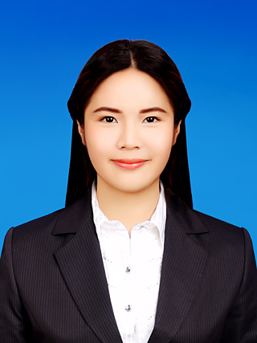

**Ms.ThitiratTaeprasert (นางสาวฐิติรัตน์แต้ประเสริฐ) 郑佳玲**

**E-mail:** tae.thitirat@gmail.com **Home Phone:** 02-902-3076

**Address:** 88/149 Saransiri village, Khlongsong, Klongluang **Cell Phone:** 086-604-5223

Patumthani, Thailand,12120

**Personal Data**

**Nationality:** Thai

**Height:** 160 cm.

**Weight:** 54 kg.

**Birth Date:** January 1, 1995

**Career Objective**

-To make a benefit for firms

-To learn some new experiences from experienced

People

-To get more opportunities in order to improve skills

**Education**

**Bachelor of Arts in Chinese studies**

**Thammasat University, Thailand**

Expected graduation June 2017, Current GPA 3.78

Exchange student for one semester in Fudan University, Shanghai, China (semester2/2016)

**High School**

High school diploma (Chinese-English Program) December 2011, Saint Francis Xavier School, Thailand

GPA 3.86

**AFS** Exchange Program to Sao Paulo, Brazil(2011-2012)

**Activities**

1.PridiBanomyong International College Student

Council Committee 2014

2. Thammasat University Student Union 2015

3. As a delegate from Thammasat University, to

Participate in the Asia Pacific Student Leaders

Conference 2015 (APSLC) in Malaysia (August3-6,

2015)

4. A member of AIESEC in Thailand as a Manager of

outgoing Global Community Development Program.

**Part Time Employment**

-Lecturer and staff in English Camp of Funny Trip

Company

-Coordinatorfor DINDIN China E-commerceof Hong

Kong Dada Enterprise

-Coordinator for Intellectual Property Fair by

stationing at Business Matching Lounge(Aug 11-14,

2016)

-freelance at Wongnai.com in Thai description part (October-December)

-Coordinator for The 1st ASEAN Conference on Crime Prevention and Criminal Justice at Dusit Thani hotel (Nov 9-11, 2016)

-Chinese and English Tutor for 2 years (Freelance)

**Skill and Languages**

**Thai:** Fluent

**English:** Intermediate

**Mandarin Chinese**: HSK level6

**Portuguese**: Intermediate

**Computer**

Microsoft Word Advanced

Microsoft Power Point Advanced

Microsoft excel

Internet Advanced

**Reference**

Mr.KenWithoonchat(adviser)

Thammasat University tel. 081-808-0176

**My Strength**

1. Responsible

2. Communication skill

3. Flexible

4. Active

5. Reliable