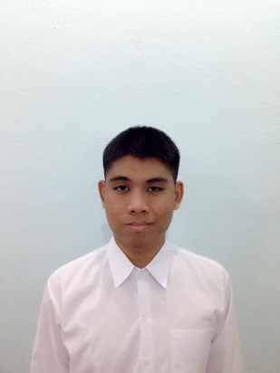Name: JULDANAI J. SUNGSUB SEX: Male Date of birth: 08 May 1994 Age: 22

Race: Thai Nationality: Thai Marital Status: Single

Address: 269/2 Phitsanulok-Bungpra Road Muang District, Phitsanulok 65000 Thailand

Tel: 66-81-9737661 E-mail: juldanai@yahoo.co.th

OBJECTIVE

To work in a position related to aeronautical engineering where I can apply my knowledge and skills in aircraft design, assembly and maintenance.

EDUCATION

* 2012 – 2016 Suranaree University of Technology, Nakhon Ratchasima Thailand

B. Eng. In Aeronautical Engineering, graduation – January 2016 With the first Honor.

* 2009 – 2012 Naresuan University Demonstration School, Phitsanulok Thailand

High School Diploma

EXTRACURRICULAR ACTIVITIES

* President of Flying Club(RC) of Suranaree University of Technology.
* Hobbies: reading books and participating in student activities.

QUALIFICATIONS

* Good in English (TOEIC score : 715)
* Good in Computer programing(C# and GTK# language)
* Proficient in Microsoft Word and Excel
* Fair in 3D CAD design software(Auto CAD and Solidwork)

REFERENCES

|  |  |
| --- | --- |
| Asst. Prof. Dr. Jiraphon Srisertpol  Advisor and Lecturer  Institute of Mechanical Engineering  Suranaree University of Technology  Nakhon Ratchasima 30000 Thailand  Tel: (66)(44) 224412 | Dr. Chalothorn Thumthae  Lecturer  Institute of Aeronautical Engineering  Suranaree University of Technology  Nakhon Ratchasima 30000, Thailand  Tel: 66-85-7779655 |