Wiphada Dendee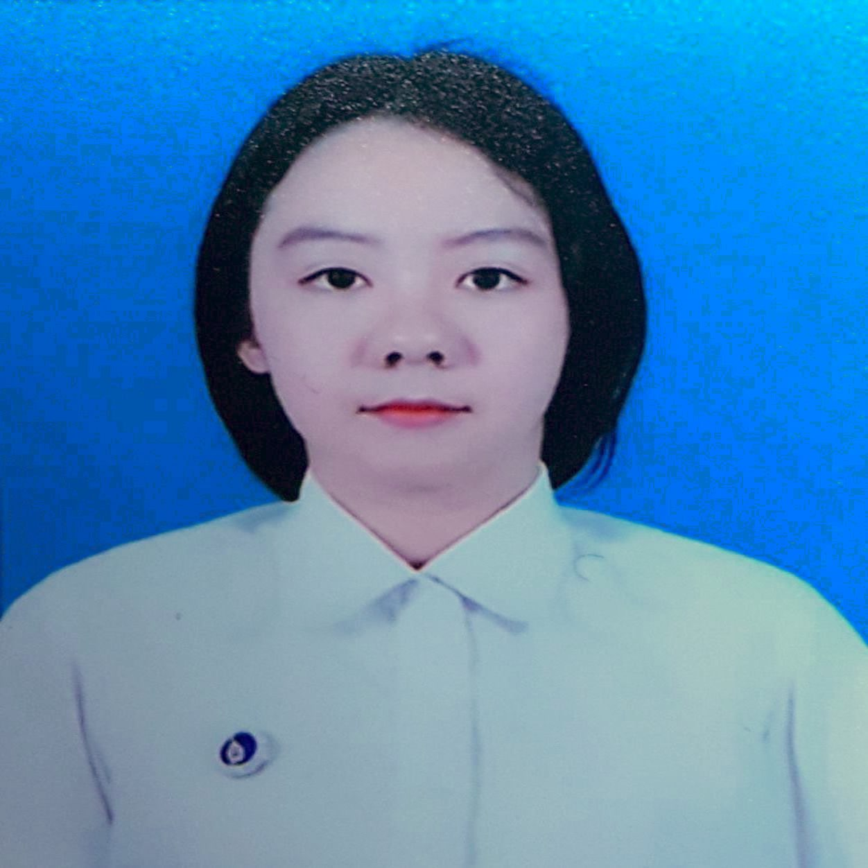

30/22 Udomsuk42, Sukhumvit 103 Road, Bangna, Bangkok 10260 **Mobile:** 085-1539541 **Email:** wiphada.den@gmail.com

**Linkedln:** www.linkedin.com/in/wiphadaden

**TECHNICAL SKILLS**

* + **Computer language :** C, SQL, Java, JavaScript, HTML, CSS, PHP,python
  + **RDBMS :**  MySQL, MongoDB, SQL server, PostgreSQL
  + **Mobile OS:** Android
  + **IDE :**  Eclipse, Android studio, MicrosoftVisual studio
  + **Hardware:** Kinect for windows
  + **Business tools:** Salesforces, localytics, Amplitude, Facebook

advert, Business Manager, Appflyer

**ABILITIES**

* + Innovative & Creative
  + Excellent critical thinking
  + Public speaking
  + Ability to analyze
  + Social skill
  + Ability to work individual and collaboration
  + Ability to accept change and different idea
  + Positive attitude
  + Project management
  + Advanced English skills (TOEIC: 750)

**EDUCATIONS**

* + B.Sc., (Computer Science), Information & Communication Technology, International Program, Mahidol University, Thailand, 2017 (Current GPA : 3.84)

**EXPERIENCES**

* 1. Paid Marketing Internship at Hotelquickly (Dec 2016 - Feb 2017 (2 months))

My responsibility

Used Salesforce to analysis the marketing such as EDM

Use Facebook Advert and Bussiness Manager to create creative for Facebook ads

Use localytics to analysis push notification (write script) and inbox (write html)

Write php and sql to extract the data from database

Write script for Mongo DB and python to extract the data

Analysis data from in-app events from Amplitude and Appflyer

2. Research Internship at Faculty of ICT, Mahidol University at Faculty of Information and Communication Technology, Mahidol University (June 2016 - July 2016 (2 months))

My responsibility

Research about Internet of Thing (IoT) and designed it with LEGO EV3 Mystorm to create the model for teaching ICT students.

Research MOOC (Massive Open Online Course )

Research MU Literacy, which is the test to measure IT literacy for prospect ICT students.

3. Participant in Google Ignite at Google adwords (June 2016 - June 2016 (1 month))

Participated In Google Ignite that taught about Google Adwords. Then, I did the the Google Adwords Certification exams and finally I got the certification.

4. Participant in Study Jams at Google (December 2015 - December 2015 (1 month))

Participated in Study Jams, which is the Google project for studying Android programming.

5. Participation in ACM - ICPC Asia Thailand programming 2015 at ACM International Collegiate Programming Contest (October 2015 - October 2015 (1 month))

Participated In ACM-ICPC programming contest 2015 as MUICT_TheFaithTH Team. In this year, I was able to pass through Asia rounds.

6. Participation in ACM-ICPC Thailand Central 2014 at ACM International Collegiate Programming Contest (September 2014 - September 2014 (1 month))

Participated In ACM-ICPC programming contest 2014 as MUICT_NEVERMIND Team

**ACCOMPLISHED PROJECT**

* 1. TETIS GAME (C programming)

Implementing the TETIS game in C

* 1. WHAT TO WARE (Andriod)

Android application about sharing, searching and collecting clothes

* 1. Unbelle (Web Pragramming)

Website for clothing store programming by SQL, PHP, HTML, JavaScript and CSS

4. BM card (Software Engineering)

Designed BM system to provide the service for both BTS and MRT

Wrote Vision and Supplementary specification