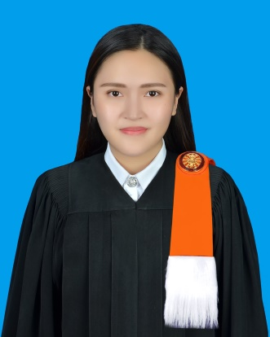**Kanyapas TAVEESIRIVATE**

Room No.2406, Summer Mansion, 441,

Soi Ratchadaphisek 14,Huai Khwang,

Huai Khwang, Bangkok, 10310

*Mobile: +66(0)82-3536699*

*E-mail: taveesirivate.k@gmail.com*

**Date of Birth**: December 16, 1994

**Sex**: Female

**Nationality**: Thai

**Religion**: Buddhism

**Marital Status**: Single

**Expected Salary:** Negotiable

**Start Date:** Immediately

**EDUCATION:**

**2013-2017:** B.A. (French, Thammasat University, Bangkok, THAILAND) GPA 2.7

**2015-2016:** Student Exchange Program (Franche-Comté University, Besançon, France)

**2007-2013:** Suksanari School (Arts-French Program, Bangkok, THAILAND) GPA 3.2

**EXPERIENCES:**

**2017-2013:** Student representatives (Tra-Goon) of Liberal Arts, Thammasat University

**2016:** Coordinator of Tour du monde en 80 plats activity, Besançon

Coordinator of Thai Dinner activity, Besançon

**2015:** Tutor of French Exam (PAT7.1)

**2014:** Liberal Arts’ Volunteer, Kamphaeng Phet

**2013:** Student representatives of Suksanari School, Rangsit University

**LANGUAGES:**

**Thai: Excellent (Maternal language)**

**English: Good command –TOEIC score: 670 points**

- Listening: 315 points

- Reading: 355 points

**French: Good command-**

**- Passed DELF B2 Public** (Diploma of study French language)