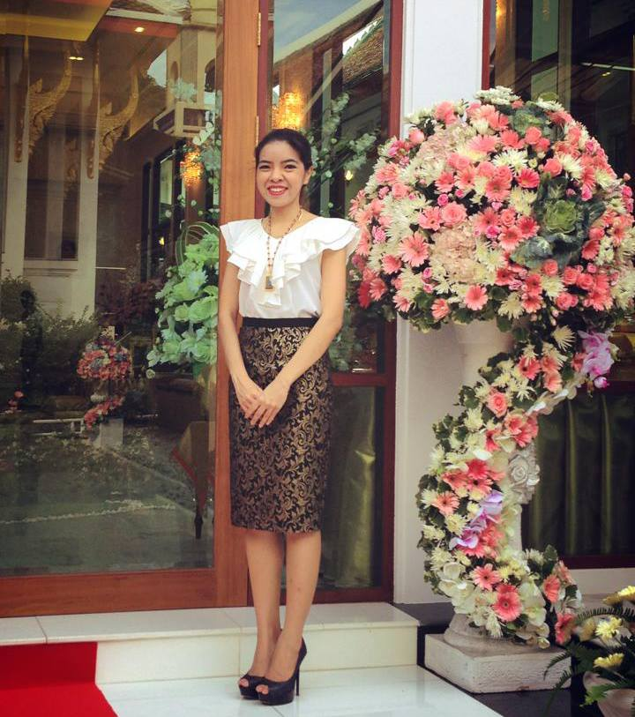

**DR. CHATCHAREE BUNNAG**

**(ดร.ชัชรีย์ บุนนาค)**

**Current Job Title:**

**Chief Executive Officer (ผู้ก่อตั้งและกรรมการผู้จัดการบริษัท ชัชรีย์ (2559) จำกัด)**

Chatcharee (2559) Company Limited

**Part-time Lecturer (อาจารย์พิเศษ)**

Faculty of Liberal Arts, Kasem Bundit University; Department of Hotel Management (International Program)

คณะศิลปศาสตร์ ภาคการโรงแรม (หลักสูตรนานาชาติ) มหาวิทยาลัยเกษมบัณฑิต

**Guest Speaker (วิทยากร)**

Department of Social Development; Bangkok Metropolitan Administration (สำนักพัฒนาสังคม กรุงเทพมหานคร)

Department of Skill Development; Ministry of Labor (กรมพัฒนาฝีมือแรงงาน กระทรวงแรงงาน)

**Freelance Translator / Interpreter (ล่ามอิสระ / ผู้แปลเอกสารอิสระ)**

(Thai – English, and English – Thai)

**Entrepreneur / Food Business Owner**

Somdet Cuisine (ร้านอาหารครัวสมเด็จ เขตคลองสาน ธนบุรี)

Charlene – Catering Service Provider (บริการจัดเลี้ยงอาหารทุกประเภท พร้อมบริการจัดเบรก)

**Date of Birth:** May 21, 1981

**Address:** 53 Somdetchaopraya Road, Klongsan, Bangkok 10600

**Contact Numbers:** 094 669 1924; 089 519 6936; 099 159 4545

**Line ID:** cherie.atwood

**E-mail Address:** chatcharee.bunnag@gmail.com; chatchareeeducation@gmail.com

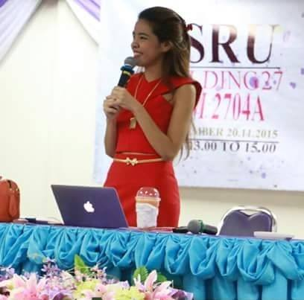

**DR. CHATCHAREE BUNNAG**

**(ดร.ชัชรีย์ บุนนาค)**

**Areas of Expertise (as a teacher / corporate trainer / class facilitator / coach / instructor)**

* English Language Training
  + Early English for Kindergarten
  + Basic English Conversation for Young Learners / Teenagers / Adults
  + English for Customer Service Providers / Restaurant or Hotel Staff / Office Staff
  + English for Tourist Guides
  + English for Tourism and Hospitality
  + English for Presentation
* Service Excellence for Customer Service Providers / Restaurant Staff / Front Office Staff / Hotel Staff
* Coaching and Mentoring Skills / Supervisory Skills / Leadership Skills
* Team Building (Workshop / Camp)

**Areas of Expertise (as a lecturer)**

* Human Resource Management (Undergraduate Level)
* Organizational Behavior (Undergraduate Level)
* Management – Theory and Practice (Undergraduate Level)
* Leadership – Theory and Practice (Undergraduate Level)
* Ethics in Hotel Businesses (Undergraduate Level)
* Cost Management and Control in Food Businesses (Undergraduate Level)
* Entrepreneurship (Undergraduate Level)
* Marketing Management in Service Sector (Undergraduate Level)

**Professional Profile**

A positive and proactive entrepreneur with an outgoing personality and determination to succeed. Experienced in working in a variety of industries with the primary focus on Human Resources Management and Development. Possesses excellent interpersonal, communication and negotiation skills and the ability to develop and maintain mutually beneficial internal and external relationships. Enjoys being part of, as well as managing, motivating and coaching a successful and productive team, and thrives in highly pressurized and challenging working environments.

**Key Skills**

* Human Resources Management Skills; including HR planning skills, recruitment & selection skills, and Talent Attraction & Recruitment skills
* Human Resources Development Skills; covering coaching and mentoring skills, training and development programs design and implementation, Performance Management System design and implementation, Competency Development Program design and implementation, and Individual Development Program design and implementation
* Organizational Development Skills; including Organizational Structure design, job analysis, Job Description creation, and Corporate KPI’s setting and distribution to all departments, sections and individuals
* Used to working well under pressure, to tight deadlines and unsupervised

**Academic Qualifications**

May 26th, 2017

* **Honorary Doctor of Religious Philosophy in Meditation; Universal Ministries of the King’s College, Florida**

August 2015 – Present

* **Studying for Master of Education (Educational Administration); Suan Sunandha Rajabhat University, Bangkok, Thailand.**

September 2004 – October 2005

* **Master of Arts (MA) Business and Culture Studies; Witan International College, Reading, England.**

June 1999 – May 2003

* **Bachelor of Arts (BA) Economics, Thammasat University, Bangkok, Thailand.**

August 1998 – June 1999

* Participated in an Intercultural Program (AFS # 37); The Netherlands.

**Career History**

October 2013 – November 2016

* Managing Director; Charee Company Limited

November 2012 – September 2013

* Human Resources Development Manager; Com7 Public Company Limited

June 2011 – October 2012

* Retail Operations Manager; Com7 Public Company Limited

April 2010 – June 2011

* Café Amazon Operations Manager; PTT Retail Management Company Limited

October 2009 – March 2010

* General Manager; Wine Loft Company Limited

January 2008 – September 2009

* District Manager; Starbucks Coffee (Thailand) Company Limited

July 2006 – December 2007

* Area Manager; Distri-Thai Limited

August 2004 – July 2006:

* Barista/Shift Supervisor/Retail Management Trainee; Starbucks Coffee UK Company

**IT Skills**

* Word, Excel, PowerPoint, Internet & Email (Outlook)
* Pages, and Keynotes (for MAC)

**Personal Details**

Health Excellent

Interests Sports, Family Activities, Thai History and Traveling

References are available on request.