**JDA**

This document highlights all the self-learnings about JDA and provides links for deep-dives too.

**About JDA**

The company - For over 30 years, JDA has been the leading provider of end-to-end, integrated retail and supply chain planning and execution solutions.

**In GFS**

JDA’s software is being used by Gordon Food Service(GFS) in the following manner –

The JDA DP and DRP Application includes three major components:

**Demand Planning** - The JDA Demand Planning software takes GFS sales history as input and then applies a forecasting method to produce a time phased order forecast by item and ship dc.

**Fulfillment** - The JDA DRP software takes the forecast from Demand Planning as input and then nets out the on-order and the on-hand quantities from the forecast to create recommended shipments for an item at a ship dc.

**Load Builder** - The GFS proprietary software takes the recommended shipments from DRP as input and then builds planned orders for a vendor by matching recommended shipments with vendor and item load building parameters. (Only for POs)

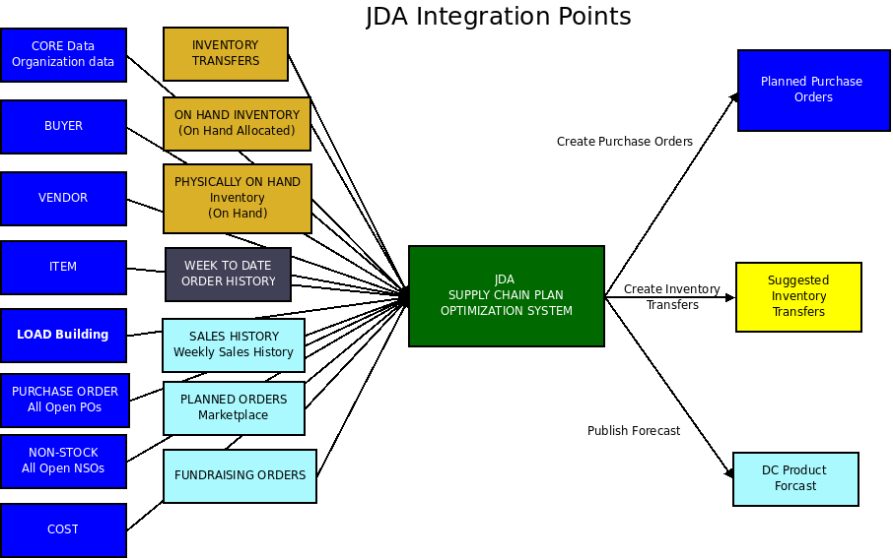

Upgrade to JDA –

1. Enterprise DB will be moved to SAP.
2. Extract/flat file etc will be sent from SAP(new system replacing legacy enterprise system) to the existing JDA stage tables (latest understanding)

Important Links –

Inventory Optimization* - <https://drive.google.com/open?id=0BxrL9YYFOnBLQmxvM2N6dU5tQ1U>

JDA technical FAQ(most important link) - <https://confluence.gfs.com/confluence/display/CORPISSCMPRODUCTACQUISITION/JDA-Tech-FAQ#JDA-Tech-FAQ-HowdoIchangeTooltipsinDSW?>

JDA Use Cases - <https://confluence.gfs.com/confluence/display/CORPISSCMPRODUCTACQUISITION/JDA+-+Use+Cases>