**Functional Understanding of OTM Application:**

Tanya Kurbanova – Scrum Master & Business Analyst

Dan Trump – Onshore Developer

OTM: Stands for **Oracle Transportation Management** system. It is used to handle/mange inbound freight for GFS. It has an integration with the legacy PO system. From the PO system when order gets released, it reaches the OTM system when an AUTOSYS job is run.

OTM is not for Vendor Dropship Orders, because that is not inbound into GFS. It goes directly to Customers. Only the transportation of orders that are inbound into GFS are managed by OTM.

Access to the application will be given by **Dan**. NOT through mysit.gfs.com

Here is what the application looks like:

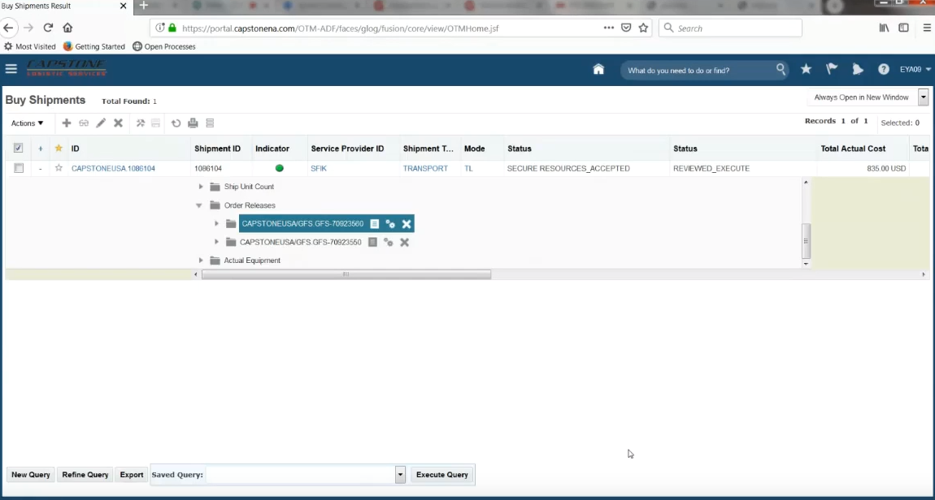

All orders are prefixed with **GFS-**. Otherwise orders have the same Id as in the PO in OTM.

Jobs can be run and are scheduled through **AUTOSYS** application, which handles the integration between PO and OTM. These jobs are prefixed with TMS, to differentiate them from Jobs that the PO system uses for example.

Jobs currently in production are shown below:

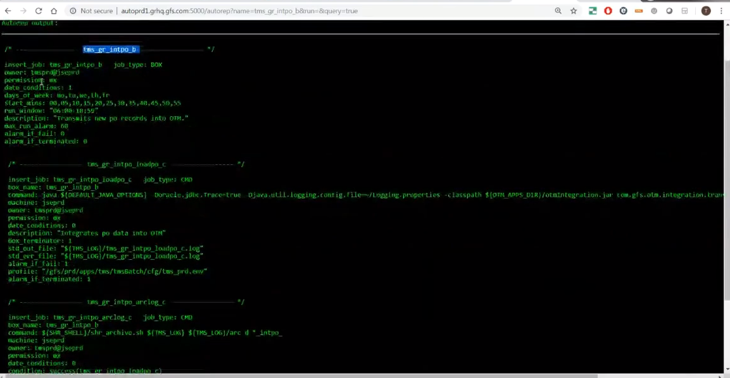

The job to transmit newly created POs to OTM is run every 5 minutes and can also be manually run.

More than one PO can be a part of a single shipment in OTM as depicted (highlighted) in the first screenshot. Shipments are created automatically by the OTM application to manage the transportation of the goods inbound into GFS.

OTM calculates things like financials, weight of the shipment, an ID automatically and populated them.

**Carriers** or **Service Providers** are actually doing the transport.

OTM sends email / EDI document to service providers / carriers called **TENDER** to acknowledge the orders. Service Providers review the message and either decline or accept the tender.

OTM calculates the amount as well for the freight. This information is sent back to PO system and can be viewed in the PO system on the following screen at the bottom in the **PO Consolidation** section:

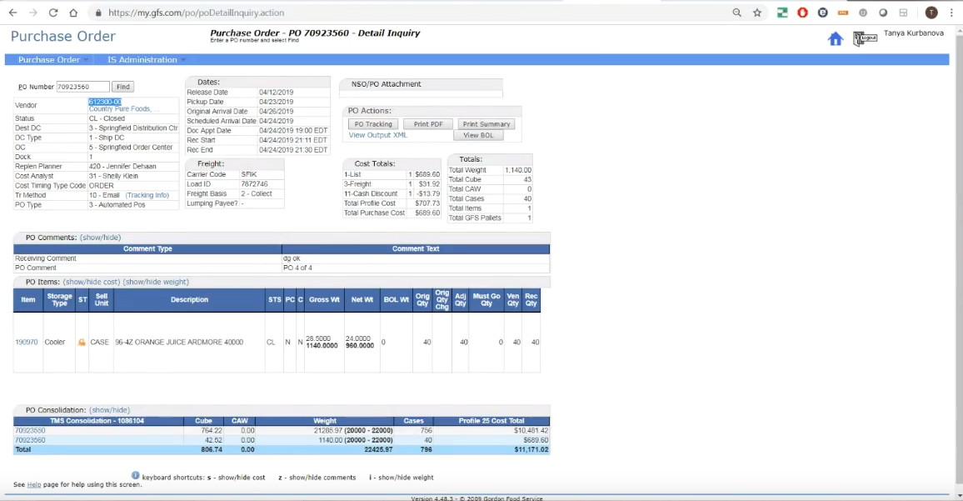

After a shipment is executed an invoice gets generated. EDI Carrier will send us invoice through an EDI transaction.

Invoices are then transported from the OTM system into General Ledger system.

Everything from planning to shipment is done by business users in the OTM Application, which is a specific User Role that can be obtained from the OTM Admin (Tanya).

**Shipments:**

Shipment details can be obtained by clicking on the Shipment in the below page to open a new Window:

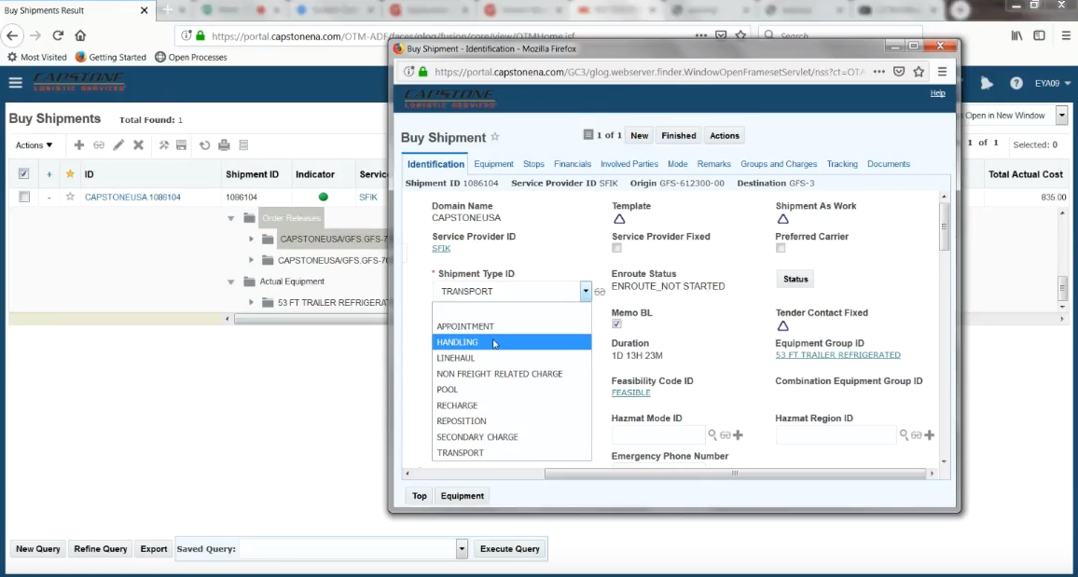

Shipment stops section has pickup Vendor location and Delivery information.

Approximately 1000 POs reach OTM per day in production.

We can have 3 or 4 stops in between when a shipment is being transported. Shipments can start at cross docks as well. Cross docks are intermediate stops where shipments can be dropped off to be collected by other trucks.

Bills would be for customers. Invoices will be for GFS. GFS can pay the vendors for the products and then bill the same amount to the Customer.

Carriers / Service providers can generate Invoice in OTM once they review the agreed upon price, or send it to using EDI. Carriers have a portal in OTM as well.