File: greater.asm

@7

D=A

@R1

M=D // RAM[1] = 7

@11

D=A

@R2

M=D // RAM[2] = 11

@5

D=A

@R3

M=D // RAM[3] = 5

@R1

D=M // D = RAM[1] (7)

@R2

D=D-M // D = RAM[1] (7) - RAM[2] (11)

@COMPARE_ONE // (R1 >= R2)

D;JGE // GOTO (COMPARE_ONE) IF D (-4) >= 0

@R2 // (R1 >= R2) == false

D=M // D = RAM[2] (11)

@R3

D=D-M // D = RAM[2] (11) - RAM[3] (5)

@COMPARE_TWO // (R2 >= R3)

D;JGE // GOTO (COMPARE_TWO) IF D (6) >= 0

@R3 // (R2 >= R3) == false

D=M // D = RAM[3] (5)

@R0

M=D // RAM[0] = RAM[1] (7)

@END

0;JMP // GOTO (END)

(COMPARE_ONE) // (R1 >= R2) == true

@R1

D=M // D = RAM[1]

@R3

D=D-M // D = RAM[1] (7) - RAM[3] (5)

@COMPARE_ONE_ONE // (R1 >= R3)

D;JGE // GOTO (COMPARE_ONE_ONE) IF D (2) >= 0

@R3 // (R1 >= R3) == false

D=M // D = RAM[3] (5)

@R0

M=D // RAM[0] = RAM[3] (5)

@END

0;JMP // GOTO (END)

(COMPARE_ONE_ONE)

@R1

D=M // D = RAM[1]

@R0

M=D // RAM[0] = RAM[1] (7)

@END

0;JMP // GOTO (END)

(COMPARE_TWO)

@R2

D=M // D = RAM[2]

@R0

M=D // RAM[0] = RAM[2] (11)

@END

0;JMP // GOTO (END)

(END)

@END

0;JMP // INFINITE LOOP @END

File: greater.png

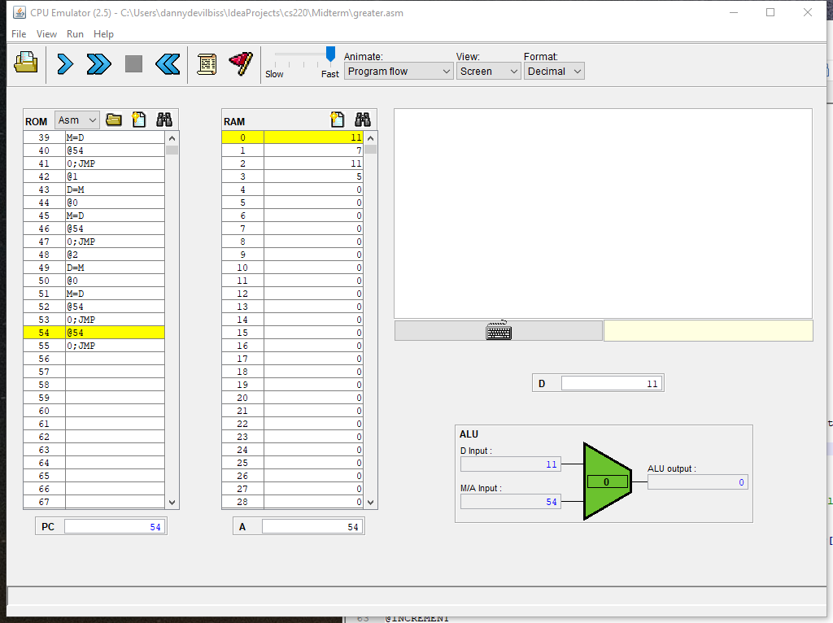

File: greatest.asm

@R0

M=-1 // RAM[0] = -1

@5

D=A

@size

M=D // RAM[size] = 5

@i

M=1 // i = 1

@1

D=A

@R1

M=D // RAM[1] = 1

@3

D=A

@R2

M=D // RAM[2] = 3

@9

D=A

@R3

M=D // RAM[3] = 9

@7

D=A

@R4

M=D // RAM[4] = 7

@5

D=A

@R5

M=D // RAM[5] = 5

(LOOP)

@i

D=M // D = i

@size

D=D-M // D = (i) - size

@END // (i < size)

D;JGT // GOTO (END) IF D (i) > 0

@i

D=M // D = i

A=D // A = i

D=M // D = arr[i] (Took me forver to figure this out.)

@R0

D=D-M // D = RAM[0] - arr[i]

@COMPARE // (arr[i] > RAM[0])

D;JGT // GOTO (COMPARE) IF D (RAM[0] - arr[i] > 0)

@INCREMENT

0;JMP // (If arr[i] is not greater than RAM[0], INCREMENT and loop again.)

(COMPARE)

@i // (Same thing as before, this time setting RAM[0] = arr[i].)

D=M // D = i

A=D // A = i

D=M // D = arr[i]

@R0

M=D // RAM[0] = arr[i]

@INCREMENT

0;JMP // (INCREMENT and loop again.)

(INCREMENT) // (Just to cut down on repetitiveness. Loops are completely terminated.)

@i

M=M+1 // i++

@LOOP

0;JMP // GOTO (LOOP)

(END)

@END

0;JMP // INFINITE LOOP

