Melodizer User Manual
v1.0.0
Table of Contents
Overview 3
Oscil Controls 4
Wave 4
P/W 4
Glide 4
Move 4
Envelope Controls 5
A, D, S, R 5
Effects Controls 6
Delay 6
Feed 6
Mix 6
Flange 6
Rate 6
Depth 6
Feed 6
Mix 6
Clock Controls 7
Source 7
BPM 7
Step 7
Swing 7
Transport (Play, Pause, Stop) 8
Pitch Controls 8
Key 8
Scale 8
Octave 8
Range 9
Master Controls 9
Volume 9
Width 9
Voices 9
Seed 9
Sequence Controls 10
Step Mode 10
P(N) 10
L-R 11
V 11
A, D, S, R 11
RAND 11
Presets 11
MIDI and Audio 12
Preferences (Standalone) 12
Midi Input 12
Midi Output 12

Overview
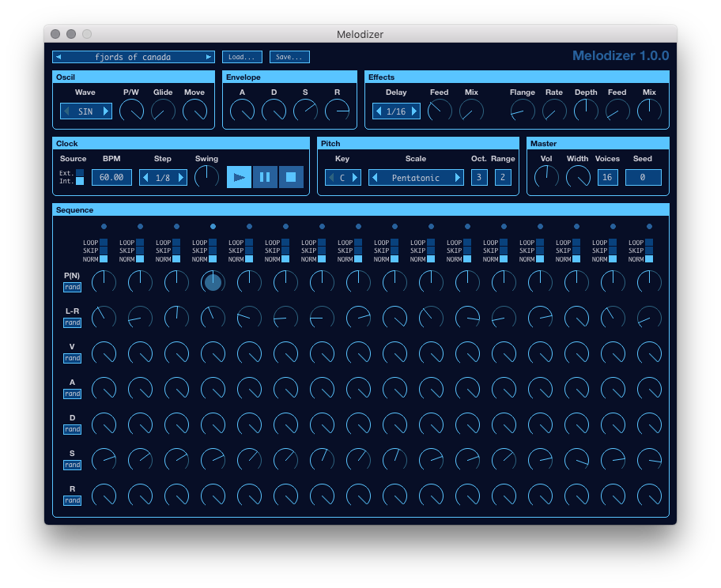
Melodizer works like an analog sequencer where each step in the sequence is controlled by a column of knobs. Rather than having a Pitch and Gate knob for each step, Melodizer's main knob is Probability. At each step you can control the probability that the sequencer will play a note when that step is activated. The actual pitch played will depend on the chosen Key, Scale, Octave, and Range. At each step you can also control how the note is panned, set the velocity, and shape the amplitude envelope of the note using ADSR knobs (attack, decay, sustain, release).
Melodizer will play notes using a built-in oscillator and effects, but also sends MIDI note messages so that you can use it to drive any soft-synth you already own. Any MIDI notes received by Melodizer will be used to change the Key and Octave or, in the case of the Fingered Scale, will be used as the pool of notes to choose from.
When running the Standalone version, you can use the Preferences dialog to set the MIDI In device, which will allow you to use MIDI notes, MIDI CC messages, and MIDI MMC messages to control the app. For more detail, refer to the MIDI and Audio section of this manual.

Oscil Controls
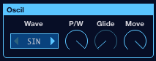

Wave
The Wave control sets the waveform that will be used by the next note that is played by the sequencer. Notes that are already playing will not change their waveforms. The available waveforms are:
- SIN: a sine wave
- TRI: a triangle wave
- SAW: a saw wave
- SQR: a square wave
- SIN4: a sine wave with 4 addtional harmonics
- SIN8: a sine wave with 8 additional harmonics
- SIN16: a sine wave with 16 additional harmonics
- SIN32: a sine wave with 32 additional harmonics
Wavesforms are not band-limited. This means that you will hear increasingly loud aliasing as the frequency of notes increases, though how soon will depend on the sample rate. This was done to enable the production of metallic-like sounds when the Octave setting is cranked way up.

P/W
The P/W control sets the pulse width of any Wave. As you reduce the pulse width, you effectively squish the left half of the waveform and elongate the right half. For example, with Wave set to SQR and P/W set to 25%, you will get a quarter-pulse square wave. In general, reducing the pulse width introduces more harmonics and makes a Wave sound "brighter" or "sharper".

Glide
The Glide control sets how many seconds a new note will take to smoothly change its frequency from the frequency of the most recently played note to its target frequency.

Move
The Move control sets how many seconds a new note will take to smoothly change its panning position from the panning position of the most recently played note to its target panning position, which is set with the L-R knob in the Sequence section.

Envelope Controls
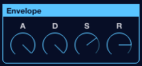

The Envelope section contains controls for configuring the global ADSR for the synth. Each note that is triggered by the Sequencer will have an amplitude envelope based on the knobs in this section and the corresponding knobs for the note's step in the sequence. Once a note begins to play, its envelope will not change, even if one or more of the controls do.

A, D, S, R
The A control sets the duration (in seconds) of the Attack portion of the global note envelope. When a note is triggered, its amplitude will ramp up to full volume (the setting of the V knob of the note's sequence step) from silence over a duration that is equal to the percentage of the global Attack duration set for the note's step. For example, if the global A knob is set to 1 second and a step's A knob is set to 50%, then a note triggered by that step will have an Attack of 0.5 seconds.
The D control sets the duration (in seconds) of the Decay portion of the global note envelope. The Decay begins when the Attack portion ends. The amplitude of the note will decrease from the maximum amplitude to the level indicated by the S knob. As with Attack, the actual duration of a note's Decay depends on the setting of this knob and a step's D knob.
The S control sets the level of the Sustain portion of the global note envelope. This is expressed as a percentage, where 100% is full amplitude (ie the amplitude that the Attack portion ramps up to) and 0% is silent. The actual Sustain level for a note will depend on the setting of this knob and the step's S knob. For example, if the global Sustain is at 50% and a step's S knob is also at 50%, then the Sustain level for a note triggered by that step will be 25%.
The R control sets the duration (in seconds) of the Release portion of the global note envelope. As with Attack and Decay, the actual Release duration for a note will be scaled by each step's R knob. The Release portion of the envelope begins when the Sequencer moves to the next step in the sequence after triggering a note, but only if a note has finished the Attack and Decay portions of its envelope. Otherwise, a note will auto-release once it finishes the Decay. This enables the production of long notes even if the tempo is quite high.

Effects Controls
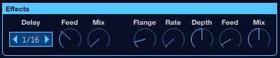

Delay
The Delay control sets the delay time of a single-tap Delay effect to a musically defined duration. That is, the actual delay time in seconds will depend on this setting and the BPM setting. Delay times can be set to 64th notes up to Quarter notes, with either Triplet, Straight, or Dotted durations. (ie 1/16T is a 16th note triplet, 1/8. is a dotted 8th note, etc).

Feed
The Feed control that is next to the Delay control is the percentage of the delayed signal is fed back into the delay effect.

Mix
The Mix control sets a percentage for a wet/dry mix of the effect. At 0% the Delay effect will output only the dry signal. At 50% it will output the full dry signal mixed with the full wet signal. At 100% it will output only the wet signal.

Flange
The Flange control sets the delay time of a single-LFO Flanger effect. The duration is in milliseconds and ranges from 0.01ms to 50ms.

Rate
The Rate control sets the frequency of the Flanger's LFO in Hz.

Depth
The Depth control sets how much the LFO impacts the delay time. At a Depth of 100%, the Flanger's delay time will oscillate between 0 and double the Flange setting.

Feed
The Feed control that is next to the Depth control is the percentage of the Flanger's wet signal is fed back into the Flanger.

Mix
The Mix control sets a percentage for a wet/dry mix of the effect. At 0% the Flanger effect will output only the dry signal. At 50% it will output the full dry signal mixed with the full wet signal. At 100% it will output only the wet signal.

Clock Controls
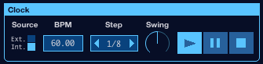

Source
The Source for the Sequencer's clock can be set to either Internal (Int.) or External (Ext.). When Source is set to Int. The Sequencer will use the tempo set in BPM. When Source is set to Ext. the Sequencer will sync to tempo and musical position (if available) of the Host. In the Standalone version, Ext. will lock the tempo to 120 BPM because it does not support receiving external clock messages.

BPM
The BPM control is for setting the tempo (beats per minute) of the Sequencer. This setting is only used when Source is set to Int. and will be greyed out when Source is set to Ext. It can be changed by scrolling the mouse while hovering over the control or by clicking on the text and typing a new value.

Step
The Step control is for setting the musical length of one step in the Sequencer. Each step in the Sequencer is represented by a column of knobs with an LED at the top that blinks when the sequence reaches that step. Step lengths range from 64th notes to Quarter notes in Triplet, Straight, and Dotted lengths. Note that these are ordered by duration, so, for example, 1/8T comes before 1/16. in the list because a Triplet 8th note is shorter than a Dotted 16th note.

Swing
The Swing control makes it possible to lengthen or shorten every other step in the sequence. For example, when considering the first two steps in the sequence:
- Swing of 50% will make both steps the same length
- Swing of 75% will lengthen the first step and shorten the second by the same amount. If Step is set to 1/8, then this will result in a Dotted 8th followed by a 16th, followed by a Dotted 8th, followed by a 16th, and so on.
- Swing of less that 50% will shorten the first step and lengthen the second by the same amount. So at 25% the rhythm will be the reverse of 75%.
Swing can be set as high as 90% or as low as 10%. At these extremes it will tend to sound like steps are triggered in pairs.

Transport (Play, Pause, Stop)
The Transport buttons can be used to control the play state of the sequencer. When pressing the Play button while in a stopped state, the sequence will begin playing from the first step in the sequence and the RNG will be reseeded. The sequence can be Paused while playing, which will immediately Release the most recently played note, but allow notes to finish their envelopes. When Unpaused, the sequence will resume playing from where it was paused. When Stop is pressed, all notes are immediately silenced and effect buffers are cleared.

Pitch Controls
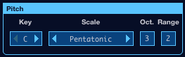

The Pitch section controls how the sequencer chooses the pitch of a note when it decides to trigger a note at a step. The pitch of the note is chosen from the current Scale, transposed into the Key and Octave (unless the current Scale is Fingered). All notes in the Scale are equally likely to be chosen, except for the note most recently played (i.e. Melodizer will never play the same pitch twice in a row, unless the Scale contains only one note). Once the Scale note is chosen, it is then shifted into a random octave based on the Range setting (unless the current Scale is Fingered), yielding the final MIDI note number.
The Pitch settings can be controlled by sending MIDI notes to Melodizer (either by setting the MIDI Input device in the Standalone, or routing MIDI to the plugin). When a MIDI note on message is received, it will be used to set the Key and Octave, unless the Scale is set to Fingered, in which case it will be added to a list of notes that the sequencer will use as the Scale. Notes are removed from the Fingered Scale when a note off for that note is received.

Key
The Key control is for setting the Root Note of the Scale.

Scale
The Scale control is for setting the musical Scale that notes will be chosen from by the sequencer. The available Scales are Monotonic (only the Root Note pitch is used), Pentatonic, Major, Pentatonic Minor, Natural Minor, Harmonic Minor, Blues, Chromatic, Dorian, Mixolydian, and Fingered.

Octave
The Octave control (Oct. in the UI) is for setting the lowest octave that pitches will be chosen from. The octave number corresponds to the ISO MIDI octave numbers (see: https://www.midikits.net/midi_analyser/midi_note_numbers_for_octaves.htm). So if Key is set to C and Octave Is set to 4, then the Root Note of the chosen Scale will be middle C.
The Octave setting ranges from -1 to 9, which covers all Octaves defined for MIDI notes.

Range
The Range control is for setting how many octaves should be used when choosing a note from the Scale. When Range is 1, all notes will be in the same octave. When Range is 2, each note in the scale can be in either the same octave as the Octave setting, or in the octave above. For example if Key C, Octave Is 4, and Range is 2, then both C4 and C5 are pitches that might be chosen by the sequencer.
The Range settings ranges from 1 to 10 to enable choosing notes from the full MIDI note range when Octave is -1. Notes beyond the end of the MIDI note range will still be played, but will result in very high frequencies. Generally, due to the lack of band-limiting in the Waves, very high notes will wind up sounding like weird metallic instruments and contain harmonics arranged in unexpected ways.

Master Controls
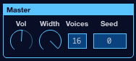

Volume
The Volume (Vol in the UI) control is a master volume for the instrument, expressed in dB.

Width
The Width control is for reducing the stereo spread of notes caused by moving the L-R knobs of each step away from the center. When Width is 0%, all notes will be played panned dead center, regardless of the L-R settings. As Width increases, the L-R knobs will have a larger effect.

Voices
The Voices control is for setting the maximum number of simultaneous tones. Voices in the synth are cycled through in order, they are not directly connected to any particular step. Generally, 16 voices will be enough to prevent a tone from getting truncated to play a new tone. Voices can be set as low as 1 and as high as 32.

Seed
The Seed control is for setting a "seed' number for the RNG (random number generator) used to determine when a step should generate a tone and what pitches will be played. The RNG is reseeded every time the sequencer begins to Play after having been Stopped. When Seed is 0 (zero), the RNG will be seeded with a different number every time it is reseeded, which means the results will be different, even when none of the other settings change. When Seed is non-zero, then every time the sequencer begins to Play after having been Stopped, the output will be the same (but different for different values of Seed).

Sequence Controls
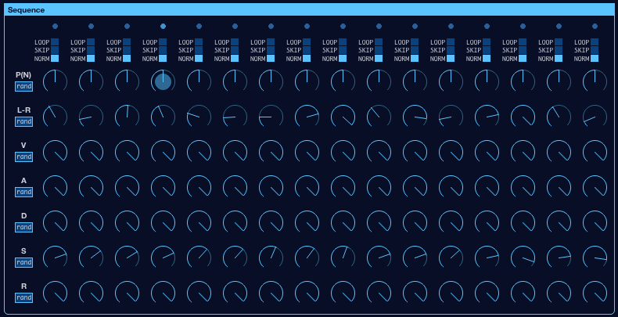
The Sequence section contains 16 columns of controls, each of which represents one step in the sequence. The settings of the controls in each step determine how the sequence behaves when it reaches that step. The progress through the sequence is shown using blinking dots at the top of each column. A dot will blink if that step is evaluated, but due to the nature of this sequencer, it may or may not actually start a note. If a note is started, the step's P(N) knob will blink.
Each step in the sequence contains the following controls:

Step Mode
The Step Mode control can be in one of three states: LOOP, SKIP, or NORM. In the NORM state, the step will be evaluated normally. In the SKIP state, the step will be skipped over by the sequencer as if it did not exist. It will search ahead until it finds a step that is not set to SKIP and that step will evaluate. In the LOOP state, the sequencer will jump back to the beginning of the sequence, as if that was the next step. Again, steps marked SKIP or LOOP will never evaluate, they simply redirect the sequencer to a step that should evaluate in their place.

P(N)
The P(N) control is used to set the probability that a step will generate a note.
To determine whether or not a note should be played at the current step, Melodizer generates a random number and compares it to the value of the step's P(N) knob. If the number is less than or equal to the value of the knob, a note is played (refer to the Pitch section for a description of how the pitch of a note is chosen).
It is possible to use Melodizer more like an analog sequencer by setting P(N) to 100% for steps that should play notes and to 0% for rests. Of course, the actual pitches chosen will still be random, such is the nature of the instrument.

L-R
The L-R control is used to set the left-right pan position for a tone generated by a step. As mentioned in the Master section, this is scaled by the Width setting. So in order to generate tones panned hard-left and hard-right, Width must be at 100%.

V
The V control sets the Velocity of the tone generated by a step. This is effectively a [0-1] amplitude, which will be used in the tone's ADSR as the peak amplitude (i.e. the amplitude that Attack ramps up to).

A, D, S, R
The A, D, S, and R controls are used to set the percentage of the global ADSR values that should be used for that step's amplitude envelope. For example, if the global Attack setting is 1 second and a step has its A knob set to 50%, then that step's amplitude envelope will have an Attack of half a second. Similarly, if a step's S knob is set to 50%, it will decay to an amplitude percentage that is half that of the global S knob.

RAND
Each row of knobs in the Sequence has a RAND button underneath the label. When pressed, it will randomize the value of each knob in that row, giving a quick way to create some variation in a sequence. These RAND buttons are backed by plugin parameters, so randomization can also be triggered via automation by changing the value from 0 to 1.

Presets
Melodizer comes with several presets to demonstrate the range of sounds it can produce. These can be chosen from a dropdown by clicking the wide box in the upper left of the UI or by clicking one of the blue arrows in that box to cycle through them.
The Save button can be used to save the current settings to an fxp file and the Load button can be used to load settings from an existing fxp file. This is a good way to save settings when playing in the Standalone if you want to recall them in a DAW later.
When an fxp file is saved or loaded, the first preset will be overwritten with the current settings. When saving, the preset dropdown box will update to match the filename that was provided.

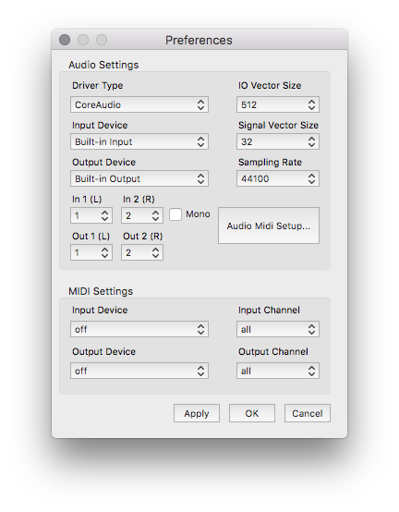
MIDI and Audio

Preferences (Standalone)
The Standalone version has a Preferences menu that can be opened from the Melodizer menu in OSX or the File menu in Windows.
From here you can configure audio input, audio output, sample rate, and set the MIDI input and output device to enable sending MIDI to the app.
If you want to reduce aliasing in higher frequencies of the synthesizer, set the Sampling Rate as high as your system will allow.

Midi Input
As mentioned earlier, the Pitch settings can be controlled via MIDI notes. When a MIDI note on message is received, it will be used to set the Key and Octave, unless the Scale is set to Fingered, in which case it will be added to a list of notes that the sequencer will use as the Scale. Notes are removed from the Fingered Scale when a note off for that note is received.
The Standalone version includes a MIDI Learn feature that enables controlling any parameter via MIDI CC messages. Simply right-click on a control and choose MIDI Learn from the popup, then twist / press the control on the MIDI Input Device to assign its CC to the control. Melodizer ignores the channel of CC messages, so if a MIDI device generates the same CC on different channels, it may be necessary to set Input Channel in Preferences to filter out messages on other channels.
The Standalone version also responds to the MIDI MMC messages Play, Pause, and Stop as if the corresponding Transport button was pressed.

Midi Output
Melodizer outputs MIDI Note messages when the sequencer is running that correspond to the pitches it has chosen. Note On is sent if the step triggers a note. The MIDI note's Velocity will be set using the step's V knob. Note Off is sent when the step ends. These messages enable using Melodizer strictly as a MIDI note generator that can be used to drive any other synth in a DAW. MIDI notes are always sent on channel 0, unless the Output Channel in the Standalone has been set to a specific channel. Melodizer does not clamp MIDI note numbers, so the behavior of other plugins receiving MIDI notes from Melodizer might be unexpected when note numbers exceed the range of the MIDI standard (ie note numbers higher than 127).
In the Standalone version, any control that has MIDI Learn enabled will send MIDI CC messages when that parameter changes. These messages are always sent on channel 0, unless Output Channel has been set to a specific number in Preferences. This makes it possible to keep MIDI controllers with value indicators (like a ring of LEDs) in sync with the UI, even when tweaking knobs by hand or when using the RAND buttons.

