SpectralHarp User Manual
v1.1.0
Table of Contents
Overview 3
Strings 4
String to Frequency Mapping 4
Spectrum Selection 4
Density 5
Tuning 5
Synthesis 5
Volume 5
Decay 5
Spread 5
Brightness 6
Crush 6
Pitch 6
MIDI and Audio 6
Preferences (Standalone) 6
Midi Input 6
Midi Output 6

Overview
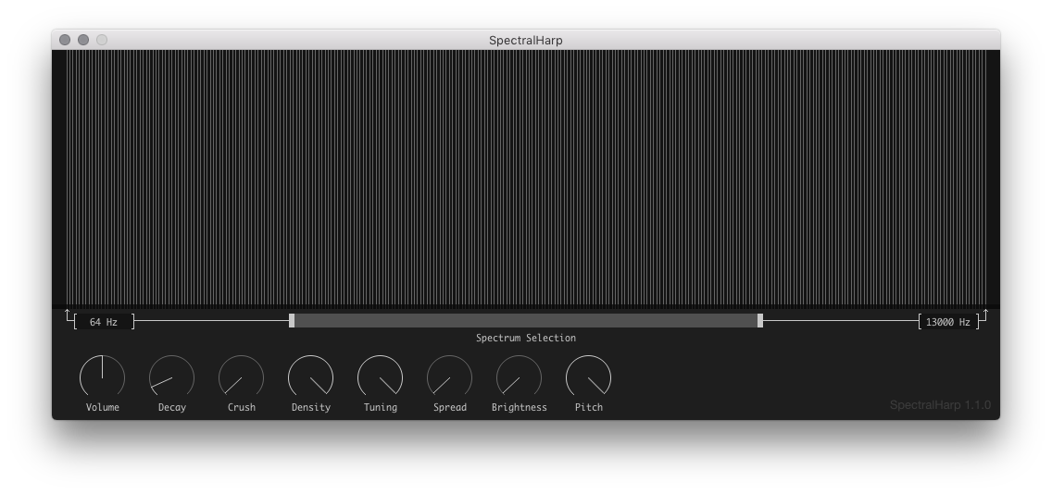
SpectralHarp lets you strum the sound spectrum in various ways by giving you a set of strings that activate different frequencies depending on how you configure them. You can choose the portion of the sound spectrum you want to strum, how many strings to display from that portion, and how to "tune" strings between logarithmically spaced frequencies and linearly spaced frequencies. There are additional knobs for Pitch, Decay, Crush, Spread, and Brightness, which allow you to further modify the sound.
If you want to directly play specific frequencies in the spectrum, you can send MIDI notes to SpectralHarp. The standalone version also supports controlling parameters with MIDI: simply right-click on a control, select MIDI Learn, and then twiddle a knob on your connected device to map it to that control.
When running the Standalone version, you can use the Preferences dialog to set the MIDI In device, which will allow you to use MIDI notes and MIDI CC messages to control the app. For more detail, refer to the MIDI and Audio section of this manual.

Strings
The majority of the interface is a "strummable" area that displays the number of strings indicated by the Density setting. These strings can be activated in several ways:
- Click and drag across the interface to strum strings. Moving the mouse quickly will skip some strings.
- Click directly on a string to activate it. When Density is high, this will activate several adjacent strings. Holding the mouse button down will keep the string(s) active until the mouse is moved away or the mouse button is released.
- Change the Pluck X or Pluck Y parameters via automation or MIDI. Pluck X maps left to right on the strings. Plucky Y maps bottom to top.
The strings also serve as visual feedback for the current state of the frequency spectrum. So, for example, if you increase Spread and then click on a string, you'll see adjacent strings vibrate with smaller amplitudes. This reflects the fact that Spread causes each string to excite a portion of the spectrum around the string's frequency.
You can also directly activate strings by sending MIDI notes to SpectralHarp. When a note on is received, the note number is converted to a frequency and the string with that frequency is activated as if it had been clicked on by the mouse. The string will remain active until a note off is received for that note number. If the string that was activated is one that is currently displayed in the UI, you will see it vibrate. MIDI notes can be combined with strumming.

String to Frequency Mapping
The left-most and right-most strings will always activate the frequencies indicated in the UI. When Tuning is set to 1, strings in-between those will have frequencies based on their horizontal position. That is to say, the string in the center of the UI will have a frequency that is halfway between the lowest frequency and the highest frequency. When Tuning is set to zero, frequencies will increase from low to high in a logarithmic (or musical) way. For example, if the lowest frequency is 220 Hz, the highest frequency is 440Hz, Density is 12, and Tuning is 0, then each string will activate a semitone in a chromatic scale starting at A below Middle C .

Spectrum Selection
The Spectrum Selection control is a multi-slider that provides two handles for controlling the frequency of the left-most string and the frequency of the right-most string. If the handles are not positioned at the very edges of the control, it is also possible to click and drag the area between the handles to keep the same distance between them but shift the area of the spectrum represented.
The actual frequencies of the left-most and right-most strings are displayed in text boxes on the far left and far right of the interface. To set one of these strings to a specific frequency, you can click in the box and type in a number.
For the purposes of minimizing the number of strings that map to the same frequency, these controls will enforce a minimum distance between the lowest and highest frequency.
These frequencies can also be automated in a DAW using First Band and Last Band.

Density
The Density control sets how many strings are available for strumming, which can range from 12 strings to 288.

Tuning
The Tuning control sets the interpolation amount between logarithmically spaced frequencies and linearly spaced frequencies.

Synthesis
SpectralHarp synthesizes sound by constructing a frequency spectrum using the frequencies of the strummed strings, exciting nearby frequencies based on the Spread control, adding harmonics based on the Brightness control, and then using an Inverse FFT to generate audio. This audio is then fed through a bit-crush effect (Crush) and a playback rate effect (Pitch).

Volume
The Volume control is simply a master volume control that scales the final output. It is recommended to keep this relatively low, especially when using high Spread, Density, and Brightness, since it can be quite easy to overdrive the output in that situation.

Decay
When a string is not being continually activated, it's amplitude will decay to zero over the number of milliseconds set by the Decay control. This remains constant even when Pitch is reduced, but very short Decay values will sometimes result in almost non-existent sound when Pitch is also set very low.

Spread
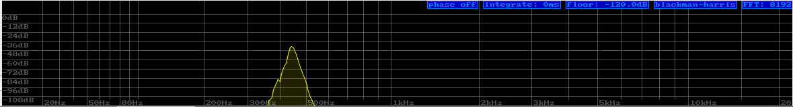
The Spread control sets the "width" of a string in Hz. With a Spread of 0 Hz, each string will add only that frequency to the final spectrum, but as Spread increases, a string will add to a section of the frequency spectrum with the same bandwidth as Spread, centered around the string's frequency. The amplitude of frequencies in the band will falloff exponentially as they move out from the center. For example, if a string of 440 Hz is activated and Spread is set to 200 Hz, then that string will excite a portion of the spectrum ranging from 340 Hz to 540 Hz. Here's what that looks like in a spectrum analyzer:

Brightness
The Brightness control sets the strength of the harmonics added to the spectrum after Spread has been applied. At 100% a single string will sound like a Saw Wave when Spread is 0 Hz. As Brightness is reduced, it will sound like a low pass filter being applied to the signal.

Crush
The Crush control sets the strength of the bit crush effect.

Pitch
The Pitch control sets a playback rate that effectively lowers the pitch of the sound. At 0.5 SpectralHarp will sound an octave lower than it does when Pitch is 1.

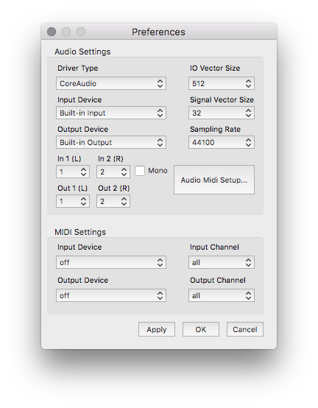
MIDI and Audio

Preferences (Standalone)
The Standalone version has a Preferences menu that can be opened from the SpectralHarp menu in OSX or the File menu in Windows.
From here you can configure audio input, audio output, sample rate, and set the MIDI input and output device to enable sending MIDI to the app.
Sampling Rate impacts the resolution of the FFT used during synthesis, so higher sampling rates are generally better if you are interested in generating accurate musical pitches.

Midi Input
As mentioned earlier, when a MIDI note on message is received, it will be used to directly strum the string whose frequency matches the note number. The amplitude of the string will be set with the note's velocity. As long as the note remains held, the string will remain active.
The Standalone version includes a MIDI Learn feature that enables controlling any parameter via MIDI CC messages. Simply right-click on a control and choose MIDI Learn from the popup, then twist / press the control on the MIDI Input Device to assign its CC to the control. SpectralHarp ignores the channel of CC messages, so if a MIDI device generates the same CC on different channels, it may be necessary to set Input Channel in Preferences to filter out messages on other channels.

Midi Output
In the Standalone version, any control that has MIDI Learn enabled will send MIDI CC messages when that parameter changes. These messages are always sent on channel 0, unless Output Channel has been set to a specific number in Preferences. This makes it possible to keep MIDI controllers with value indicators (like a ring of LEDs) in sync with the UI, even when tweaking knobs with the mouse.

