Evaluator User Manual
v1.1.0
Table of Contents
Overview 3
Interface 4
VOL 5
BITS 5
RUN MODE 5
BPM (Standalone) 5
Play / Pause / Stop (Standalone) 6
V0 – V7 6
SAVE / LOAD 7
PROGRAM 8
AUTO 8
WATCH 8
SCOPE 8
Help 9
Preferences (Standalone) 9
Program Syntax 10
Basics 10
Variables 11
Conditional and Relational Operators 11
Unary Operators 12
Watches 14
Program Errors 15

Overview

Evaluator allows you to write short C-style programs whose output is used to generate sound.
It is inspired by bytebeat, a "genre" of music discovered by viznut, which he documented in several youtube videos.
Evaluator's approach, however, is not purist, and its language is not C. The language contains much of the same syntax, most of the operators, and the same operator precedence, but introduces some additional features that make generating musical sounds a little bit easier and also make real-time MIDI control of the program possible. It also includes several built-in presets that demonstrate all the language features, supports save/load to fxp, and loading a program from a plain text file.
The basic idea is that a program operating on 64-bit unsigned integers is used to generate every audio sample. The program essentially runs in a while loop that automatically increments the variables t, m, and q before executing the program code each time. These will be described in more detail below.
Evaluator makes some incoming audio and MIDI available to the program. The first two channels of incoming audio can be accessed using [0] and [1]. The most recent MIDI Note On number and velocity can be accessed with the n and v variables. MIDI Control Change values can be retrieved using the C unary operator (eg: C10 will be the most recent value recieved for MIDI CC 10).
When running the Standalone version, you can use the Preferences dialog to set the MIDI In device, but if you don't have a device you can also generate a limited number of MIDI notes by using the computer keyboard. The computer keyboard method is not a great implementation due to limitations of the framework used for the Standalone version, so a better solution could be to use a program like MidiKeys as a virtual MIDI keyboard.

Interface

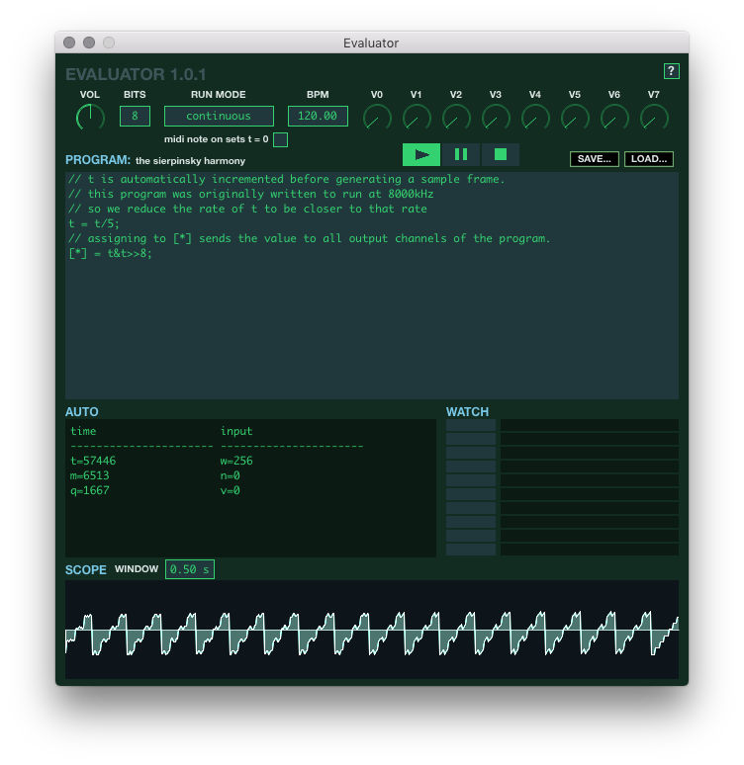

VOL
The VOL knob controls the overall volume of the output. Since the output of programs can often be quite harsh, it is usually nice to keep this around 50%.

BITS
The BITS value describes how the output of the program is interpreted in terms of bit depth. In other words, it indicates that the program output be treated like 8-bit audio, 16-bit audio, 2-bit audio, etc. Programs operate on 64-bit unsigned integers to allow for the largest mathematical space possible, but the output values are wrapped to [0, 1<<BITS] and then converted to [-1,1] floating point values. The "wrap" value is automatically set in the w variable, which can be seen in the AUTO window in the screenshot above. The w variable is used by some of the language's unary operators (eg. $ and T), but it is also often useful within a program.

RUN MODE
The RUN MODE setting controls how the variable t will be automatically incremented. In the Standalone version, there are two possibilities:
- continuous: increment t every audio sample, regardless of the current input to the program
- with midi: increment t every audio sample only when there is at least one active MIDI Note On
When running in a DAW, a third option is available:
- project: set t to the current project time in samples
This third option is particularly useful when a program's output changes a lot over time and you want to be able to jump directly to the output that would result at a particular point in time. The first setting will work similarly if you start playback in the DAW from the very beginning of the project, but it won't work if you start playback somewhere in the middle, due to the fact that DAWs typically reset plugins when playback begins, which will cause t to start counting up from zero.
Run Mode also impacts when m and q are incremented, since these are based on the current value of t:
- m is how many milliseconds the current value of t represents
- q is how many 128th notes the current value of t represents
When Run Mode is continuous or with midi, a checkbox is shown labeled midi note on sets t = 0. When it is checked, the variable t will be set to 0 (zero) whenever Evaluator receives a MIDI Note On message, either from the DAW, a connected MIDI device, or the computer keyboard.

BPM (Standalone)
The BPM setting is only available in the Standalone version. When running in a DAW the BPM will always match the project tempo. In both cases, BPM controls how q is calculated from the current value of t.

Play / Pause / Stop (Standalone)
The Standalone version includes Play, Pause, and Stop buttons that act as a global control for whether or not the app runs the program. These operate independently of the Run Mode. When the Play button is pressed, the app will reset t, m, and q and begin running according to the current Run Mode. When the Pause button is pressed while in Play mode, the app will stop running the program, regardless of Run Mode. Pressing the pause button again will unpause and resume running the program without reseting t, m, and, q. Pressing the Stop button will exit play/pause modes, causing the program to stop running.

V0 – V7
The V knobs are generic controls whose values can be accessed by the program by using the V unary operator. The knobs range in value from 0 to 255 and can be automated when running in a DAW. To view the current value of a knob, you can either hover over it with the mouse, or enter the name of the knob in a Watch entry.

SAVE / LOAD
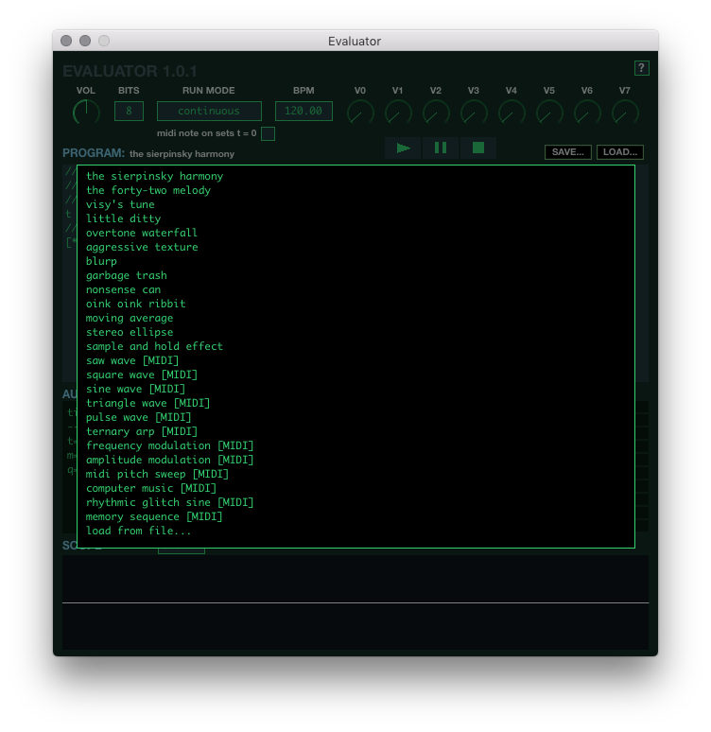
The Save button can be used to save the entire state of the interface to an fxp file.
The Load button opens an overaly that allows for recall of several built-in presets, as well as the option to "load from a file...". When loading from a file you can choose either a plain text file, whose contents will replace what is in the Program Window, or from an fxp that was previously created with the Save button. Presets marked with [MIDI] will require MIDI input to generate sound.

PROGRAM
The Program Window is where the program itself is edited. Click anywhere in the window and type as you would in a text editor. To compile the program so that it can be used to generate sound, either click outside of the Program Window or press Ctrl+Enter (Cmd+Enter on Mac).

AUTO
The Auto Window is used to display program variables that are automatically updated by the app:
- t is incremented every audio sample, based on the current T-MODE
- m is how many milliseconds the current value of t represents
- q is how many 128th notes the current value of t represents
- w is the value the program output will be wrapped to before being converted to [-1,1] floating point values. It will always be equal to 1<<BITS.
- n is set to the most recent MIDI Note On note that has been received. It will be 0 if there aren't any active notes, and will never be greater than 127.
- v is set to the velocity of the most recent MIDI Note On and will always be in the range [0,127].

WATCH
The Watch section can be used to monitor values in program memory that are not present in the Auto Window. These include user-defined variables, user memory addresses, V knobs, and MIDI CC values. We'll return to this after discussing all of the language features (ie how to write programs).

SCOPE
The Scope displays the output of the program in the style of an oscilloscope. The Window knob can be used to control length of time in seconds that is being visually represented.
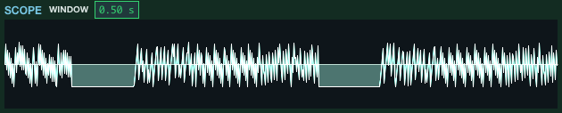

Help
By clicking the ? Icon in the upper right of the interface, you can expand it to display a quick reference of the language syntax. The Manual button in this section will attempt to open this document from locations where it is typically installed.

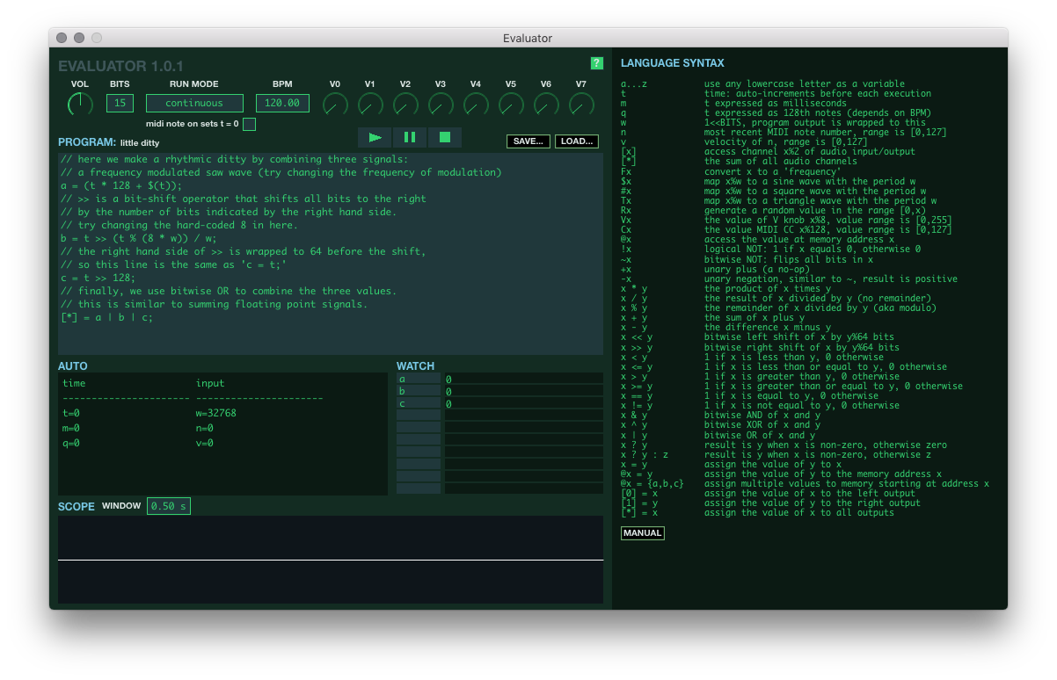
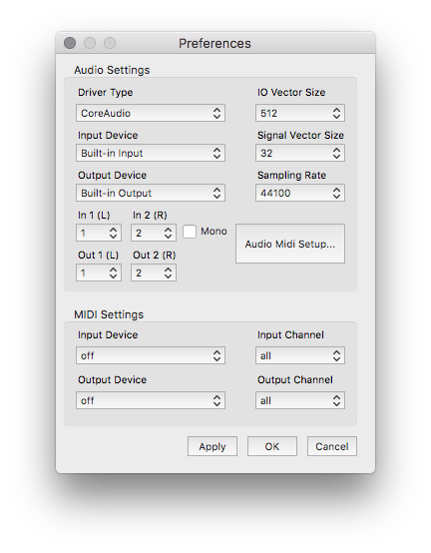
Preferences (Standalone)
The Standalone version has a Preferences menu that can be opened from the Evaluator menu in OSX or the File menu in Windows.
From here you can configure audio input and output, sample rate, and set the MIDI input device to enable sending MIDI to the app.
In some cases, the app may not choose the correct Audio Output Device the first time it is launched and there will be no sound. To fix this, open the Preferences menu, choose the correct Output Device, and click Apply.

Program Syntax

Basics
Evaluator's language is largely based on C but lacks control structures, functions, types, arrays, and memory management. There are no types because every value in a program is a 64-bit unsigned integer. There is no memory management because all program memory is allocated when it is compiled and accessed through various means. There are no control structures, functions, or arrays because these are hard to implement.
A program must output values in order to be a valid program. The simplest program you could write that has non-constant output might look like this:
[*] = t;

This program assigns the current value of t to all outputs. The line is terminated with a semi-colon, as in C-style languages, although the final line of a program doesn't require this. Here's a program that assigns different values to left and right outputs:
[0] = t;
[1] = -t;

Neither of these programs will produce audible output because they are both essentially generating very low frequency saw waves (recall that program output is wrapped to 1<<BITS).
In order to hear anything interesting, we have to write some kind of arithmetic expression. Here's a surprisingly simple one from viznut's collection that sounds nice with BITS set to 8:
[*] = t&t>>8

All of the arithmetic and bitwise operators from C are available in Evaluator's language. The main thing worth noting is that bitwise left shift and bitwise right shift will shift by the right-hand operand modulo 64, so it is not possible to over-shift the left-hand side.
A program can also use [0] and [1] to access audio coming into the program from the Host. This could be microphone input in the Standalone app or it could be the output of whatever comes before Evaluator in an effects chain in your DAW. This program swaps the left and right channels of the incoming audio:
a = [0];
b = [1];
[0] = b;
[1] = a;

Finally, two forward slashes can be used to add comments to a program:
// this is a comment
[*] = t*128 // also a comment

Variables
The small programs above access the variable t, which has its value set automatically before every execution of the program, however any lowercase letter can be used as a variable in a program. Variables don't need to be declared before being used, their value will be zero until assigned a new value by a program. Values assigned to variables will persist from one execution to the next, with the exception of variables in the Auto Window, whose values are sometimes changed before a program is executed, but there's nothing stopping a program from changing their values during execution. Here's a program that increments a variable every execution:
a = a + 1;
[*] = a;

The output of this program across 10 executions will be: 1, 2, 3, 4, 5, 6, 7, 8, 9, 10
Once a program becomes sufficiently complicated, it can be nice to be able to monitor the value of variables that are in use. Any variable name can be entered into one of the Watch rows to do this.

Conditional and Relational Operators
Evaluator's language includes a conditional operator that can be used in a ternary or binary form and all of the relational operators from C. By using these it is possible to achieve behavior that is similar to branching. Consider the "ternary arp" preset:
// q is incremented every 128th note, so we can divide by 32
// to get a number that increments every sixteenth note.
s = q/32;
// if s is odd, we want to increase the note by an octave.
a = n + (s%2 ? 12 : 0);
[*] = t*Fa

Since the language does not have a boolean type, the ternary conditional operator will resolve to the second operand if the first operand is non-zero and to the third operand if the first operand is zero. In this example, it suffices to use s%2 to get a steady alteration, since that expression on its own oscillates between 0 and 1.
The conditional above could also be written like this:
a = n + (s%2 ? 12);

In this form, the expression following the question mark will be used for the value of the conditional if the first operand is positive, otherwise the conditional will evaluate to zero. Since the conditional operator does not evaluate the expression following the question mark when the first operand is zero, you can use it to create basic if/else statements that produce side-effects, like changing the value of a variable. For example, in the following, the value of a will increment when s%2 is 1 and b will increment when s%2 is 0:
s%2 ? a = a+1 : b = b+1;

When dealing with a larger range, we can use <, <=, >, or >= to create a 0 or 1 value. Here's an example that turns a saw wave into a pulse wave using this method:
a = (t*F60)%w;
[*] = a < 8800 ? w-1 : 0;

Of course, it is also possible to use the result of a relational operator arithmetically. The second line of the above program could be more succinctly written:
[*] = (a < 8800)*(w-1);

Finally, == and != are also available for comparisons to specific values. For example:
// initialze a to a value when the program starts
t==0 ? a = 20;

// set b equal to 1 every 3rd 128th note
b = (q%3 != 2 ? 0 : 1);

Unary Operators
Evaluator's language includes only the +, -, ~, and ! unary operators from C, but adds additonal operators to aid in the creation of short programs that produce musical ouput.
F will convert a MIDI note number to a "frequency" suitable for generating a sound with the same pitch. This program will produce a saw wave with a pitch of C, but the octave will depend on the BITS setting:
[*] = t*F60

# will "square" a value by changing it to 0 if is less than w/2 or 1 if not. This program will produce a square wave with a pitch of C:
[*] = #(t*F60)

$ will "sine" a value by remapping it to a sine wave with a period of w. This program will produce a sine wave with a pitch of C:
[*] = $(t*F60)

T will "triangle" a value by remapping it to a triangle wave with a period of w. This program will produce a triangle wave with a pitch of C:
[*] = T(t*F60)

R will generate a random value between 0 and its operand. This program will sound like white noise:
[*] = Rw

V will retrieve the value of one of the corresponding V knobs. So V4 will be the value of the the V4 knob and Va will be the value of the knob corresponding to the current value of a. The operand value will be wrapped to the number of knobs, so you'll always get a useful value out of this. Here's a program that uses the value of the V0 knob to control the speed of a "modulator":
[*] = t*Fn + $(t*V0)

C will retrieve the value of the corresponding MIDI CC value. So C1 will be the value of the Mod Wheel CC (see: https://www.midi.org/specifications/item/table-3-control-change-messages-data-by...). Similarly, Ca will access the MIDI CC value corresponding to the current value of a. Like with the V operator, the operand is wrapped to the number of CC messages, which is 128. Here's a program that uses the Mod Wheel CC to sweep an oscillators pitch up:
a = Fn + (F(n+12) - Fn)*C1/127;
o = n>0 ? o + a : w/2;
[*] = o;

@ will use the value of the operand to allow access to "user" memory, which contains 65536 contiguous values that can be read from or written to, just like variables. This is most useful if you want to store "arrays" of values that the program can access by index. The memory for variables immediately follows this "user" memory, so @65536 is the same as a. The operand will be wrapped to the full size of the program's memory space before being used for access to prevent out-of-bounds access that might crash the app. Here's the "memory sequence" preset, which demostrates this operator nicely:
@0 = 0; @1 = 4; @2 = 7; @3 = 12;
i = q/32 % 4;
[*] = n>0 ? t*F(n+@i) : w/2;

It is also possible to use array-like syntax to set multiple contiguous values in memory. The first line of the above example could be written like this:
@0 = { 0, 4, 7, 12 };

Each item in the list can be a full expression. During execution, list elements are evaluated in order and then the results are assigned to memory starting from the address on the left-hand side of the equals sign.

Watches
It can be helpful to monitor variables in a running program to understand what is going on or to debug why something isn't working as expected. The Watch section of the interface provides 10 slots where you can enter variable names and some simple expressions. The unary operators V, C, and @ can be used in Watch rows in conjuction with a number or variable name. V0, Va, C15, Cb, @128, and @c are all legal Watch expressions.
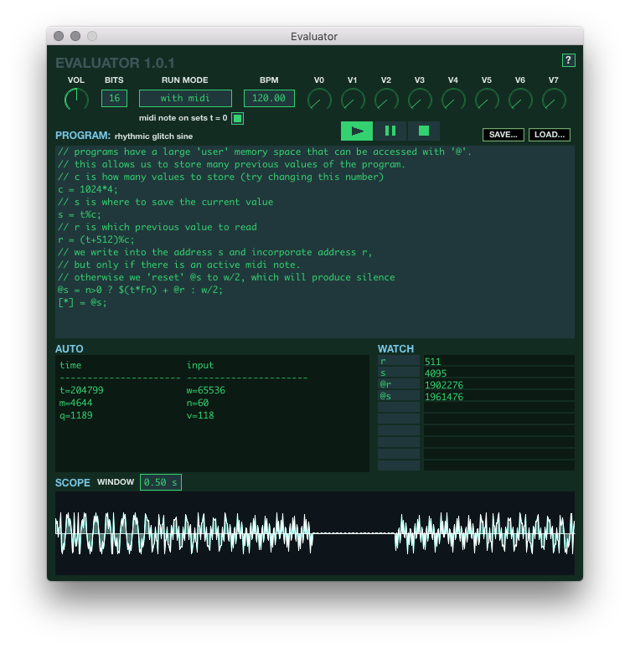

Program Errors
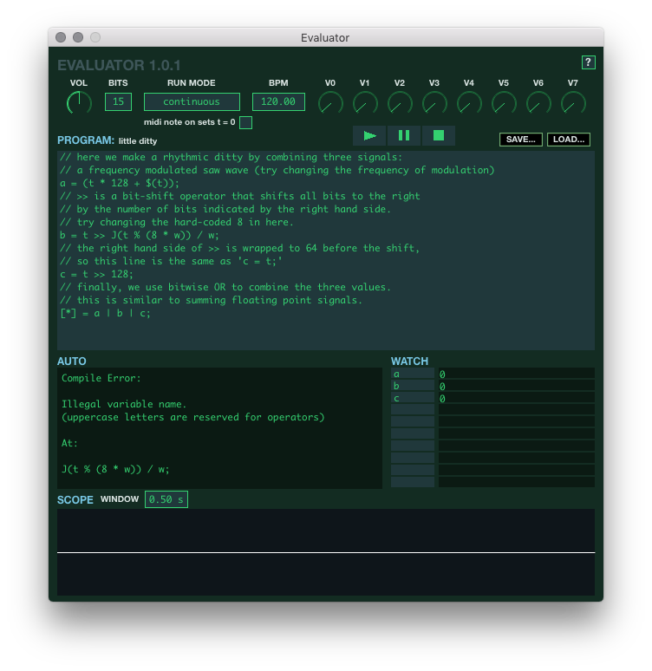
A program can produce compliation errors and runtime errors. Compilation errors occur when there is a mistake in the program text that prevents compiling it into a set of instructions. Runtime errors occur when executing a compiled program fails for some reason (usually due to divide by zero). In both cases, the error will be shown in the Auto Window instead of the usual program state.

