**1. In the below elements which of them are values or an expression? eg:- values can be integer or string and expressions will be mathematical operators.**

*

'hello'

-87.8

-

/

6

**Ans:**

|  |  |
| --- | --- |
| **String/ Expression** | **Integer/ Values** |
| * , ‘hello’,  - , / , + | -87.8  6 |

**2. What is the difference between string and variable?**

**Ans:**

|  |  |
| --- | --- |
| **String** | **Variables** |
| Strings are any name or they can write along with value and it must be written with double or single quotes. eg. “test” , ‘test’ , “test1”, ‘test1’ | Variable is just the name that assigns a value or expressions. Its stores the data for the name of string, here string may be value or expression. eg. Message = “hello” , m = 14 , |

**3. Describe three different data types.**

**Ans:**

|  |  |  |
| --- | --- | --- |
| **Data type** | **Used for** | **Example** |
| String | Alphanumeric characters | Hello, dhananjay123 |
| Integer | Whole number system | 1, 2, 3, 999 |
| Boolen | Logical values | TRUE, FLASE |

**4. What is an expression made up of? What do all expressions do?**

**Ans:**

Expressions are representation of value. For example any string is also an expression since it represents the value of the string as well. Expression is built with data, values, and mathematical operators. It has only contained identifiers, literals, and operators. In python having some advanced ‘constructs’ for manipulation of ‘values’. They may be generator or conditional one.

eg. a = 2, b = 4, c = a+b

**5. This assignment statements, like spam = 10. What is the difference between an expression and a statement?**

**Ans:**

|  |  |
| --- | --- |
| **Expression** | **Statement** |
| An expression evaluates to a value | A statement executes something |
| Every expression can’t be a statement. | Every statement can be an expression. |
| Expressions are safe and compact to write, it is a combination of values and functions to create new value. | Each and every line of code write in programming is called statement. |
| **Example:**  >>> a = 4  >>> a + 16  >>> 20 | **Example: Input** >>> x = 7 …..*(statement)*  >>> print(x)  **Output:**  7 |

**6. After running the following code, what does the variable bacon contain?**

bacon = 22

bacon + 1

**Ans:** After execution it gives **23** as an output, as shown in below screenshot.

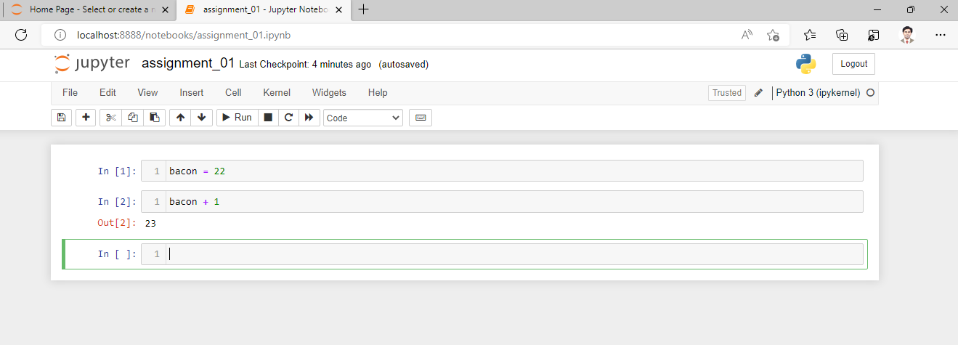

**7. What should the values of the following two terms be?**

'spam' + 'spamspam'

'spam' * 3

**Ans:** After execution it gives **same answer** as an output, as shown in below screenshot.

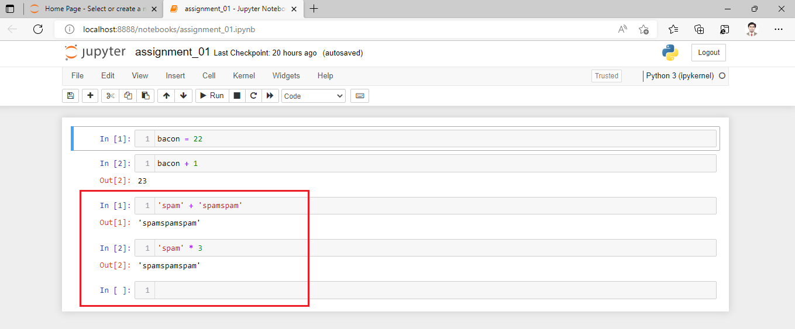

**8. Why is eggs a valid variable name while 100 is invalid?**

**Ans:** Variable is not an integer as if we start write only 100, if we start with alphanumeric like e100 or eggs100 then it is a valid variable name.

**9. What three functions can be used to get the integer, floating-point number, or string version of a value?**

**Ans:** int() , float(), str()

**10. Why does this expression cause an error? How can you fix it?**

'I have eaten ' + 99 + ' burritos.'

**Ans:** After execution a above given code, it gives type error, because 99 is an integer, and only strings can be concatenated to other strings with the ‘ + ’ operator. The correct code is:  'I have eaten ' + str(99) + ' burritos.' As shown in below screenshot.

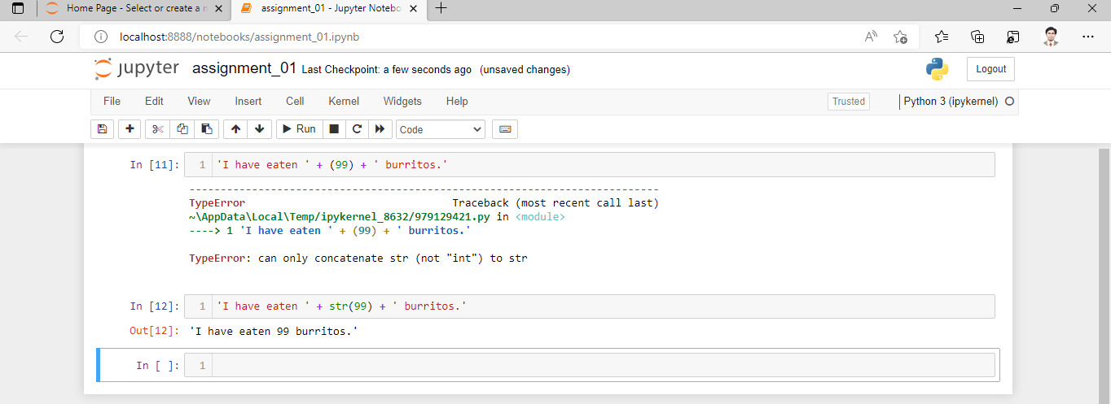

****END****