**1. What are the two values of the Boolean data type? How do you write them?**

Ans: False *and* True are Boolean data type, F and T are capital and rests of letters are lowercase.

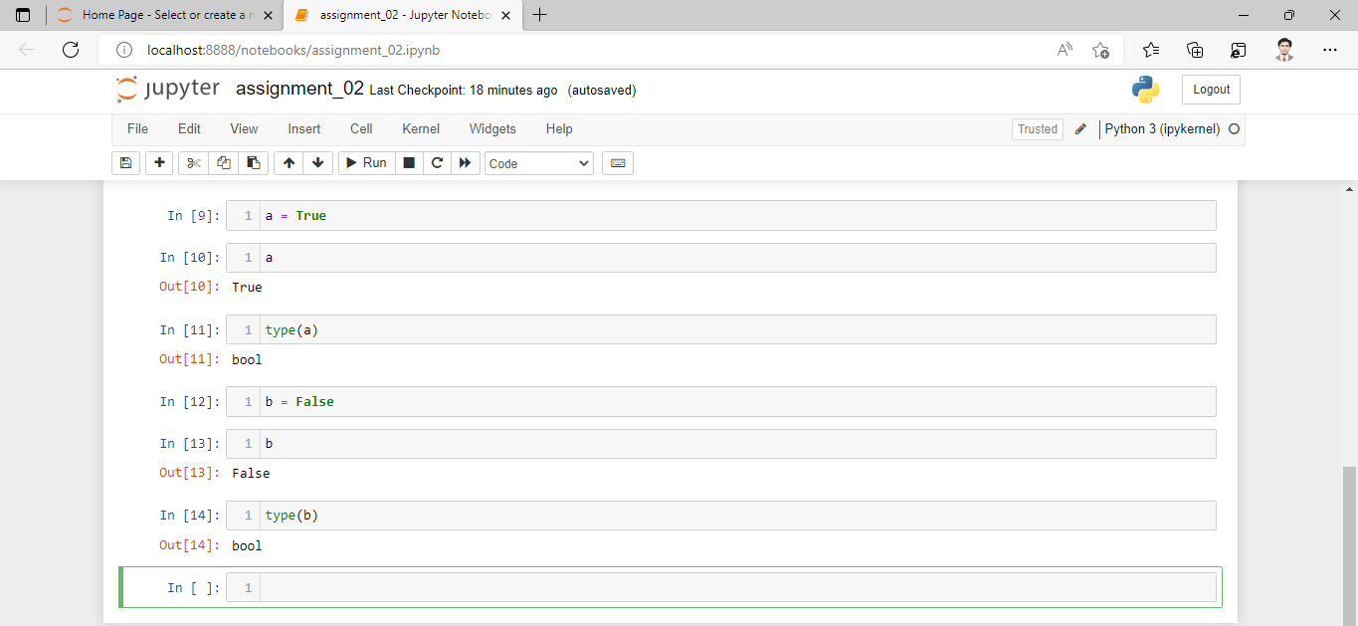

**2. What are the three different types of Boolean operators?**

**Ans:** Boolean operators are:- and , or, not

**3. Make a list of each Boolean operator's truth tables (i.e. every possible combination of Boolean values for the operator and what it evaluate ).**

**Ans:** In ‘Jupyter Notebook’ after writing a code with Boolean operators and found following results.

|  |  |
| --- | --- |
| **Input** | **Output** |
| True and True | True |
| True and False | False |
| False and True | False |
| False and False | False |
| True or True | True |
| True or False | True |
| False or True | True |
| False or False | False |
| not True | False |
| not False | True |

**4. What are the values of the following expressions?**

(5 > 4) and (3 == 5)

not (5 > 4)

(5 > 4) or (3 == 5)

not ((5 > 4) or (3 == 5))

(True and True) and (True == False)

(not False) or (not True)

**Ans:** In ‘Jupyter Notebook’ after writing a given Boolean code and found following results.

|  |  |
| --- | --- |
| **Input** | **Output** |
| (5 > 4) and (3 == 5) | False |
| not (5 > 4) | False |
| (5 > 4) or (3 == 5) | True |
| not ((5 > 4) or (3 == 5)) | False |
| (True and True) and (True == False) | False |
| (not False) or (not True) | True |

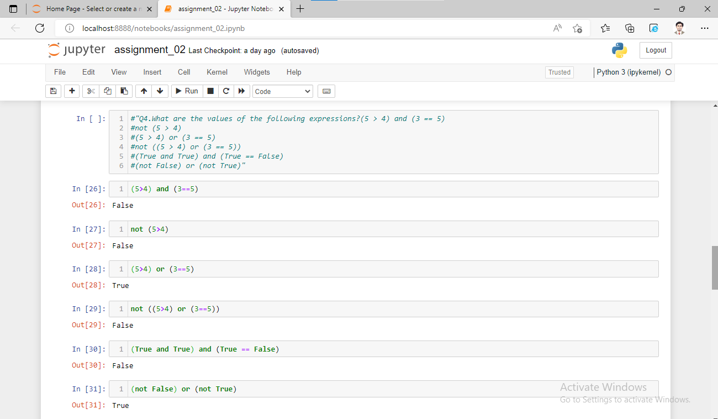

**5. What are the six comparison operators?**

**Ans:**

|  |  |
| --- | --- |
| **Comparison operators** | **Meaning** |
| == | Check for equality |
| <= | Less than or equal to |
| >= | Greater than or equal to |
| != | Check not equal |
| < | Less than |
| > | Greater than |

**6. How do you tell the difference between the equal to and assignment operators? Describe a condition and when you would use one.**

**Ans:**

|  |  |
| --- | --- |
| **Comparison operators** | **Used for** |
| == | It is the equal to operator that compares two values and evaluates to a Boolean. |
| = | It is the assignment operator that stores a value in a variable. |

**7. Identify the three blocks in this code:**

spam = 0

if spam == 10:

print('eggs')

if spam > 5:

print('bacon')

else:

print('ham')

print('spam')

**Ans:** After execution a code following results are shown as Output;

ham

spam

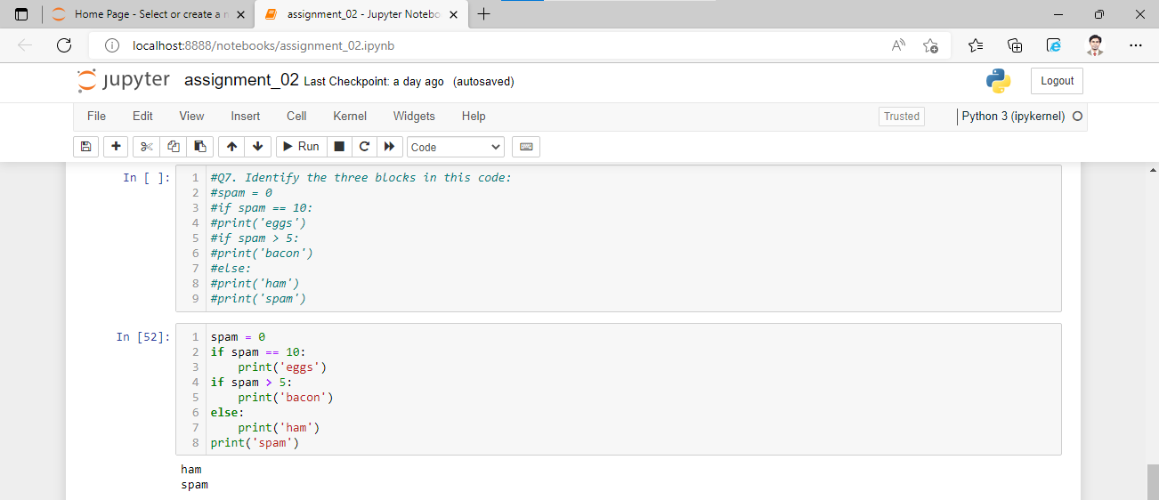

**8. Write code that prints Hello if 1 is stored in spam, prints Howdy if 2 is stored in spam, and prints Greetings! if anything else is stored in spam.**

**Ans: [In]:** if spam == 1:

print('Hello')

elif spam == 2:

print('Howdy')

else:

print('Greetings!')

**[Out]:** 'Greetings!

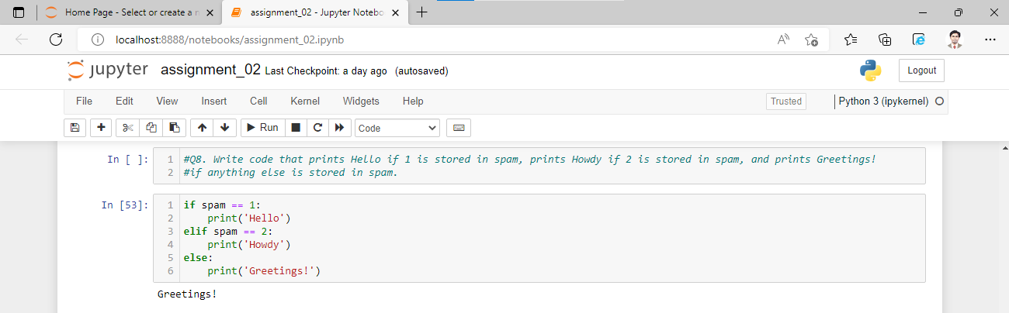

**9. If your programme is stuck in an endless loop, what keys you’ll press?**

**Ans:** Press ­­­­­­­­­­­­­­­­­­­­­CTRL-C keys to stop a program stuck in an infinite loop.

**10. How can you tell the difference between break and continue?**

**Ans:** The break statement will move the execution outside and just after a loop. The continue statement will move the execution to the start of the loop.

**11. In a for loop, what is the difference between range(10), range(0, 10), and range(0, 10, 1)?**

**Ans:** All gives same results. The range(10) call ranges from 0 up to (but not including) 10, range(0,10) explicitly tells the loop to start at 0, and range(0,10,1) explicitly tells the loop to increase (jump) the variable by 1 on each iteration.

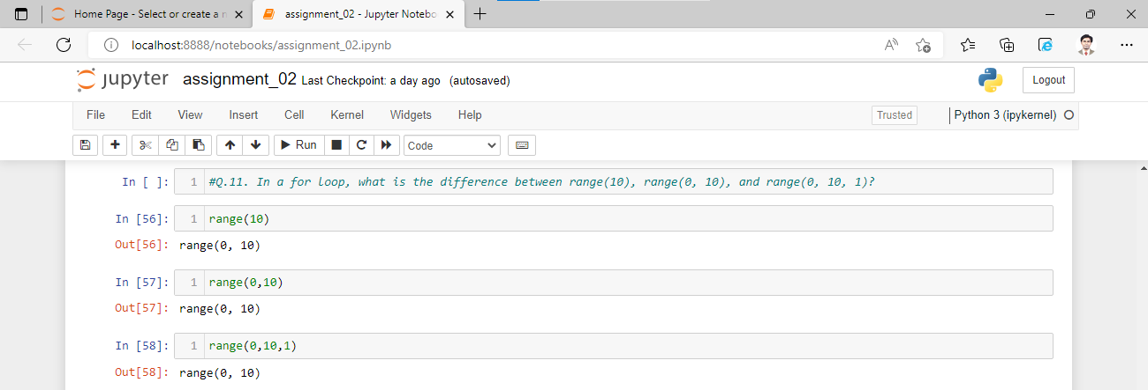

**12. Write a short program that prints the numbers 1 to 10 using a for loop. Then write an equivalent program that prints the numbers 1 to 10 using a while loop.**

**Ans:** After execution code for loop and while loop, it’s give same results as shown in following screenshot.

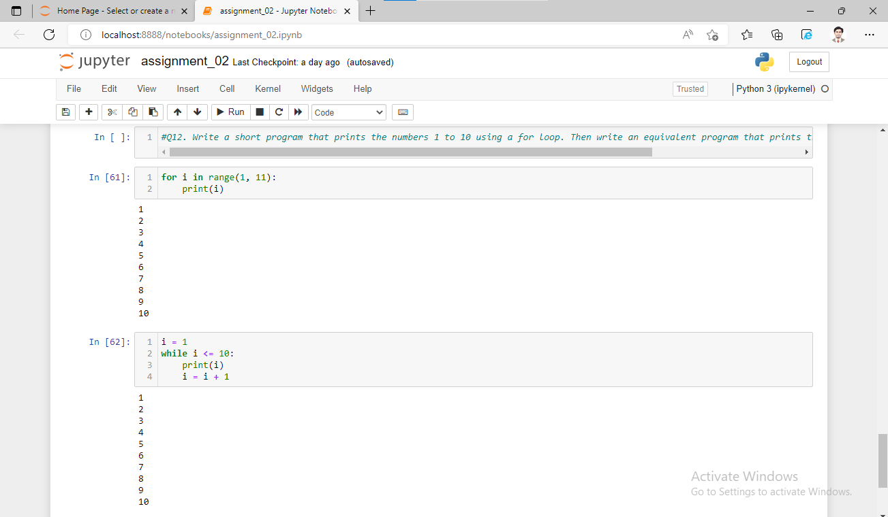

**13. If you had a function named bacon() inside a module named spam, how would you call it after importing spam?**

Ans: spam.bacon()