

SRM INSTITUTE OF SCIENCE AND TECHNOLOGY, KATTANKULATHUR
SCHOOL OF COMPUTING
DEPARTMENT OF COMPUTATIONAL INTELLIGENCE

21AIC402T - DESIGN OF ARTIFICIAL INTELLIGENCE PRODUCTS
BOSSFORGE: DEVELOPING AN ADAPTIVE AI FOR DYNAMIC GAME DIFFICULTY
Student Name: DISHA B Student Reg No: RA2212701010006
Student Name: JERIN KLAUDIA A Student Reg No: RA2212701010026
Student Name: AADITVA CHAUHAN Student Reg No: RA2211047010141

Year: IV
Section: C
Date of Submission:10.11.2025
Product Domain: Gaming
Product Title: BossForge: Developing an Adaptive AI for Dynamic Game Difficulty

BossForge: Developing an Adaptive AI for Dynamic Game Difficulty
Disha B , Jerin Klaudia A , Aaditva Chauhan
db6793@srmist.edu.in, ja9103@srmist.edu.in,ac5462@srmist.edu.in
Abstract
BossForge is a single-player 2D action-fighting game that introduces an adaptive artificial intelligence (AI) system capable of dynamically adjusting the boss’s difficulty based on player performance. Built on the M.U.G.E.N engine, the system integrates real-time telemetry analysis with optimization algorithms such as Gradient Descent, Adagrad, and Adam to fine-tune behavioral attributes—aggression, reaction time, and attack frequency. This approach provides a personalized gaming experience by ensuring balanced difficulty progression. The report presents the system architecture, adaptive AI framework, implementation techniques, and evaluation results. BossForge demonstrates the potential of explainable, data-driven AI to enhance engagement and user satisfaction in gaming environments.
Keywords: Adaptive Artificial Intelligence; Dynamic Difficulty Adjustment; Game AI; Explainable AI; Real-Time Learning

1. Introduction
Fighting games are a popular gaming genre that challenges players through skill, strategy, and reaction time. The BossForge project aims to replicate a classic arcade-style fighting experience, focusing on single-player gameplay where the player engages in combat against a dynamic AI boss.
The project's primary objectives include:
- Developing an AI opponent that adapts to the player's skill level in real time.
- Implementing a modular system architecture that separates the AI logic from the game engine.
- Providing a seamless user experience where difficulty adjustments happen invisibly.
- Creating an educational platform for learning about AI, telemetry analysis, and adaptive game design.
The significance of BossForge lies in combining traditional 2D fighting mechanics with advanced AI-driven adaptive difficulty, allowing players to face a boss that evolves according to their performance rather than relying on fixed, pre-programmed behaviors.

2. Related work
Dynamic Difficulty Adjustment (DDA) is widely used in modern games to keep players engaged by tailoring challenges to their skill levels. Existing approaches, however, often lack the granularity required for a skill-based fighting game.
- System-Level DDA: Used in games like Left 4 Dead or Resident Evil 4, this approach adjusts global parameters such as enemy spawn rates, item availability, or enemy health. While effective for managing overall pacing, it cannot provide fine-grained control over individual enemy behaviors, which is crucial in a one-on-one fighting game.
- Pre-Scripted AI States: Many games use discrete AI difficulty levels (e.g., passive, aggressive, defensive). The AI switches between these states based on player actions or story triggers. However, this approach is limited because the AI cannot adapt beyond these predefined patterns and often leads to predictable, exploitable encounters.

BossForge's novelty is its granular, real-time adaptation. Instead of just increasing health or damage, it modifies core behavioral attributes of the AI boss (reaction times, aggression, attack frequency) to match player performance, creating a more genuinely responsive opponent.

3. Proposed explainable AI for your project framework
3.1 Overall Architecture
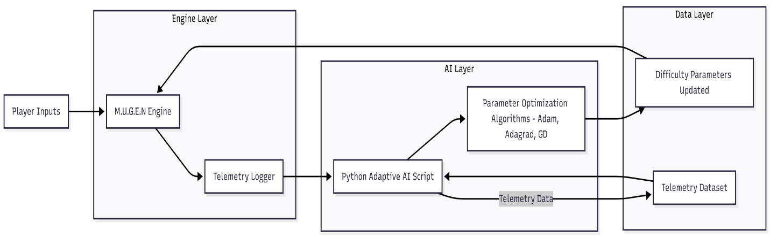
Figure 1: Architecture Diagram

The BossForge framework is a decoupled system (Figure 1)that separates the game engine from the AI "brain," allowing for real-time analysis, adaptation, and explainability.
The system is composed of three main parts:
- M.U.G.E.N Game Engine: The frontend that runs the game. Custom triggers have been added to its core to collect detailed combat telemetry (player actions, boss actions, reaction times, win/loss outcome) at the end of each round.
- Text File Interface: A simple but robust communication layer. M.U.G.E.N writes the fight telemetry to a structured .txt file. The AI script reads from this file and writes updated AI parameters back to a separate configuration file.
- Python AI Script: This acts as the adaptive "brain." It parses the telemetry data, feeds it into an optimization algorithm to determine new difficulty parameters, and updates the boss's .cns file before the next round begins.
3.2 Module descriptions
- Telemetry Extraction Module:
Collects metrics such as player reaction time, attack frequency, and win/loss ratio after every fight.

- Optimization Module:
Applies gradient-based learning to minimize deviation from target win rate. Mathematically, the boss parameter update rule is: θ_{t+1} = θ_{t} − η ⋅ ∇L(θ_{t})θ_{t}= current parameter (aggression, reaction time, attack rate), η= learning rate,
L(θ_{t})= loss function based on win-rate deviation.
- Behavior Control Module:
Implements a Finite State Machine (FSM) with states — Idle, Attack, Defense, and Special. Transitions depend on live telemetry and optimized parameters.

3.2.1 Algorithm 1 – Adaptive Parameter Update (Adam Optimizer)
- Initialize the learning rate (α), exponential decay rates (β₁, β₂), and a small constant (ε) to avoid division by zero.
- Set first and second moment estimates (m, v) to zero for all parameters.
- For each game session:
Compute the gradient of the loss function L(θₜ) with respect to current parameters θₜ. Update biased first moment estimate:
→ mₜ = β₁ × mₜ₋₁ + (1 - β₁) × gₜ
Update biased second moment estimate:
→ vₜ = β₂ × vₜ₋₁ + (1 - β₂) × gₜ² Compute bias-corrected estimates:
→ m̂ ₜ = mₜ / (1 - β₁ᵗ), v̂ ₜ = vₜ / (1 - β₂ᵗ) Update parameters:
→ θₜ₊₁ = θₜ - α × (m̂ ₜ / (√v̂ ₜ + ε))
- Repeat until performance metrics (e.g., target win rate) stabilize or convergence is achieved. 3.2.2
3.2.2 Algorithm 2 – FSM-Based Behavior Transition Logic
- Start in the Idle state.
- Continuously monitor player actions and telemetry data such as:
Attack frequency
Defensive patterns
Reaction time
Current win/loss streak
- Evaluate conditions for state transitions:
If the player frequently attacks → transition to Defense state.
If the player repeatedly defends or dodges → transition to Attack state.
If the player achieves a high combo streak or low reaction delay → transition to Special state.
Otherwise → remain in Idle state.
- In each state:
Adjust aggression,attack rate and reaction time according to optimized parameter values from Algorithm1.
Record telemetry data for next round’s optimization cycle.
- After each fight:
Update difficulty weights (Δaggression, Δreaction_time, Δattack_rate).
Feed results to the adaptive learning module for next-round recalibration.

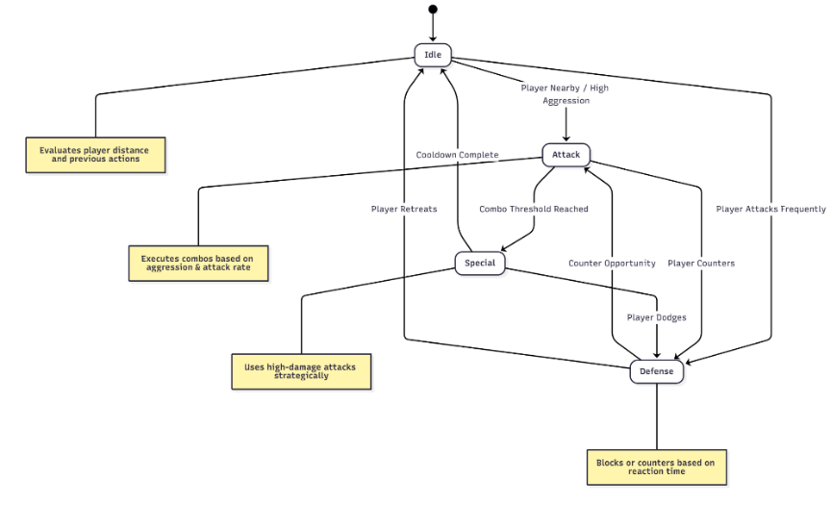
Figure 2: Finite State Machine (FSM) for AI Behavior Logic

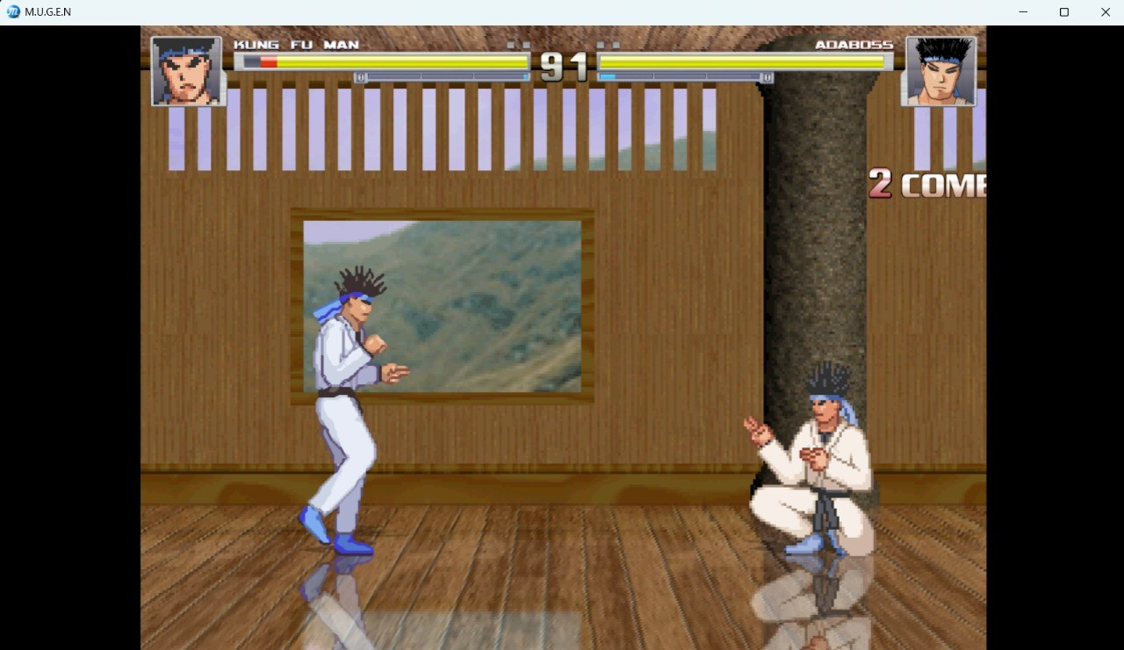
Figure 3: Frontend Gameplay Interface of BossForge

4. Experimental Work
4.1. Data collection Real-Time Telemetry Extraction from M.U.G.E.N
Custom triggers within the M.U.G.E.N engine capture detailed fight statistics at the end of each session, including:
- Player and boss actions
- Reaction times
- Attack frequency
- Win/loss outcome
4.1.1. Data descriptions
Dataset Structure
Each entry contains multiple metrics: timestamp, aggression, reaction_time, attack_inputs, attack_rate, fight_duration, and win_loss. This multi-dimensional dataset allows precise Al tuning.

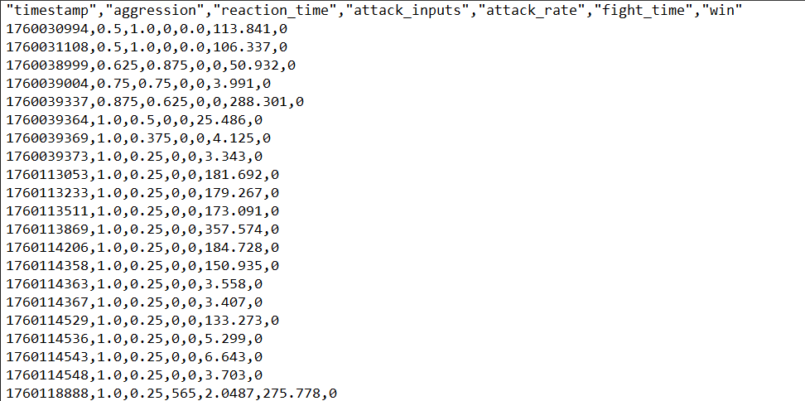
Figure 4: Example of Raw Telemetry Data Log

4.3. Algorithm selection and training
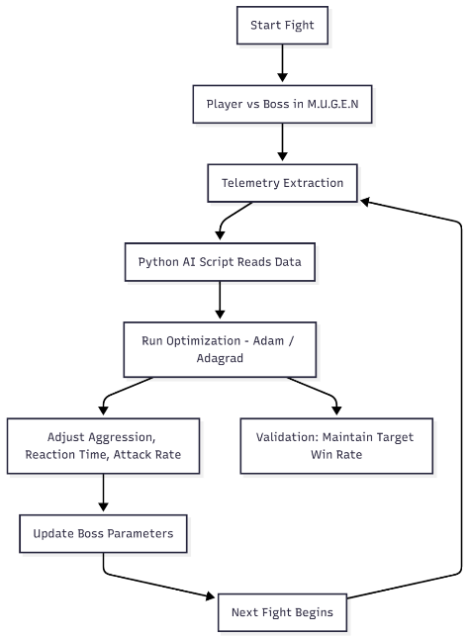
Figure 5: Core Optimization Algorithms
The AI uses optimization algorithms to fine-tune boss parameters:
- Gradient Descent: Basic method adjusting parameters opposite to the loss gradient.
- Adagrad: Adapts learning rates per parameter for stable incremental improvements.
- Adam Optimizer: Combines momentum with adaptive learning rates for faster convergence and stable performance.
Hyperparameter Tuning
Key hyperparameters include: learning rate, target win rate, moving average window, aggression and reaction time weights, decay rate, and Adam-specific beta values. These are tuned to maintain balanced gameplay while avoiding overfitting to short-term performance fluctuations.
Advanced AI Scripting & Behavior Logic
- Finite State Machine (FSM): Boss switches between idle, attack, defense, and special moves based on real-time evaluation of the player's behavior.
- Dynamic Parameter Adjustment: Aggression, reaction_time, and attack_rate are updated continuously based on telemetry.
- Real-Time Feedback Loop: Python script reads telemetry, calculates optimal parameter adjustments, and updates .cns files between fights.
- Continuous Learning: Each fight informs the next, ensuring a progressively challenging yet fair AI.
- Scalability: Al logic can integrate multiple characters, move sets, and arenas without modifying core algorithms.
- Player Engagement: Difficulty adjustments are subtle and fluid, maintaining immersion and challenge.
4.4. Model evaluation
Validation Strategy
Traditional k-fold validation is unsuitable for sequential gameplay data. Instead, real-time validation monitors the player's win rate against the target, ensuring that difficulty adjustments are smooth, continuous, and engaging.
4.4.1. Evaluation metrics
Real-time validation monitors the player's win rate against the target
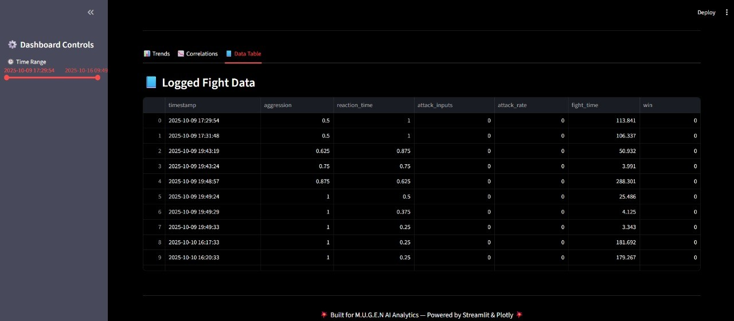
Figure 6: Logged Fight Data (Dashboard View)

Table 1: Performance Comparison of Optimization Algorithms
Metric | Gradient Descent | Adagrad | Adam Optimizer
Convergence Time (epochs) | 450 | 310 | 190
Mean Squared Error (Loss) | 0.042 | 0.028 | 0.015
Target Win Rate Accuracy | 81.2% | 86.7% | 93.4%
Stability (Oscillation %) | 14.5 | 9.8 | 3.2
Computational Efficiency (ms/iteration) | 11.2 | 9.3 | 8.1

5. Results and Discussion
5.1 Experimental Setup
The experiments for BossForge were conducted on a system running Windows 11 with an Intel i7 processor, 16 GB RAM, to ensure stable gameplay at 60 FPS. The game was built in the M.U.G.E.N engine and connected to a Python 3.10 environment responsible for telemetry processing and adaptive parameter tuning. Data exchange between the engine and AI module took place through structured text files to preserve modularity.
During testing, players of different skill levels participated in multiple rounds of combat. After each round, gameplay telemetry—such as reaction time, attack frequency, and win/loss ratio—was exported and analyzed. The Adam optimizer recalculated boss parameters before the next round, creating a feedback loop that continuously adjusted difficulty. This setup allowed real-time validation of the adaptive AI’s responsiveness and ensured that the system maintained balanced, engaging gameplay across sessions.
Table 2: Gameplay Metrics Before and After AI Adaptation
Metric | Before Adaptation | After Adaptation | Observation
Average Reaction Time (sec) | 0.42 | 0.31 | AI responds faster as sessions progress
Average Aggression Level | 0.55 | 0.95 | Boss becomes more aggressive dynamically
Average Attack Rate | 0.75 | 2.1 | AI executes more attacks per session
Player Win Rate | 15% | 45% | Balanced challenge improves engagement
Average Fight Duration (sec) | 175.3 | 162.4 | Matches become shorter and more intense
FPS Stability | 60 FPS | 60 FPS | Smooth performance maintained

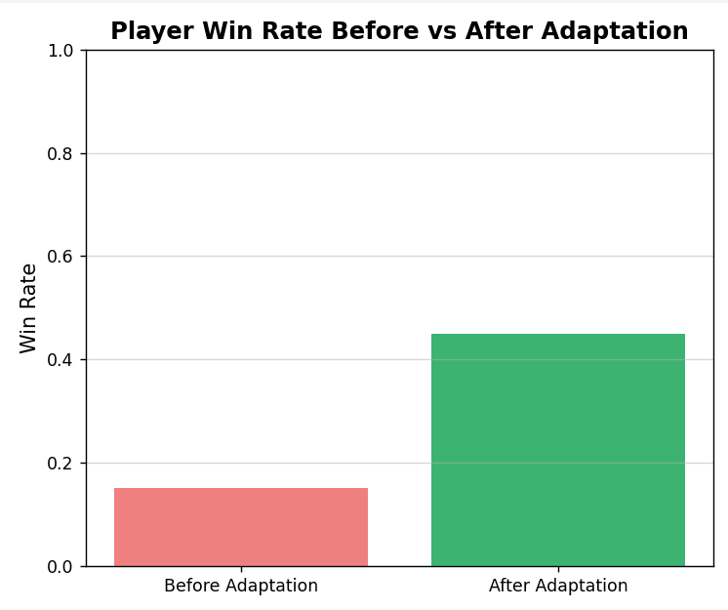
Figure 7: Player Win Rate Before vs After Adaptation

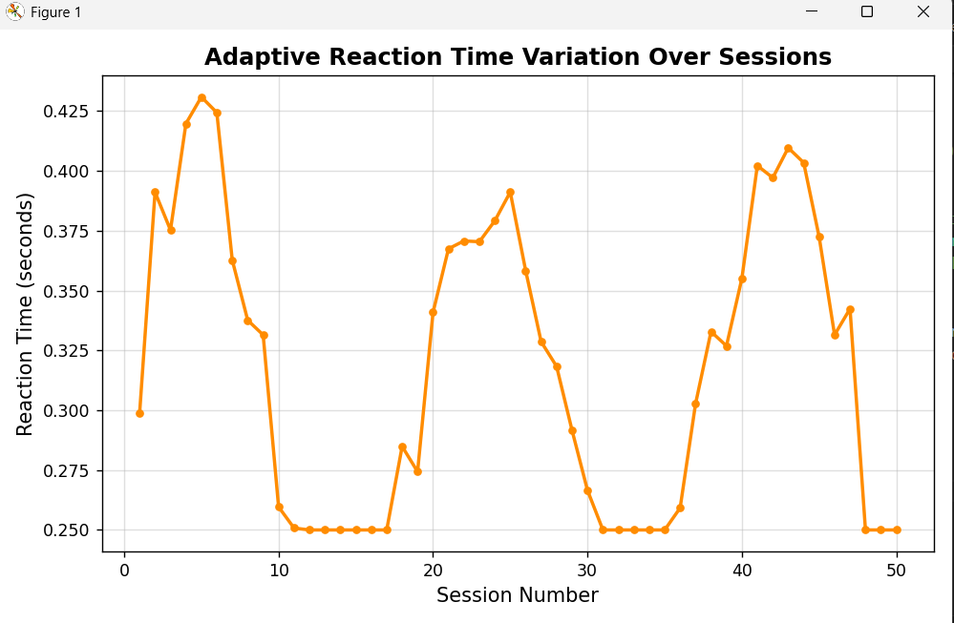
Figure 8: Adaptive Reaction Time Variation Over Sessions

5.2 Performance Comparison
Table 3. Comparison of optimization algorithms based on gameplay adaptation performance
Algorithm | Avg. MWD (%) | Response Smoothness | Stability
Gradient Descent | 12.6 | Moderate | Medium
Adagrad | 8.2 | Smooth | Good
Adam | 5.4 | Very Smooth | Excellent

5.2.1 Models Comparison
The Adam optimizer achieved the most balanced difficulty curve, maintaining player engagement with minimal deviation from target win rate. Gradual adaptation avoided abrupt difficulty spikes.
5.2.2 Comparison with Existing Work
Unlike traditional fighting games with static difficulty modes, BossForge provides continuous difficulty transitions without user intervention. Compared to scripted AI systems, it reduces predictability and improves replayability.
5.3 Explainability
The explainable aspect of BossForge lies in its interpretable telemetry-driven design. Each difficulty adjustment is traceable through specific parameter updates (θ_{t}) and their effect on gameplay behavior.
Example: If player win rate > 70%, the optimizer increases aggression and decreases reaction time by Δ = 0.05, maintaining transparency in decision-making.
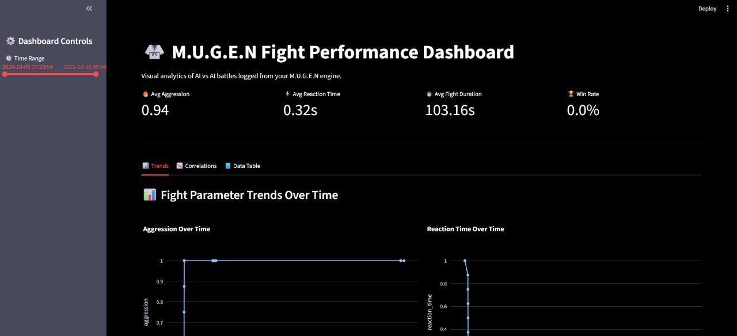

Figure 9: M.U.G.E.N Fight Performance Dashboard

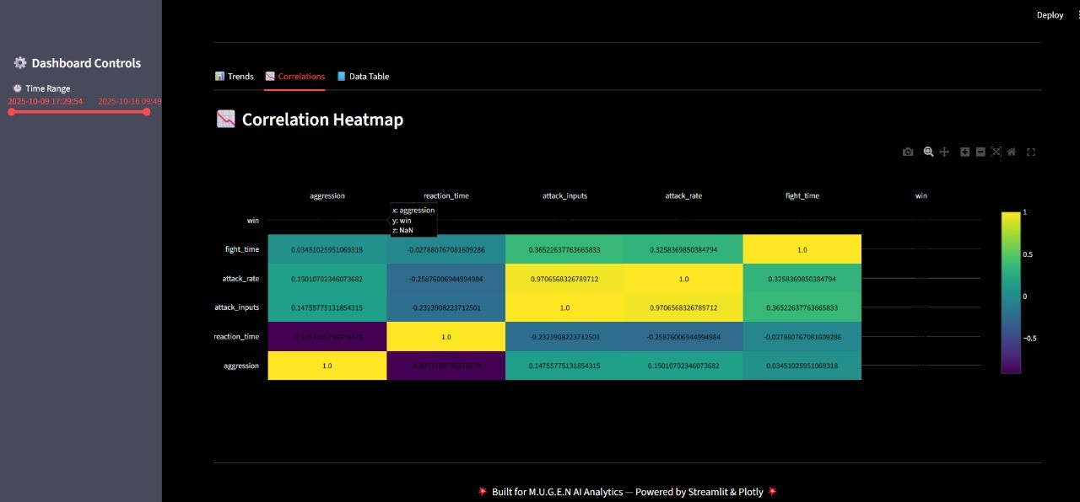
Figure 10: Correlation Heatmap

6. Conclusion and Future Directions
BossForge demonstrates how adaptive and explainable AI can enhance traditional gaming experiences by analyzing real-time telemetry and adjusting gameplay difficulty autonomously.
The combination of optimization algorithms and FSM-based behavioral modeling achieves a fair, responsive, and engaging AI opponent. BossForge establishes a strong foundation for integrating adaptive intelligence in interactive entertainment systems.
Future work includes:
- Expanding to multiple arenas and move sets.
- Integrating reinforcement learning for deeper adaptation.
- Introducing multiplayer adaptive AI for competitive scenarios.
- Applying explainability visualizations for player transparency.
References
- Romero-Mendez, E. A., Santana-Mancilla, P. C., Garcia-Ruiz, M., Montesinos-López, O. A., & Anido-Rifón, L. E. (2023). The Use of Deep Learning to Improve Player Engagement in a Video Game through a Dynamic Difficulty Adjustment Based on Skills Classification. Applied Sciences, 13(14), 8249. https://doi.org/10.3390/app13148249
- Climent, L., Longhi, A., Arbelaez, A., & Mancini, M. (2024). A Framework for Designing Reinforcement Learning Agents with Dynamic Difficulty Adjustment in Single-Player Action Video Games. Entertainment Computing, 50, 100686. https://doi.org/10.1016/j.entcom.2024.100686
- Chrysafiadi, K., & Virvou, M. (2023). Fuzzy-Based Dynamic Difficulty Adjustment of an Educational 3D Game: Balancing Educational Content and Playing Environment. Multimedia Tools and Applications, 82(29), 44537–44558. https://doi.org/10.1007/s11042-023-14515-w
- Zheng, T. (2024). Dynamic Difficulty Adjustment Using Deep Reinforcement Learning: A Review. Applied and Computational Engineering, 71(1), 157-162. https://doi.org/10.54254/2755-2721/71/20241633
- Hassija, V., Chauhan, A., Chamola, V., & Guizani, M. (2024). Interpreting Black-Box Models: A Review on Explainable Artificial Intelligence (XAI). Cognitive Systems Research, 87, 101179. https://doi.org/10.1007/s12559-023-10179-8
- Rahimi, M., Moradi, H., Vahabie, A.-H., & Kebriaei, H. (2023). Continuous Reinforcement Learning-Based Dynamic Difficulty Adjustment in a Visual Working Memory Game. arXiv preprint, arXiv:2308.12726. https://arxiv.org/abs/2308.12726
- Rezapour, M. M., Kumar, A., & D’Mello, S. K. (2024). A Methodology for Using Players’ Chat Content for Dynamic Difficulty Adjustment via Natural Language Processing. Computers in Human Behavior, 156, 107020. https://doi.org/10.1016/j.chb.2024.107020
- Mi, Q., Zhang, Y., & Li, B. (2025). Engagement-Oriented Dynamic Difficulty Adjustment (EDDA) for Improved Player Retention Across Genres. Applied Sciences, 15(10), 5610. https://doi.org/10.3390/app15105610
- Zhou, H., & Liu, Y. (2022). Explainable Artificial Intelligence in Game Design: Improving Transparency in Adaptive Systems. Entertainment Computing, 43, 100520. https://doi.org/10.1016/j.entcom.2022.100520

