Course Name: | Basic of Electrical Engineering Laboratory  316U06L102 | Semester: | I
Date of Performance: | / / 2025 | Batch No:
Faculty Name: |  | Roll No:
Faculty Sign & Date: |  | Grade/Marks: | /25

Experiment No: 6
Title: Power factor improvement (parallel)

Aim and Objective of the Experiment:
- To improve power factor of a single phase inductive AC circuit using capacitor across the load.

COs to be achieved:
CO2: Analyse single phase AC circuits

Requirements:
Inductor box, 1 KΩ-3W Resistor, Capacitor box, AC Ammeter and AC Voltmeter, 0-230V auto-transformer.

Theory:
When we need to convert electrical energy to mechanical energy, electric motors are used for it. These AC motors converts electric energy in two forms namely mechanical energy in the form of rotary motion and other is magnetic field. Magnetizing currents are lagging to the supply voltage. This magnetic energy is not a mechanical energy so it is kind of wastage, but without which motor will not run and convert electric energy into mechanical energy. Such form of energy is called as reactive power. Reactive power must be as less as possible so that the load will utilize maximum power and current requirement will be less for the same amount power. As the current requirement is less, so wire thickness will be small in diameter. Installation cost and energy cost will be also reduced. To reduce reactive power of the circuit, different power factor improvement methods are used. One of the most familiar method is the use of capacitor bank. We can use capacitor in series with the load or across the load. Following diagrams are illustrating effect of PF on active power.
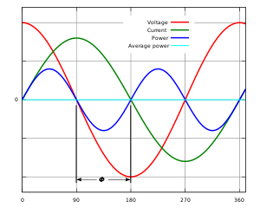

In the above figure instantaneous and average power calculated from AC voltage and current with a zero power factor. The blue line shows all the power is stored temporarily in the load during the first quarter cycle and returned to the grid during the second quarter cycle, so no real power is consumed by the load which is shown by sky-blue colour line.

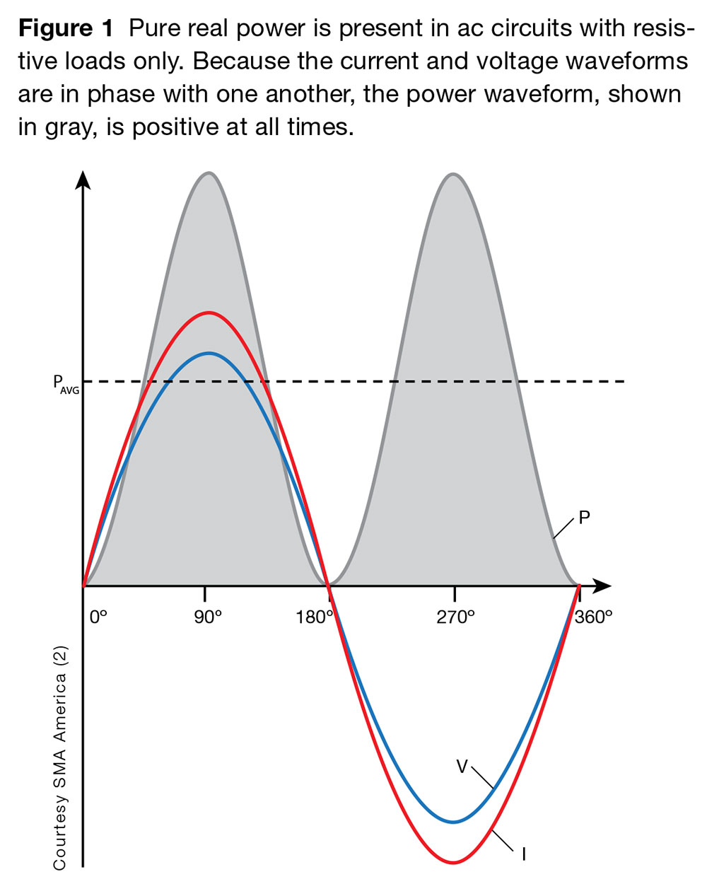

In the above figure instantaneous and average power calculated from AC voltage and current with a unity power factor. The gray part shows all the power is absorbed in the load during the first half cycle as well as the second half cycle, so real power is fully consumed.

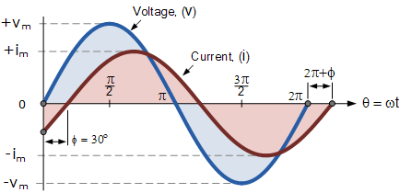

When power factor is between zero and unity, then real power consumed by the load depends upon PF of the circuit. Greater the power factor is always better to consume power.
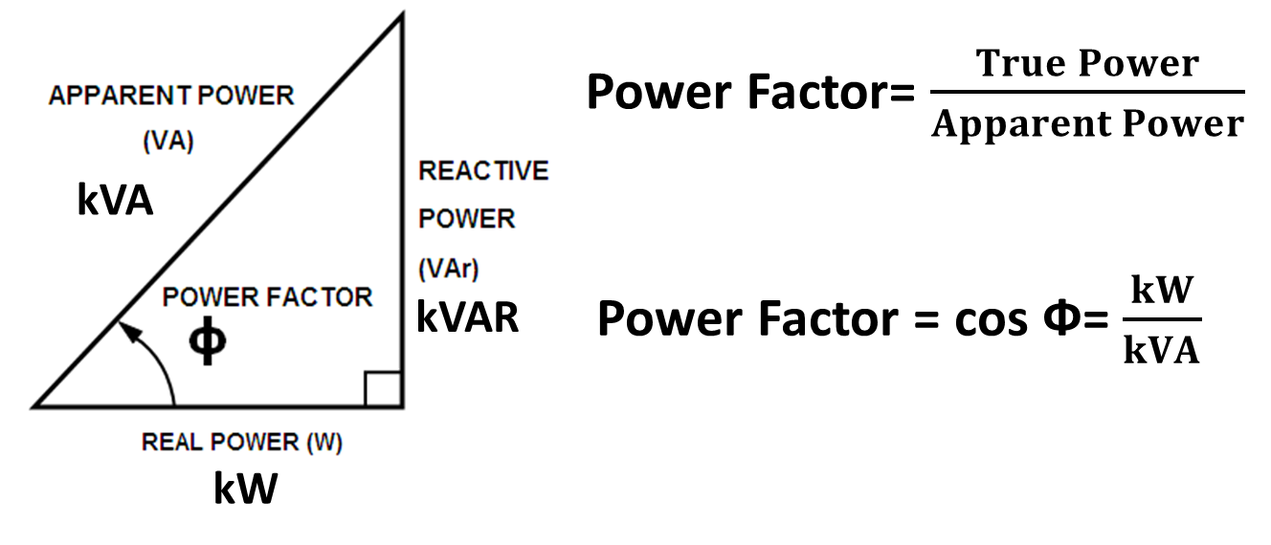

Circuit Diagram/ Block Diagram:

Stepwise-Procedure:
1. Connect series R and L circuit across 50V, 1ø, 50 Hz AC supply and note down circuit voltage and current.
2. Calculate practical value of circuit power factor by taking ratio of active power (P) and apparent power (S).
3. Connect required value of capacitor in parallel with R-L load and switch on power supply to note circuit voltage and current.
4. Calculate practical value of circuit power factor by taking ratio of active power (P) and apparent power (S).
5. Compare theoretical and practical values of PF before connecting the capacitor and after connecting capacitor.

Observation Table:
Sr No | Type of load | Voltage (V) |  | Current (mA) |  | P (W) = I²R |  | S (VA)= V_{s}*I_{L} |  | Power factor = P/S
 |  | Th | Pr | Th | Pr | Th | Pr | Th | Pr | Th | Pr
1 | R-L | 50
2 | R-L-C | 50

Sample Calculations:
Theoretical Calculations to find circuit current and PF of the inductive load:

Practical calculations to find PF of the inductive load:

Calculations to find value of the capacitor to be connected across the load:

Practical calculations to find improved PF of the circuit:

Post Lab Subjective/Objective type Questions:
- What are benefits of connecting capacitor across the load to improve circuit PF?

Conclusion:

Signature of faculty in-charge with Date:

