Course Name: | Structured Programming methodology | Semester: | I
Date of Performance: | ___ / ___ / ______ | DIV/ Batch No:
Student Name: |  | Roll No:

Experiment No: 2
Title: Use of decision-making control structures

Aim and Objective of the Experiment:
Write a program in C to demonstrate the use of decision-making and branching control structures

COs to be achieved:
CO2: Demonstrate the use of control structures

Theory:
An if-else statement is a conditional statement that executes a different set of statements based on the condition that is true or false.
Syntax :
if (condition) {
//code
}
else {
//code
}

A switch statement is a conditional statement used to check the value of a variable and compare it with all the cases. If the value is matched with any case, then its corresponding statements will be executed.

Syntax :
switch (expression) {
case value1:

break;
case value2:

break;
default:

}

Problem Statements:
Write a program for the following:
- The marks obtained by a student in a subject are entered through the keyboard. The program should calculate the student's grade based on their marks using if–else statements.
The grades are awarded as follows:
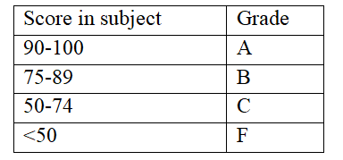

- Enter a number (1–7) through the keyboard and display the corresponding day of the week using switch case statements.

Number | Day
1. | Sunday
2. | Monday
3. | Tuesday
4. | Wednesday
5. | Thursday
6. | Friday
7. | Saturday

Code :
1.
#include <stdio.h>
#include <stdlib.h>

int main(){

int marks;
char subject[100];
char name[100];

printf("Enter the name of the student whose marks are to be entered: ");
scanf("%99[^\n]", name);
while (getchar() != '\n');
printf("\nEnter the subject for which marks are to be entered: ");
scanf("%99[^\n]", subject);
while (getchar() != '\n');
printf("\nEnter the marks obtained in %s: ", subject);
scanf("%d", &marks);

if (marks >= 90 && marks <= 100){
printf("\nThe grade obtained by %s in %s is: A", name, subject);

}
else if (marks >= 75 && marks <= 89){
printf("\nThe grade obtained by %s in %s is: B", name, subject);
}
else if (marks >= 50 && marks <= 74){
printf("\nThe grade obtained by %s in %s is: C", name, subject);
}
else if(marks >= 0 && marks < 50){
printf("\nThe grade obtained by %s in %s is: F", name, subject);
}
else {
printf("Invalid marks entered, please enter a value between 0 to 100");
}
while (getchar() != '\n');
printf("\nPress Enter to exit");
getchar();
return 0;
}

2.
#include <stdio.h>
#include <stdlib.h>

int main(){
int day;
printf("Enter a number (1 through 7) for the corresponding day of the week: ");
scanf("%d", &day);
switch (day){
case 1:
printf("It's Sunday\n");
break;
case 2:
printf("It's Monday\n");
break;
case 3:
printf("It's Tuesday\n");
break;
case 4:
printf("It's Wednesday\n");
break;
case 5:
printf("It's Thursday\n");
break;
case 6:
printf("It's Friday\n");
break;
case 7:
printf("It's Saturday\n");
break;
default:
printf("Invalid entry. Please enter a number from 1 through 7\n");
break;
}
while (getchar() != '\n');
printf("Press Enter to Exit");
getchar();
return 0;
}

Output:
1.
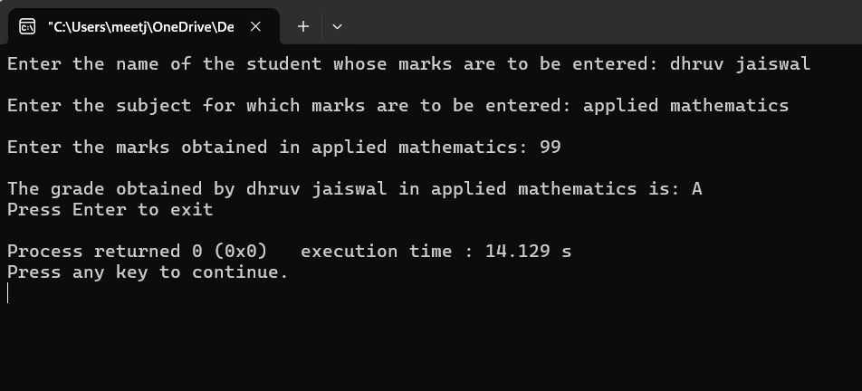

2.

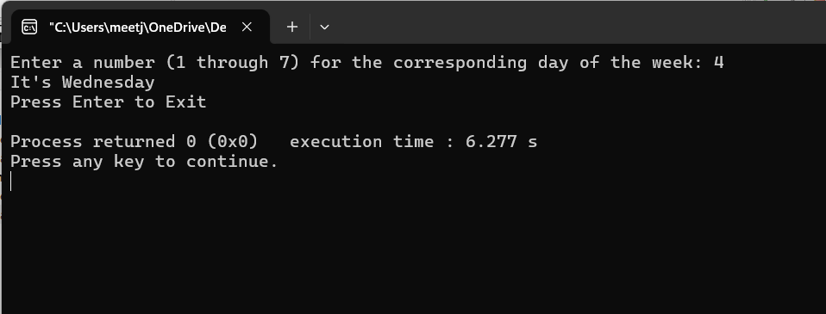

Post Lab Subjective/Objective type Questions:
Write a C program to ask the user to input a number. Check whether the number is even or odd.
Solve the problem using:
- Nested if–else statement
- Ternary operator
1. Nested if-else statement
#include <stdio.h>
int main(){
int num;
printf("Enter number: ");
scanf("%d", &num);
if (num != 0){
if(num % 2 == 0){
printf("\n%d is an even number", num);
}
else{
printf("\n%d is an odd number", num);
}
}
else{
printf("\n0 is an even number");
}
return 0;
}

- Ternary Operator:

#include <stdio.h>
int main(){
int num;
printf("Enter an integer: ");
scanf("%d", &num);
(num % 2 == 0) ? printf("\n%d is an even number", num) : printf("\n%d is an odd number", num);

while(getchar() != '\n');
printf("\nPress Enter to Exit");
getchar();
return 0;
}
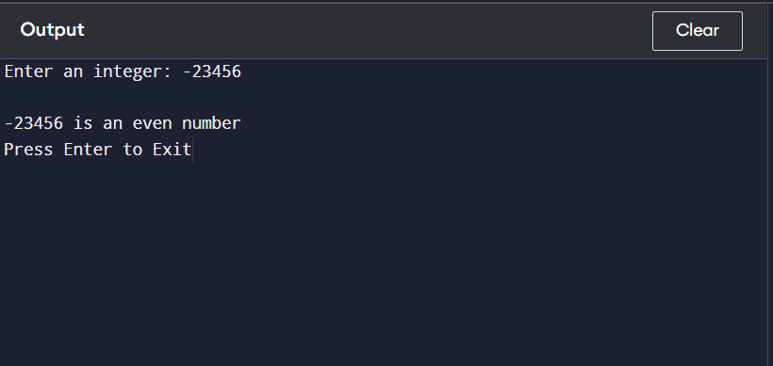

- Check the output of the following program:
int main()
{
char op;
double num1, num2, result;

printf("Enter an operator (+, -, *, /): ");
scanf(" %c", &op); // space before %c to skip newline

printf("Enter two numbers: ");
scanf("%lf %lf", &num1, &num2);

switch (op) {
case '+':
result = num1 + num2;
printf("%.2lf + %.2lf = %.2lf\n", num1, num2, result);
break;

case '-':
result = num1 - num2;
printf("%.2lf - %.2lf = %.2lf\n", num1, num2, result);
break;

case '*':
result = num1 * num2;
printf("%.2lf * %.2lf = %.2lf\n", num1, num2, result);
break;

case '/':
if (num2 != 0)
printf("%.2lf / %.2lf = %.2lf\n", num1, num2, num1 / num2);
else
printf("Error! Division by zero is not allowed.\n");
break;

default:
printf("Invalid operator!\n");
}

return 0;
}

This program functions as a calculator, it first asks to enter what operation is to be conducted and then asks two numbers on which the selected operation is to be performed.
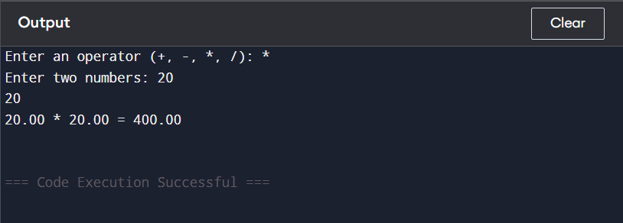

Conclusion:

Signature of faculty in-charge with Date:

