Course Name: | Structured Programming Methodology | Semester: | I
Date of Performance: | 31 / 9 / 2025 | DIV/ Batch No: | M 1
Student Name: | Dhruv Deepak Jaiswal | Roll No: | 21

Experiment No: 3
Title: Write a program in C to demonstrate the use of looping control structures

Aim and Objective of the Experiment:
Write a menu-driven program for the following option

a. Print Numbers 1 to 10 using for loop

b. Find the factorial of a number using a while loop.
c. Asks the user to enter numbers and calculates their sum. The program should keep asking until the user enters 0, using a do…while loop.

COs to be achieved:
CO: Apply basic concepts of C programming for problem-solving. (CO1 and CO2).

Theory:
Loops in programming are used to repeat a block of code until the specified condition is met. A loop statement allows programmers to execute a statement or group of statements multiple times without code repetition.
There are mainly two types of loops in C Programming:

- Entry Controlled loops: In Entry Controlled loops, the test condition is checked before entering the main body of the loop. For Loop and While Loop are Entry-controlled loops.
- Exit Controlled loops: In Exit controlled loops the test condition is evaluated at the end of the loop body. The loop body will execute at least once, irrespective of whether the condition is true or false. do-while Loop is Exit Controlled loop.

for Loop
for loop in C programming is a repetition control structure that allows programmers to write a loop that will be executed a specific number of times. for loop enables programmers to perform n steps together in a single line.
Syntax:

for (initialize expression; test expression; update expression)
{
//
// body of for loop
//
}
For Example:-
for(int i = 0; i < n; ++i)
{
printf("Body of for loop which will execute till n");
}

While Loop
While loop does not depend upon the number of iterations. In the for loop the number of iterations was previously known to us but in the While loop, the execution is terminated on the basis of the test condition. If the test condition becomes false then it will break from the while loop else body will be executed.

while (test_expression)
{
// body of the while loop

update_expression;
}

do-while Loop
The do-while loop is similar to a while loop but the only difference lies in the do-while loop test condition which is tested at the end of the body. In the do-while loop, the loop body will execute at least once, irrespective of the test condition.

do
{
// body of do-while loop

update_expression;

} while (test_expression);

Problem Statements:

a. Print Numbers 1 to 10 using for loop

b. Find the factorial of a number using a while loop.
c. Asks the user to enter numbers and calculates their sum. The program should keep asking until the user enters 0, using a do…while loop.
Sample run for c:- Enter numbers to add (enter 0 to stop):
5
10
3
0
Sum of entered numbers = 18

Code :
A)

#include <stdio.h>
#include <stdlib.h>

int main()
{
int i;
for(i=1;i<=10;i++){
printf("%d ", i);
}
return 0;
}

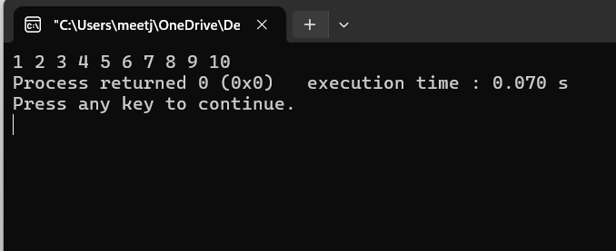

B)

#include <stdio.h>
int main(){
int i = 1;
int fact = 1;
int n;
printf("Enter the integer: ");
scanf("%d", &n);

while(i<=n){
fact = fact*i;
i++;
}
printf("\nThe factorial of %d is: %d", n, fact);
return 0;
}

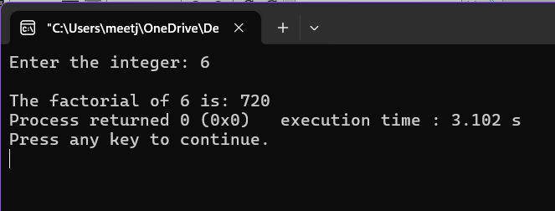

C)
#include <stdio.h>
int main(){
int num;
int sum = 0;
do{
printf("\nEnter number to add: ");
scanf("%d", &num);
sum = sum + num;
while(getchar() != '\n');
}while(num != 0);

printf("The sum of the entered numbers is: %d", sum);
return 0;
}

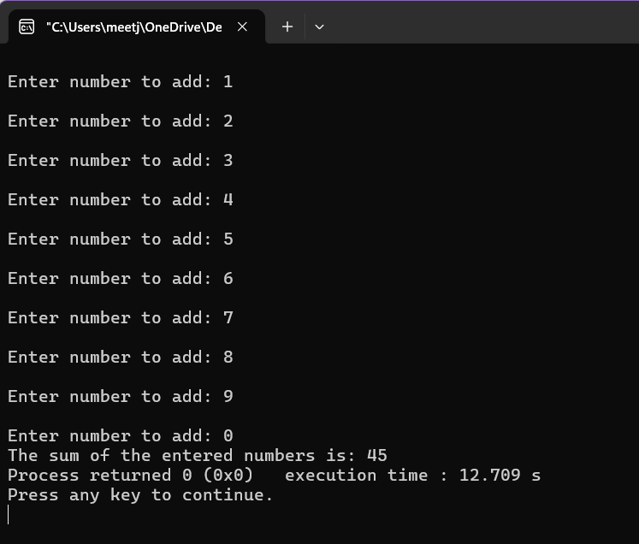

Output:

Post Lab Subjective/Objective type Questions:
- Write a program in C to display the n terms of a harmonic series and their sum.
1 + 1/2 + 1/3 + 1/4 + 1/5 ... 1/n terms
- Write a C program that displays the n terms of the square natural numbers and their sum.
1 4 9 16 ... n Terms

1.
#include <stdio.h>
#include <stdlib.h>

int main()
{
int n;
float sum = 0;
printf("Number of terms of harmonic series: ");
scanf("%d", &n);

for(int i = 1;i<=n;i++){
sum = sum + 1.00/i;
if(i == n){
printf("1/%d", i);
break;}
printf("1/%d + ", i);

}
printf("\nThe sum of the harmonic series for %d terms is: %f", n, sum);
return 0;
}

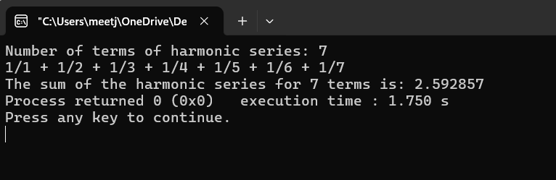

2.
#include <stdio.h>

int main()
{
int i;
int n;
int sum = 0;
int square;
printf("Enter the number of terms: ");
scanf("%d", &n);
for(i = 1; i <= n; i++){
square = i*i;
printf("%d ", square);
sum = sum + square;
}
printf("\nThe sum of squares of natural numbers upto %d is: %d", n, sum);
return 0;
}

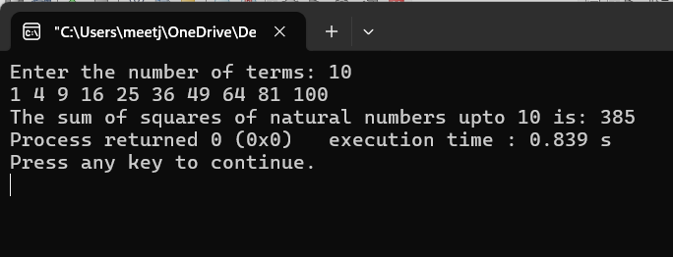

Conclusion:
Applied basic concepts of C programming for problem-solving.

Signature of faculty in-charge with Date:

