Course Name: | Structured Programming Methodology | Semester: | I
Date of Performance: | 29/10/2025 | DIV/Batch No: | M1
Student Name: | Dhruv Jaiswal | Roll No: | 16014125021

Experiment No: 5
Title: Strings and String Handling Functions

Aim and Objective of the Experiment:
Write a program in C to demonstrate the use of strings and string-handling functions.

COs to be achieved:
CO3. Apply the concepts of arrays and strings.

Theory:
In C programming, a string is an array of characters terminated by a null character ('\0'). Strings are represented using character arrays. To handle strings effectively, C provides a set of built-in functions in the <string.h> library.

Key functions for string:

- strlen(): Returns the length of a string (excluding the null-terminator).
- strcpy(): Copies a string from source to destination.
- strncpy(): Copies up to n characters from source to destination.
- strcat(): Appends one string to the end of another.
- strncat(): Appends up to n characters from source to destination.
- strcmp(): Compares two strings lexicographically.
- strncmp(): Compares the first n characters of two strings.
- strchr(): Searches for the first occurrence of a character in a string.
- strrchr(): Searches for the last occurrence of a character in a string.
- strstr(): Searches for the first occurrence of a substring in a string.
- strtok(): Tokenizes a string into substrings based on delimiters.
- sprintf(): Formats and stores a string into a character array.
- sscanf(): Reads formatted input from a string and stores it in variables.
- strdup(): Duplicates a string by allocating memory and copying it.
- strspn(): Returns the length of the initial segment of a string containing only characters from a set.
- strcspn(): Returns the length of the initial segment of a string excluding characters from a set.
- strpbrk(): Searches for the first occurrence of any character from a set in a string.
- strtok_r(): A reentrant version of strtok() for thread-safe tokenization.
- memcpy(): Copies memory from source to destination.
- memset(): Sets a block of memory to a specified value.

Problem Statements: Write C code
- Write a program that takes a string as input and counts the number of vowels and consonants in the string without using the built-in library functions. Ignore spaces and punctuation.
- Write a program to manage student records. The program will handle the following operations using the string functions provided:
- Input the student's name and grade (two strings).
- Display the length of both the student's name and grade.
- Copy the student's name into a new string and display it.
- Concatenate a fixed string (e.g., " - Excellent Student") to the student's name and display the result.
- Search for a substring in the student's name (e.g., "John" in "Johnny") and display the position of the first occurrence.
- Search for a character in the grade string (e.g., 'A') and display the position of the first occurrence.

Flowchart/Algorithm:
1.
- Start
- Initialize string,
- Initialize int vowelcount, set to 0
- Initialize int consonant count, set to 0
- Initialize int i for iteration loop
- Initialize char ch to check whether vowel or consonant through the loop
- Input string
- Set up loop to iterate through each character of input string
- Set condition for iterating character: should be a letter, ignore spaces and punctuation
- Iterate through each character and check if vowel or consonant
- If character belongs to {a,e,i,o,u,A,E,I,O,U}, increment vowelcount by 1
- Otherwise, increment consonant count by 1
- Display the count of vowels and consonants in the input string
- End

----------------------------------------------------------------------------------------------------------------------
2)
- Start
- Initialize character array for name
- Initialize character array for grade
- Initialize character array for copy of name
- Initialize character array for concatenated array
- Initialize character array for substring to search in name
- Initialize character to search in grade
- Initialize integer for length of name
- Initialize integer for length of grade
- Initialize integer for position of substring within name
- Initialize integer for position of sub char within grade
- Receive student name
- Replace newline in name string with null char
- Receive grade
- Replace newline in grade string with null char
- Print student name and grade
- Set namelength to length of student name
- Set gradelength to length of grade
- Print name length
- Print grade length
- Copy name string into namecopy array
- Conca

Code : (pseudocode)

Code:
1.
#include <stdio.h>
#include <stdlib.h>

int main()
{
char string[200];
int vowelcount = 0;
int conscount = 0;
int i;
char ch;

printf("Please enter your string: ");
fgets(string, sizeof(string), stdin);

for (i = 0; string[i] != '\0'; i++){
ch = string[i];
if ((ch >= 'a' && ch <= 'z') || (ch >= 'A' && ch <= 'Z')){
if (ch == 'a' || ch == 'e' || ch == 'i' || ch == 'o' || ch == 'u' || ch == 'A' || ch == 'E' || ch == 'I' || ch == 'O' || ch == 'U'){
vowelcount++;
}
else {
conscount++;
}
}
}

printf("In the string, the number of vowels is %d and the number of consonants is %d", vowelcount, conscount);
return 0;
}

-------------------------------------------------------------------------------------------------------------------------

2.
#include <stdio.h>
#include <stdlib.h>
#include <string.h>

int main()
{
char name[100];
char grade[10];
int namelength;
int gradelength;
char namecopy[100];
char nameandsuffix[200];
char substring[100];
char searchchar;
char *possubstring;
char *poschar;
int posstr;
int posch;

printf("Please enter student name: ");
fgets(name, sizeof(name), stdin);

name[strcspn(name, "\n")] = '\0';

printf("Please enter %s's grade: ", name);
fgets(grade, sizeof(grade), stdin);

grade[strcspn(grade, "\n")] = '\0';

printf("\nThe details entered are: \n");
printf("Student Name: %s\n", name);
printf("Student Grade: %s\n", grade);

namelength = strlen(name);
gradelength = strlen(grade);

printf("\nStudent Name Length: %d", namelength);
printf("\nStudent Grade Length: %d", gradelength);

strcpy(namecopy, name);

printf("\nCopy of Student Name: %s", namecopy);

strcpy(nameandsuffix, name);
strcat(nameandsuffix, " - Excellent Student!");

printf("\nConcatenated String with Name and given Suffix: %s", nameandsuffix);

printf("\nEnter a substring to search within name %s: ", name);
fgets(substring, sizeof(substring), stdin);

substring[strcspn(substring, "\n")] = '\0';

possubstring = strstr(name, substring);

if (possubstring == NULL){
printf("\nThe given substring %s was not found within %s", substring, name);
}
else {
posstr = possubstring - name;
printf("\nThe substring %s was found within %s at position %d", substring, name, posstr);
}

printf("\nEnter a character to search within grade %s: ", grade);
scanf(" %c", &searchchar);

poschar = strchr(grade, searchchar);

if (poschar == NULL){
printf("\nThe given character %c was not found within %s", searchchar, grade);
}
else{
posch = poschar - grade;
printf("\nThe character %c was found within %s at position %d", searchchar, grade, posch);
}
return 0;
}

Output:
1)

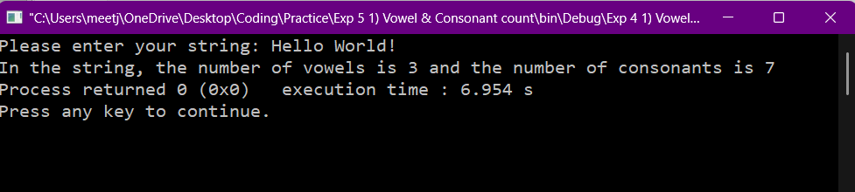
2)
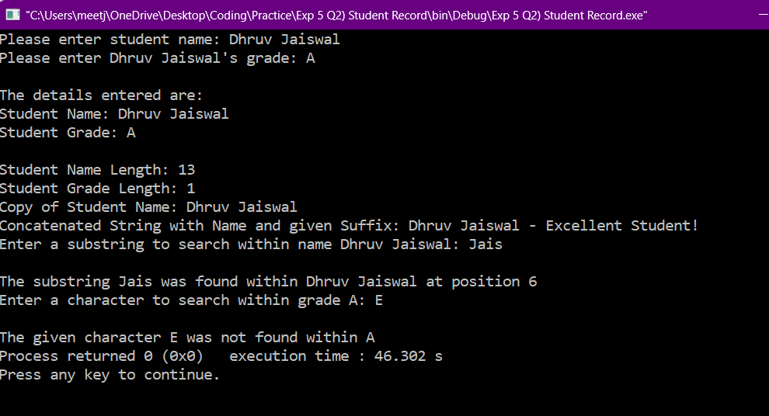

Objective-type Questions: Answer in Brief.
- In C, what will happen if you pass an uninitialized string or a string without a null terminator to any of the string handling functions (e.g., strcpy(), strlen(), strcmp())?
In C, if you pass an uninitialized string or a string without a null terminator to a string handling function, there will be errors and possible cases of attempt to write or read information beyond the memory the string handling function should have access to, resulting in crashes and segmentation faults.

If there is no null terminator in the string passed to the string handling functions, then the function won’t know where to stop reading the input, and might attempt to read beyond the memory location of the content you want it to read. It will keep reading beyond the buffer until it finds a null terminator(0) in some other data.

Also, in the worst cases, a segmentation fault may occur, crashing the program, if the string handling function attempts to write over or read information from sections of memory that it should not have access to or that are protected/private. This could also lead to corruption of other data.

If you pass an uninitialized string, it will be padded with garbage data in the memory, so the string handling functions will use the garbage data to perform their function which will result in errors.

- In C, how does memory allocation for strings work? What are the potential risks associated with string manipulation in C, and how can buffer overflow issues be prevented?
In C, strings are stored as an array of characters.
The risks involved with string handling in C are due to the complete burden of program checking and correction being on the programmer. C will not do any thorough checks to verify whether a certain string handling function will cause an error.
Some errors that can occur are due to buffer overflow and missing null terminator.

If there is a missing null terminator in the string you use a string handling function on, then the function will not know where to stop reading/writing, and it will end up breaching the boundaries of the data allocated to the string and read/writeover data in other neighbouring memory locations, potentially resulting in corruption of data.

Buffer overflow occurs when the data input into a string is larger than the size of the memory allocated for it. For example, a string initialized as str[100] receives an input which is larger than 100 characters. In this case, the input data overflows from the buffer allocated to it, potentially ending up overwriting other data in neighbouring memory locations.
Buffer overflow can be prevented by:
- Performing proper and thorough manual checks and debugs through your code so that you can catch errors in the code and check if you have provided enough bytes of memory to the strings you are working with during initialization.
- Use string handling functions that have a size limiter up to which they perform their functions. For example, instead of strcpy, use strncpy, in which it copies upto n characters from the source string into the destination string, with the format being
strncpy(destination_string, source_string, n), where n is the number of characters you want to copy from source string to destination string

Conclusion:

Signature of faculty in charge with date:

