Course Name: | Structured Programming Methodology | Semester: | I
Date of Performance: | 29 / 10 / 2025 | DIV/ Batch No: | M1
Student Name: | Dhruv Deepak Jaiswal | Roll No: | 16014125021

Experiment No: 6
Title: User defined functions

Aim and Objective of the Experiment:
Write a program to implement user-defined functions.

COs to be achieved:
CO4: Design modular programs using functions and the use of structure.

Theory:
Introduction to User-Defined Function

In C programming, a User-Defined Function (UDF) is a function that is defined by the programmer to perform a specific task. Functions are essential tools for modularizing a program, allowing complex tasks to be divided into smaller, more manageable chunks. User-defined functions enhance code reusability, maintainability, and readability by encapsulating specific functionality into independent units.

In C, a function is defined once and can be called multiple times within a program. This allows for more organized, efficient, and error-free code.

A User-Defined Function in C consists of the following parts:

- Function Declaration/Prototype (Optional but recommended)
- Function Definition
- Function Call

Function Declaration/Prototype: The function prototype is a declaration of the function that specifies the function name, return type, and the types of parameters. It is often placed before the main function to inform the compiler about the function's characteristics, which helps in type checking during compilation.

Syntax:
return_type function_name(parameter_type1, parameter_type2, ...);

Example:
int add(int a, int b); // Function prototype

Function Definition: This is where the function is actually defined. It includes the function's body, where the desired operations are performed. The function definition must match the declaration or prototype.

Syntax:
return_type function_name(parameter1, parameter2, ...) {
// Body of the function
// Perform operations
return result; // Optional, if return type is not void
}

Example:
int add(int a, int b) {
return a + b; // Adds the two integers and returns the result
}

Function Call: This is where the function is invoked in the program. To call a function, you simply write its name followed by parentheses, passing the necessary arguments (if any).

Example:
int sum = add(5, 3); // Calling the 'add' function with arguments 5 and 3

Function Types in C
Functions with Return Values: These functions perform a task and return a value. The return type is specified in the function prototype and definition. For example, the add() function in the previous example returns an integer.

Functions without Return Values (void functions): These functions do not return any value. The return type in the function prototype and definition is void. Such functions are typically used to perform actions like printing messages or modifying global variables.

Example:
void print_hello() {
printf("Hello, World!\n");
}

Functions with Arguments: These functions take arguments as input, which are used in the body of the function to perform a specific task. Arguments can be passed by value or by reference (using pointers).

Example:
int multiply(int a, int b) {
return a * b; // Multiplies two integers and returns the result
}

Functions without Arguments: These functions do not take any arguments, but they may still perform a task like printing output or modifying data.

Example:
void display_message() {
printf("This is a user-defined function without arguments.\n");
}

Benefits of Using User-Defined Functions in C:
- Reusability: Once a function is defined, it can be called multiple times in different parts of the program, reducing redundancy and enhancing code reusability.

- Modularity: Functions allow the programmer to divide the program into smaller, more manageable sections, making the code easier to read, debug, and maintain.

- Improved Readability: By using functions, the program becomes more organized. Instead of having one large block of code, the program can be divided into smaller sections, each performing a specific task.

- Easier Debugging and Testing: Since each function is focused on a single task, testing and debugging become easier. If there is an issue with the function, you can focus on fixing that specific function without impacting the rest of the program.

- Abstraction: Functions abstract away the details of the implementation. This means that the main part of the program only needs to know what the function does, not how it does it.

- Better Maintenance: If a function needs to be updated or modified, you can change the function definition in one place, and all calls to that function throughout the program will automatically use the updated version.

Problem Statements:
- Write a C program that counts how many numbers in an array are even and how many are odd, using user-defined functions.
- Write a C program that reads a matrix from the user and displays its transpose using user-defined functions.

Algorithm / Flowchart:

Code :
1.
#include <stdio.h>
#include <stdlib.h>

int counteven(int arr[], int n);

int countodd(int arr[], int n);

int main()
{
int evencount;
int oddcount;
int i;
int n;

printf("Please enter the number of integers in the array: ");
scanf("%d", &n);

int arr[n];

printf("\nPlease enter %d elements: ", n);
for (i = 0; i<n; i++){
scanf("%d", &arr[i]);
}

printf("\nEntered array: \n");
for (i = 0; i<n; i++){
printf("%d ", arr[i]);
}

evencount = counteven(arr, n);
oddcount = countodd(arr, n);

printf("\nThe number of even elements in the array are: %d", evencount);
printf("\nThe number of odd elements in the array are: %d", oddcount);

return 0;
}

int counteven(int arr[], int n){
int evencount = 0;
for (int i = 0; i < n; i++){
if (arr[i] % 2 == 0){
evencount++;
}
}
return evencount;
}

int countodd(int arr[], int n){
int oddcount = 0;
for (int i = 0; i < n; i++){
if (arr[i] % 2 != 0){
oddcount++;
}
}
return oddcount;
}

_______________________________________________________________________________

2.
#include <stdio.h>
#include <stdlib.h>

void matrixinput(int rows, int columns, int matrix[rows][columns]);
void transposing(int rows, int columns, int matrix[rows][columns], int transposedmatrix[columns][rows]);
void printmatrix (int rows, int columns, int matrix[rows][columns]);
void printtranspose(int rows, int columns, int transposedmatrix[columns][rows]);

int main()

{
int i, j;
int rows;
int columns;

printf("Please enter the number of rows in the matrix: ");
scanf("%d", &rows);

printf("Please enter the number of columns in the matrix: ");
scanf("%d", &columns);

int matrix[rows][columns];
int transposedmatrix[columns][rows];

matrixinput (rows, columns, matrix);
printmatrix (rows, columns, matrix);
transposing (rows, columns, matrix, transposedmatrix);
printtranspose (rows, columns, transposedmatrix);

return 0;
}
void matrixinput (int rows, int columns, int matrix[rows][columns]){
printf("\nPlease enter the elements of matrix (%d by %d)\n", rows, columns);
for (int i = 0; i < rows; i++){
for (int j = 0;j<columns;j++){
printf("Enter element [%d][%d]: ", i+1, j+1);
scanf("%d", &matrix[i][j]);
}
}
}

void printmatrix (int rows, int columns, int matrix[rows][columns]){
printf("\nEntered Matrix: \n");
for (int i = 0; i<rows;i++){
for (int j = 0;j<columns;j++){
printf("%d ", matrix[i][j]);
}
printf("\n");
}
}

void transposing (int rows, int columns, int matrix[rows][columns], int transposedmatrix[columns][rows]){
for (int i = 0; i<columns;i++){
for (int j = 0;j<rows;j++){
transposedmatrix[i][j] = matrix[j][i];
}
}
}

void printtranspose (int rows, int columns, int transposedmatrix[columns][rows]){
printf("\nTransposed Matrix: \n");
for (int i = 0;i<columns;i++){
for (int j = 0; j < rows; j++){
printf("%d ", transposedmatrix[i][j]);

}
printf("\n");
}
}

Output:
1)
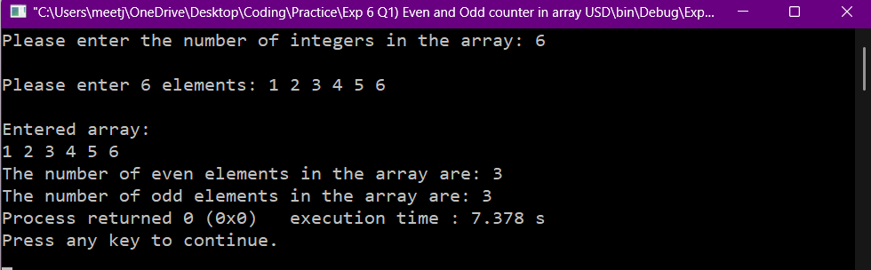

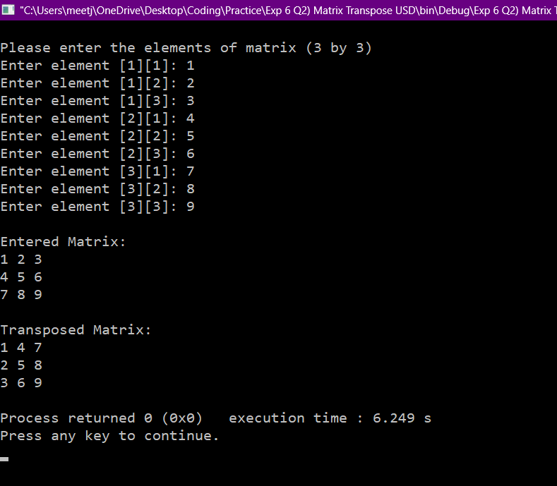

Post Lab Subjective/Objective type Questions:
- What is the difference between Call by Value and Call by Address?

In user defined functions, there are two ways to call upon parameters to use in the function. They are calling by value and calling by address.
When you call by value, essentially a copy of a particular variable from the main function gets made and passed to your function to use as an argument. Thus, the value changed (if the value of the variable is intended to be changed), will be of the copy of the variable, not of the actual variable. So, the value of the original variable will remain the same
When you call by address, instead of passing a copy of the variable value to the function to use as parameter, you instead pass a pointer to the memory address where the value of the particular variable is stored. So, the function operates on the value stored in that particular memory address, and it directly changes the data stored at that particular memory address. So, the value of the original variable will get changed.

- Explain recursion using functions in C with an example. (Handwritten)

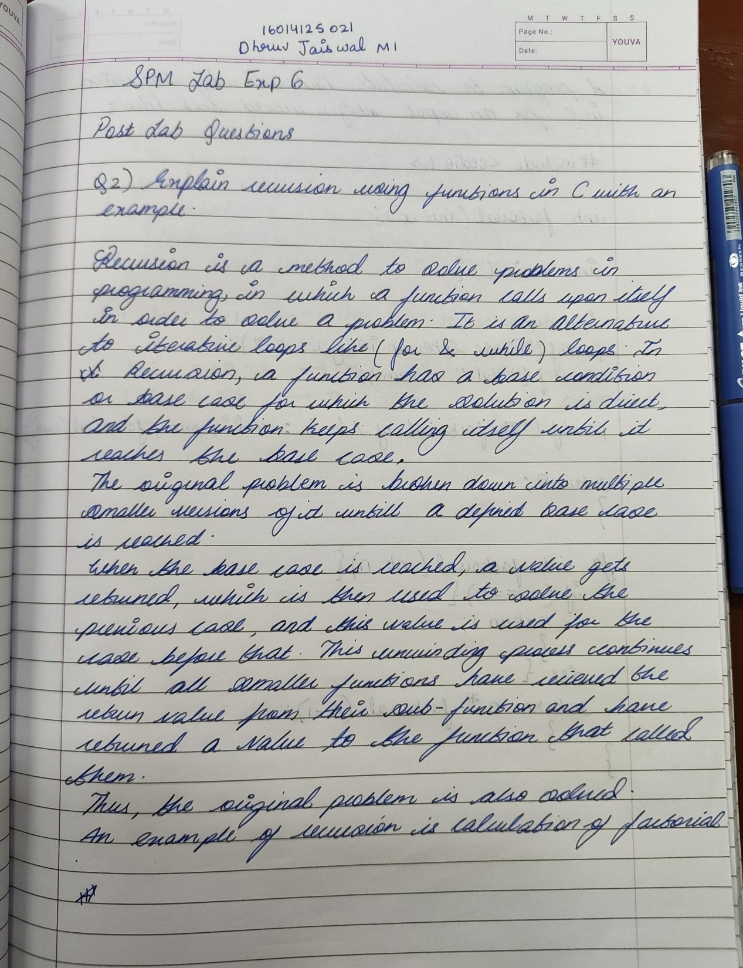
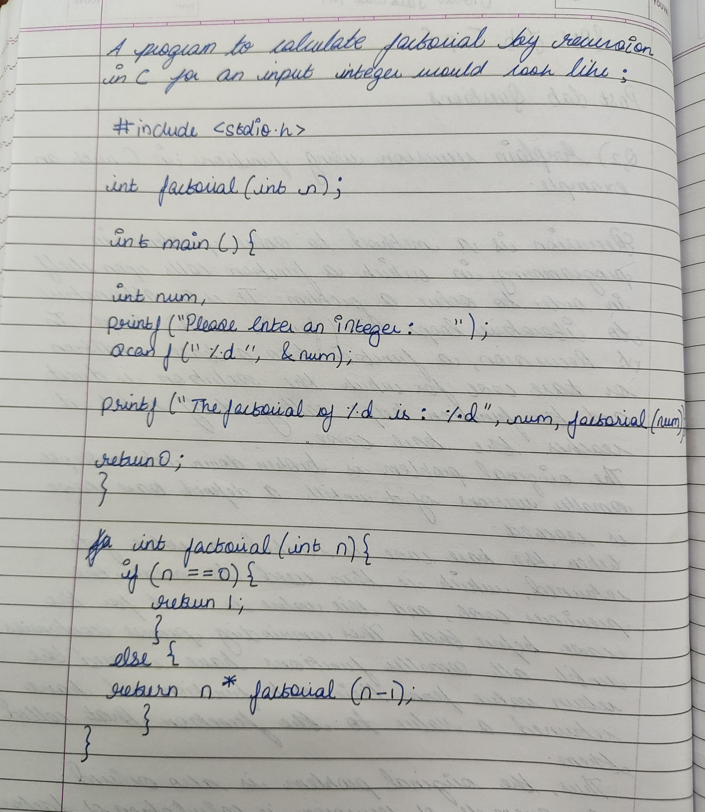
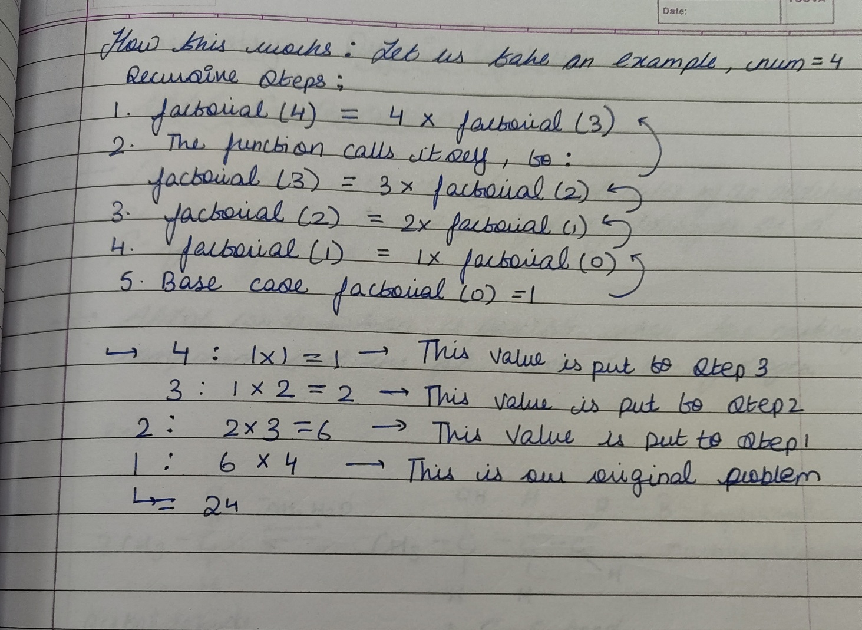
Conclusion

Signature of faculty in-charge with Date:

