
K. J. Somaiya School of Engineering
Department of Science and Humanities
Applied Chemistry Laboratory
Subject: Engineering Chemistry
^{CO:} Name:
Roll No.
Batch: Date:
Experiment No. 4
Title
Spectrophotometric Determination of Optical Band Gap of Cobalt (II) Chloride
Aim
To determine the optical band gap energy (Eg) of Cobalt (II) chloride using UV–Visible spectrophotometry. (V-Lab)
Principle / Theory
When light passes through a material, photons with energy equal to or greater than the band gap can excite electrons from the valence band to the conduction band. This causes absorption at specific wavelengths.
The absorption coefficient (α) is related to photon energy (hν) by the Tauc equation: Where:
• α = absorption coefficient
• hν = photon energy (eV)
• Eg = optical band gap
• A = constant
• n = ½ for direct allowed transition
• n = 2 for indirect allowed transition
For most metal chlorides, direct transition is assumed:
Plotting (αhν)² vs hν and extrapolating the linear portion to the x-axis gives Eg. Importance of Cobalt(II) Chloride:
ASL Sem-II (2025- 26)

K. J. Somaiya School of Engineering
Department of Science and Humanities
Applied Chemistry Laboratory
Subject: Engineering Chemistry
• Cobalt (II) chloride [CoCl₂] is not a conventional semiconductor like silicon, but it plays an important role in the preparation and modification of semiconducting materials.
• CoCl₂ is widely used as a precursor for synthesizing cobalt-based semiconductors such as cobalt oxides, sulfides, and selenides, which are applied in photocatalysis, sensors, solar cells, batteries, and supercapacitors
• It serves as a dopant source for materials like ZnO, TiO₂, and CdS, introducing new energy levels that improve conductivity, light absorption, and magnetic properties.
• Due to its strong electronic transitions, CoCl₂ helps in “band gap engineering” and modification of optical properties.
• Being inexpensive, soluble, and easy to process, CoCl₂ is suitable for large-scale and low-temperature synthesis.
• Thus, Cobalt (II) chloride is an important chemical for developing and tuning semiconducting materials.
•
Apparatus & Chemicals
• UV–Visible spectrophotometer
• Quartz cuvettes
• Analytical balance
• Volumetric flasks
• Distilled water
• Cobalt (II) chloride (CoCl₂)
• Pipettes, beakers
NOTE: The virtual setup is available in simulation of physical chemical lab at amrita vlab portal.
Preparation of Sample Solution
1. Select Cobalt (II) chloride in from drop-down menu of solution. 2. Set concentration of Cobalt (II) chloride 0.001 M.
ASL Sem-II (2025- 26)

K. J. Somaiya School of Engineering
Department of Science and Humanities
Applied Chemistry Laboratory
Subject: Engineering Chemistry
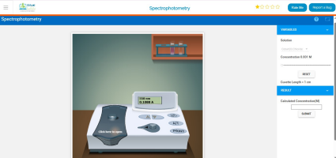
3. Click on “Click to Open” to open the UV–Visible spectrophotometer.. 4. Place the blank cuvette in the sample holder and adjust the absorbance to zero. Remove the blank cuvette with a single click.
5. Place the cuvette containing 0.001 M Cobalt (II) chloride solution in the sample holder.
6. Record the absorbance of 0.001 M Cobalt (II) chloride in the wavelength range 350–600 nm.
7. Prepare an Excel sheet and enter the absorbance values at the corresponding wavelengths.
8. You can get approximate optical band gap values with formula, 1240/λmax .
9. Now for exact band gap measurement, we will make tauc plot with Use of Origin software (or Excel).
10.Calculate photon energy (hν).
11. Calculate the absorption coefficient (α) for each wavelength and (αhν)². 12.Plot (αhν)² versus hν.
13.Extrapolate the straight-line portion of the plot to intersect the energy axis and determine the band gap energy.
ASL Sem-II (2025- 26)

K. J. Somaiya School of Engineering
Department of Science and Humanities
Applied Chemistry Laboratory
Subject: Engineering Chemistry
Calculations
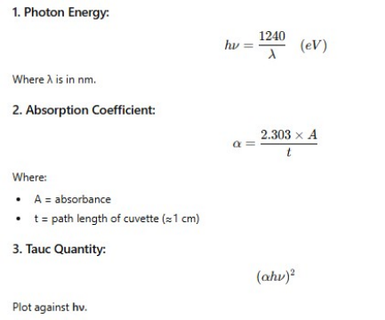
Graph
Plot: (αhν)² vs hν
Y-axis:(αhν)²
X-axis: hν (eV)
The straight line portion is extrapolated to intersect X-axis.
ASL Sem-II (2025- 26)

K. J. Somaiya School of Engineering
Department of Science and Humanities
Applied Chemistry Laboratory
Subject: Engineering Chemistry
Add screen shot of the workbook and tauc plot from origin
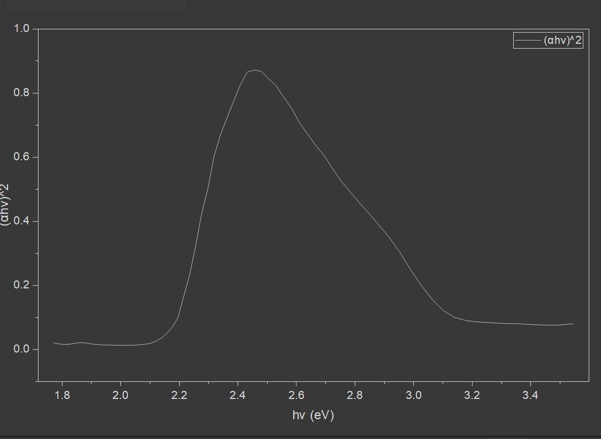
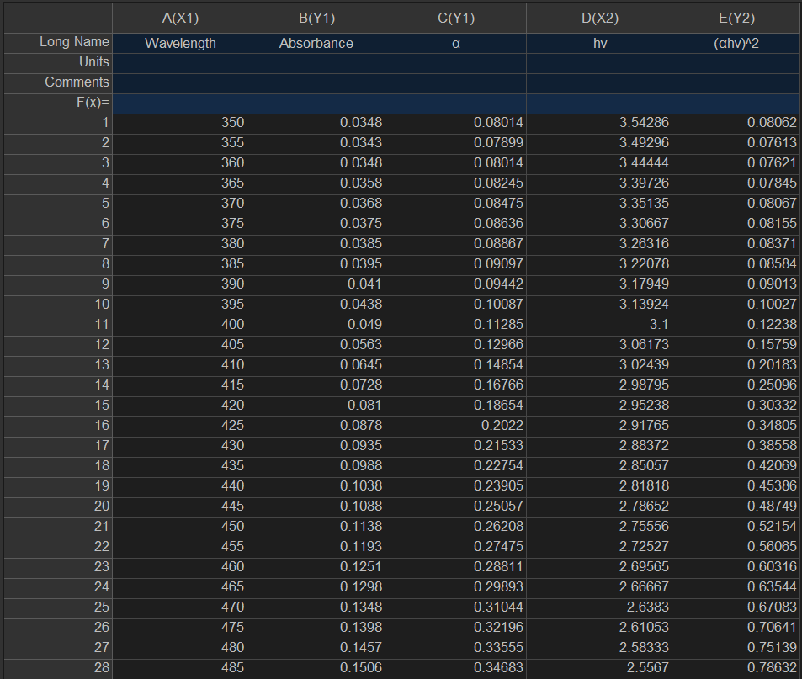
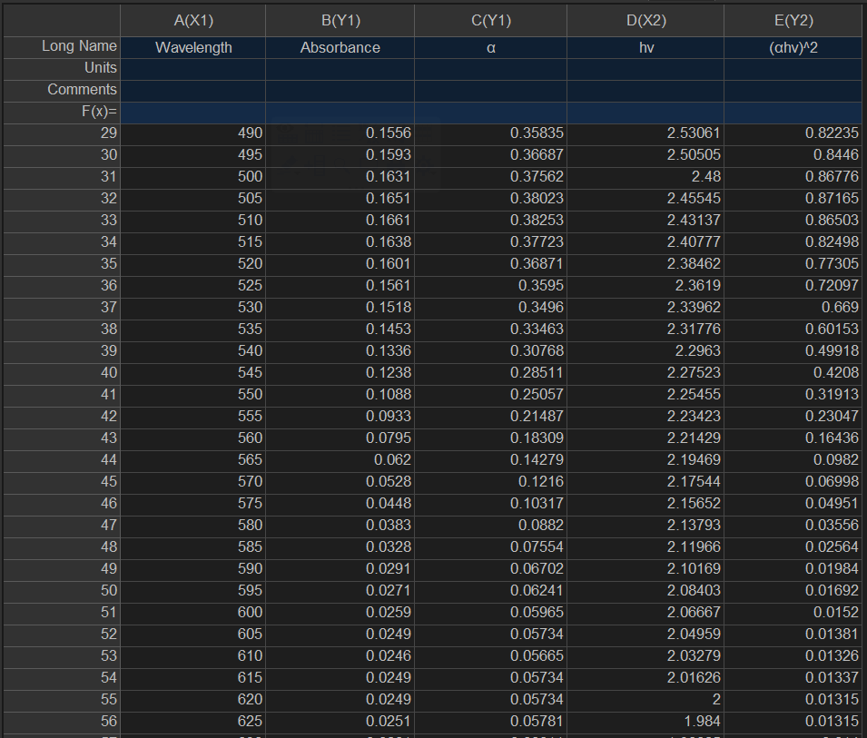
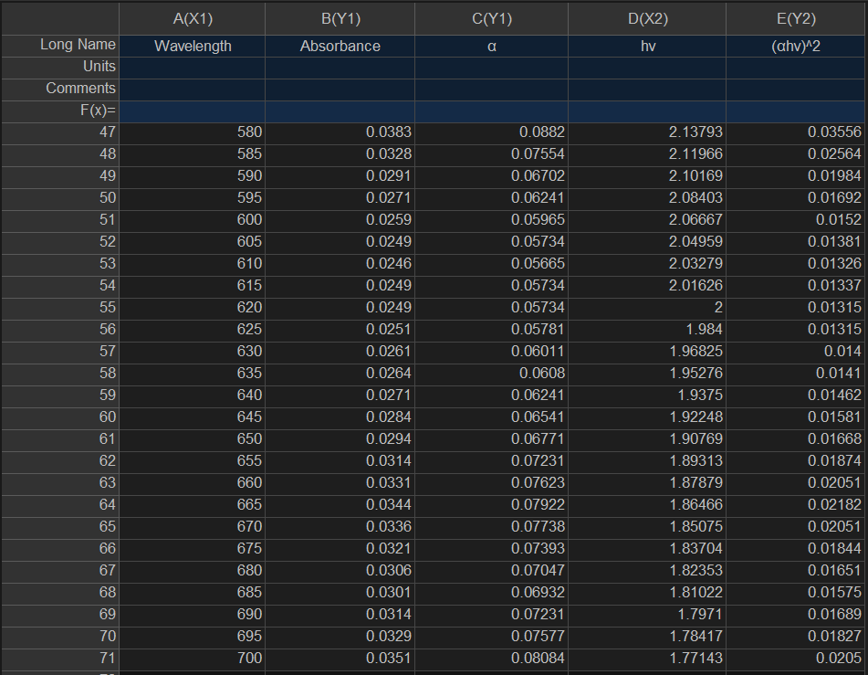
Result
The optical band gap of Cobalt (II) chloride is found to be:
[E_{g} = _______ eV]
(Typically reported value lies around 2.0 – 2.5 eV, depending on form and conditions.)
ASL Sem-II (2025- 26)

