Course Name:  Course Code: | Digital Logic Design Laboratory (DLDL)  316U06L202 | Semester: | II
Date of Performance: | 20 / 03 /20--26 | Batch No:
Student Name: |  | Roll No:
Faculty Sign & Date: |  | Grade/Marks: | / 2
Experiment No: 10
Title: Implementation of 4-bit Serial-In Parallel-Out Shift Register
Aim and Objective of the Experiment:
Implementation of 4-bit Serial-In Parallel-Out Shift Register using V-LAB.. Design and implement sequential logic circuits and their applications

COs to be achieved:
CO4: Implement sequential logic circuits and applications using MSI devices.
CO5: Understand basic principles required for advanced Digital Design

- Use the following link to implement and verify the above circuit Virtual Labs (vlabs.ac.in)

Pin Diagram: D-FF IC 7474

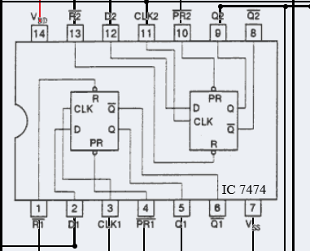

Logic Diagram: 4-bit synchronous counter

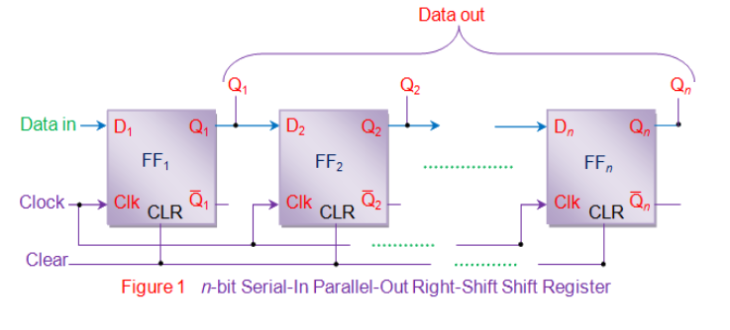

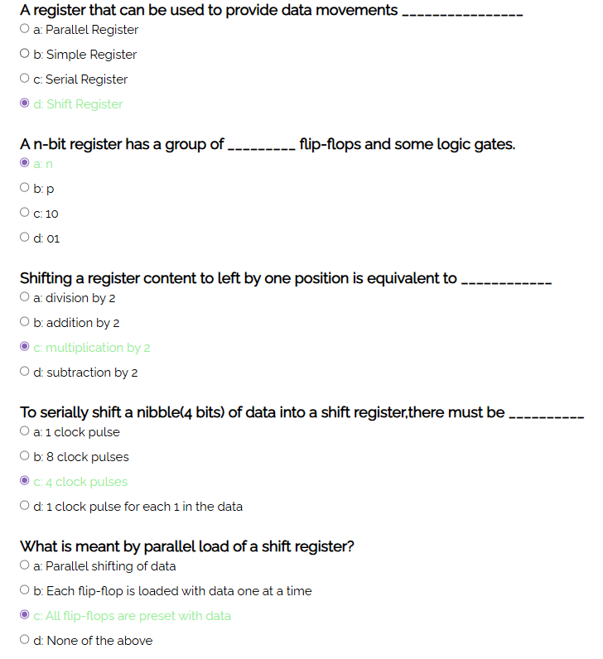

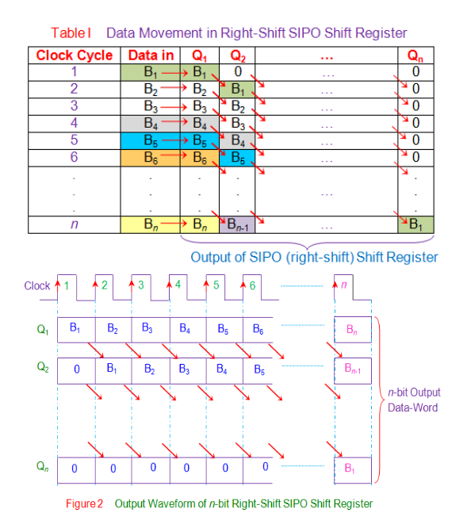

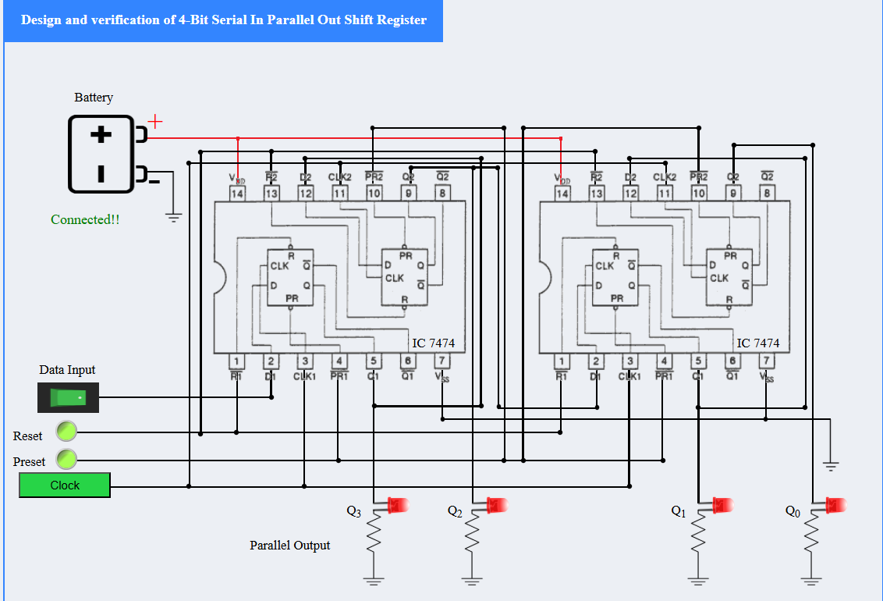

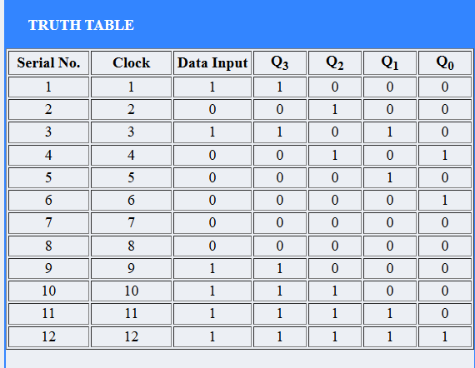

Conclusion: Designed and implemented 4 bit Serial In Parallel out Shift Register using IC 7474

Signature of faculty in-charge with Date:

