Module 2 Equilibrium of forces
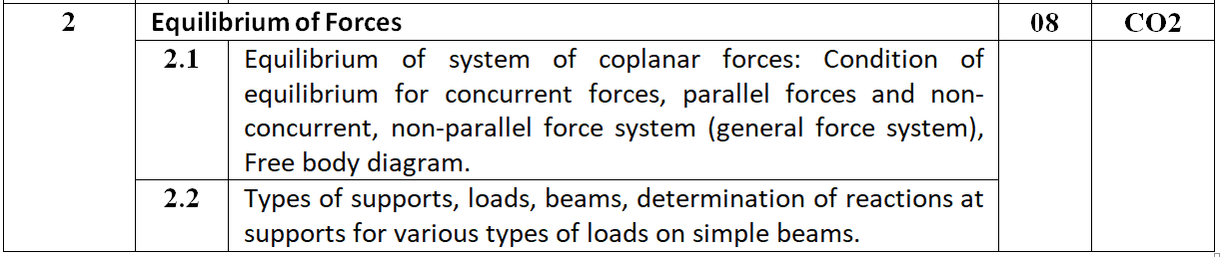

2. If the mass of cylinder C is 40 kg, determine the mass of cylinder A in order to hold the assembly in the position shown. (Take g as 10 m/second²)

The 60-lb collar A can slide on a frictionless vertical rod and is connected as shown to a 65-lb counterweight C. Draw the free-body diagram needed to determine the value of h for which the system is in equilibrium.
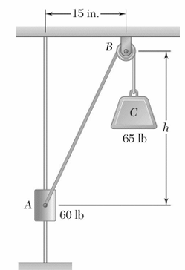

4. Find the force transmitted by wire BC. The pulley E can be assumed to be frictionless in this problem. ( Ans : BC = 113.14, AB = 180, BD = 128.13 )
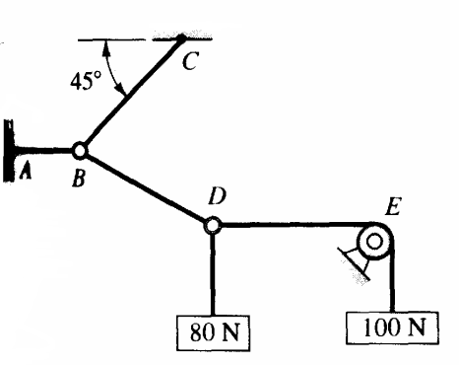

Two spheres, each of weight 1000 N and of radius 25 cm rest in a horizontal channel of width 90cm as shown in Fig. Find the reactions on the points of contact A, B and C. ( Ans : R_{A} = R_{C} = 13b33.33, R_{B} = 2000 , R_{D} = 1666.67 )
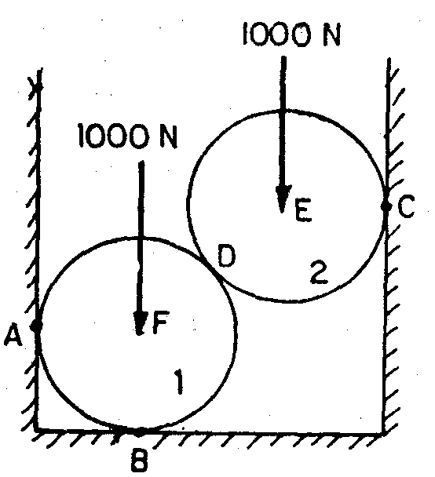

Two identical rollers P and Q, each of weight W, are supported by an inclined plane and a vertical wall as shown in Fig. Assume all the surfaces to be smooth. Draw the free body diagrams of: (i) roller Q, (ii) roller P and (iii) rollers P and Q taken together. (iv) If W = 1000 N find reactions at all contact surfaces. ( Ans : R_{A} = 866 , R_{C} = 1154.7, R_{D} = 500 , R_{B} = 1443.3 )
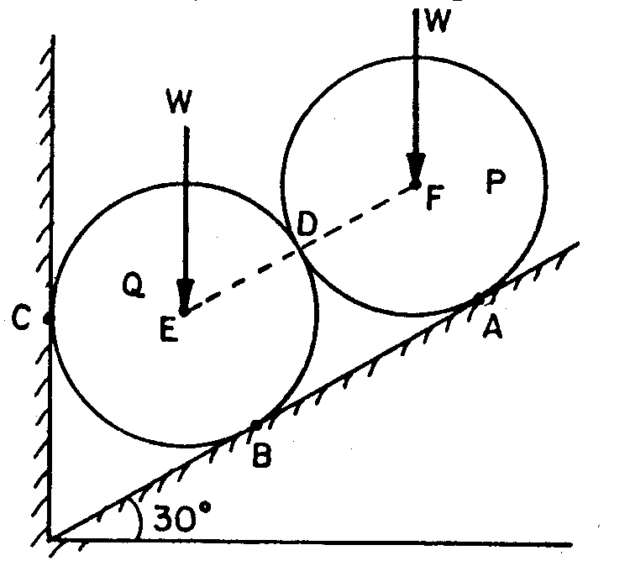

15. A 4 m long joist weighing 100 N is raised by a man, by pulling the rope connected to it as shown a Fig. Find the tension T in he rope and the reaction at A.
( Ans ; T = 70.71, H_{A} = 68.3 , V_{A} = 118.3 )
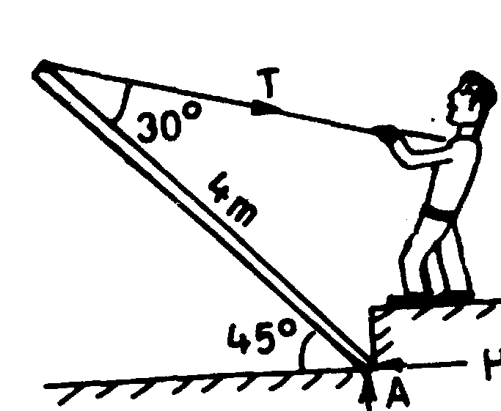

Two homogeneous solid cylinders of identical weight of 5000 N and radius of 0.4 m are resting against inclined wall and sloping ground as shown in the figure. Assuming all smooth surfaces find the reactions at A, B and C of the contact points on ground and wall.
( Ans : R_{A} = 4330.13, R_{B} = 4330.13, R_{C} = 5000 )

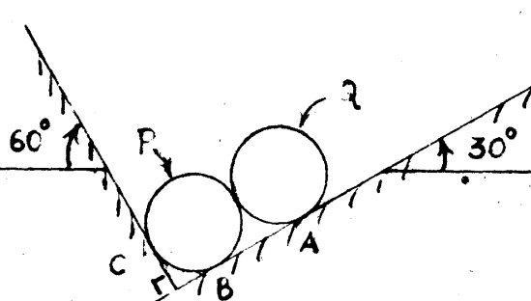

The roller shown in fig is of weight 1500 N . What force T is necessary to start the roller over the block A?( Ans : 1759.34 )
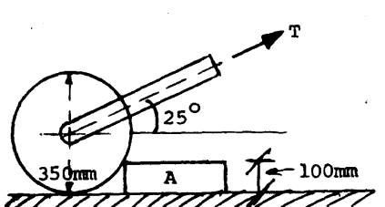

Three similar tubes of weight 8 KN each are placed as shown in the fig. Determine the forces exerted by the tubes on the smooth walls and floor.( Ans : R_{A} = R_{B} = 6.928, R_{C} = R_{D} = 12 )

