Wedge Friction
1. Find the force “P” applied to the lower block “B” so as to just start the upward motion of block “A”. The angle of friction for all contact surfaces is “Φ = 16°”.
( Ans: 43.93)
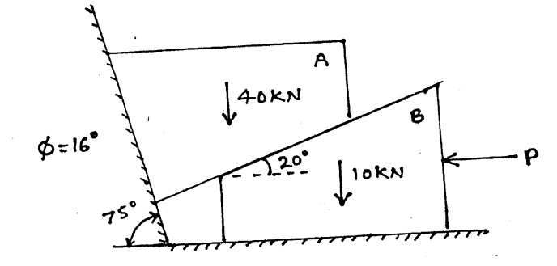

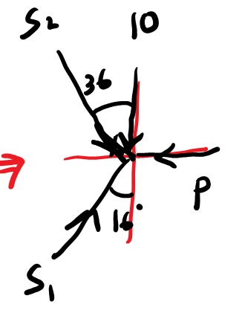
2. A horizontal force of 5 KN is acting on the wedge as shown in Figure. The coefficient of friction at all rubbing surfaces is 0.25. Find the load ‘W’ which can be held in position. The weight of block ‘B’ may be neglected.
( Ans: 22.55)
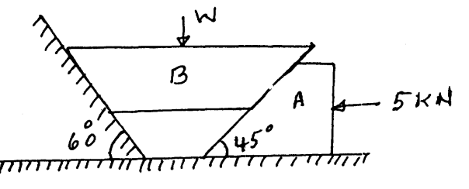

3. A block weighing 1000 N is to be raised against a surface inclined at 60° to the horizontal by means of a 15° wedge as shown in figure. Find the horizontal force P which will just start the block to move if the µ between all the surfaces of contact be 0.2. Assume the wedge to be of negligible weight. ( Ans: 594.6 )
