1. A two-stage missile is fired vertically from rest with the acceleration shown. In 15s the first stage A burns out and the second stage B ignites. Plot the v-t and graphs which describe the two-stage motion of the missile for t=0 to 20 seconds.
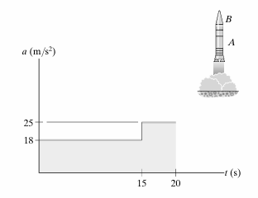

2. A car starts from rest and travels along a straight road with a velocity described by the graph. Determine the total distance travelled until the car stops. Construct the a-t and S-t graphs.
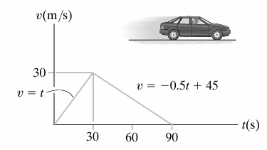

3. A car travels up a hill with the speed shown. Determine the total distance the car travels until it stops (t=60 seconds ).Plot the a-t and S-t graph.
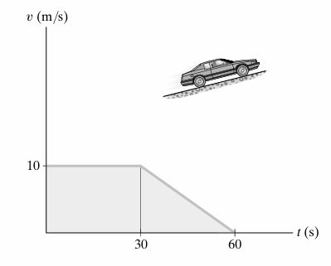

4. The position of a cyclist traveling along a straight road is described by the graph. Construct the V-t and a-t graphs,
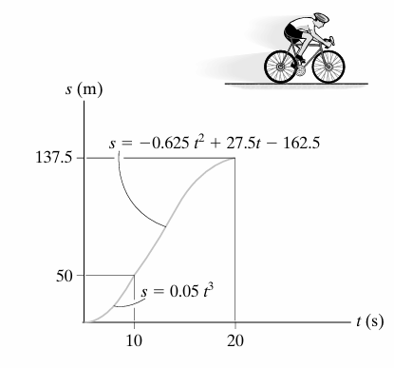

5. The s–t graph for a train has been determined experimentally. From the data, construct the v-t graphs for the motion.
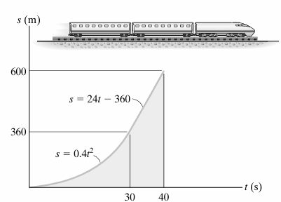

6. The car starts from rest and travels along a straight track such that it accelerates at 10 m/s² for 10 s, and then decelerates at 2 m/s². Draw the v-t and s-t graphs and determine the time t' needed to stop the car. How far has the car travelled?
