Kinematics of particles:
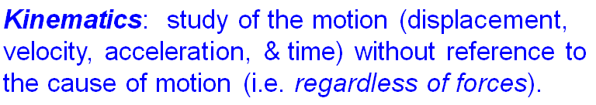

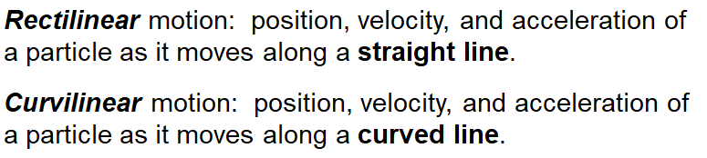
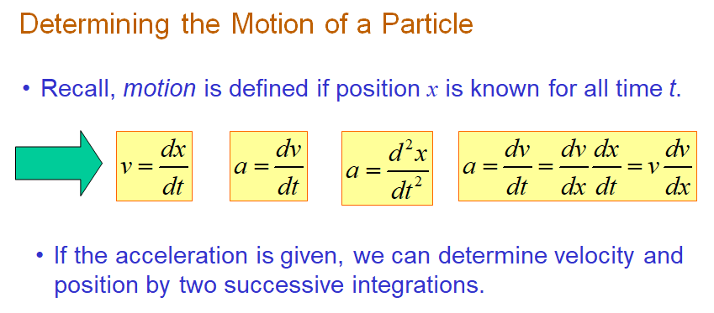
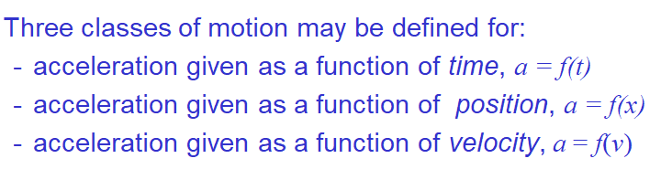

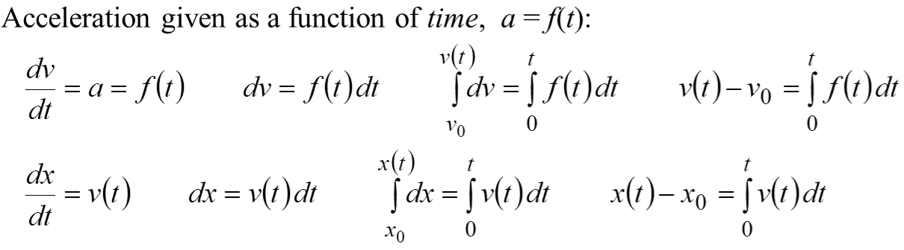

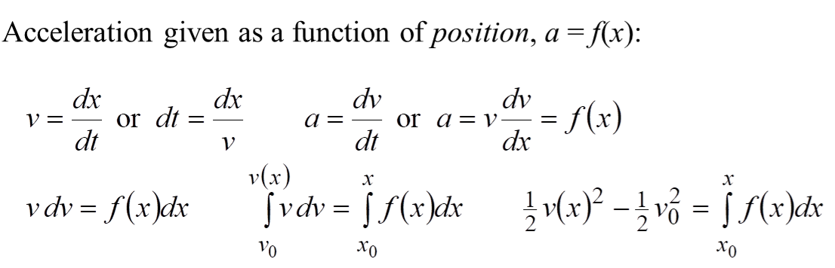

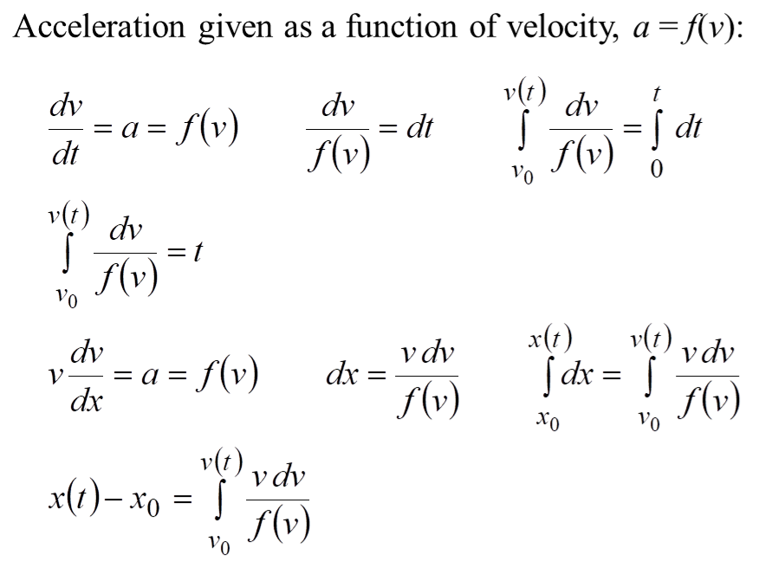
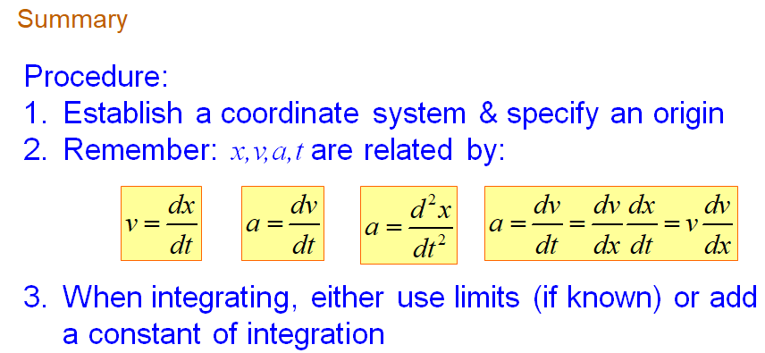

Problems of x or s function of time
1. The motion of a particle is defined by the relation
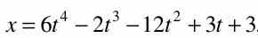
Where x and t are expressed in meters and seconds, respectively. Determine the time, the position, and the velocity when acceleration a is zero.

2. The motion of a particle is defined by the relation
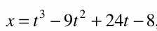
Where x and t are expressed in inches and seconds, respectively. Determine (a) when the velocity is zero, (b) the position when the acceleration is zero.

Problems on Velocity function of time:
1. The car at origin starts from the rest and moves in a straight line such that for a short time its velocity is defined by V=(9t²+2t) m/s, where t is in seconds. Find its position and acceleration when t =3 seconds.

2. For a particle, travelling along a straight line, its velocity is given by V = K2t +K1t². where V and t are in m/s and seconds respectively. K1 & K2 are the constants to be determined.
At t = 1, V = 3 m/s , a = 4 m/s2 & x = 10/3 m.
Find x,V & a at t = 3 sec.

3. The motion of a particle moving in a straight line is given by V = 4t²- 3t - 1. If the displacement x = -4m at t =0 determine the displacement and acceleration when t = 3 sec. Also find the time when the velocity becomes zero and the displacement and distance travelled by the particle during that time.

Acceleration function of time a=f(t)
1. Acceleration of a particle is directly proportional to the square of time t. When t =0; particle is at x =24m; knowing that at t = 6 sec, x =96m and v =18 m/s. Find expression of x and v in terms of t. Also find velocity and position at t = 2sec.

When t =0; particle is at x =24m; knowing that at t = 6 sec, x =96m and v =18 m/s.

2. A particle starts with initial velocity and travelling in a straight line has an acceleration of a=2t + 4 m/s². The distance covered in the first second measured from the starting point is 6.33 m. Find (a) Initial velocity (b) the distance covered in the third second.

Acceleration function of Velocity a=f(v)
1. Acceleration of a vehicle at any instant is given by
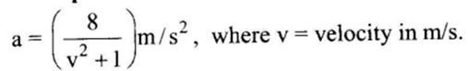
If the vehicle starts from rest find its (a) velocity when the displacement is 200m (b) displacement when velocity is 54 KPH.

2.

Acceleration function of x a=f(x)
1.
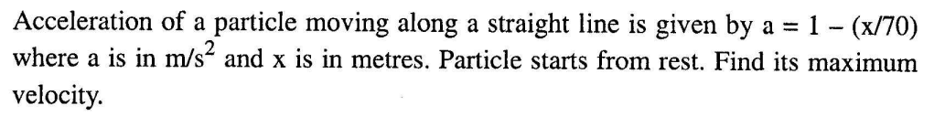

2.
