Variable Motion Problems:
A small projectile is fired vertically downward into a fluid medium with an initial velocity of 60 m/s. Due to the drag resistance of the fluid the projectile experiences a deceleration of a = (- 0.4v³) m/s2, where v is in m/s. Determine the projectile's velocity and position 4 s after it is fired.
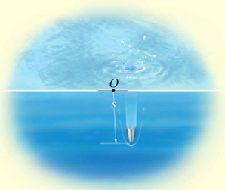

2. A metallic particle is subjected to the influence of a magnetic field as it travels downward through a fluid that extends from plate A to plate B. If the particle is released from rest at the midpoint C, s = 100 mm, and the acceleration is a = (4s) m/s², where s is in meters, determine the velocity of the particle when it reaches plate B, s = 200 mm, and the time it takes to travel from C to B.
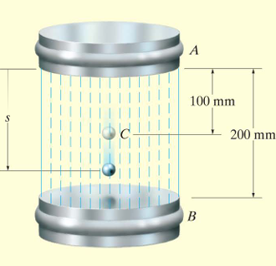

3. A piece of electronic equipment that is surrounded by packing material is dropped so that it hits the ground with a speed of 4 m/s. After contact the equipment experiences an acceleration of , a = -kx where k is a constant and x is the compression of the packing material. If the packing material experiences a maximum compression of 20 mm, determine the maximum acceleration of the equipment.

