Conservation of Momentum
1. A boat 6m long & having a mass of 150 Kg is stationary on still lake water. A flag stick is anchored vertically in the ground below & its distance from end A of the boat is 3m. A man of 50 Kg standing at end A starts walking along the boat in direction AB at 2 m/s w.r.t. boat. Find the time required by the man to pass the flag stick.
( Ans : 2 sec, S_{B} = -1 m )

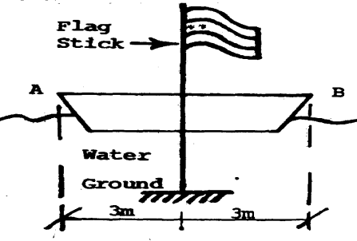

2. Two men lined up at one end of a boat, initially at rest, and run in succession with velocity u= 3 m/s relative to boat and dive off at the far end. Neglecting resistance of water to horizontal motion of the boat, find its velocity after the second man dives. Each man weighs 750 N and the boat weighs 4500 N. (Ans : - 0.8036 m/s )

3. The boy jumps off the flat car at A with a velocity v’= 4 m/s relative to he car as shown. If he lands on the second flat car at B, determine the final speeds of both cars after the motion. Each car has a mass of 80 kg. The boy mass is 60 kg. Both cars are originally at rest. Neglect the weight of the car’s wheel.
( Ans : VA/s, V_{(BOY & Car B)} = 0.904 m/s )
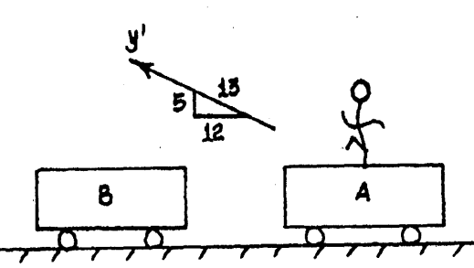

4. A man of mass 75 Kg & boy of mass 25 Kg dive off the end of a boat of mass 200 Kg so that their relative horizontal velocity w.r.t. boat is 3 m/s. If initially the boat is at rest find its final velocity (i)The two dive off simultaneously. (ii)The man dives first followed by boy. (iii) The boy dives first followed by man.
( Ans : (i) -1 m/s (ii) -1.083 m/s (iii) -1.068 m/s )

5. A man of weight 500 N is standing in a boat of weight 2000 N. The boat is initially at rest. The man moves from end A to the right a distance equal to 2.4m & stops. Find the corresponding displacement of boat.
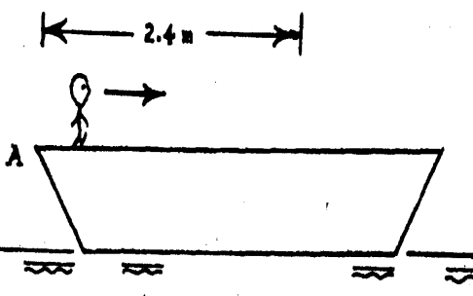

6. A boy having a mass of 60 Kg & a girl having a mass of 50 Kg stand motionless at the end of boat which has a mass of 30 Kg. If they exchange position, find the corresponding displacement of boat.
