1. Determine the coefficient of restitution e between ball A and ball B. The velocities of A and B before and after the collision are shown. Also % find loss of KE during impact.
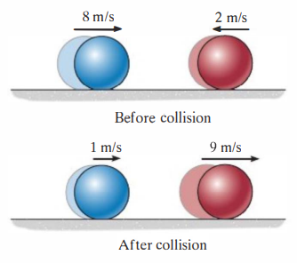

12. The 15-Mg tank car A and 25-Mg freight car B travel towards each other with the velocities shown. If the coefficient of restitution between the bumpers is e = 0.6, determine the velocity of each car just after the collision.
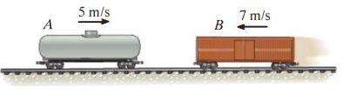

13. Two particles of masses 10 Kg & 20 Kg are moving along a straight line towards each other at velocities 4 m/s & 1 m/s respectively. If e = 0.6, find the velocities of the particles immediately after their collision and loss of K.E.
( Ans : -1.33m/s, 1.67m/s, 53.27J )

14. Two particles of masses 8 kg and 1 kg are moving towards each other at velocities of 3 m/s rightwards and 10 m/s leftwards along a straight line. If the velocity of 1 kg particle is 4 mIs rightwards after collision, determine the final velocity of 8 kg particle and coefficient of restitution.
( Ans : 1.25m/s, e = 0.211)

16. Three perfectly elastic balls A, B, C of masses 2 Kg, 4 Kg and 8Kg move along a line, with velocities 4 m/s, 1 m/s, and 0.75 m/s respectively. If the ball A strikes ball B which in turn strikes ball C, determine the velocities of the three balls after impact.
( Ans : 0, 3m/s, 2.25m/s )
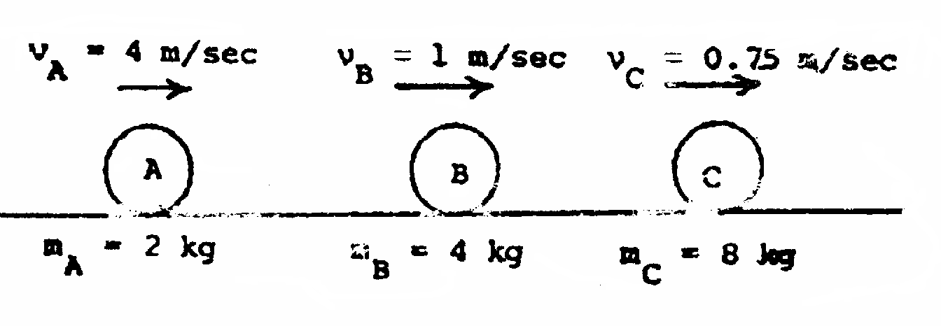

20. A billiard ball moving with a velocity of 5 m/sec strikes a smooth horizontal floor at an angle of 45° with horizontal. If the coefficient of restitution is 0.6, what is the velocity with which the ball rebounds?
( Ans : 4.13m/s, θ = 30.92° )

21. A body of mass 1000 kg moving at 30 km/hr towards North collides with another body of mass 2000 kg moving at 20 km/hr towards East. If the two bodies, on collision, coalesce, determine the final velocity of the combined body.
( Ans : 16.67 KPH, θ = 36.87° )

22. Two billiard balls of equal masses collide with velocities V₁ = 1.5 m/s and V₂ = 2 mIs. Find velocities of balls after impact and percentage loss in kinetic energy. Coefficient of restitution is 0.9.
( Ans : 0.875m/s, 2.21m/s at θ = 51.55° , 9.6%)
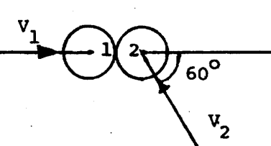

23. Two identical balls of 120 grams collide when they are moving with velocity perpendicular to each other as shown in the figure. Assuming that the line of impact is in the direction of motion of ball B determine the velocity of ball A and B completely after the impact. Take e = 0.8.
( Ans : V_{A} = 5.76m/s , V_{B} = 0.6 m/s↑ )
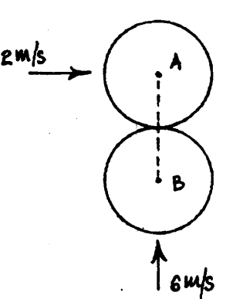

24. The magnitude and direction, of two identical smooth balls before central oblique impact are as shown in the figure. Assuming e = 0.90 determine the magnitude and direction of the velocity of each ball after impact.
( Ans : V_{A} = 6.96m/s , V_{B} = 12.58m/s )
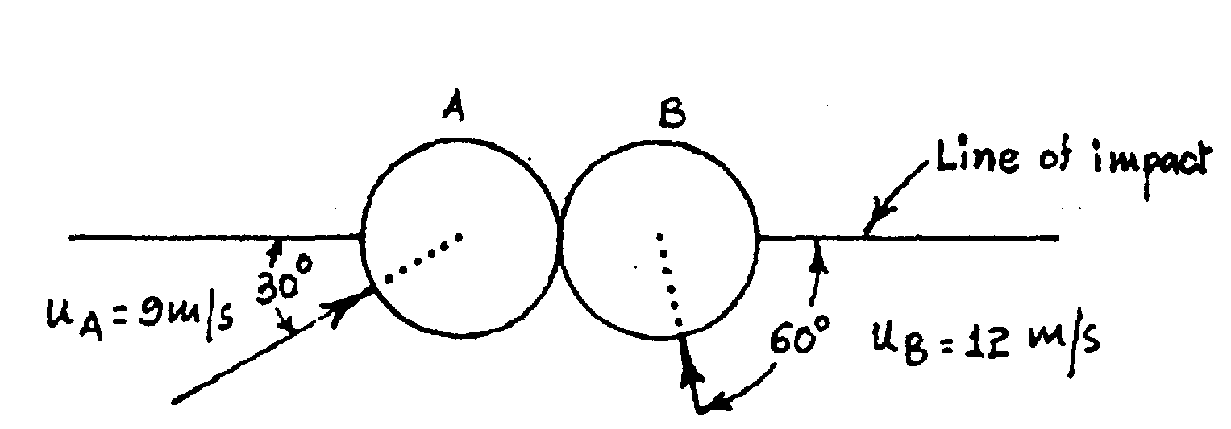

35. A 2 kg sphere A is moving to the left with a velocity of 15 m/s when it strikes the vertical face of 4 kg block B which is at rest. The block B is supported on rollers and is attached to a spring of constant k= 5000 N/m as shown in the figure. If e = coefficient of restitution for the block and sphere 0.75, determine the maximum compression - shortening of the spring due to the impact. Neglect friction.
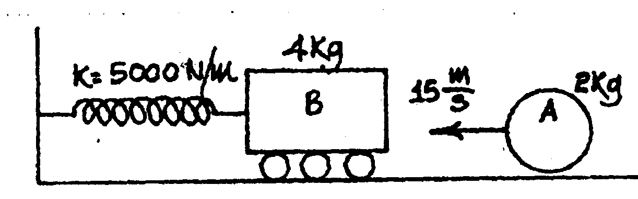
36. A 750 kg hammer of a drop hammer pile - driver falls from a height of 1.2 m on to the top of a pile of mass 2250 kg. The pile is driven 100 mm into the ground because of the impact. What is the average resistance to penetration offered by the ground after the impact? Assume perfectly plastic impact.
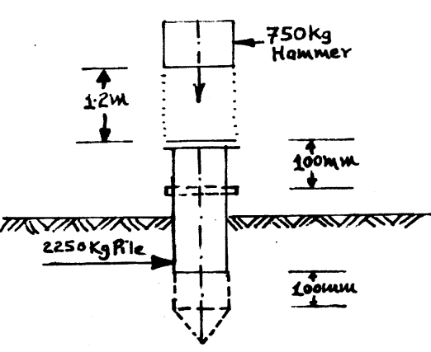
37. A pendulum, length of spring 0.9 m, having mass of the bob 1.6 kg is released from rest as shown in the Fig. It strikes a block of mass 1.8 kg at rest on a rough horizontal floor. After impact the pendulum comes to rest and the block moves through a distance of 1.3 m and ultimately comes to rest. Find (1) The coefficient of restitution, (2) The coefficient of friction.
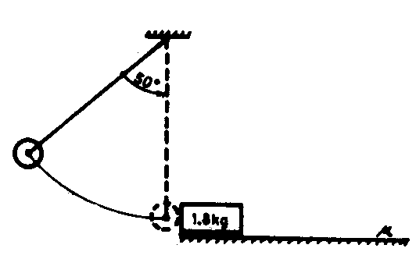
[Ans. (1) e = 0.889, (2) μ= 0.1953]
38. The pile driver weighing 2500 N drops freely through a height of 3m on the top of a pile which weigh 500 N. If the pile is driven in the ground by 75 mm, determine the average resistance of the ground to pile-driving and the amount of energy lost in impact.
( Ans : 86.2 KN )
39. A ballistic pendulum consists of a sand box weighing 25 kg which is suspended from a cord 3 m long. A shell weighing 500 gm is fired horizontally into the box and remains embedded in it. Because of impact, the sand box swings through an angle of 30°. Find the velocity with which the shell strikes the box and the loss in energy of the system.
( Ans : 144.61 m/s, 5125.18 J )
40. A bullet of mass 10 gm is moving with a velocity of 100 m/s arid hits a 2 kg bob of a simple pendulum, horizontally, as shown in the fig. Determine the maximum angle through which the pendulum string 0.5 in long may swing, if
i) the bullet gets embedded in the bob. ii) the bullet escapes from the other end of the bob with a velocity 10 m/s.
( Ans : (i) 12.94° (ii) 11.65° )

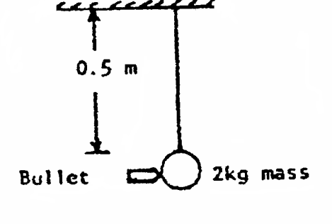
41. A 2 kg sphere A is released from rest when θ_{A}= 60º as shown in the sketch, and strikes a sphere B of mass 4 kg which is at rest. If the impact is assumed to be perfectly elastic, determine the value of θ_{B} corresponding to the highest position to which the sphere B will rise.
( Ans : 38.94° )
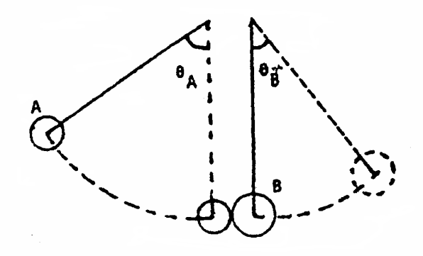
42. Block A is released from rest in position land slides without friction until it strikes the ball B of a simple pendulum. Knowing that coefficient of restitution between A and B as 0.90, determine (I) the velocity of B immediately after impact; (ii) the maximum angular displacement of the pendulum.
( Ans : (i) 2.53m/s (ii) 49.875° )
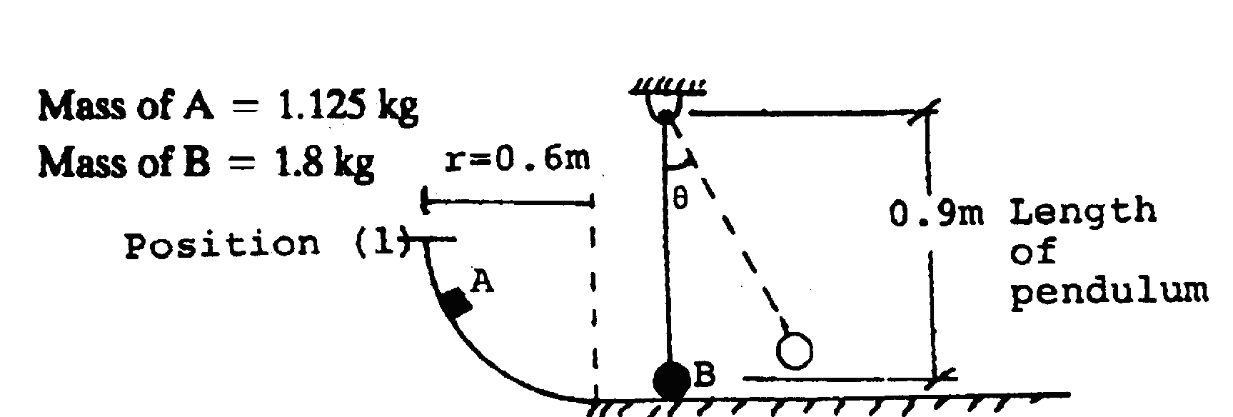
43. A gun of a shore battery is nested by three springs each of stiffness = 250 KNIcm as shown in the figure. The gun fires a 500 kg shell with a muzzle velocity of 1000 m/s. Calculate the total recoil and the maximum force developed in each spring if the gun has a mass of 80,000 kg.
( Ans : V_{Gun} = 6.25m/s , 0.204m, 5100 KN )
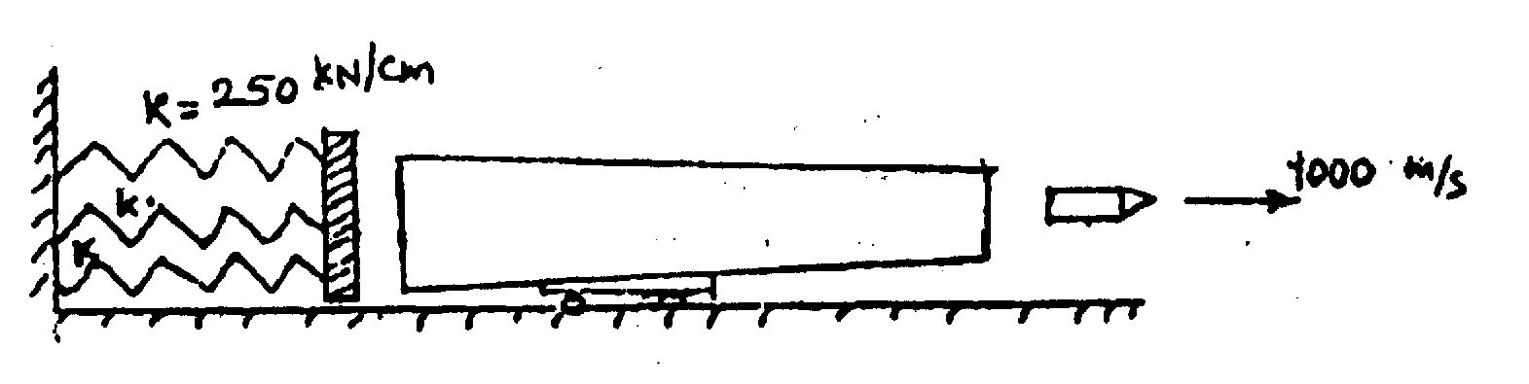
44. At t = 0, both blocks are released from the position shown. Find (I) the time at which impact occurs (ii) if e = 0.8, what are the velocities of blocks immediately after impact. Take static friction between block A and surface in incline a 0.1 and surface of incline as 0.3.
( Ans : t = 0.868 sec, V_{A} = 0.137m/s, V_{B} = 1.243 m/s )
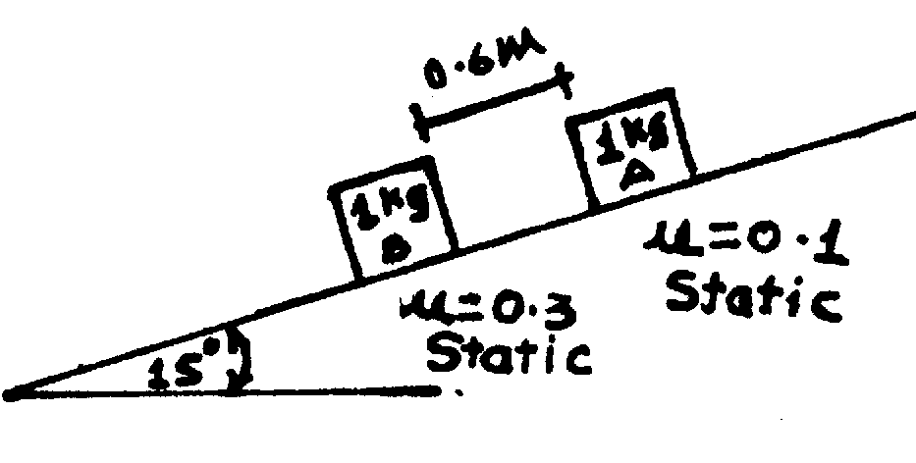
45. A 40 N ball traverse a frictionless tube as shown in figure, and falls through a height of 4 m. It then strikes a 20 N ball hung from a rope, 1.5 m long. Determine the height to which the hanging ball will rise (i) If the collision is perfectly elastic and (ii) If the co-efficient of restitution is e = 0.7.
( Ans :

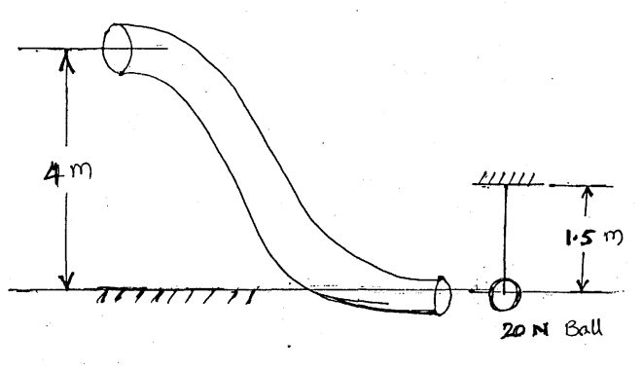

46. A bullet, weighing 0.25 N, strikes and enters a wooden block, of weight 50 N, with a horizontal velocity of 600 mIs. Wooden block is displaced through a distance of 90 cm, due to this impact, on the horizontal rough floor. Find the coefficient of friction between the block and the rough floor.
[Ans μ = 0.5]

