3. The two blocks shown are originally at rest. Neglecting the masses of the pulleys and the effect of friction in the pulleys and between block A and the incline, determine (a) the acceleration of each block, (b) the tension in the cable.
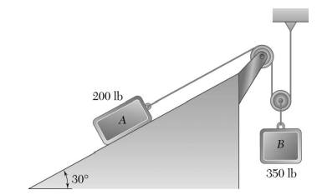

4. The coefficients of friction between blocks A and C and the horizontal surfaces are μ_{k} = 0.2.Knowing that m_{A} = 10 kg, m_{B} = 10 kg and m_{C} =5kg determine (a) the tension in the cord, (b) the acceleration of each block.
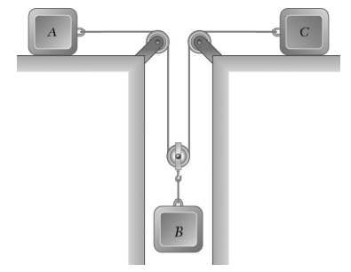

5. The blocks A and B are connected by a cable that runs around two pulleys of negligible weight. Determine the time required for A to reach a speed of 2 m/s after the system has been released from rest. Neglect friction.
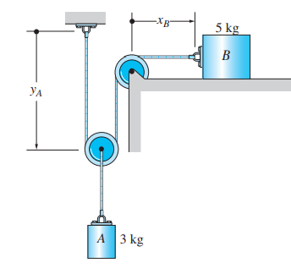

6. The 100-kg block A shown in Fig. is released from rest. If the masses of the pulleys and the cord are neglected, determine the speed of the 20-kg block B in 2 s.
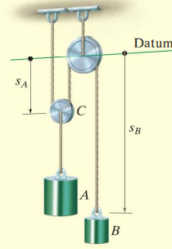

A block of weight 4 KN is being pulled up the inclined plane by using another block B of weight 8 KN as shown in the figure. Determine (i) acceleration of block A, (ii) Acceleration of block B, (iii) Tension T₁ in cord attached to block A. (iv) Tension T₂ in cord attached to Block B. Take coefficient of friction between block A and inclined plane as 0.25. Assume cords as inextensible and pulleys at C and 0 are small, frictionless and negligible mass.
( Ans : a_{A} = 2.137 m/s² , T = 3564.273 N )
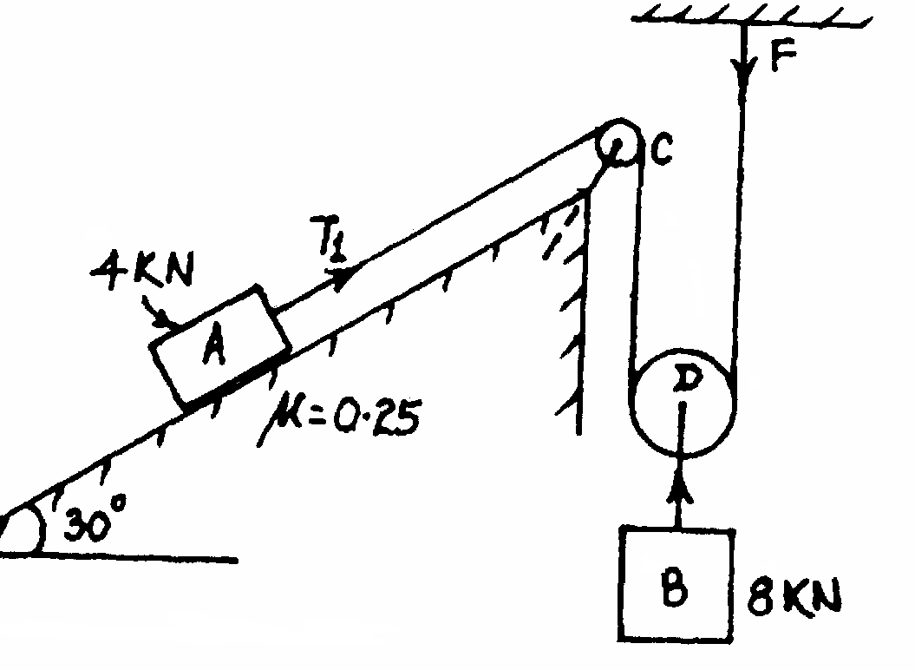

The 100 kg crate is hoisted up by the incline using the cable and motor M. For a short time, the force in the cable is F= 800t² N where t is in seconds. If the crate has an initial velocity V₁= 2 m/s when t = 0 seconds determine the velocity when t =2 seconds. The coefficient of kinetic friction between the crate and incline is μ_{k} = 0.3.
( Ans : 8.91 m/s )
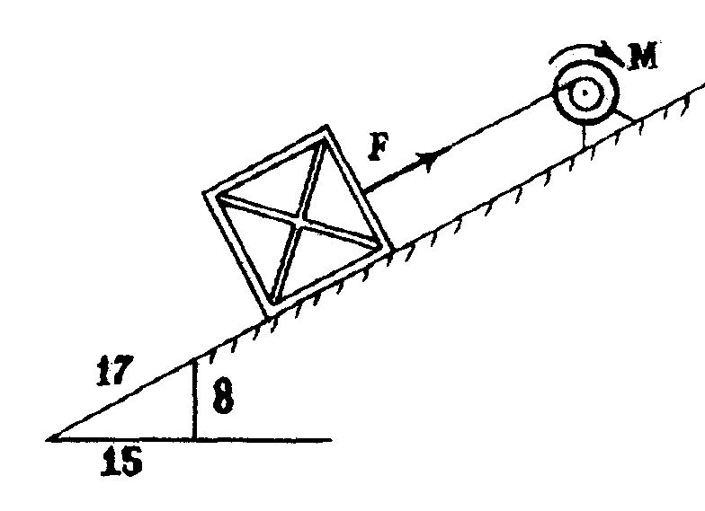

An air plane has a mass of 25000 kg and its engines develop a total thrust of 40 KN along the runway. The force of air resistance to motion of air plane is given by D = 2.25 V², where V is in m/s and D is in Newtons. Determine the length of runway required if the plane takes off and becomes airborne at a speed of 240 KPH.
( Ans : 1.598 KM )

