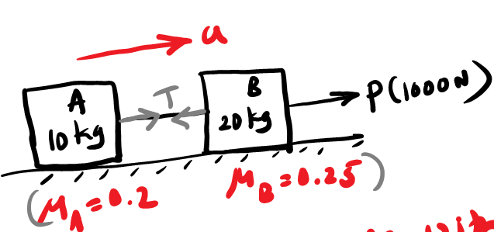

The 50-kg crate shown in Fig. rests on a horizontal surface for which the coefficient of kinetic friction is µ_{k} = 0.3. If the crate is subjected to a 400-N towing force as shown, determine the velocity of the crate in 3 s starting from rest.
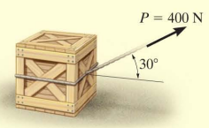

If blocks A and B of mass 10 kg and 6 kg, respectively, are placed on the inclined plane and released, determine the force developed in the link. The coefficients of kinetic friction between the blocks and the inclined plane are µ_{A} = 0.1 and µ_{B} = 0.3. Neglect the mass of the link.
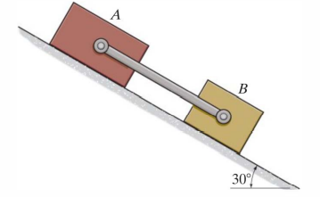

Refer fig Masses A and B are 7.5 kg and 27.5 kg respectively. Assume the coefficient of friction between A and the plane is 0.25 and between B and the plane is 0.1. What is the force between the two as they slide down the incline?
(Ans : a = 5.31 m/s² , T = 6.62 N )
