The figure shows a 1-kg collar that slides along the frictionless vertical rod under the actions of gravity and an ideal spring. The spring has a stiffness of 160 N/m, and its free length is 0.9 m. The collar is released from rest in position 2.
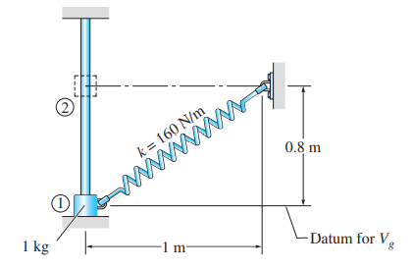

The system shown is at rest when a constant 250-N force is applied to block A. Neglecting the masses of the pulleys and the effect of friction in the pulleys and between block A and the horizontal surface, determine (a) the velocity of block B after block A has moved 2 m, (b) the tension in the cable.
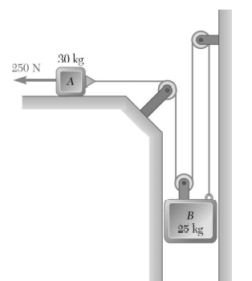

A 2-kg collar is attached to a spring and slides without friction in a vertical plane along the curved rod ABC. The spring is undeformed when the collar is at C and its constant is 600 N/m. If the collar is released at A with no initial velocity, determine its velocity (a) as it passes through B, (b) as it reaches C.
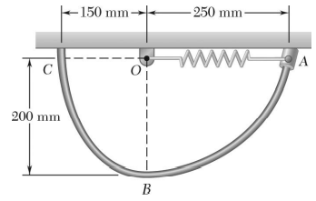

A spring is used to stop a 50-kg package which is moving down a 20º incline. The spring has a constant k = 30 kN/m and is held by cables so that it is initially compressed 50 mm. Knowing that the velocity of the package is 2 m/s when it is 8 m from the spring and neglecting friction, determine the maximum additional deformation of the spring in bringing the package to rest.
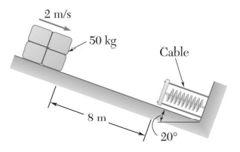

A 10 kg collar slides without friction along a vertical rod. The spring has a constant K = 500 N/M & has a free length of 100 mm. If the collar is released from rest in position 1, find its velocity after it has moved 150 mm to position 2.
( Ans : 4.06 m/s )
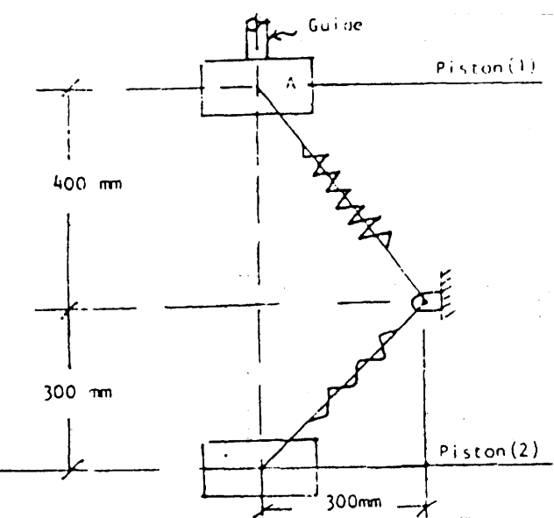

The cylinder has a mass of 20 Kg and is released from rest when h = 0. Determine its speed when h = 3m. The springs each have an unstretched length of 2m.
( Ans : 6.964 m/s )
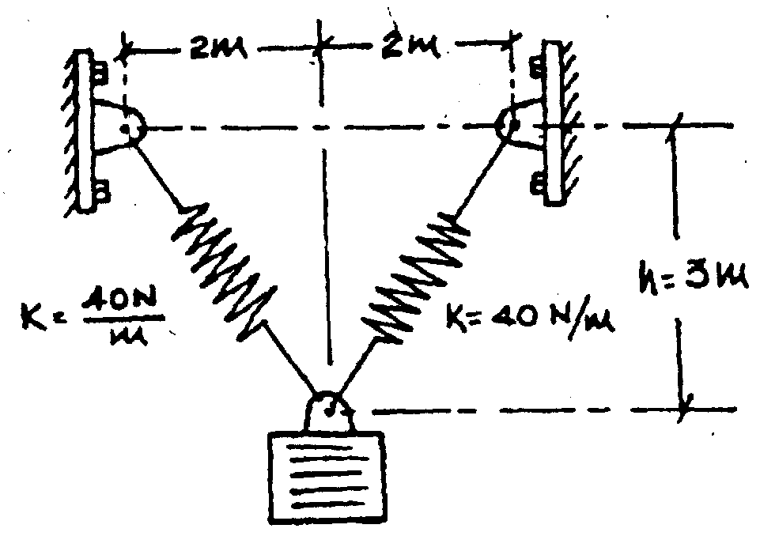

Figure shows a collar of mass 20kg which is supported on the smooth rod. The attached springs are undeformed when d = 0.5 m. Determine the speed of the collar after the applied force of F = 1000 N causes it to displace so that d = 0.3 m. The collar is at rest when d = 0.5 m.
( Ans : 4.6 m/s )
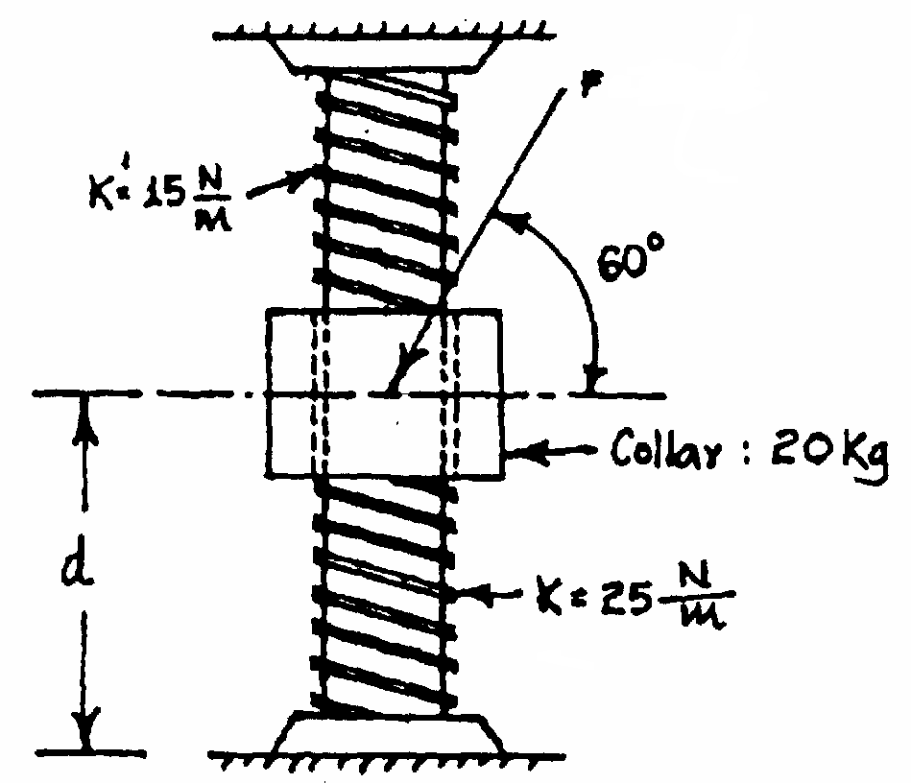

A toy spring gun is used to shoot 30-g bullets vertically upward. The undeformed length of the spring is 150 mm; it is compressed to a length 25 mm when the gun is ready to be shot and expands to a length of 75 mm as the bullet leaves the gun. A force of 50 N is required to maintain the spring in firing position when the length of the spring is 25 mm. Determine (a) the velocity of the bullet as it leaves the gun, (b) the maximum height reached by the bullet.
( Ans : 11.51 m/s, 10.57 m )
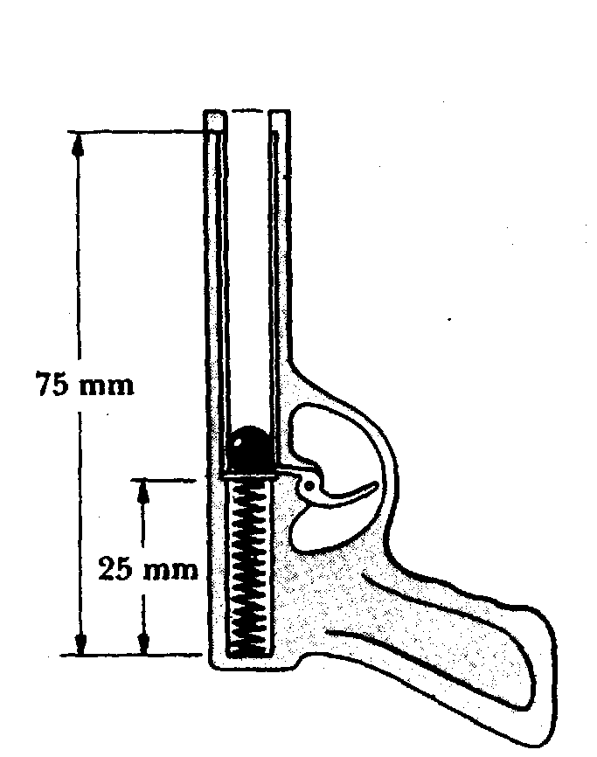

A 4 Kg collar is attached to a spring, slides on a smooth bent rod ACD. The spring has constant k = 500 N/m and is undeformed when the collar is at ‘C’. If the collar is released from rest at ‘A’ determine the velocity of collar, when it passes through ‘B’ and ‘C’. Also find the distance moved by collar beyond ‘C’ before to rest again.
( Ans : V_{B} = 6 m/s, V_{C} = 6.43 m/s, 0.952 m )
