Practice Assignment – 3 (Experiment 12)
Object Oriented Programming using Java

Instructions
- This assignment covers concepts from Experiment 10 to Experiment 11.
- Students must solve 3 questions based on their roll number.
- Use proper indentation, comments, and meaningful variable names.
- Use meaningful class and method names.

Question Allocation Based on Roll Number

Last Digit of Roll No | Questions to Solve
1 | 1, 11, 21
2 | 2, 12, 22
3 | 3, 13, 23
4 | 4, 14, 24
5 | 5, 15, 25
6 | 6, 16, 26
7 | 7, 17, 27
8 | 8, 18, 28
9 | 9, 19, 29
0 | 10, 20, 30
Section A: Packages (10 Questions)
- Develop a user-defined package called datetime with a class DateUtils. The DateUtils class should contain methods for working with date and time, such as calculating the difference between two dates, and formatting date/time in a spe- cific format. Create a Java program that uses the datetime package to perform date and time operations.

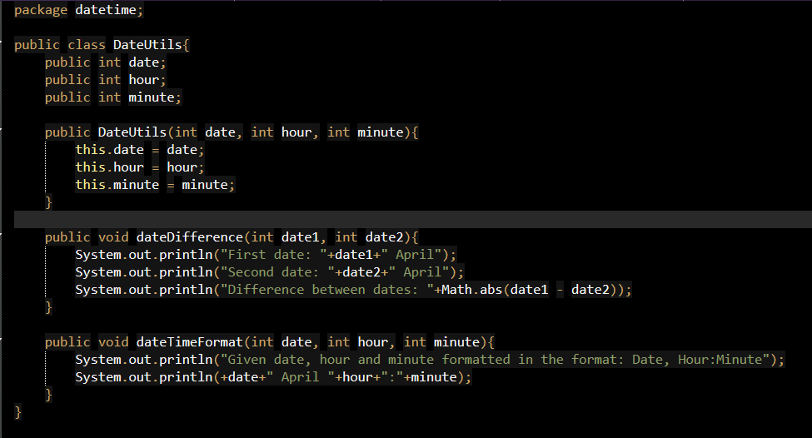

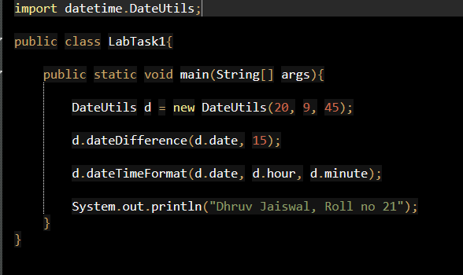
- Create a package geometry containing classes Circle and Rectangle. Each class should have methods to compute area and perimeter. Write a program to use both classes.
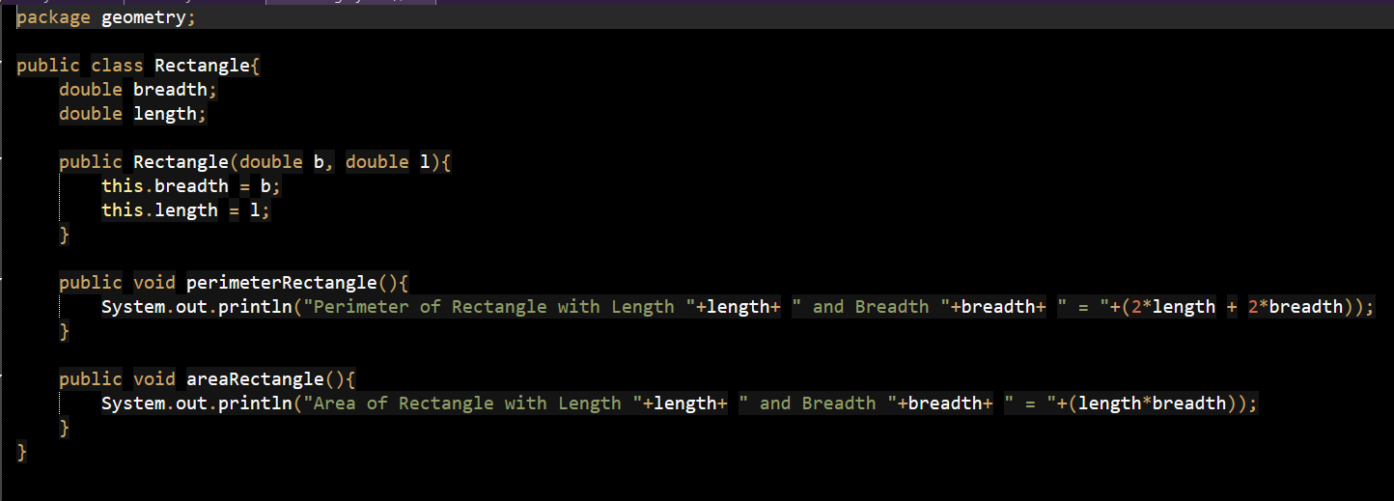
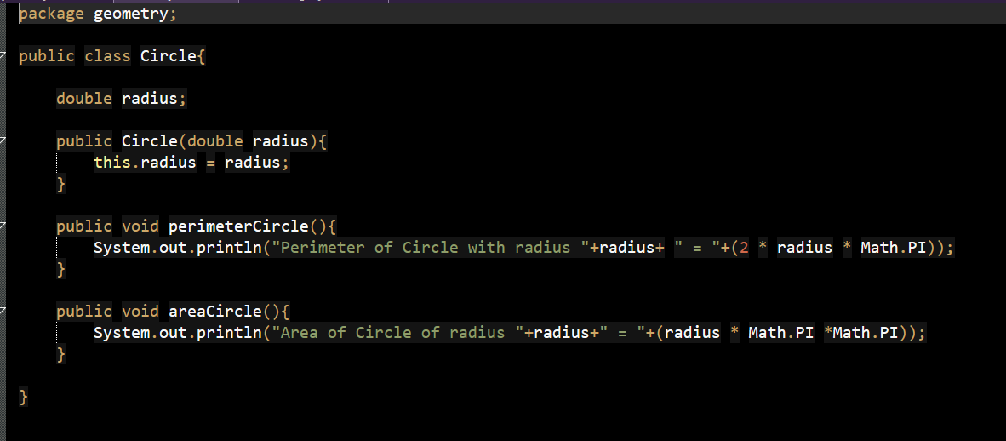
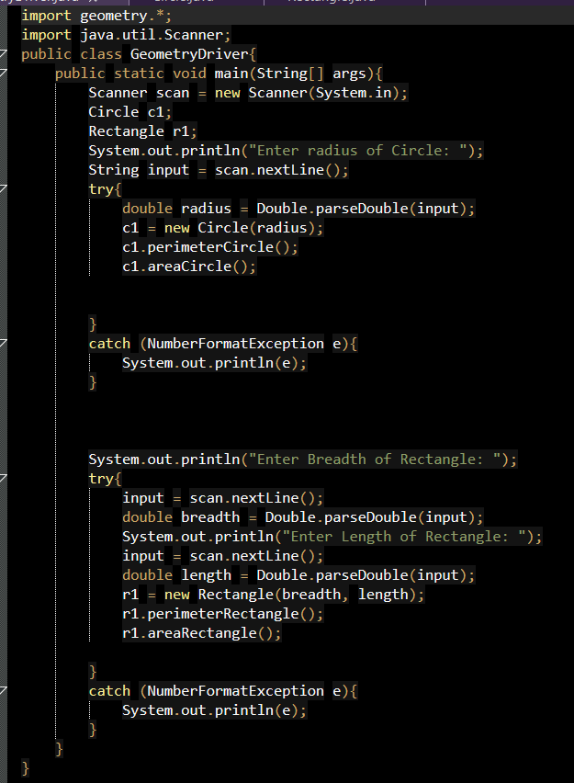

- Create two packages studentinfo and result. studentinfo contains student de- tails and result calculates total and percentage. Demonstrate interaction between packages.
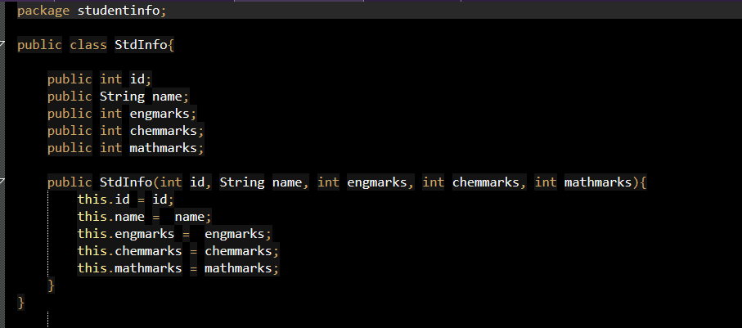
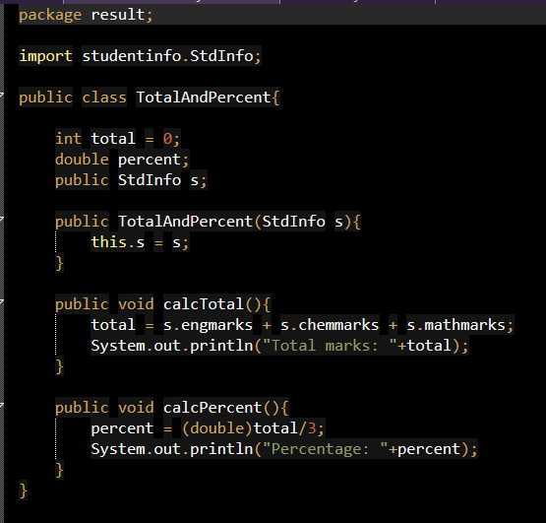
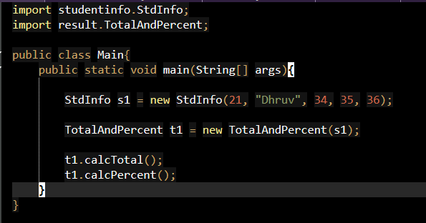

- Design a package bank with class Account. Implement deposit and withdrawal methods. Use this package in another class to simulate banking operations.

- Create a package stringutility with methods to count vowels, reverse a string, and check palindrome. Use the package in a separate program.
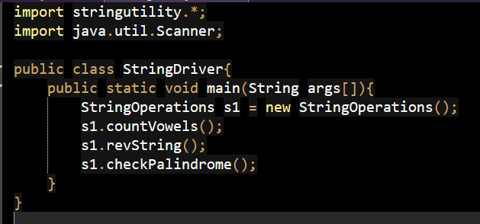
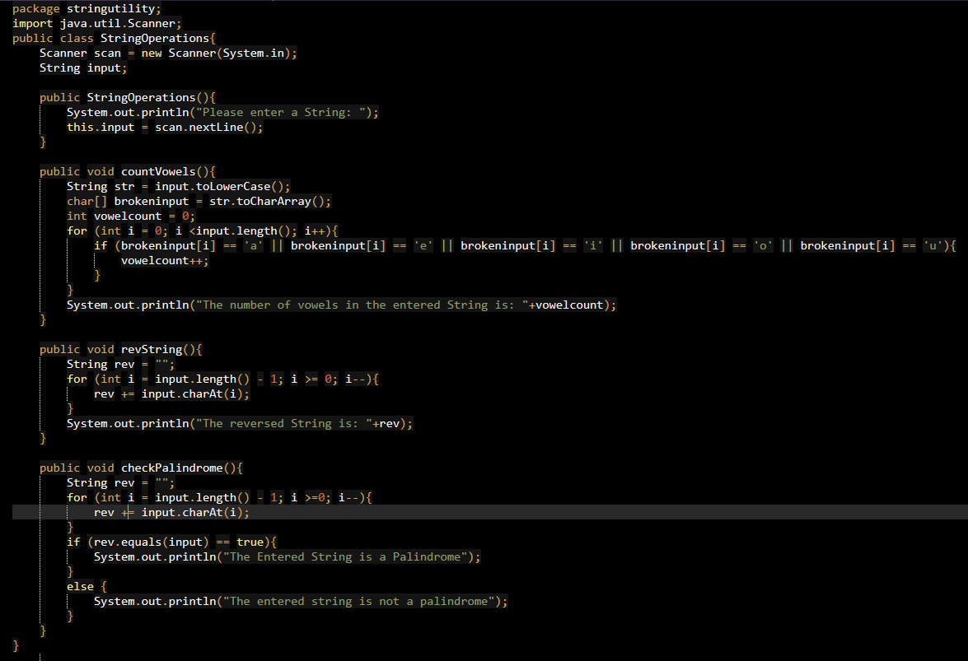
- Create a package arrayops with methods to find maximum, minimum and average of an array. Import and use in another class.
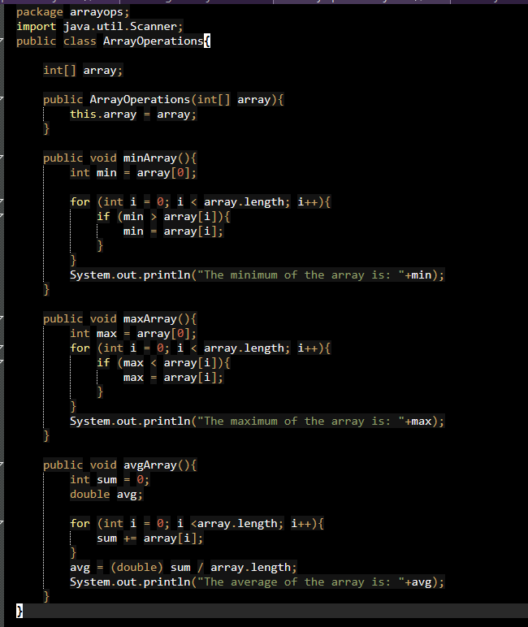
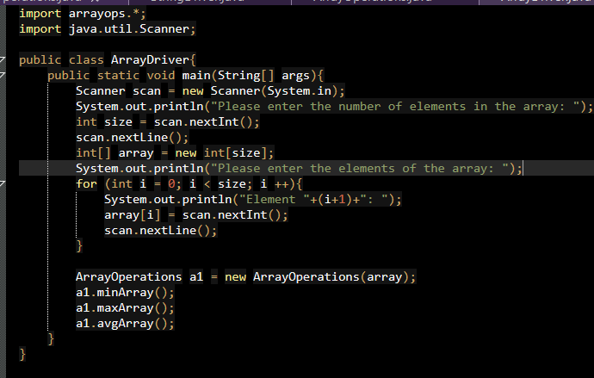
- Design a package employee with class Employee. Implement methods to calculate salary and bonus. Use it in a main program.
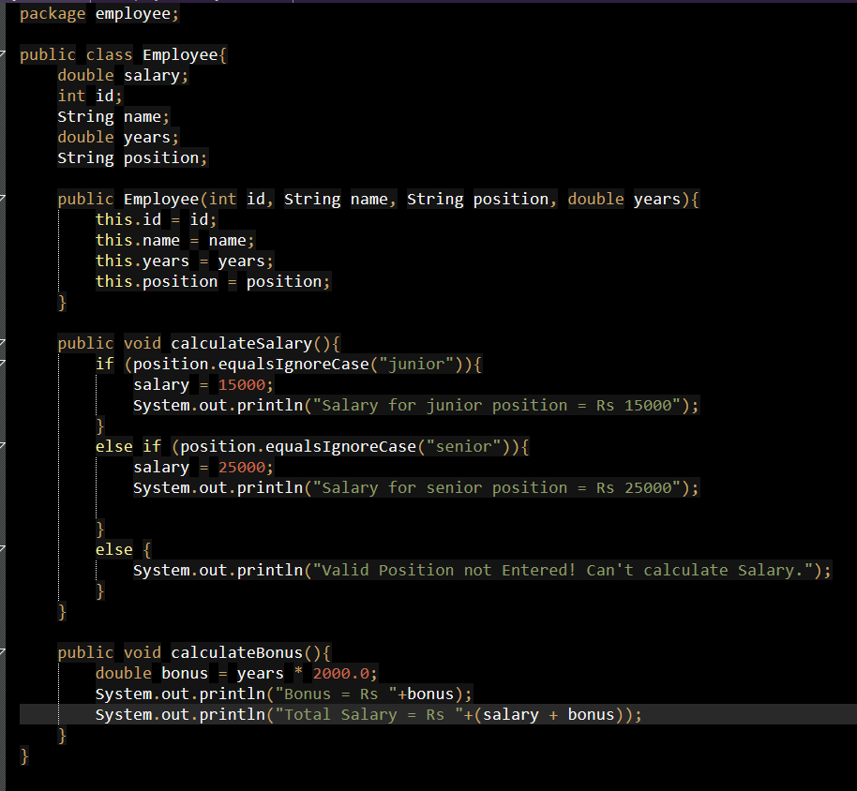
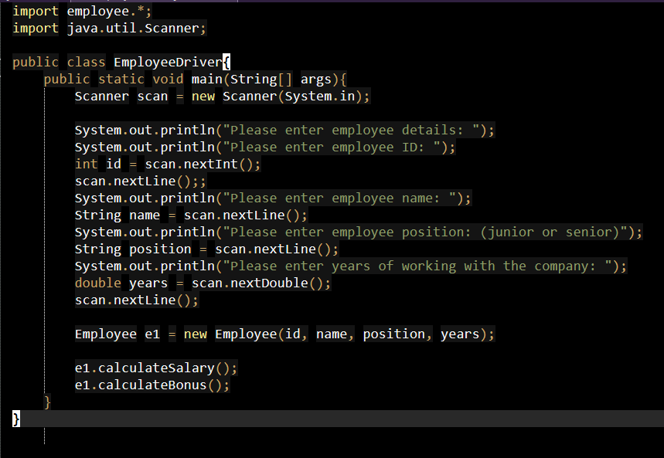
- Design a user-defined package utility containing the following classes:

  - Class MathOperations with methods:
    - int factorial(int n) – returns factorial of a number
    - int power(int base, int exp) – returns base raised to exponent
  - Class StringOperations with methods:
    - String reverse(String str) – returns reversed string
    - boolean isPalindrome(String str) – checks whether string is palin- drome
Import and use it in another program.
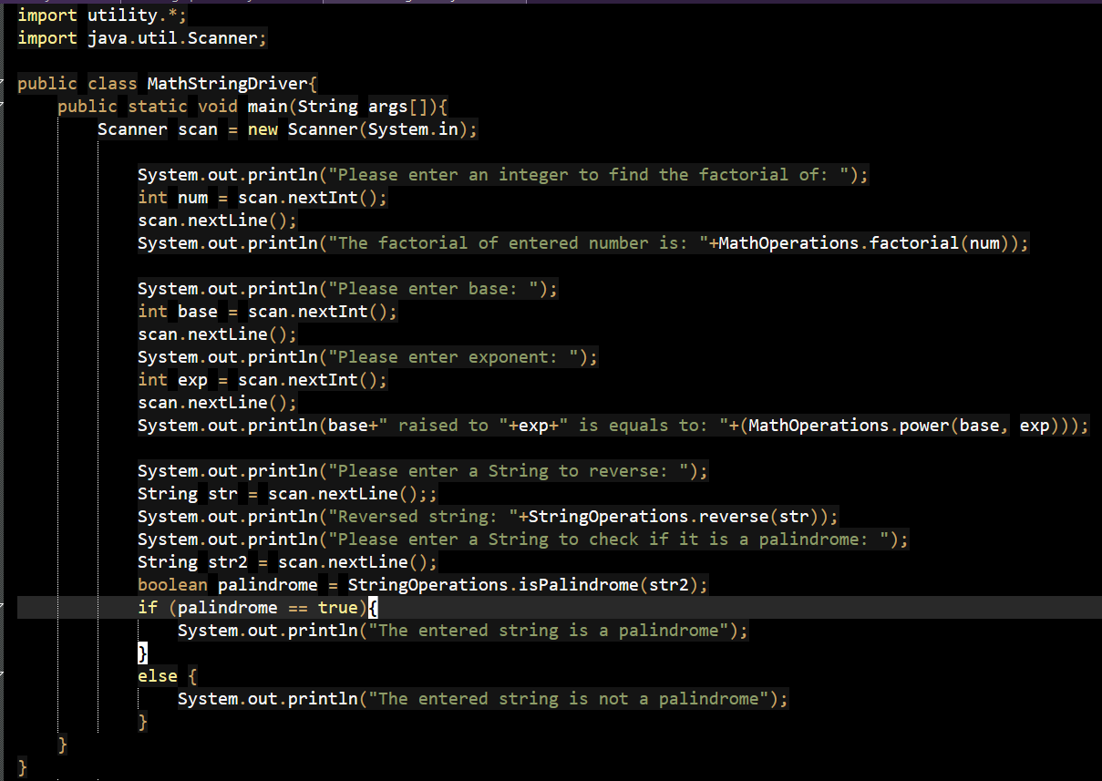
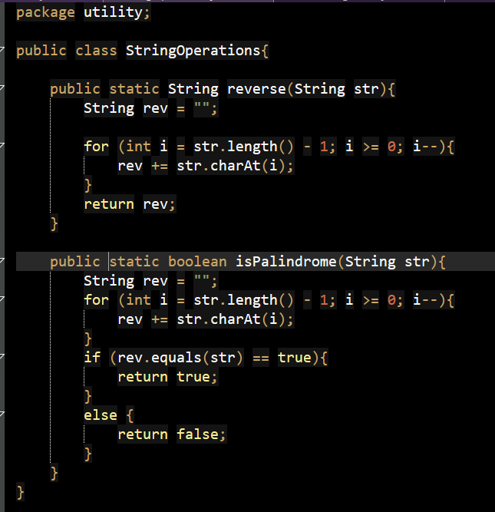
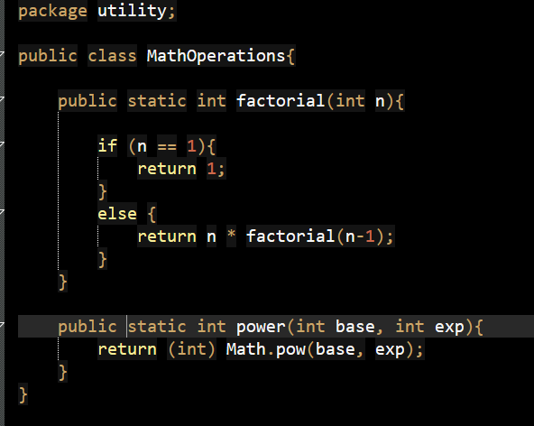
- Create a package conversion that converts: binary to decimal and decimal to hexadecimal. Use it in another class.

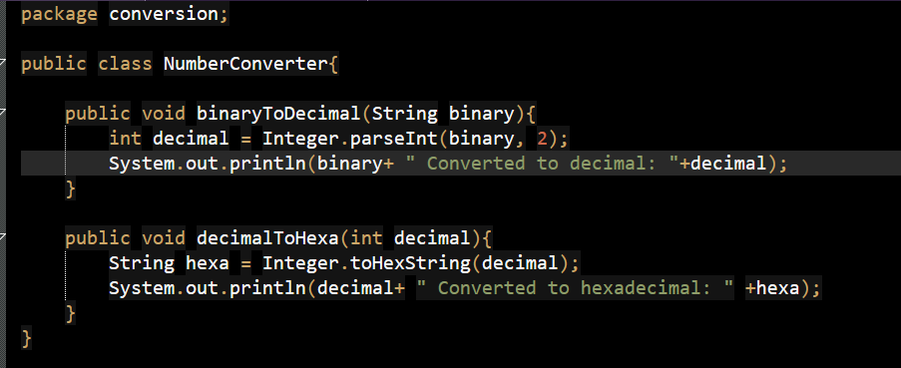
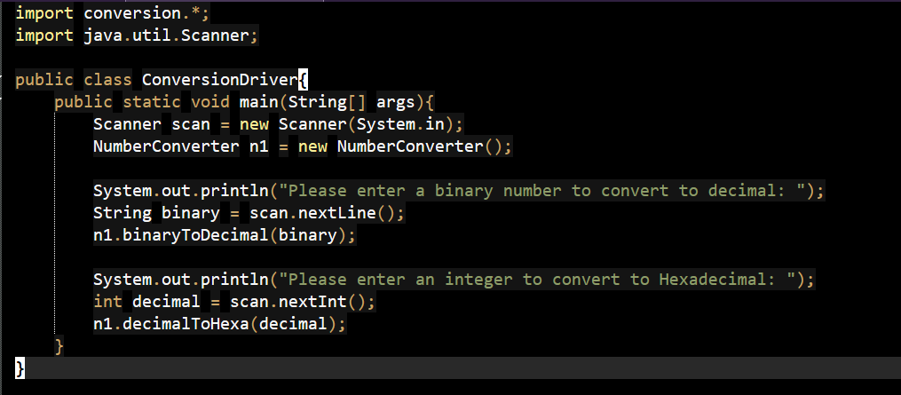

- Design two user-defined packages to demonstrate inheritance across packages.

  - Create a package employee containing class Employee:
    - data members:
∗ protected int empId
∗ protected String name
∗ protected double basicSalary
    - method:
∗ void displayEmployee() – displays employee details
  - Create another package payroll containing class Manager that extends Employee:
    - additional data member:
∗ double bonus
    - methods:
∗ double calculateSalary() – returns total salary as:

total = basicSalary + bonus

∗ void displayManager() – displays all details including total salary
  - In a main class TestInheritance:
    - import the Manager class
    - create an object and initialize values
    - call methods to display employee and salary details

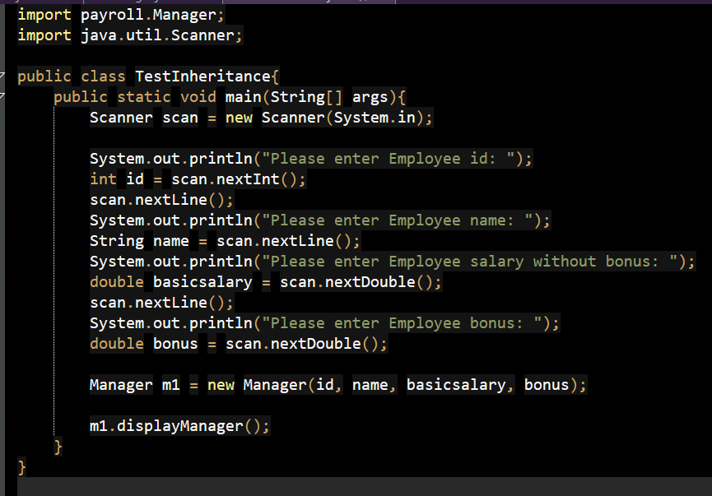
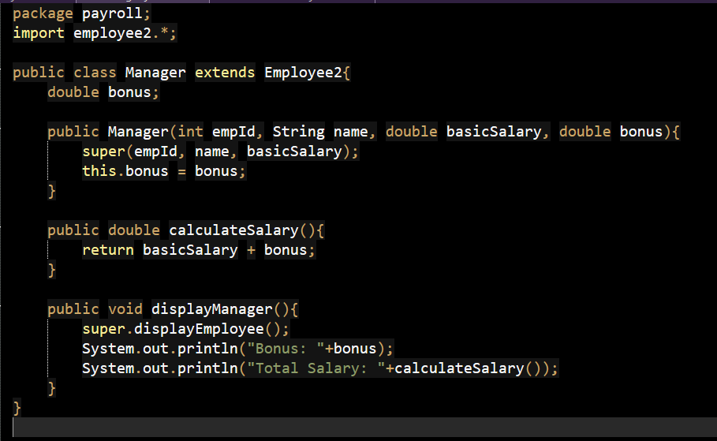
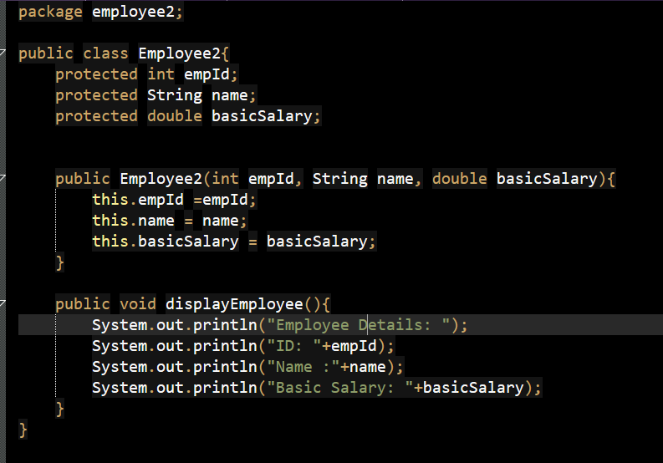

Section B: Exception Handling (10 Questions)
- Design a program to convert a string to integer and handle NumberFormatException.
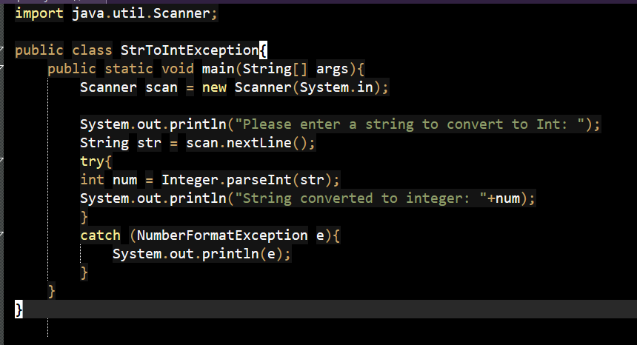

- Design a program to evaluate marks of a student in an online examination system.

  - Accept marks of N subjects (where N ≥ 3) using an array.
  - Perform the following validations:
    - If any mark is less than 0 or greater than 100, explicitly throw an exception using throw.
    - If total marks is zero, throw an exception indicating invalid result.
  - If all inputs are valid:
    - Calculate total marks and percentage
    - Assign grade based on percentage:
∗ ≥ 75 : Distinction
∗ 60–74 : First Class
∗ 50–59 : Second Class
∗ < 50 : Fail
  - Use a finally block to display: “Result processing completed”.

Constraint: Use only built-in exceptions

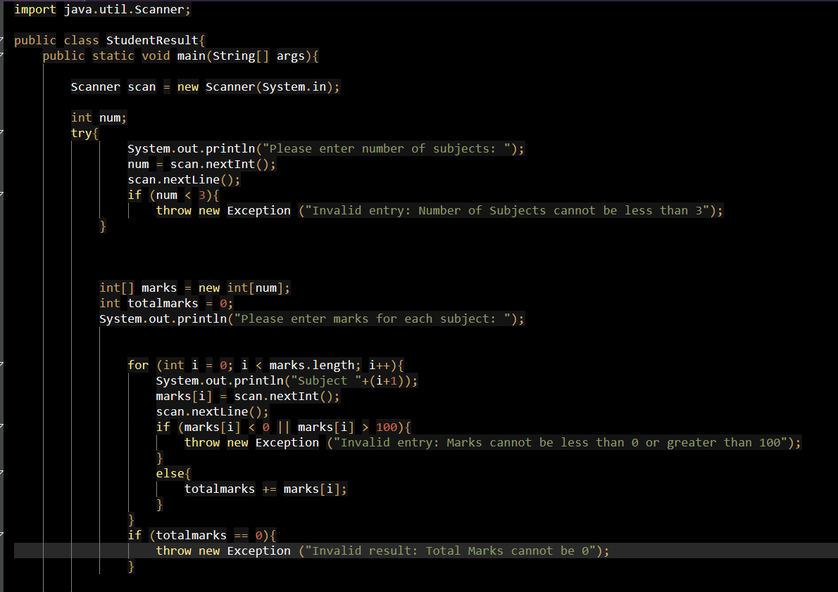
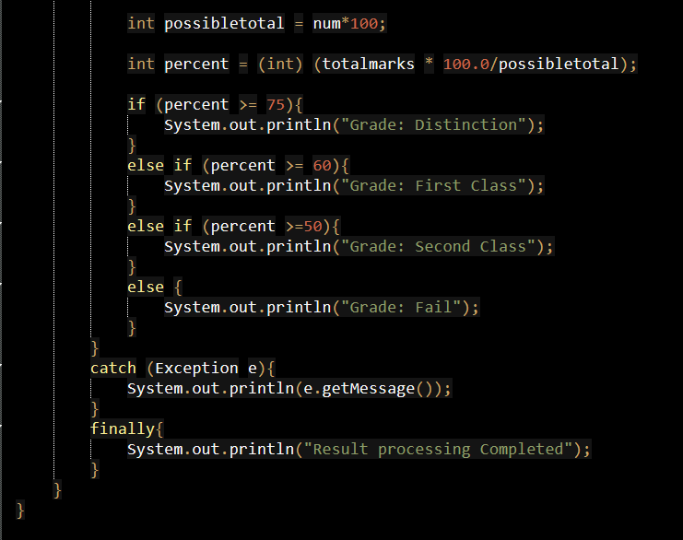
- Design a program to perform element-wise division of two integer arrays.

  - Accept size n and two arrays of size n.
  - Divide corresponding elements of the arrays and store results.
  - Use a single try–catch block to handle:
    - division by zero
  - Use a finally block to display a message: “Operation Completed”.

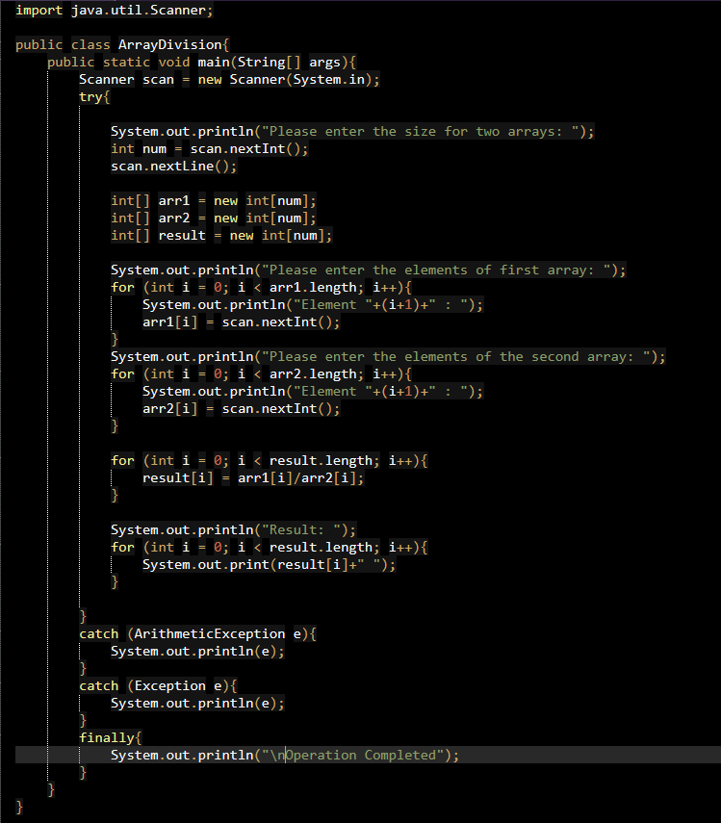

- Design a program to calculate average marks of students.

  - Accept number of subjects and marks using command line arguments.
  - Store marks in an array and compute average.
  - Handle exceptions using multiple catch blocks:
    - NumberFormatException for invalid input
    - ArrayIndexOutOfBoundsException for insufficient inputs

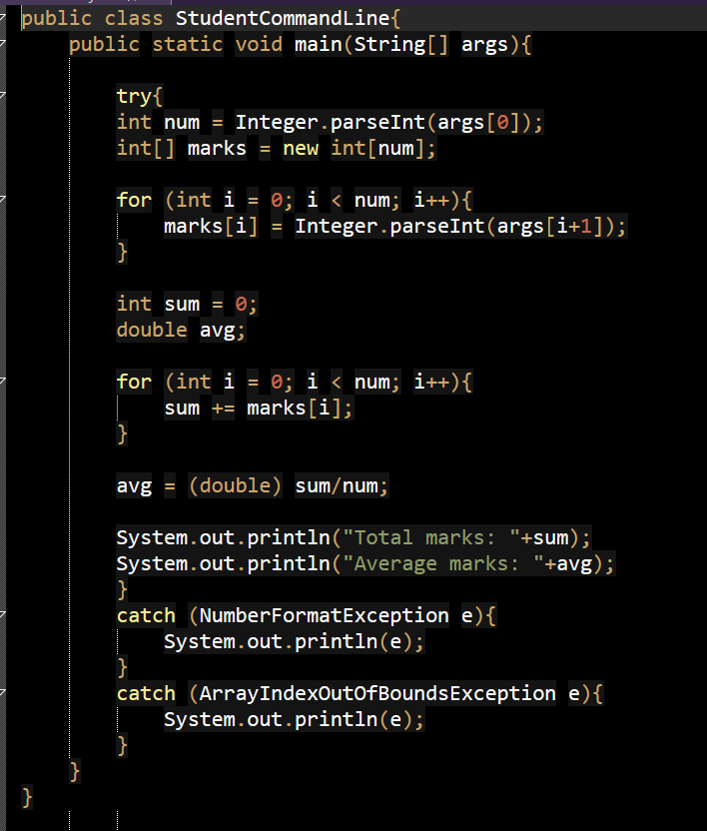

- Design a program to convert string inputs into integers and perform addition.

  - Accept two numbers as strings.
  - Convert them into integers and compute sum.
  - Use a single catch block to handle:
    - NumberFormatException
    - NullPointerException
  - Display appropriate error message.

Objective: Handle multiple exceptions using a single catch block.

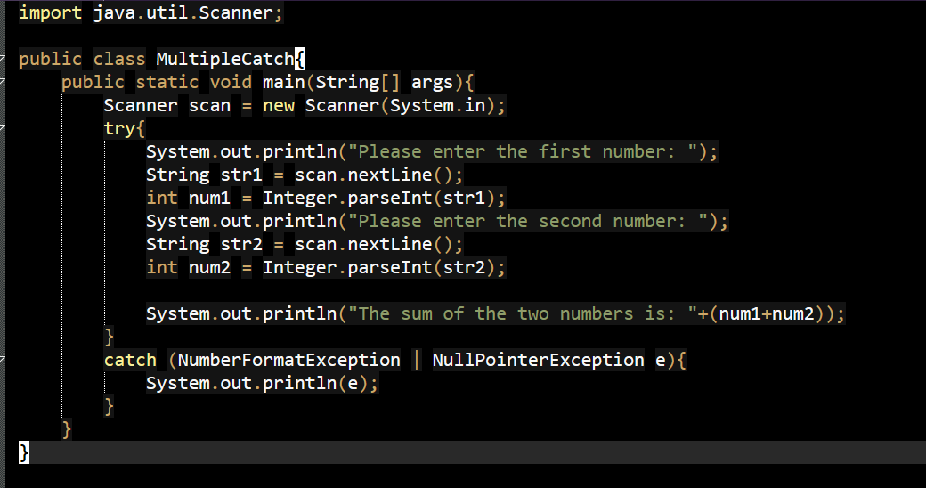
- Design a program to validate access to a file.

  - Create a method openFile(String filename) that:
    - attempts to open a file
    - declares exception using throws
  - In main(), call the method inside try–catch.
  - Handle FileNotFoundException.
  - Use a finally block to display: “File handling attempted”.

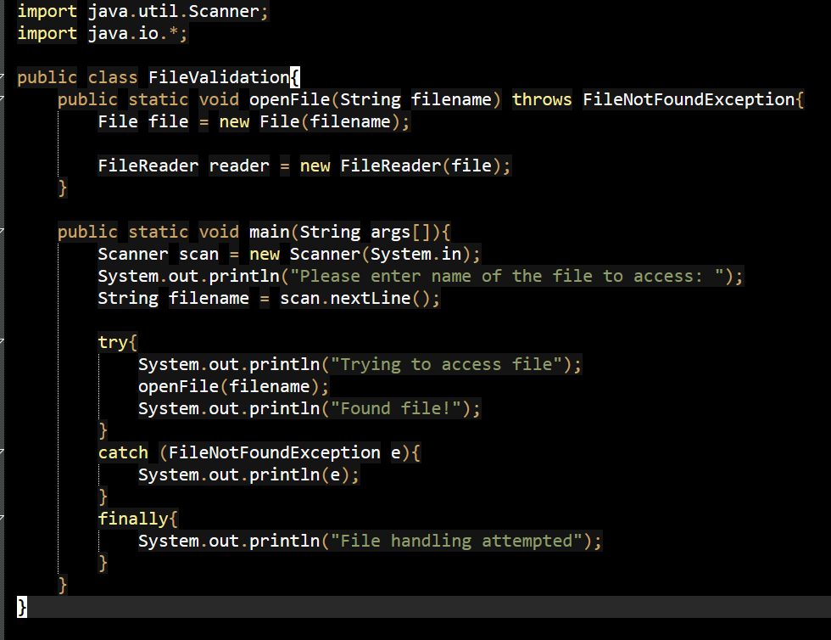

- Design a program to compute employee salary.

  - Accept employee ID and salary inputs.
  - Calculate net salary after deductions.

  - Handle exceptions using multiple catch blocks:
    - NumberFormatException
    - ArithmeticException
  - Use a finally block to display: “Salary processing completed”.

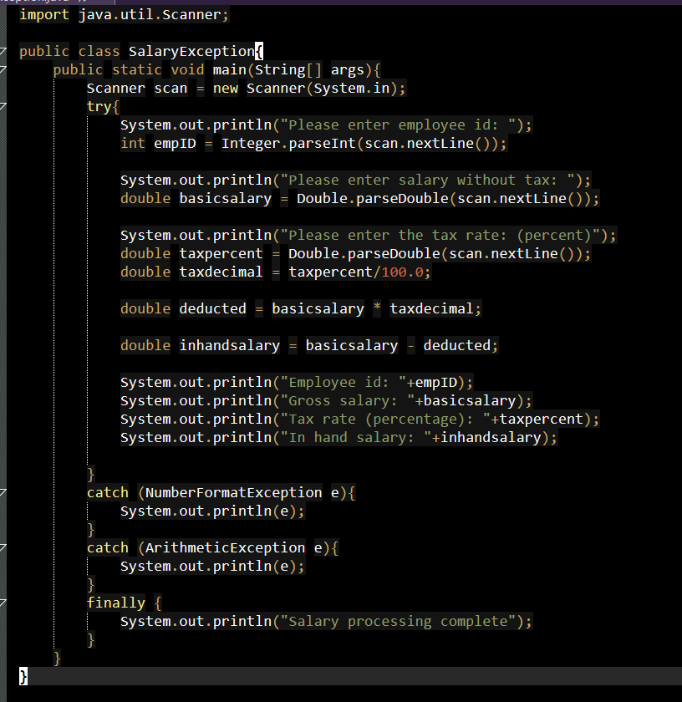

- Write a Java program that reads a list of integers from the user and throws an exception if any numbers are duplicates.
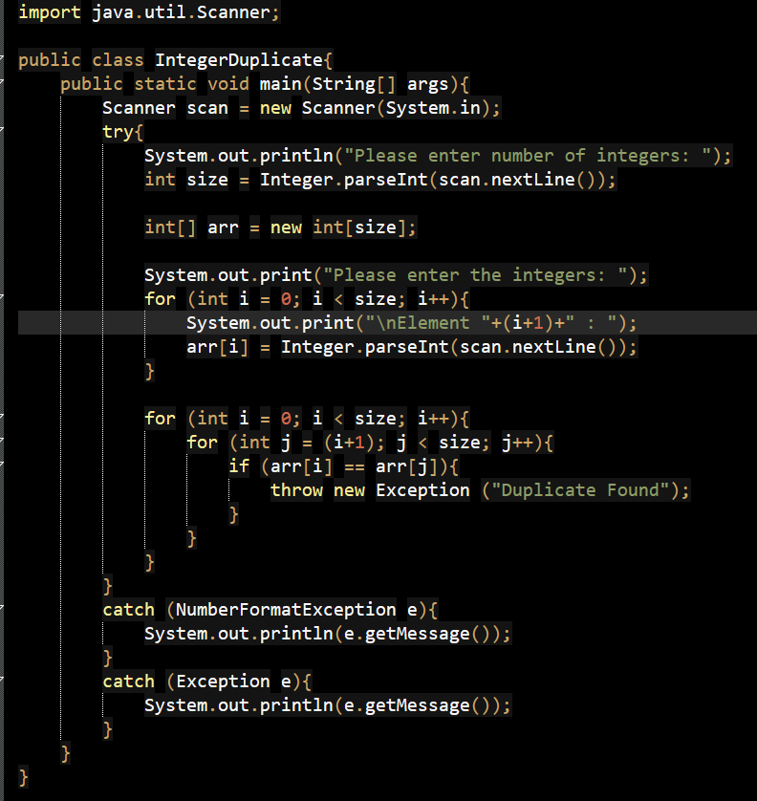
- Write a Java program to create a method that takes a string as input and throws an exception if the string does not contain vowels.
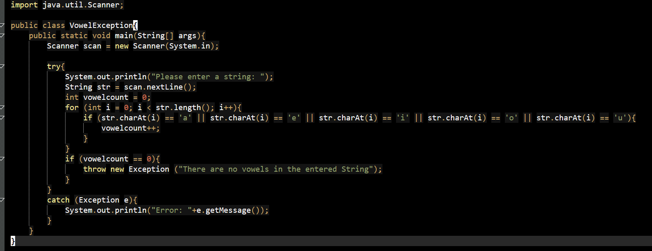
- Design a banking system where withdrawal amount exceeding balance is handled using throw keyword (use built-in exception only).
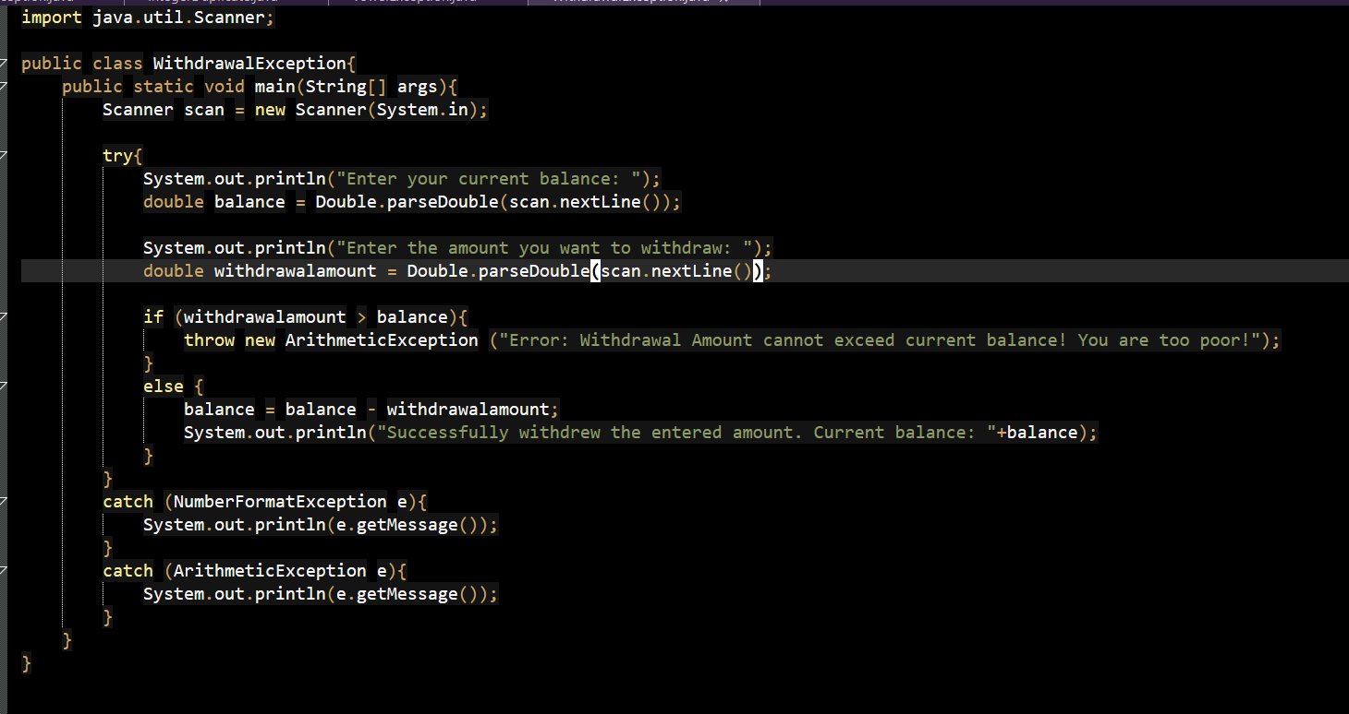

Section C: Multithreading (10 Questions)
- Create two threads using the Thread class:
  - Thread 1 calculates sum of odd numbers from 1 to N
  - Thread 2 calculates sum of even numbers from 1 to N Display both results after execution.
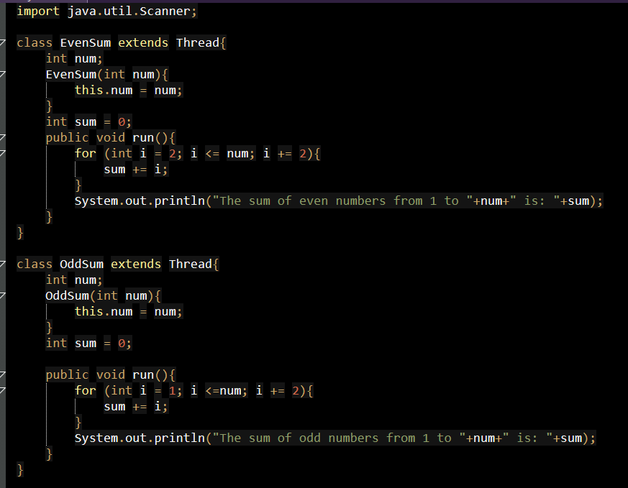
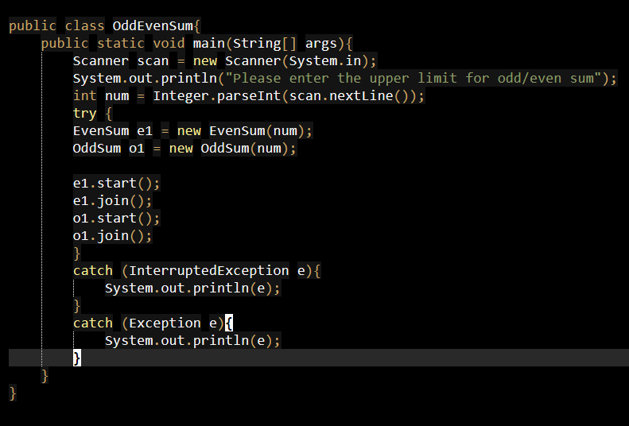
- Create a class implementing Runnable that:
  - Generates 10 random numbers between 1 and 20
  - Uses Thread.sleep(500) between each generation
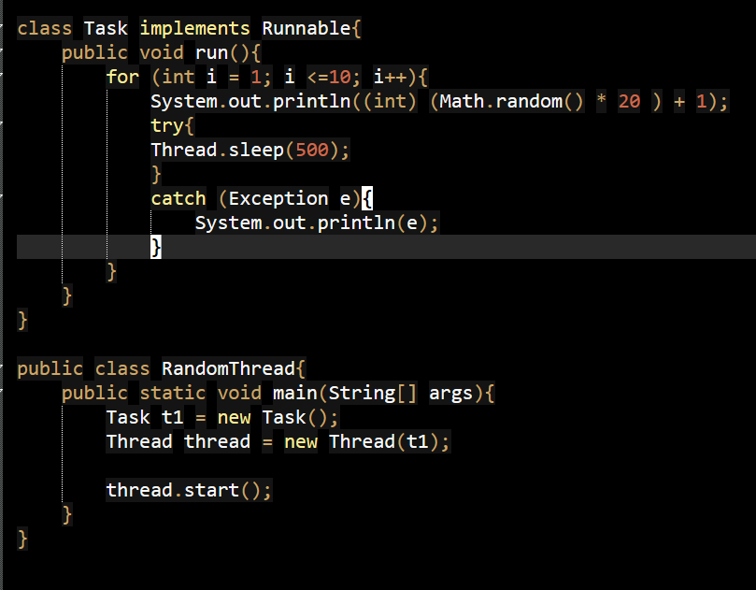
- Design a bank account system:
  - Multiple threads perform deposit and withdrawal
  - Use synchronized method to update balance safely
  - Display final balance
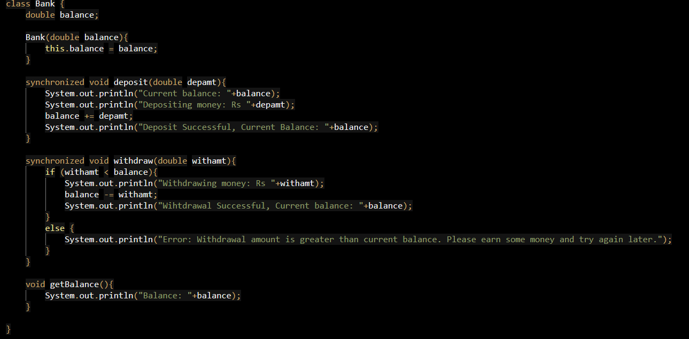
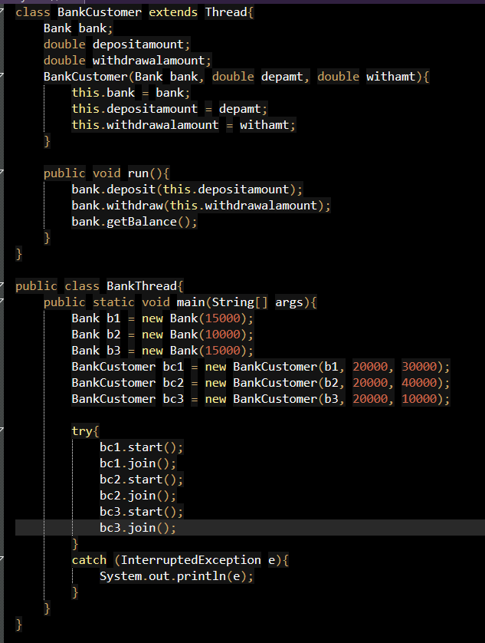
- Create a thread using Thread class:
  - Accept number of seconds from user
  - Display countdown using sleep(1000)
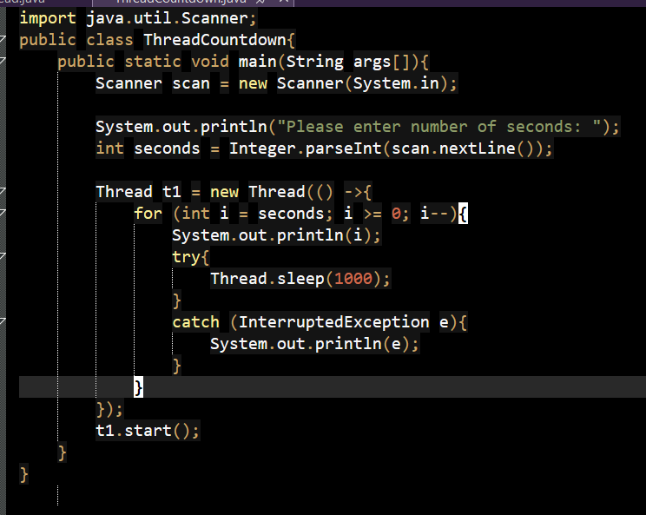
- Create three threads representing:
  - Red, Yellow, Green signals
  - Use sleep() to simulate timing
  - Ensure proper sequence of signals
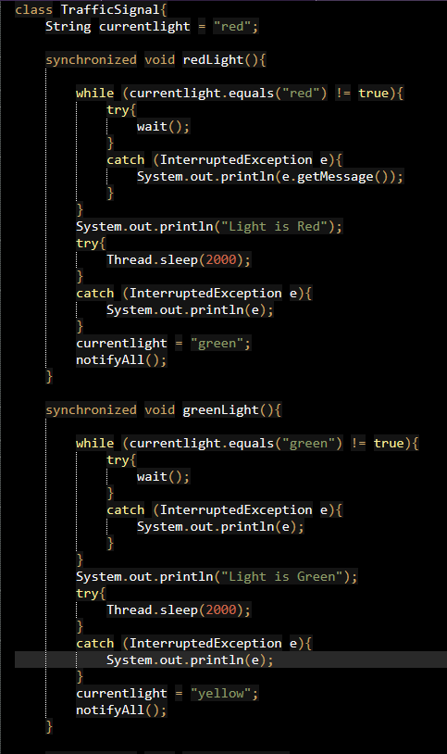
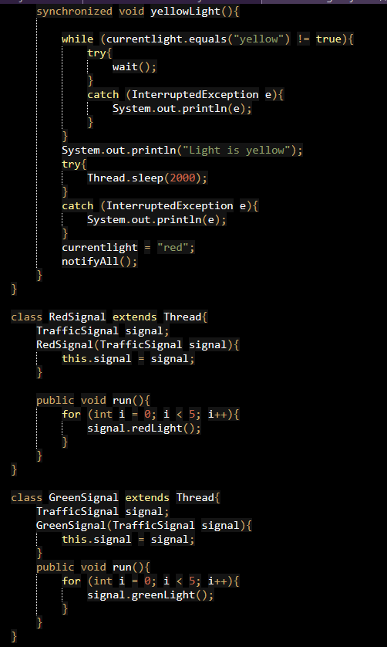
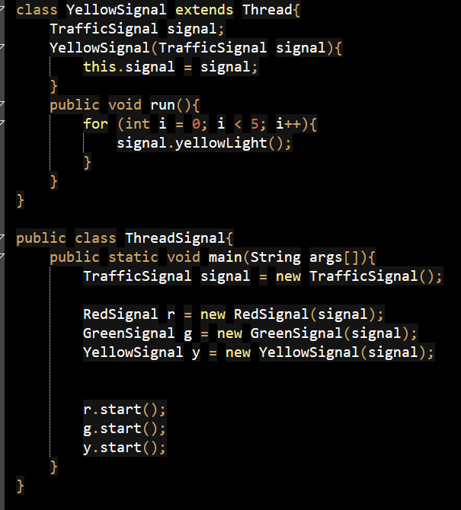
- Design a system where:
  - Customers (threads) request tables
  - Limited tables available
  - Use wait() and notify() to manage allocation
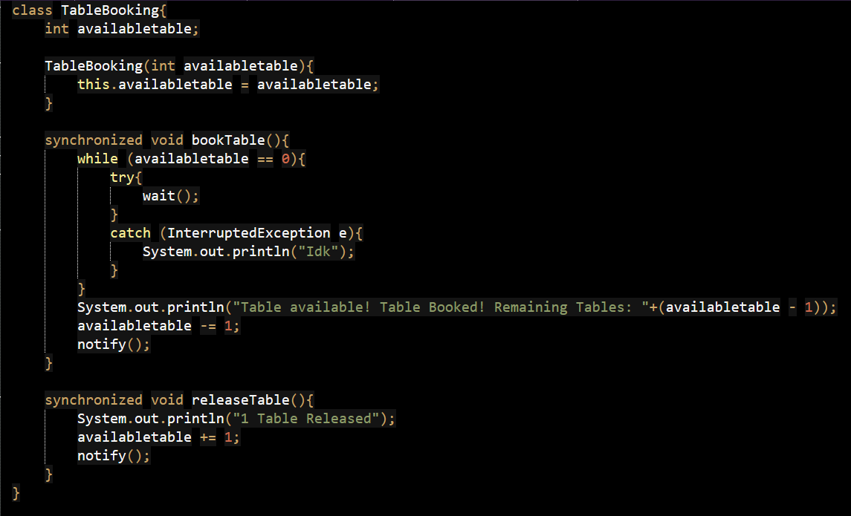
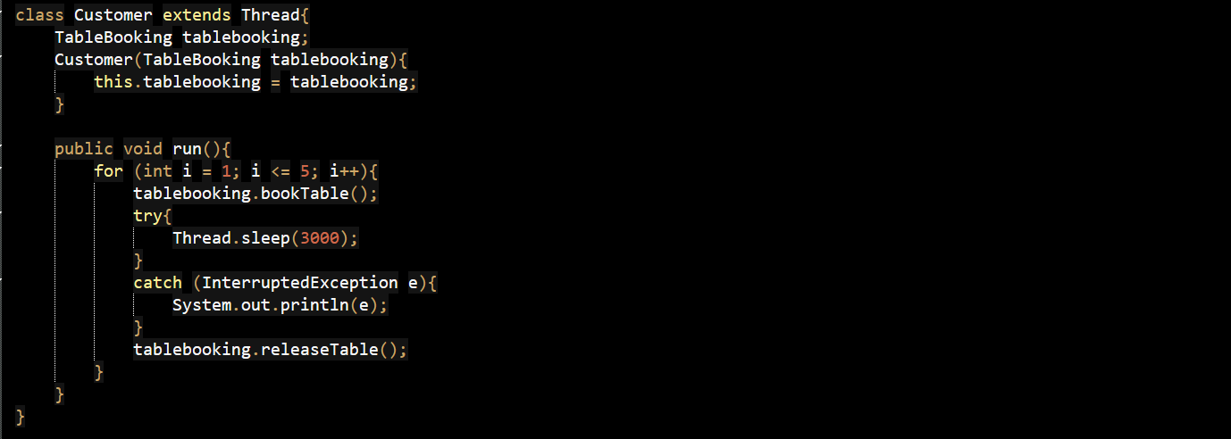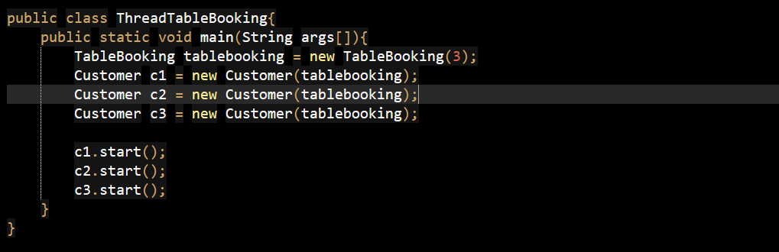
- Create multiple threads:
  - Each thread prints numbers from 1 to 5
  - Use Thread.yield() inside loop Observe execution behavior.
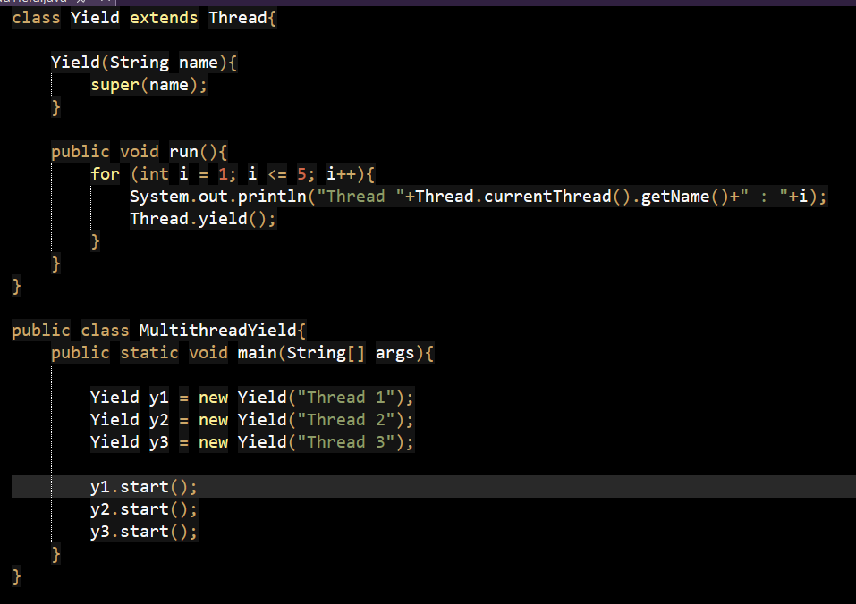
- Divide an array into two halves:
  - Use two threads to sort each half
  - Merge results in main thread
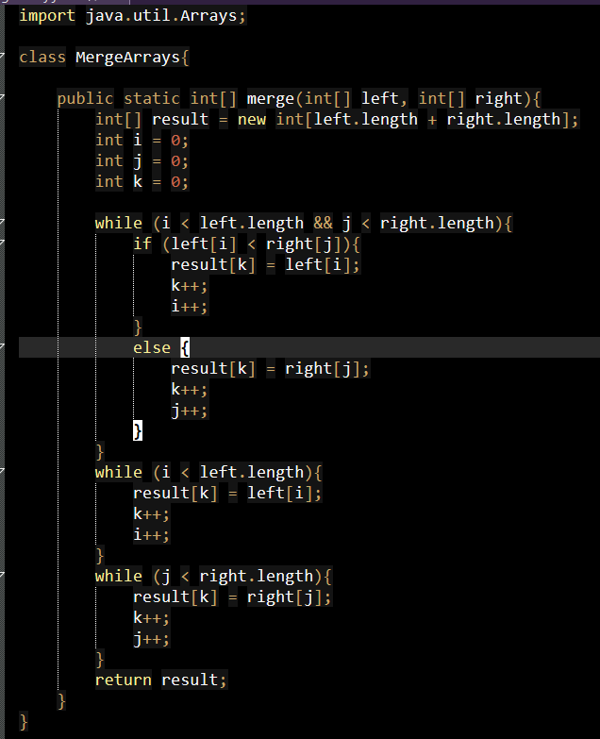
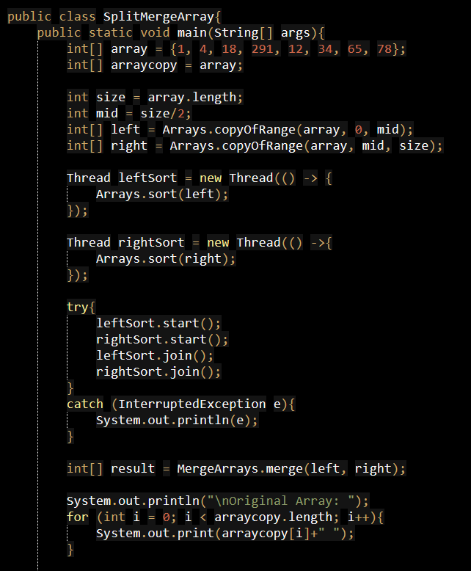
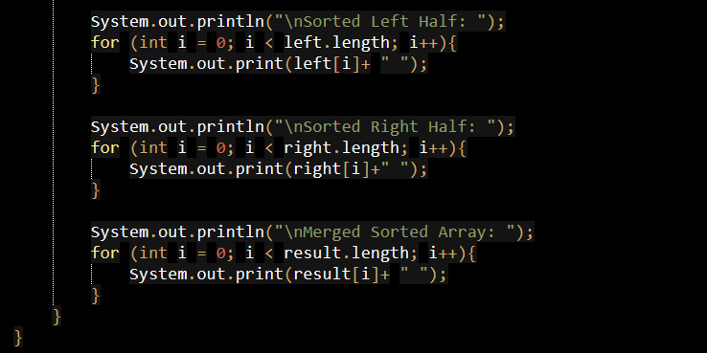
- Design a ticket booking system:
  - Multiple users (threads) try to book tickets
  - Use synchronized method to prevent overbooking
  - Display success/failure messages
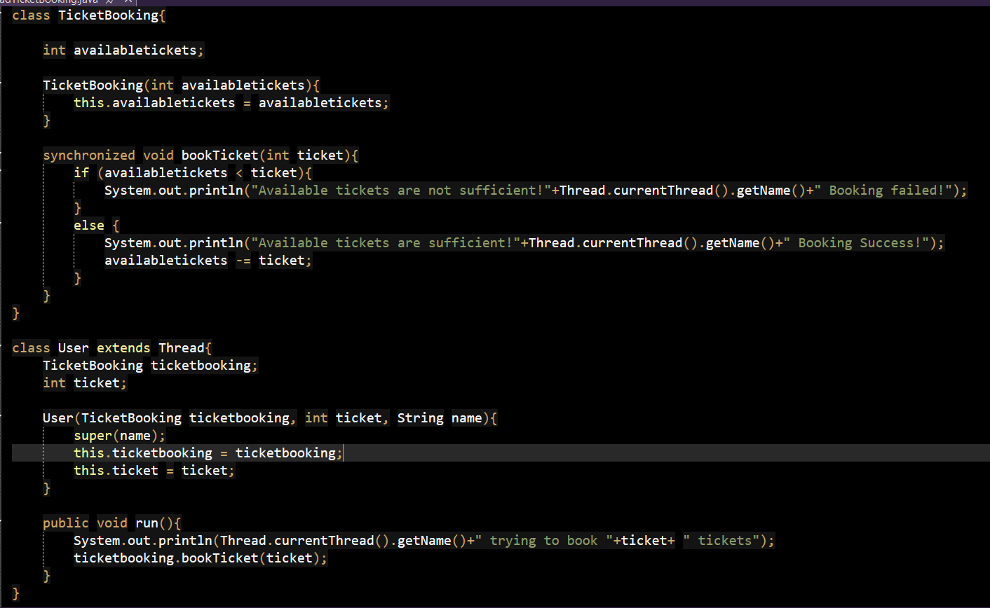
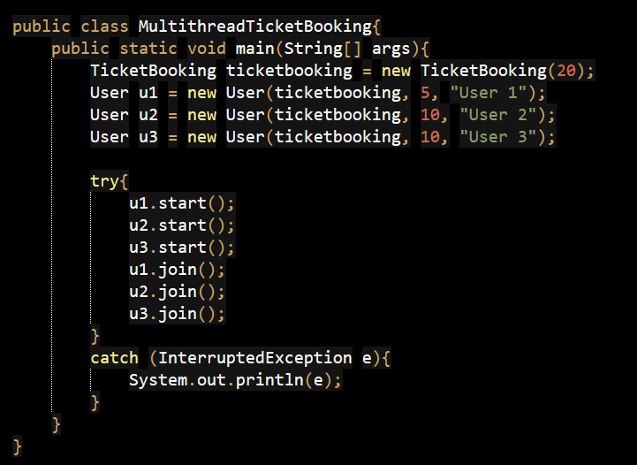
- Create threads for:
  - Buyers and Sellers

  - Use sleep() to simulate trading delay
  - Use thread control methods to pause and resume execution
