F.Y.B.Tech 
Practice Assignment – 1 (Experiment Instructions
• This assignment covers concepts from Experiment 1 to 4. • Students solve 4 questions based on their roll number.
• Use proper indentation, comments, and meaningful variable names.
Question Allocation Based on Roll Number
Last Digit of Roll No | Questions to Solve
1  2  3  4  5  6  7  8  9  0 | 1, 11, 21, 31  2, 12, 22, 32  3, 13, 23, 33  4, 14, 24, 34  5, 15, 25, 35  6, 16, 26, 36  7, 17, 27, 37  8, 18, 28, 38  9, 19, 29, 39  10, 20, 30, 40

Assignment Questions
Section A: Basics of Java and Control Structures (Exp–1)
1. Write a Java program to check whether a given number is positive, negative, or zero.
2. Write a Java program to find the factorial of a number using a while loop.
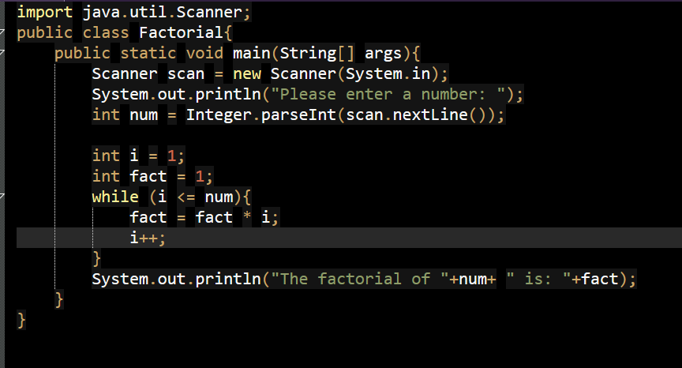3. Write a Java program to reverse a given integer number.
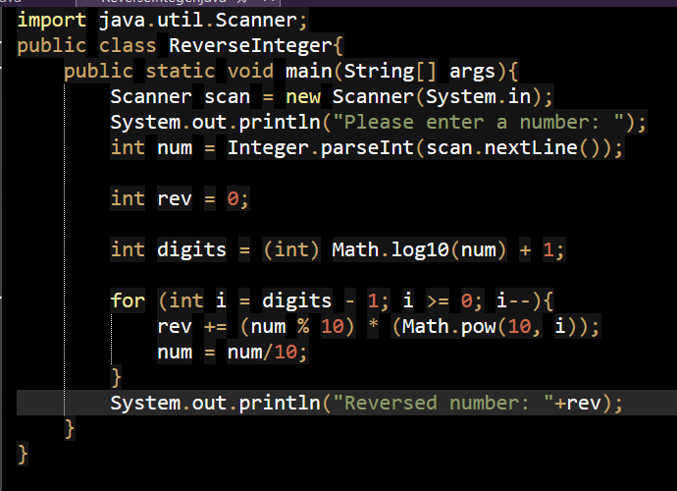

4. Write a Java program to check whether a given number is a palindrome.
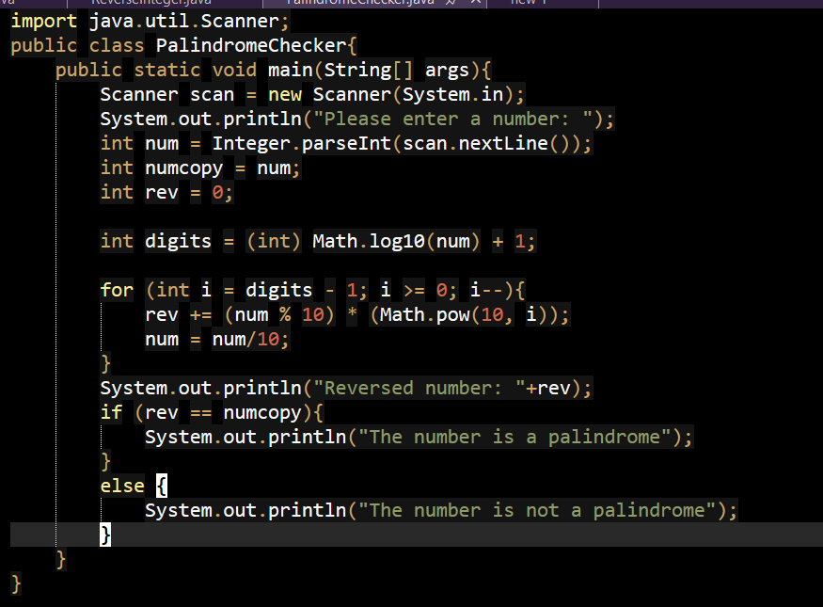
5. Write a Java program to calculate the sum of digits of a number.
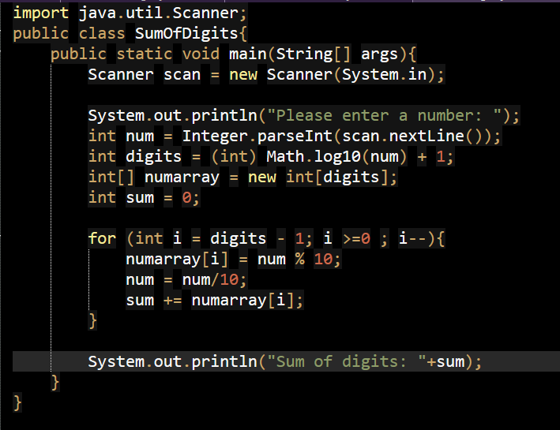
6. Write a Java program to print multiplication table of a number using for loop.
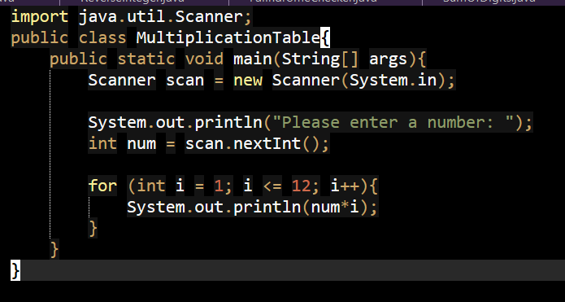
7. Write a Java program to check whether a given number is an Armstrong number or not. The number should be accepted using Scanner and logic must use a loop.

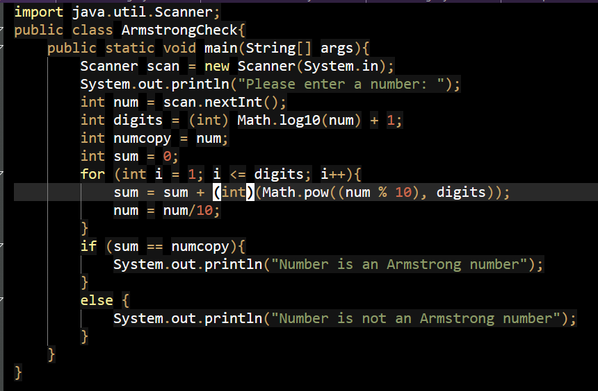
8. Write a Java program to count the total number of vowels and consonants in a given string. Use conditional statements and loops.
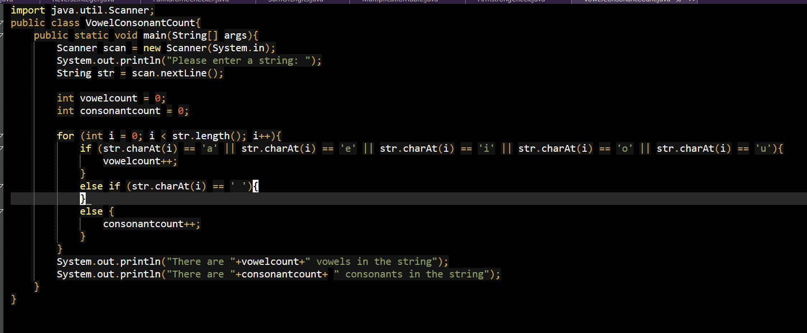
9. Write a Java program to implement a menu-driven calculator using switch--case for addition, subtraction, multiplication, and division.
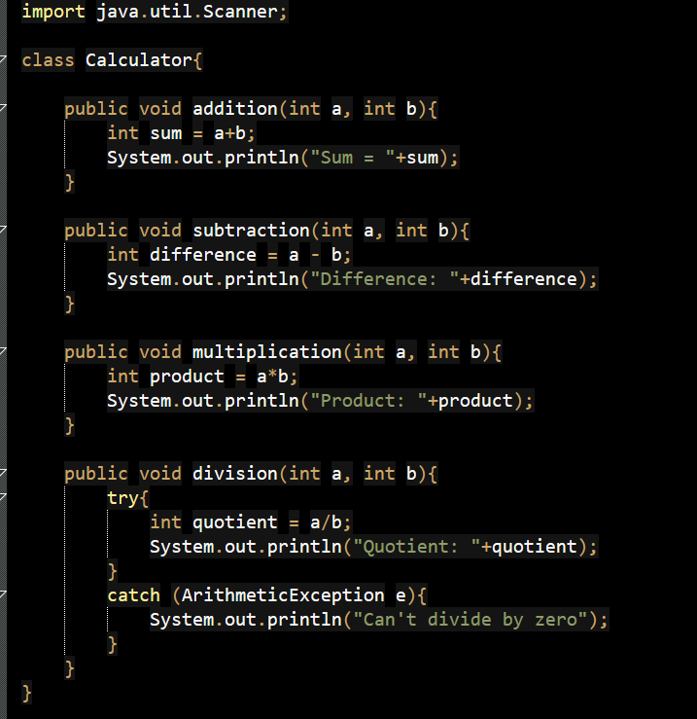
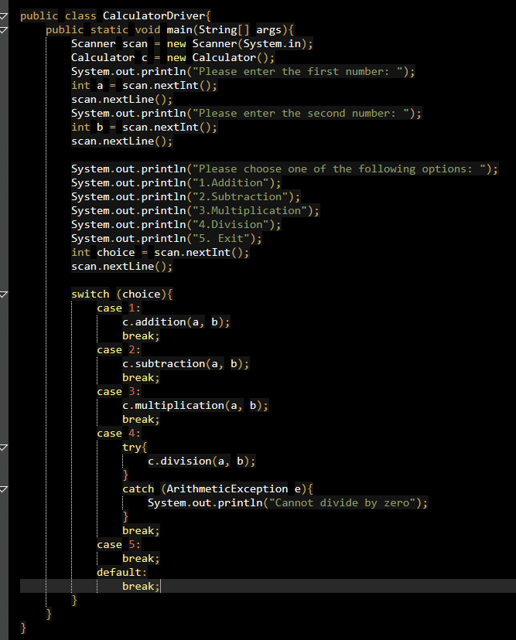
10. Write a Java program to count the number of digits in a given number.
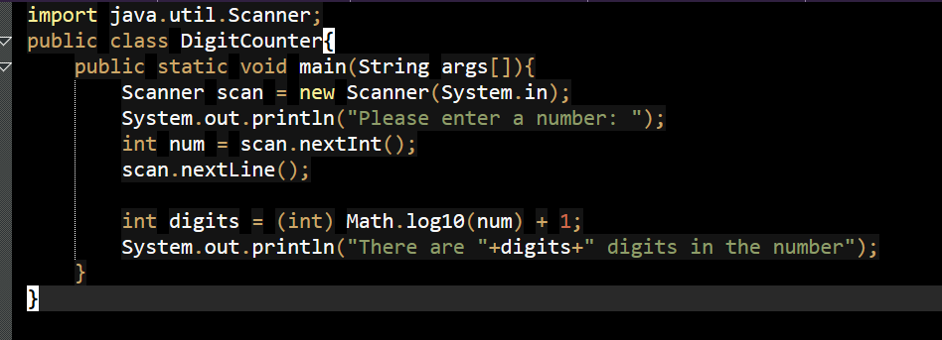
Section B: Classes, Objects and Methods (Exp–2)
11. Create a class Student with methods to:
• accept marks of N subjects using Scanner
• calculate total and average marks
• display grade using if--else

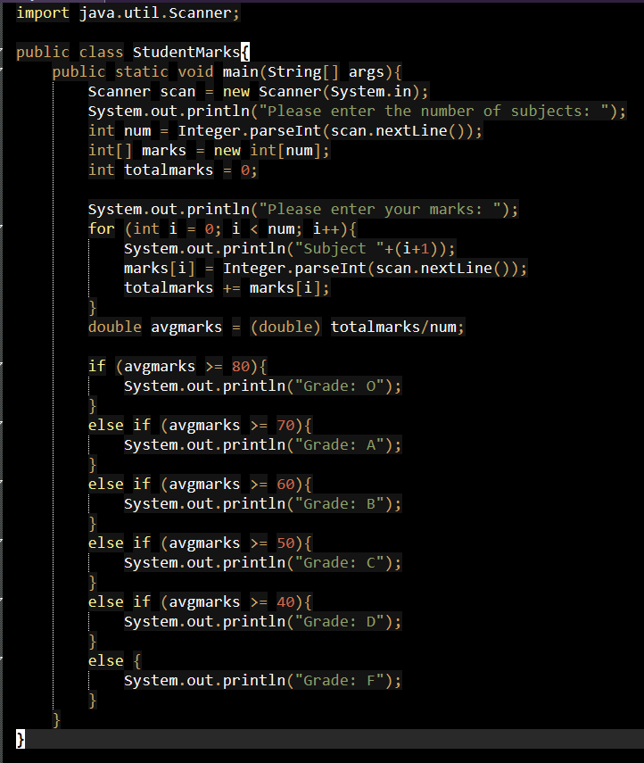

12. Create a class Employee with methods to:
• accept employee details (name, Id, Salary) using command line arguments. • Find the hightest and lowest salary of all employee.
• display details of the employee with higher salary and lower salary.
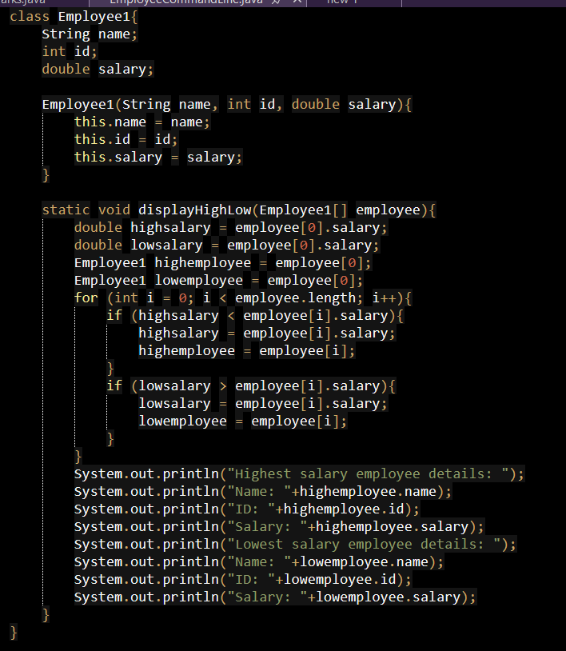
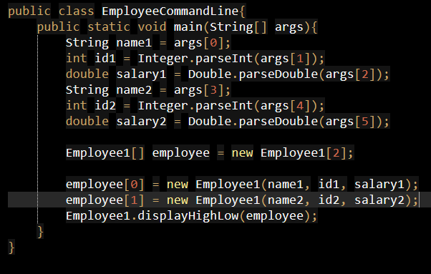
13. Create a class Point with methods to:
• accept coordinates of two points
• calculate distance between them using formula
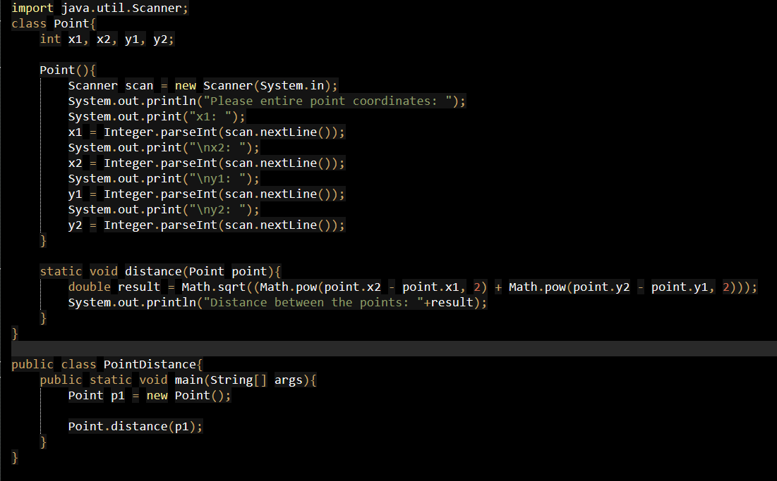
14. Create a class ArrayOperation with methods to:
• accept N integers (min 3, max 10)
• find maximum and minimum values
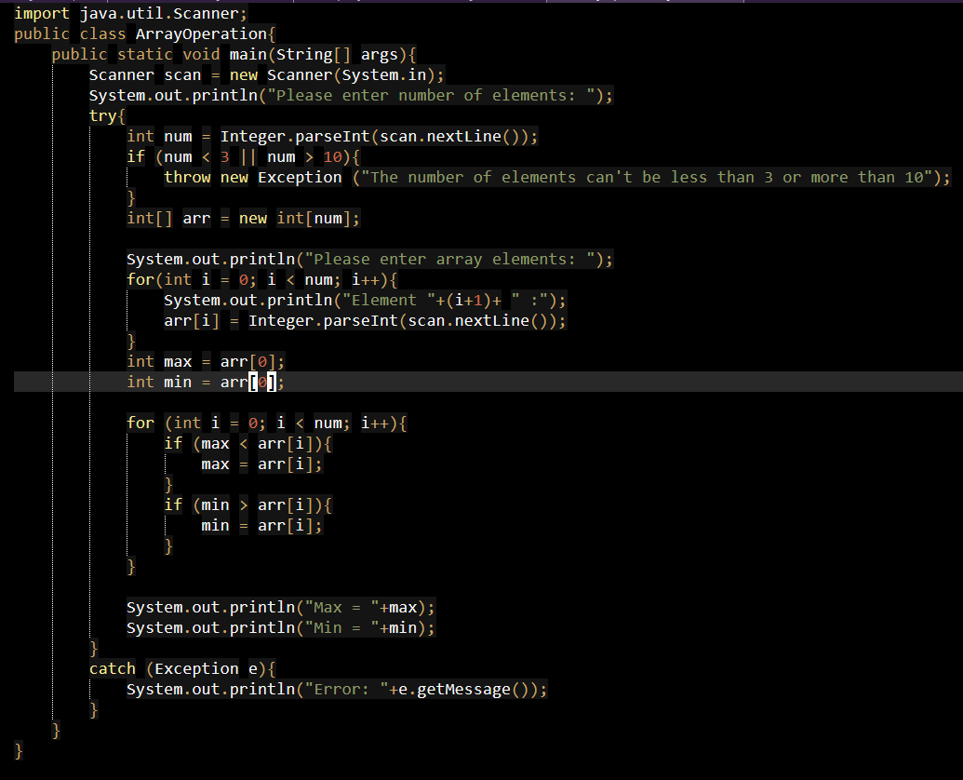
15. Create a class Matrix with methods to:
• accept two matrices
• perform matrix addition
• display the resultant matrix
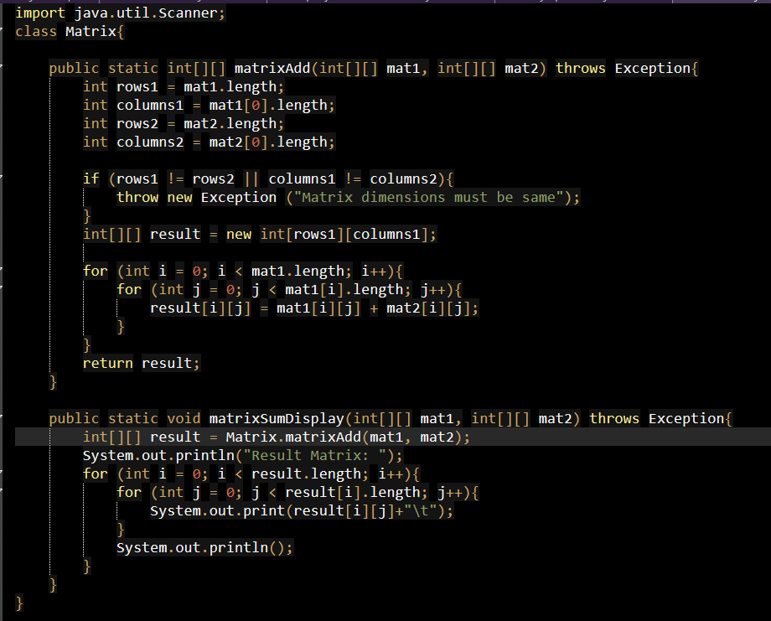
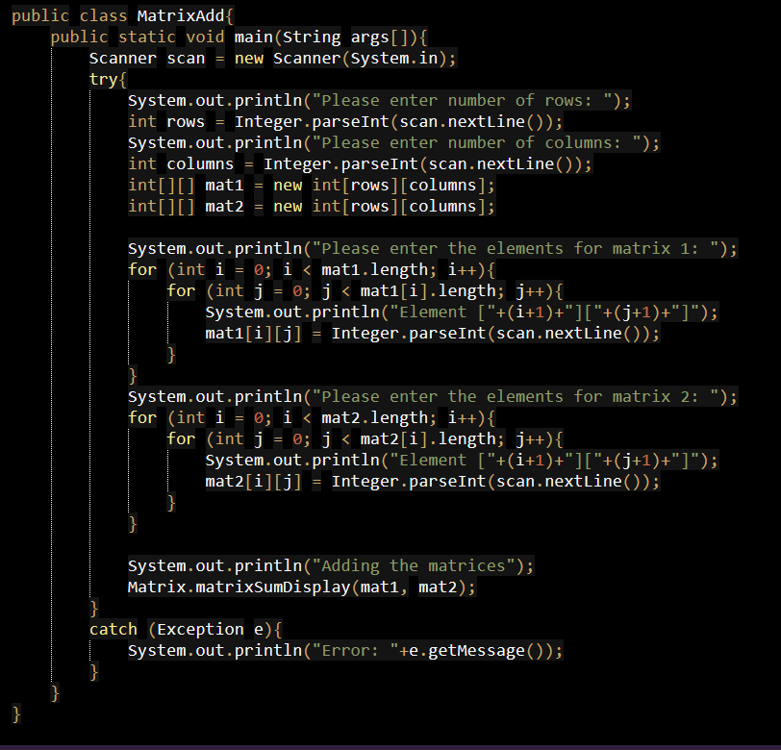
16. Create a class Book with properties title, author, and year. Implement methods to:
• display book details
• sort all books based on properties.
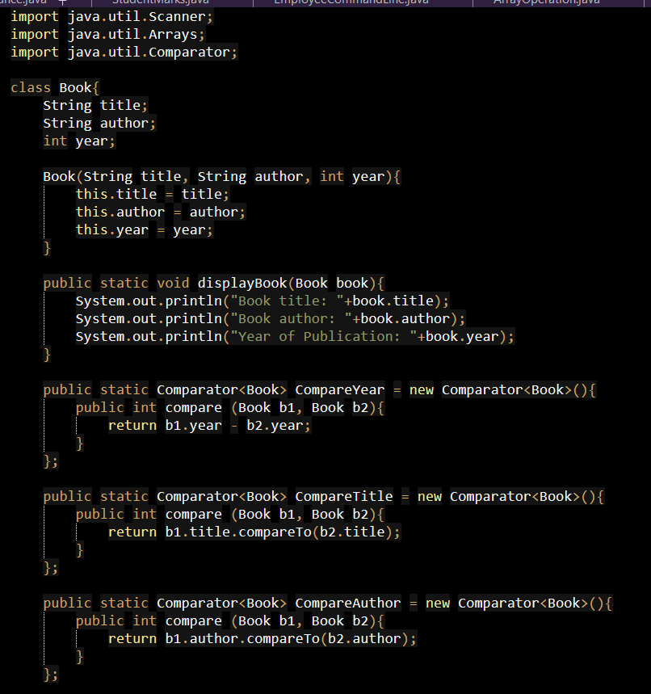
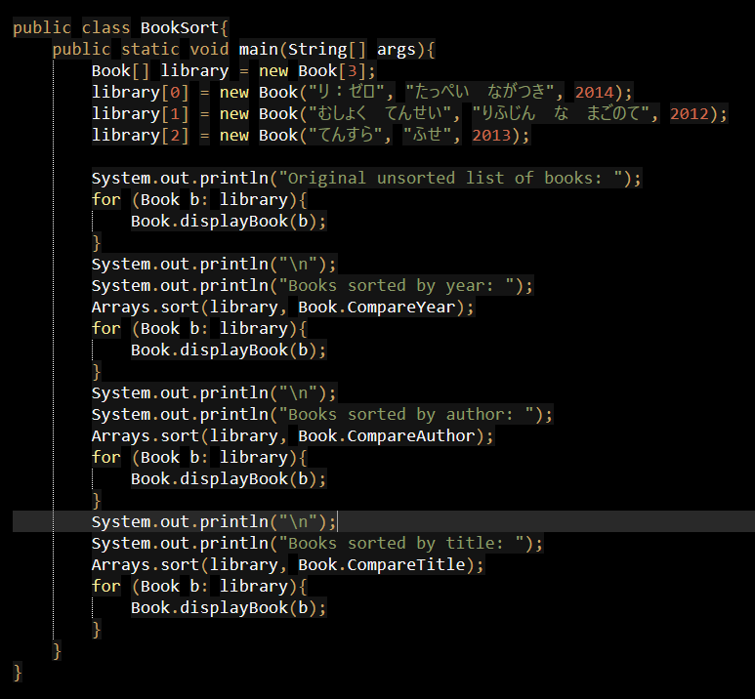
17. Create a class NumberAnalysis with methods to:
• check whether a number is Oddish or Evenish
• display appropriate message
A number is Oddish if the sum of all of its digits is odd, and a number is Evenish if the sum of all of its digits is even.
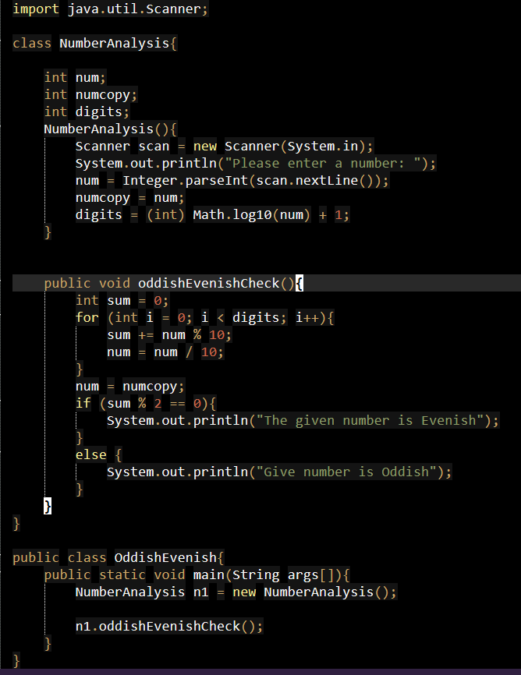
18. Create a class DigitPattern with methods to:
• accept a number(N)
• print a digit-based pattern using loops
Ex: N = 4
Pattern
1
2 2
3 3 3
4 4 4 4

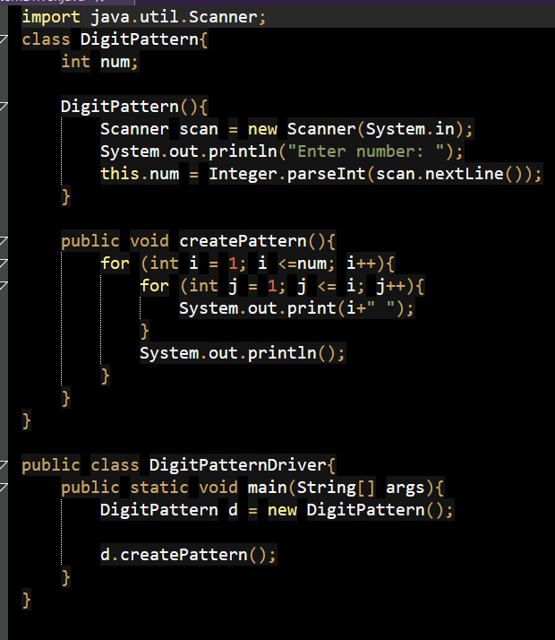
19. Create a class NumberSystem with methods to convert:
• Binary to Decimal
• Binary to Hexadecimal
• Decimal to Hexadecimal
• Hexadecimal to Binary
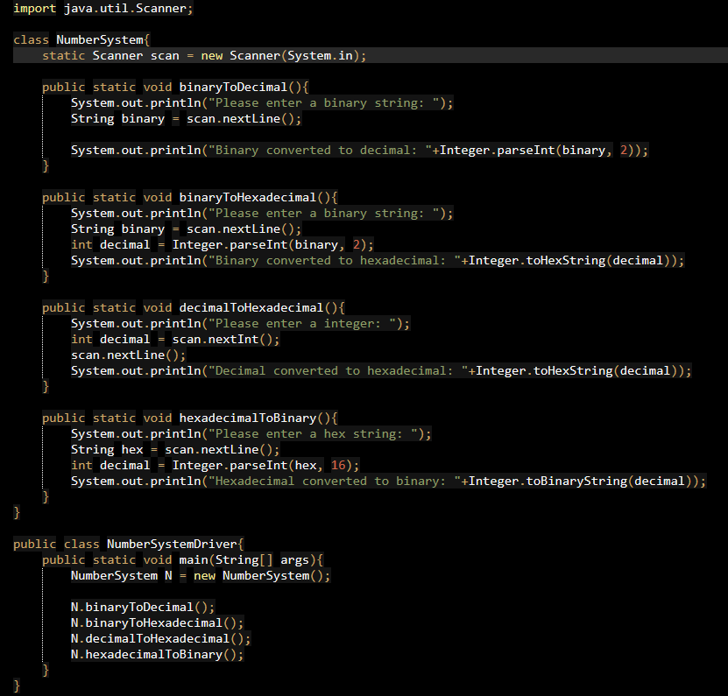
20. Create a class UniqueNumber with methods to:
• accept N numbers
• identify all unique three-digit numbers
• count how many such numbers exist
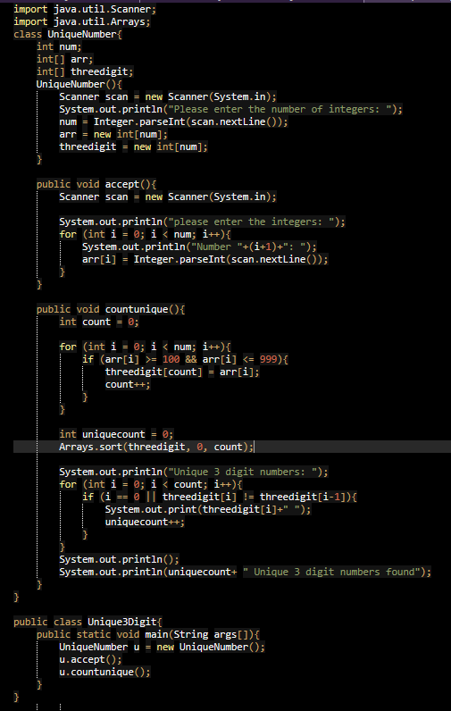
Section C: Constructors and this Keyword (Exp–3)
21. Create a class using a constructor to check whether a given number is a Disarium number. A number is said to be Disarium if the sum of its digits raised to their respective positions is the number itself.
Ex: 135
1¹ + 3² + 5³ = 1 + 9 + 125 = 135

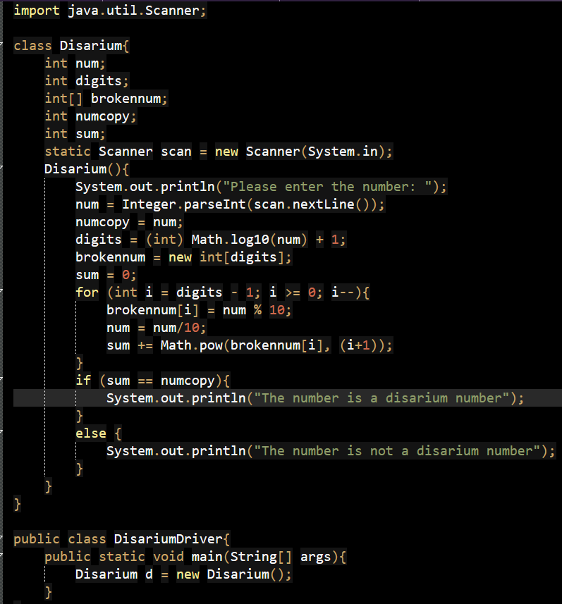

22. Create a class using constructor and this keyword to check whether a number is a Harshad number. A number is said to be the Harshad number if it is divisible by the sum of its digits. For example, if the number is 156, then the sum of its digits will be 1 + 5 + 6 = 12. Since 156 is divisible by 12. So, 156 is a Harshad number.
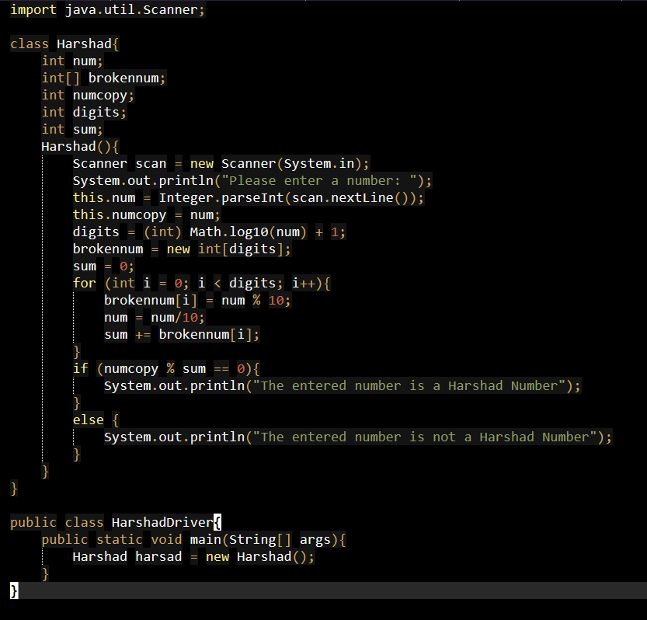
23. Create a class using constructor to check whether a given number is an Auto morphic number. A number is called an automorphic number if and only if the square of the given number ends with the same number itself. For example, 25, 76 are automorphic numbers because their square is 625 and 5776, respectively.
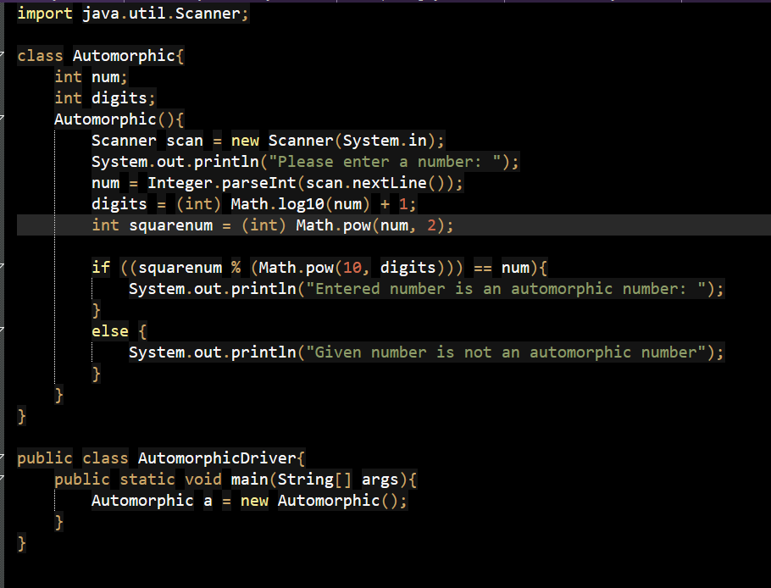
24. Create a class to calculate area and circumference of circle using constructor over loading.
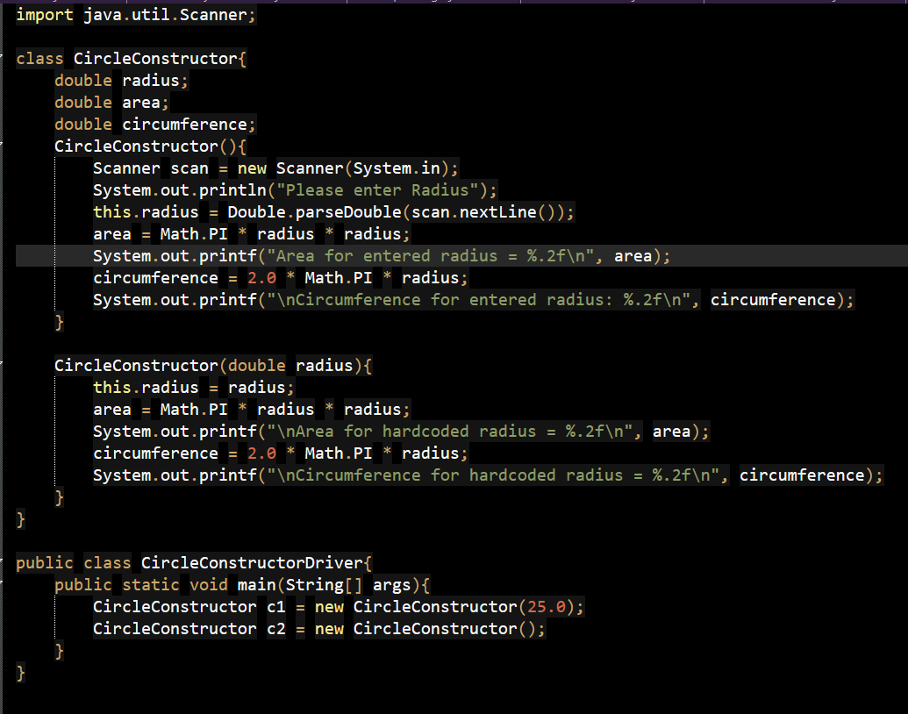

25. Write a Java program to calculate simple and compound interest using constructor overloading.
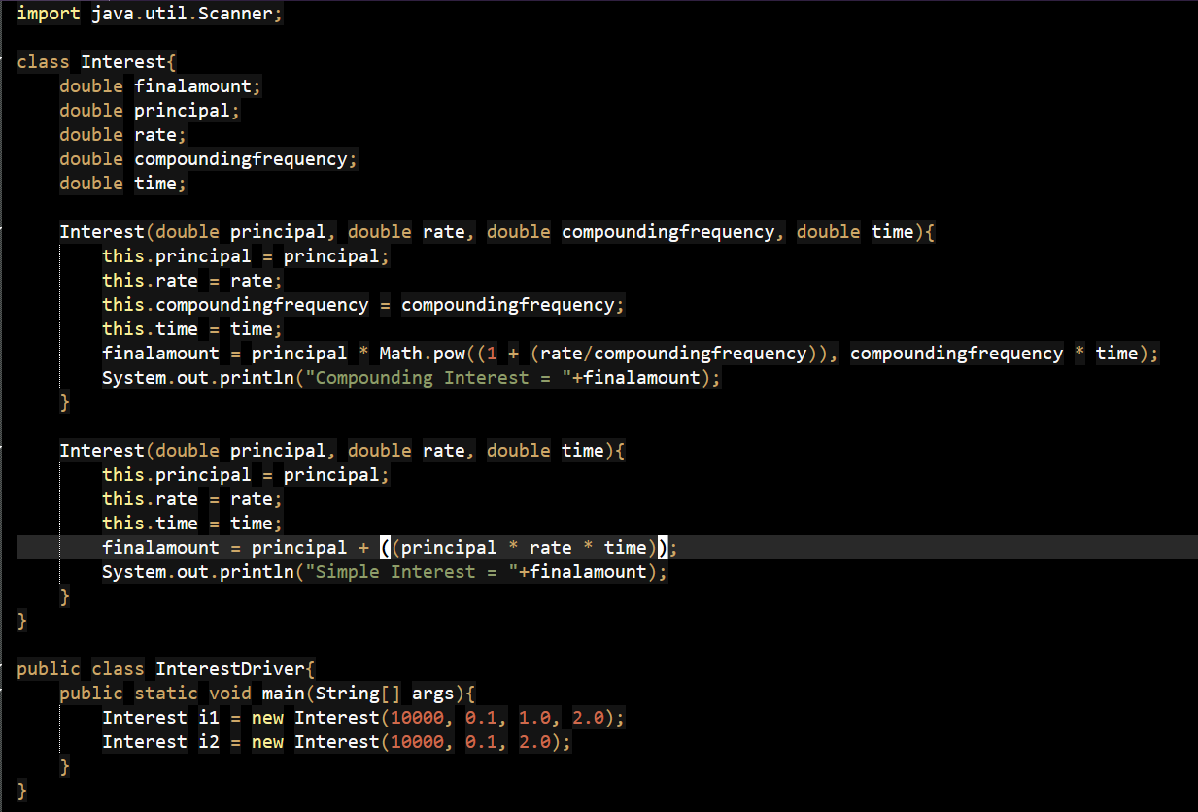
26. Create a class using constructor to check whether a given number is a Perfect number. A perfect number is a number that can be written as the sum of its factors, excluding the number itself. Ex: 28 is a perfect number, since 1 + 2 + 4 + 7 + 14 = 28
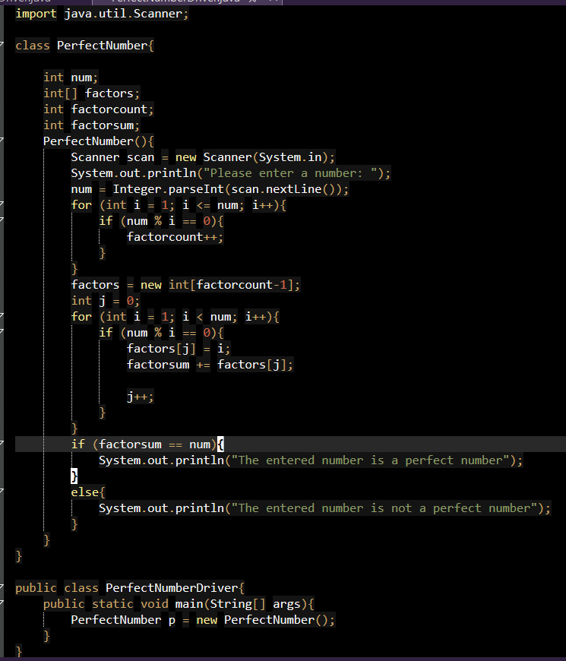
27. Create a class using constructor to convert a decimal number to binary without using built-in conversion methods.
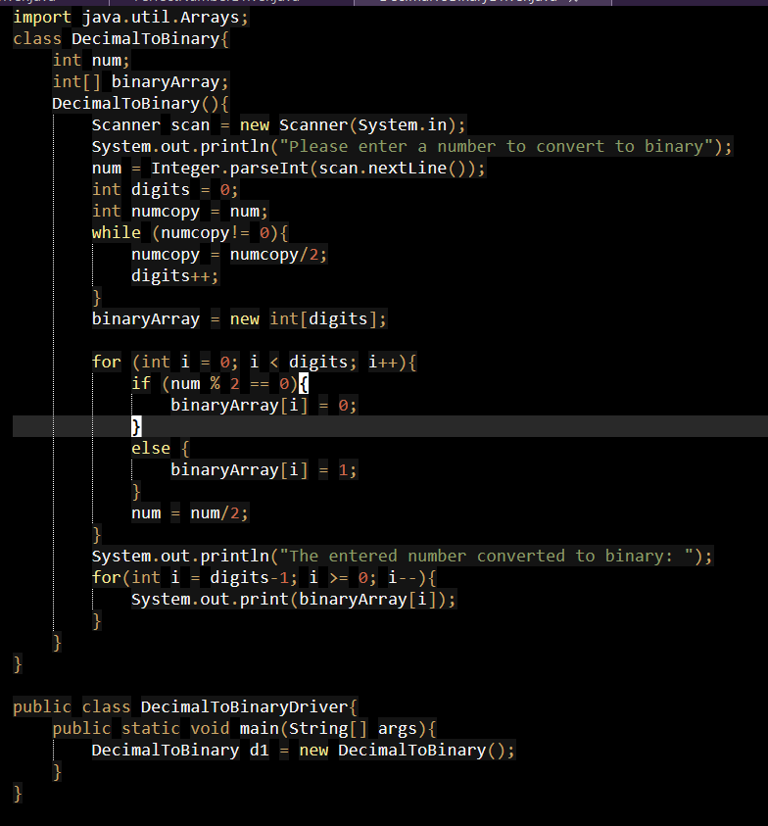
28. Create a class using constructor and this keyword to convert a Hexadecimal number to decimal without using built-in conversion methods.
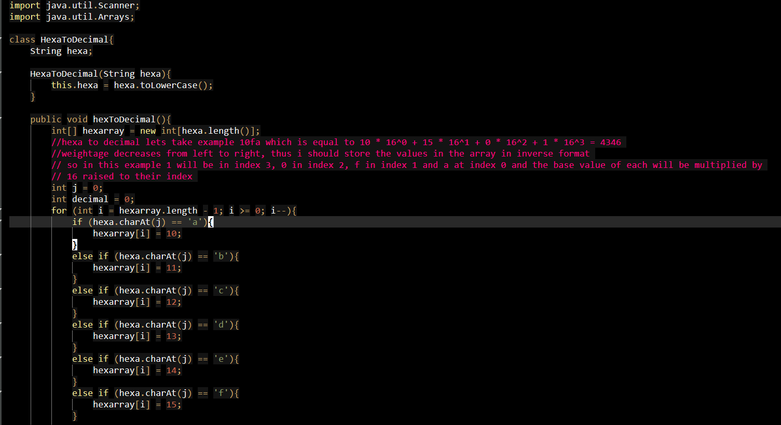
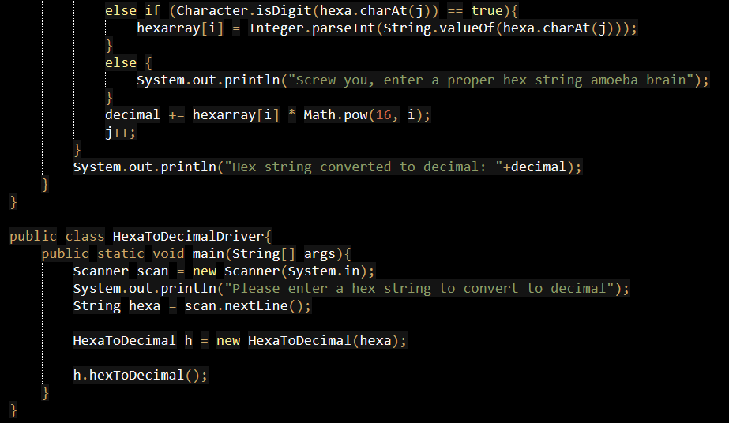
29. Create a class using constructor to generate and display the first N terms of a number series where N is passed as a parameter.
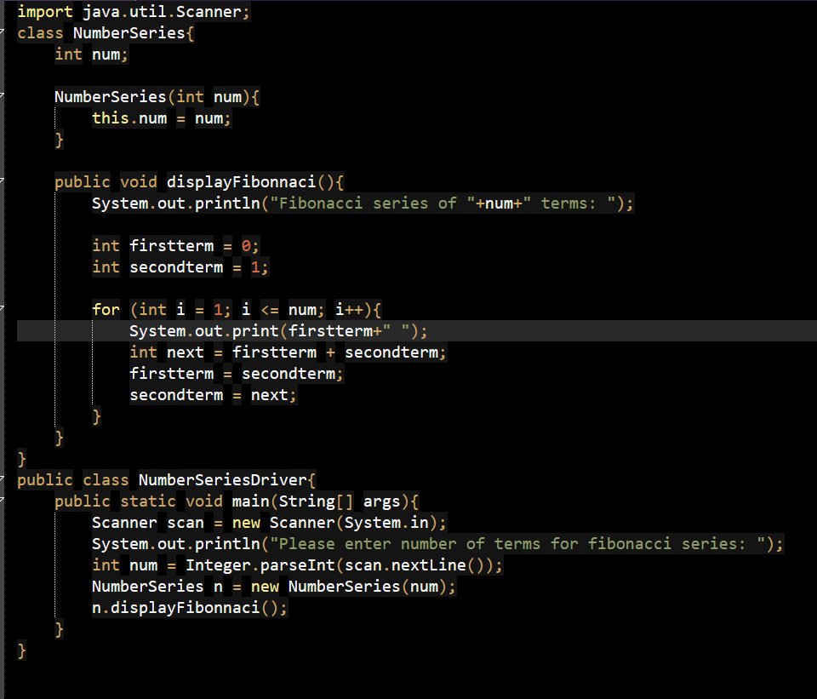
30. Create a class using constructor to accept an array of integers and count how many elements are three-digit numbers.
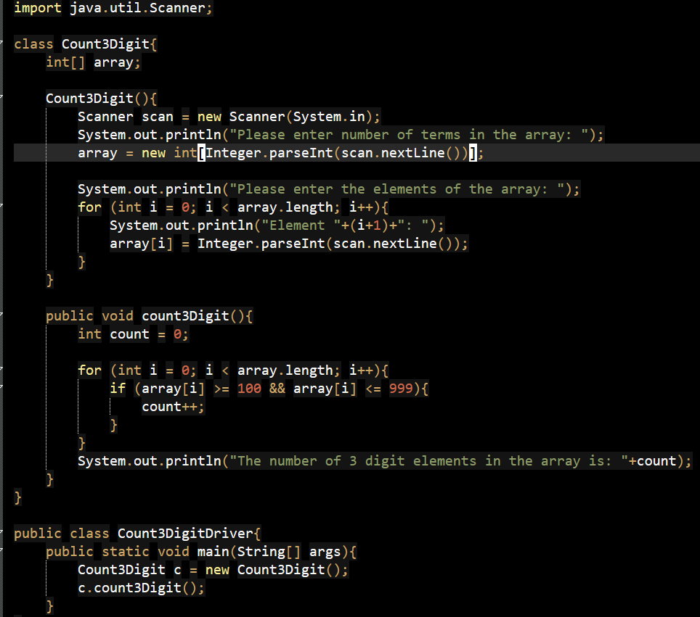
Section D: Static, Object Lifecycle and HAS-A Relationship (Exp– 4)
31. Create a utility class with:
• a static method to calculate GCD of two numbers
• a non-static method to calculate LCM using GCD
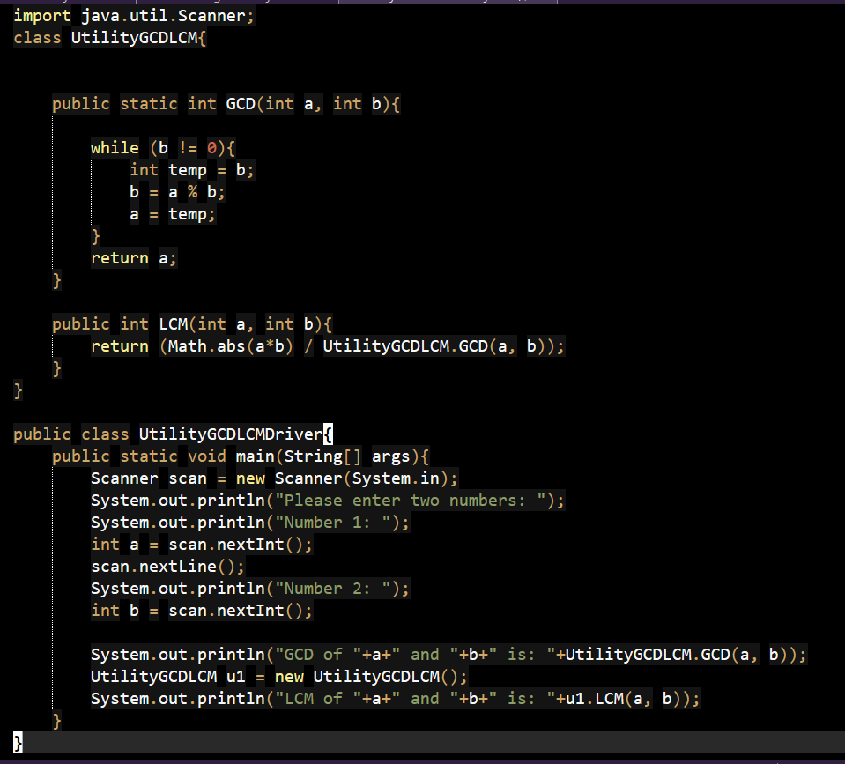
32. Write a Java program to demonstrate object lifecycle by:
• creating multiple references to the same object
• making the object eligible for garbage collection
33. Create a class that uses a static variable to count how many objects of that class are created.
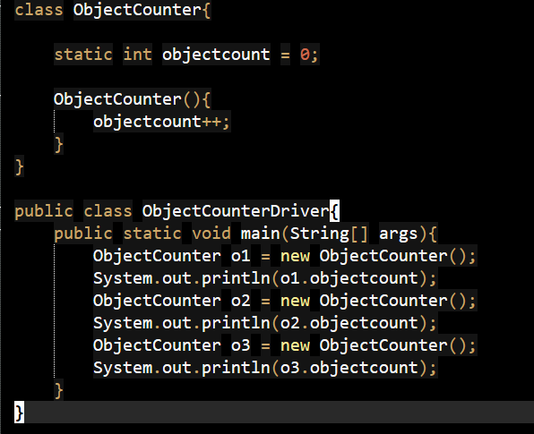
34. Create a HAS-A relationship between classes Student and Address and display complete student information, where multiple students may share the same address object.
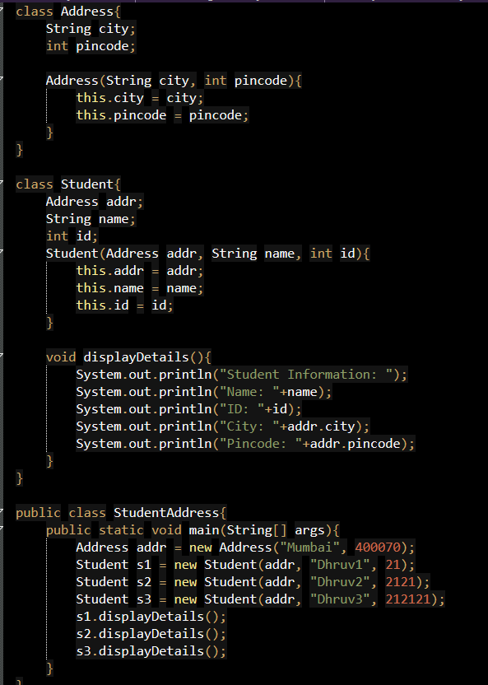
35. Write a Java program to demonstrate a HAS-A relationship between Employee and Department, where department details are passed to employee objects through constructor.
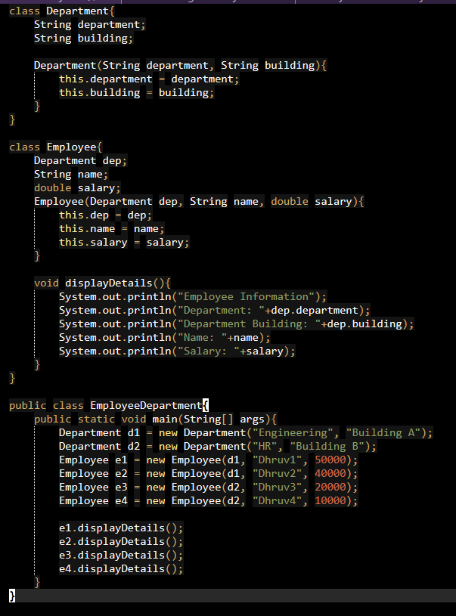
36. Write a Java program to store details of N students (3 ≤ N ≤ 10) using an array of objects and display the topper based on total marks.
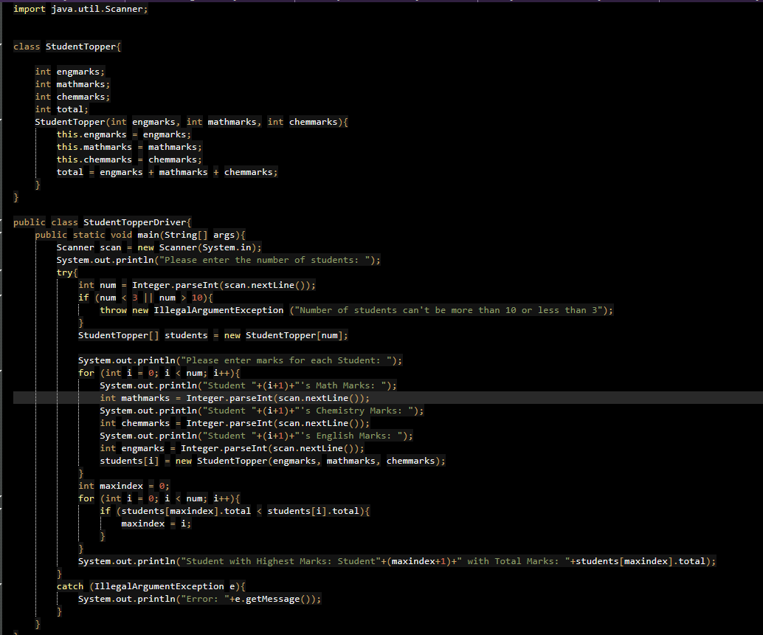
37. Write a Java program where a static method determines whether a number is prime and a non-static method generates all prime numbers up to a given limit.
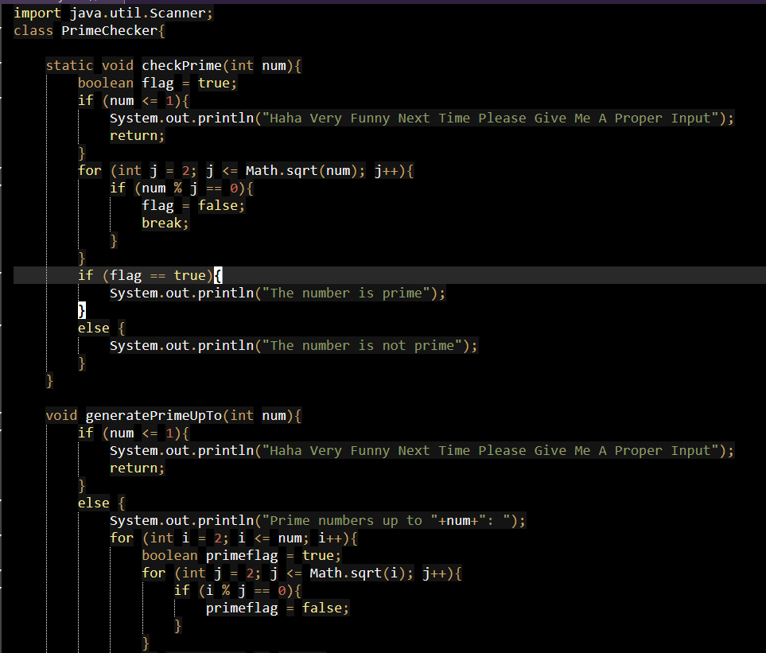
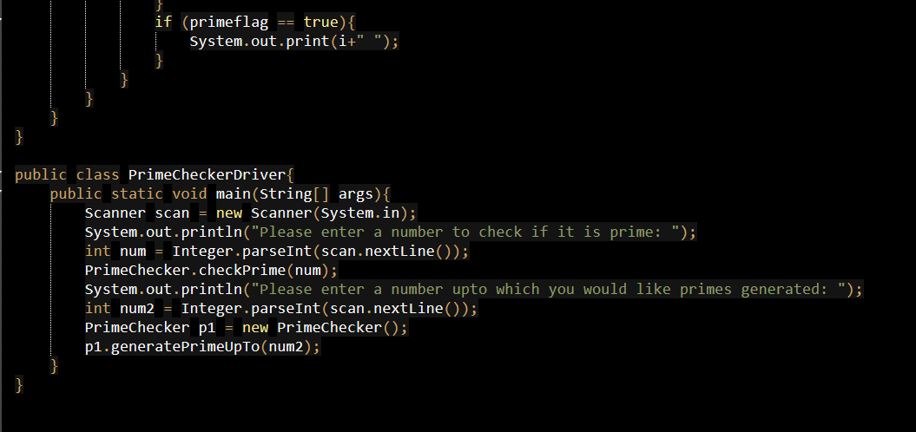
38. Write a Java program to demonstrate passing an object as an argument to a method, modifying its data members inside the method, and reflecting the changes in the calling method.
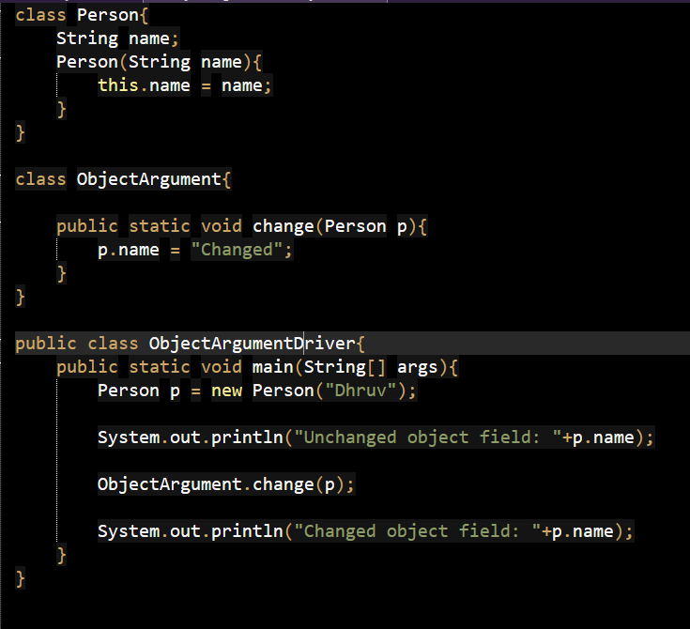
39. Develop a Java class to represent information about software company employ ees with information like salary code ,designation,salary,department. Implement method to display the employee details
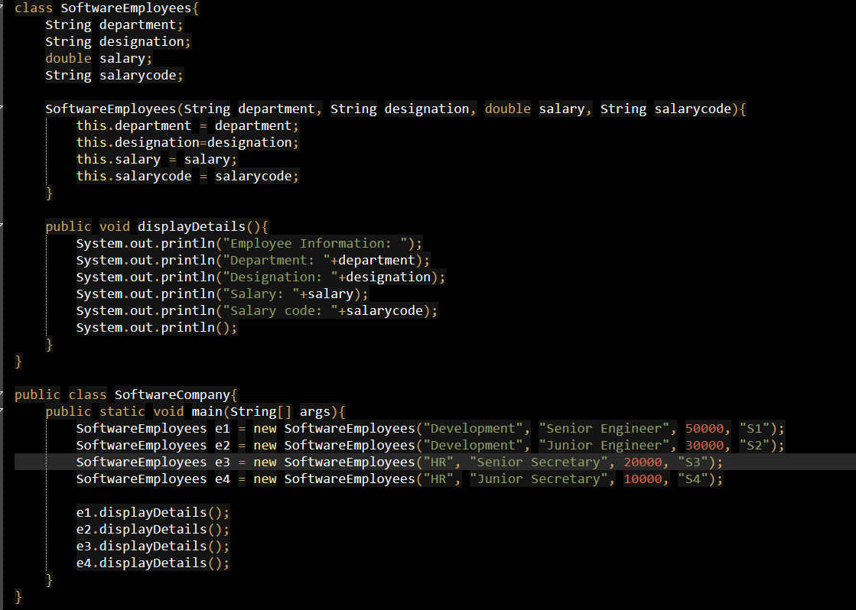
40. The daily maximum temperature recorded in 10 cities during one week (July 1 to July 7) has been tabulated as shown below.
City / Day | 1 | 2 | 3 | 4 | 5 | 6 | 7
City 1
City 2
City 3
...
City 10

Write a Java program to perform the following tasks:
• Read the temperature values into a two-dimensional array temperature[10][7].
• For each city, determine the highest temperature recorded and display the corresponding day on which it occurred.
• For each day, determine the highest temperature recorded and display the corresponding city in which it occurred.
• Determine the overall highest temperature recorded during the week and display:
– the value of the temperature
– the day on which it occurred
– the city in which it was recorded

