A Controlling Motors
Task 1: Interfacing of Servo Motor to Arduino

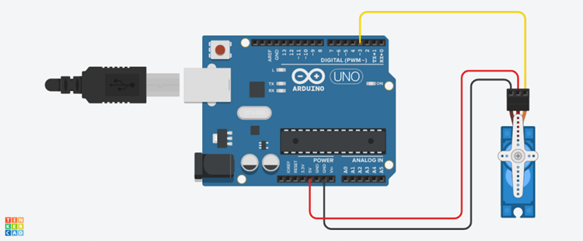
Yellow : data ( Pin 5)
Red : Vcc
Black / Brown : Gnd
Code for Servo Motor
#include <Servo.h>
Servo servo;
int angle = 10;

void setup() {
servo.attach(5);
servo.write(angle);
}
void loop()
{
// scan from 0 to 180 degrees
for(angle = 20; angle < 130; angle++)
{
servo.write(angle);
delay(15);
}
// now scan back from 180 to 0 degrees
for(angle = 130; angle > 10; angle--)
{
servo.write(angle);
delay(15);
}
}

Task 2 : DC Motor Speed and Direction Control
Try Running Motor in Forward and Reverse Direction
Control Speed of Motor
Simulate given Code in TinkerCAD
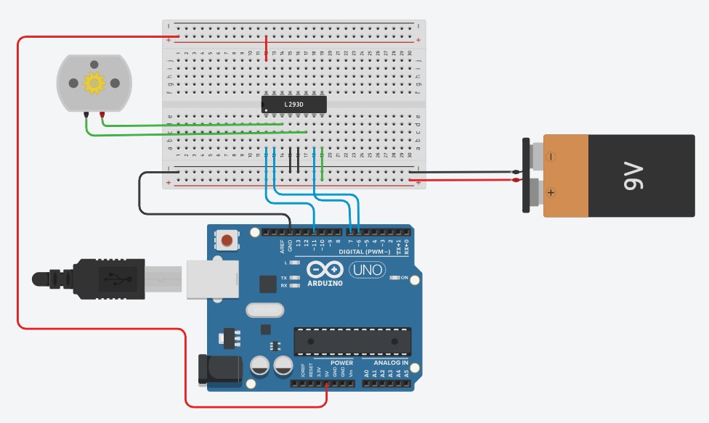
L 293 D Motor Driver IC
Pin Enable 1: Pin 11 of Arduino ( Analog Pin)
Input 1 : Pin 6 of Arduino
Input 2: Pin 7 of Arduino
Output 1: Motor
Output 2: Motor
Gnd
Vcc
Code for DC Motor Control

void setup()
{
pinMode(11, OUTPUT);// En of Motor 1
pinMode(7,OUTPUT); // In1 of Motor 1
pinMode(6,OUTPUT);// In 2 of Motor 1
}
void fwdrev() // function reverses direction of motor
{
digitalWrite(7,LOW);// In1 = 0, FWD
digitalWrite(6,HIGH);//In2 =1
digitalWrite(11,HIGH);

delay(5000); // Wait for 5 second(s)
digitalWrite(7, LOW);// In1 = 0, Stop
digitalWrite(6,LOW);// In2 = 0

delay(5000); // Wait for 1000 millisecond(s)
digitalWrite(7, HIGH);//In1 =1, REV
digitalWrite(6,LOW);//In2 =0
delay(5000);
digitalWrite(7, LOW);// In1 = 0, Stop
digitalWrite(6,LOW);// In2 = 0
}
void speed () // function for 2 speed settings of DC Motor
{
digitalWrite(7, LOW);
digitalWrite(6,HIGH);
analogWrite(11,50); // Slow Speed
delay(25000); // Wait for 1000 millisecond(s)

analogWrite(11,200);// High Speed
digitalWrite(7, LOW);
digitalWrite(6,HIGH);
delay(25000); // Wait for 1000 millisecond(s)
}

void loop()
{
fwdrev();
speed();

}

1. Interfacing DC Motor with Arduino

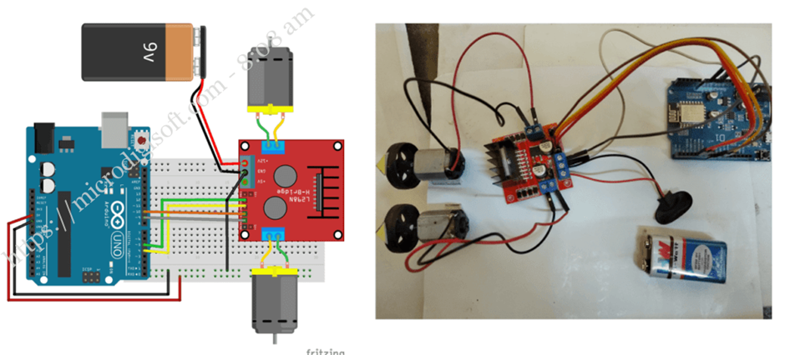

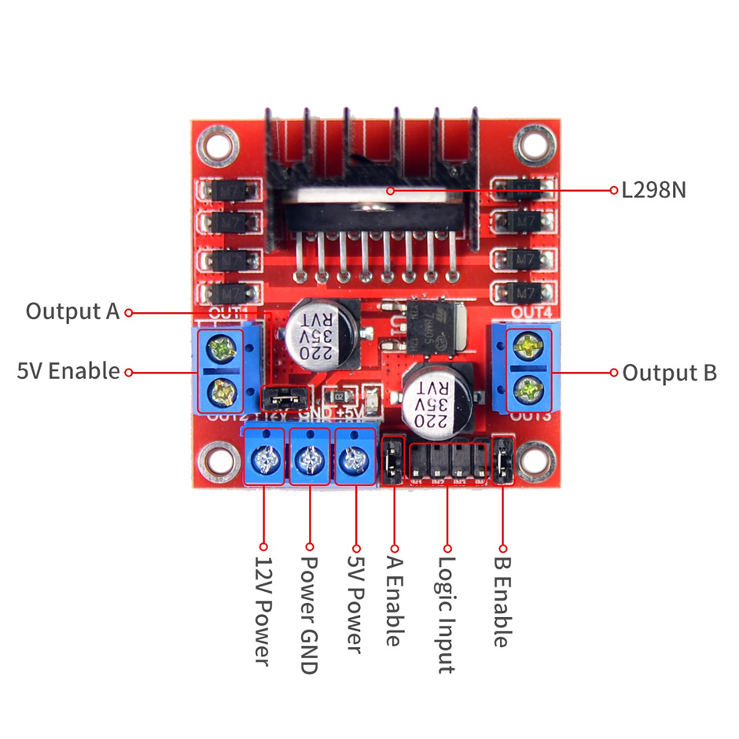
// Motor A connections
int enA = 9;
int in1 = 13;
int in2 = 12;
// Motor B connections
int enB = 3;
int in3 = 11;
int in4 = 10;

void setup() {
pinMode(enA, OUTPUT);
pinMode(enB, OUTPUT);
pinMode(in1, OUTPUT);
pinMode(in2, OUTPUT);
pinMode(in3, OUTPUT);
pinMode(in4, OUTPUT);

digitalWrite(in1, LOW);
digitalWrite(in2, LOW);
digitalWrite(in3, LOW);
digitalWrite(in4, LOW);
}

void loop() {
directionControl();
delay(1000);
speedControl();
delay(1000);
}
void directionControl() {
// Set motors to maximum speed
// PWM value ranges from 0 to 255
analogWrite(enA, 255);
analogWrite(enB, 255);

// Turn on motor A & B
digitalWrite(in1, HIGH);
digitalWrite(in2, LOW);
digitalWrite(in3, HIGH);
digitalWrite(in4, LOW);
delay(2000);

digitalWrite(in1, LOW);
digitalWrite(in2, HIGH);
digitalWrite(in3, LOW);
digitalWrite(in4, HIGH);
delay(2000);

// Turn off motors
digitalWrite(in1, LOW);
digitalWrite(in2, LOW);
digitalWrite(in3, LOW);
digitalWrite(in4, LOW);
}
void speedControl() {
// Turn on motors
digitalWrite(in1, LOW);
digitalWrite(in2, HIGH);
digitalWrite(in3, LOW);
digitalWrite(in4, HIGH);

for (int i = 0; i < 256; i++) {
analogWrite(enA, i);
analogWrite(enB, i);
delay(20);
}

for (int i = 255; i >= 0; --i) {
analogWrite(enA, i);
analogWrite(enB, i);
delay(20);
}
// Now turn off motors
digitalWrite(in1, LOW);
digitalWrite(in2, LOW);
digitalWrite(in3, LOW);
digitalWrite(in4, LOW);
}

