Course Name: | Data Visualization Laboratory (Honours_ Data Science for Emerging Analytics) | Semester: | III
Date of Performance: | 17/07/25 | Batch No: | A3
Faculty Name: | Dr. SHARVARI DESHMANE | Roll No: | 44
Faculty Sign & Date: |  | Grade/Marks: | XX/25

Experiment No: 1
Title: Exploring and Preparing Real-World Datasets for Visualization (Without Tools)

Aim and Objective of the Experiment:

1. To learn sources of dataset

2. To assess the dataset based on Metrics to Measure Data Quality

3. To finalize the features of dataset

4. To learn Data cleaning

COs to be achieved:
CO1: Learn how to locate and download datasets, extract insights from that data and present their findings in a variety of different formats

Tools required:
- Kaggle(for datasets), Excel(for csv file handling), AI Tools(for analysis) and Word(for formatting write ups)

Code/Task:

Group activity: 02 students/group

Following points should be written by students
Students are required to select a real-world dataset from a domain of your choice (e.g., Healthcare, Finance, E-Commerce, Agriculture, Social Media, Environment, etc.). You will manually explore, assess, clean, and finalize the dataset without using any programming or visualization tools.
Task should include the following:
1. Problem Domain and Statement
Problem Domain: Resale Car Market Analysis
Problem Statement: Predict the resale price of used cars based on their features such as age, brand, mileage, fuel type, transmission, and other specifications.
2. Brainstormed Features
Brand (e.g., Toyota, Tata, Maruti):
- Brand reputation heavily influences resale value. Premium brands usually retain value better.
Model:
- Certain models are more popular and reliable, affecting resale demand and price.
Year of Manufacture:
- Indicates the age of the vehicle, a key factor in depreciation.
Kilometers Driven (Mileage):
- More kilometers usually mean more wear and tear, reducing resale value.
Fuel Type (e.g., Petrol, Diesel, CNG, Electric):
- Affects operational cost and desirability. For example, diesel may be preferred for long-distance drivers, while EVs may be cost-effective in cities.
Transmission Type (Manual/Automatic):
- Automatics often have a higher resale price in urban areas due to ease of driving.

3. Dataset Source
Source: Kaggle - Indian Cars: Data Analysis and Visualization
URL: https://www.kaggle.com/datasets/bhanupratapbiswas/indian-cars-data-analysis-and-visualization
4. Sample Data (First 5 Records)
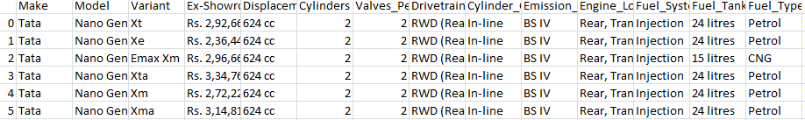
5. Data Dictionary
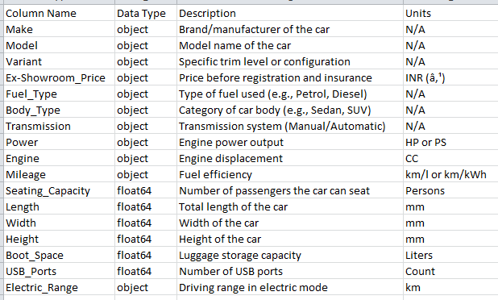
6. Column-wise Summary
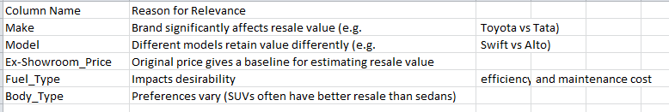
7. Data Cleaning
- Make has 75 missing values
- Body_Type has 6 missing entries
- Ex-Showroom_Price was improperly typed as string
- Standardization Needed for categorical columns like "suv" vs "SUV".

Note:
🔹 Dataset Format
Choose any one of the following formats:
- .csv, .xls, .xlsx
- .txt (structured data with tab/comma delimiter)
🔹 Dataset Size
To balance manual analysis and realism, set a manageable size:
- Rows: 30 to 100 records
- Columns (Features): 6 to 12
🔎 Tip: Subset larger datasets if needed (e.g., take first 50 rows or select only relevant columns).

Post Lab Questions:
🔶 Conceptual Questions
- What challenges did you face while exploring the raw dataset manually?
- Interpreting large amounts of data without easy visuals is time consuming.
- How would using Python/Tableau make this process easier?
- Python can automate many processes within Tableau, improving efficiency and reducing the time needed for analysis.
- Why is data cleaning a critical step before visualization?
- It ensures the accuracy, consistency, and reliability of the data without which visuals can be misleading, leading to incorrect interpretations..
🔶 Data-Specific Analysis
- Which column(s) in your dataset had the most missing or inconsistent values?
- Recommended Tyre Pressure and Other Specs had the most missing values.

- Based on your problem statement, which three features are most important and why?
- If the objective is to predict car prices then Ex-Showroom Price, Power, Engine type, Fuel type and Body type would be important.
- If the objective is to analyze fuel efficiency then Fuel type, ARAI certified mileage, city and highway mileage would be important.
- If the objective is to understand vehicle safety then Airbags, ABS, EBD, and Child Safety Locks would be important.

- What kinds of visualizations could best represent your final cleaned data?
- Scatter Plots for comparisons
- Histograms or Density Plots for Power and Efficiency figures
- Bar Charts for price and engine and transmission countables

Conclusion:
In this exp, I learnt to clean a real dataset of the resale car market in India and the factors affecting resale prices. I also understood the importance of cleaning a dataset for accurate visualisations later.

Signature of faculty in-charge with Date:

