Course Name: | Data Visualization Laboratory (Honours_ Data Science for Emerging Analytics) | Semester: | III
Date of Performance: |  | Batch No: | A1
Faculty Name: | Dr. Rupali Patil | Roll No: | 44
Faculty Sign & Date: |  | Grade/Marks: | XX/25

Experiment No: 2
Title: Datasets Importing and Preprocessing

Aim and Objective of the Experiment:
- To learn how to import and prepare datasets using Python in VS Code and Google Colab.
- To understand and perform various steps of data cleaning and preprocessing.
- To explore the importance of preprocessing for visualization and analytics.

COs to be achieved:
CO1: Learn how to locate and download datasets, extract insights from that data and present their findings in a variety of different formats
CO3: Apply data visualization best practices

Tools required:
Python

Code/Task:
🔹 Dataset Reuse:
Use the same dataset selected in Experiment 1 or any other. (Make sure it is in .csv, .xlsx, or .txt format.)
🔹 Part A: Import Dataset
✔ In VS Code
- Create a new .py file.
- Use the following Python code to load the dataset:

import pandas as pd

# Load the dataset from your local system
df = pd.read_csv('your_dataset.csv') # or pd.read_excel('your_dataset.xlsx')
print(df.head()) # First 5 records
print(df.info()) # Data types and non-null info
print(df.describe()) # Summary statistics
💡 Save your dataset in the same folder as your .py file.
✔ In Google Colab
from google.colab import files
uploaded = files.upload()

import pandas as pd
import io

# Load dataset
df = pd.read_csv(io.BytesIO(uploaded['your_dataset.csv']))
df.head()
💡 Colab allows quick uploads and runs in the cloud – no setup needed.
🔹 Part B: Understanding the Dataset
df.shape # Number of rows and columns
df.columns # List of column names
df.dtypes # Data types of each column
df['col'].unique() # Unique values in a column
df['col'].value_counts() # Frequency of values
df.info(), df.describe()
🔹 Part C: Preprocessing Tasks in Python
Task | Sample Code
1. Check for Missing Values | df.isnull().sum()
2. Drop Rows with Missing Values | df.dropna(inplace=True)
3. Replace Missing Values | df.fillna(df.mean()) or df['col'].fillna(df['col'].mode()[0])
4. Drop Irrelevant Columns | df.drop(['col_name'], axis=1)
5. Encode Categorical Columns | pd.get_dummies(df['col']) or LabelEncoder
6. Normalize Numerical Data | (df - df.min()) / (df.max() - df.min())
7. Sort Data | df.sort_values(by='col', ascending=True)
8. Rename Columns (if needed) | df.rename(columns={'old_name':'new_name'}, inplace=True)

🔹 Add 4-5 commands with explanations in Part B and Part C relevant to your dataset

Output:
Part A:
VS Code:-
Code:
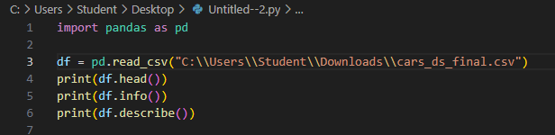
Output:
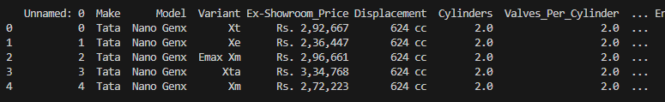
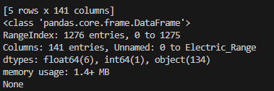
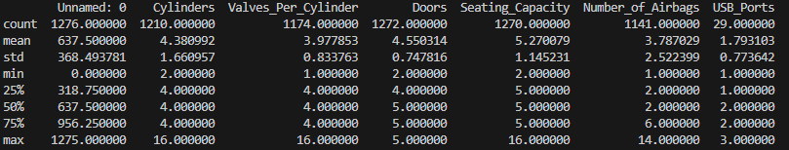

Google Colab:-
Outputs:
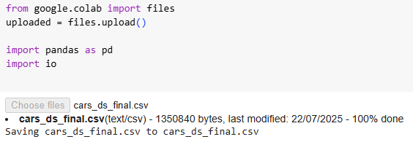
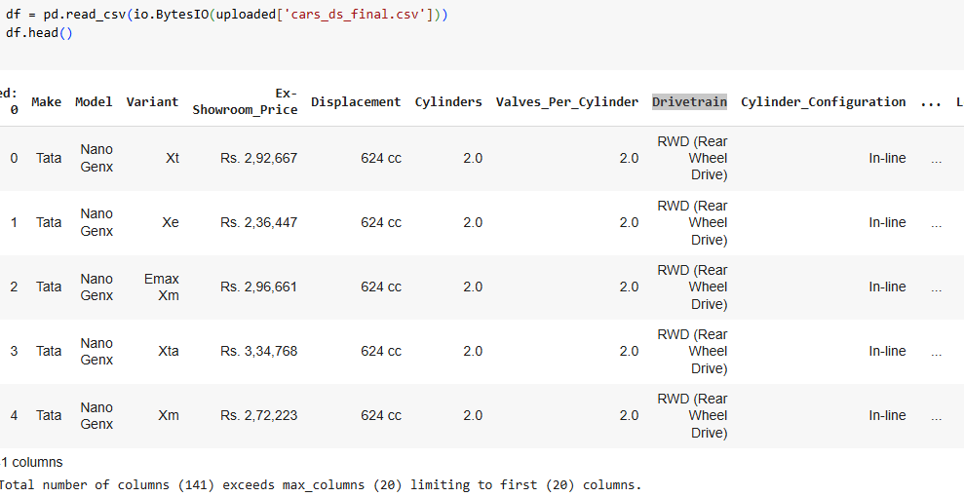
Part B:
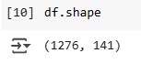
Inference: Dataset contains 1276 rows and 141 columns

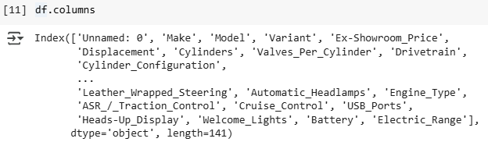
Inference: Column names of the dataset are shown

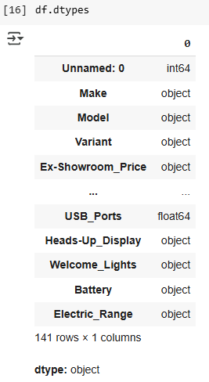
Inference: Helps in understanding types of data like categorical or numerical

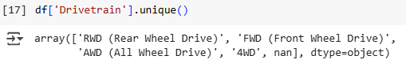
Inference: To know all types of drivetrain (or more specific about anyother column)

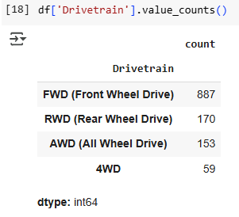
Inference: To know the no. of vehicles with the given drivetrain and understanding the market in a better way

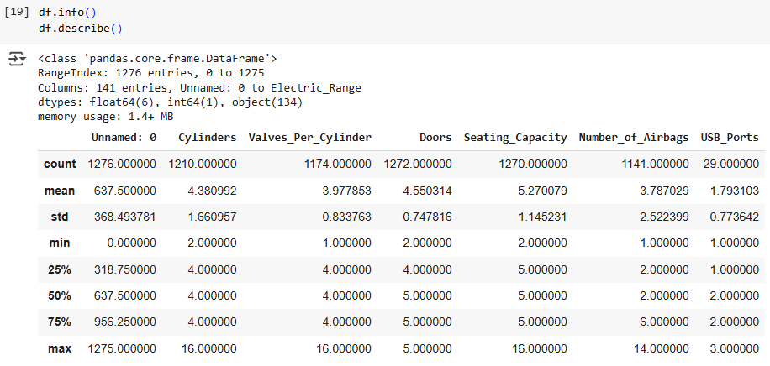
Inference: To give a short summary of the dataset

Part C:
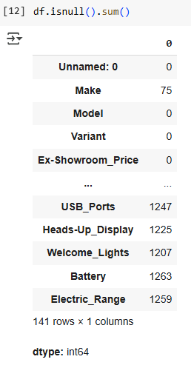
Inference:

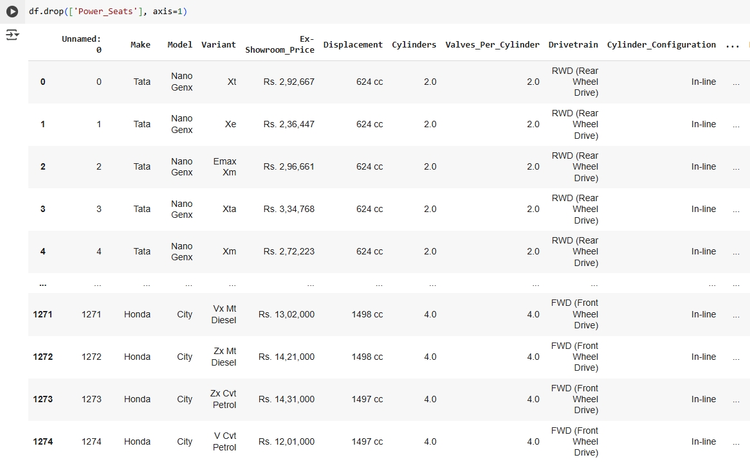
Inference: Insufficient data in the above column and is not a significant feature for buying a car

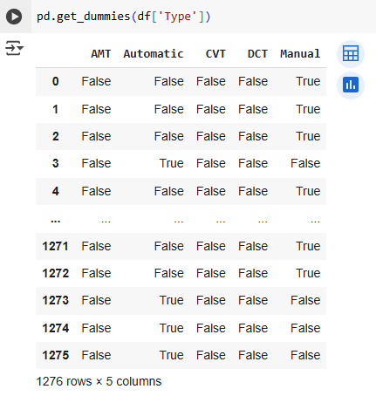
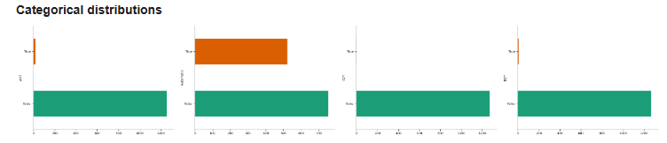Inference: Changes categorical to Binary value

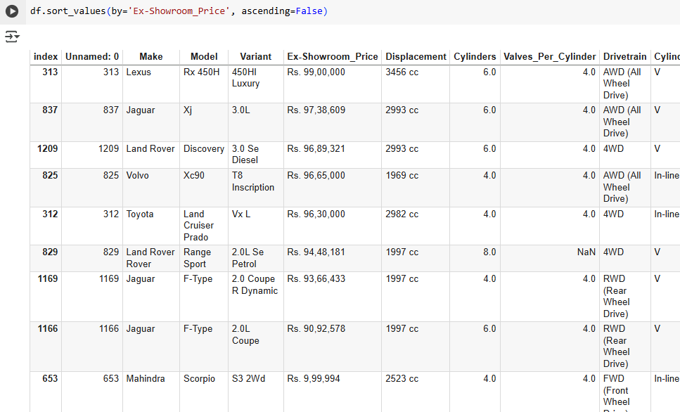
Inference: Helps to find the car within a price bracket

Post Lab Questions:
- Why is data preprocessing essential before visualization?
- For clean and relevant data which will help in making accurate visualizations.

- What methods are used for handling missing values?
- mean, median, mode and deletion

- What is the difference between normalization and standardization?
- Normalization scales to 0 to 1 while standardization scales to any other suitable range

- Which preprocessing steps were most relevant to your dataset?
- missing value handling, normalization, and encoding categorical variables (like unique func).

- If no cleaning was needed, what kind of additional transformation could still help?
- Sorting, Normalisation, etc.

Conclusion:
In this exp, I learnt how to import datasets in VS Code and Google Colab (using Python). I learnt cleaning techniques such as handling missing values, encoding categorical variables, etc. These preprocessing steps ensured that the dataset was accurate and consistent for later visualization and analysis.

Signature of faculty in-charge with Date:

