Course Name: | Data Visualization Laboratory (Honours_ Data Science for Emerging Analytics) | Semester: | III
Date of Performance: |  | Batch No: | A1
Faculty Name: | Dr. Rupali Patil | Roll No: | 44
Faculty Sign & Date: |  | Grade/Marks: | XX/25

Experiment No: 3
Title: Data visualization using various graphs and tables

Aim and Objective of the Experiment:
- To visualize the dataset prepared in Experiment 1 using various charts and plots.
- To interpret key insights from each visualization.
- To understand how visualization simplifies data analysis.

COs to be achieved:
CO1: Learn how to locate and download datasets, extract insights from that data and present their findings in a variety of different formats
CO3: Apply data visualization best practices

Tools required:
Python (Matplotlib, Seaborn)

Code/Task:
Part A: Import and Setup
import pandas as pd
import matplotlib.pyplot as plt
import seaborn as sns

df = pd.read_csv('retail_data.csv') #load Experiment 1/any other dataset
df.info()

Part B: Sample Visualizations

1. Bar Chart – Count of Products by Category
Best Chart for Categorical Comparison
# Bar chart comparing product counts in each category
sns.countplot(x='Category', data=df, palette='viridis')
plt.title('Comparison of Products by Category')
plt.xlabel('Category')
plt.ylabel('Count of Products')
plt.show()

Output & Inference
- Bars will show how many products belong to Electronics, Food, and Clothing categories.
- Helps identify which category dominates (for example, if Electronics bar is highest).
2. Pie Chart – Returned Products
returned_counts = df['Returned'].value_counts()
plt.pie(returned_counts, labels=returned_counts.index, autopct='%1.1f%%')
plt.title('Returned Products Distribution')
plt.show()

Output & Inference: ~55% products were not returned.

3.Heatmap – Correlation of Numeric Fields
sns.heatmap(df.corr(numeric_only=True), annot=True, cmap='coolwarm')
plt.title('Correlation Heatmap')
plt.show()

Output & Inference: Unit Price and Quantity Sold have weak correlation.

Output:
Students should perform all visualizations mentioned in Experiment 1 on the dataset selected in Experiment 1

Students are supposed to add results as per the following format:
Code and output screenshot of every visualization
Related Inference/explanation/conclusion as per selected dataset

1:
sns.countplot(x='Make', data=df, palette='viridis')
plt.title('Sales of cars by Company')
plt.xlabel('Company')
plt.ylabel('Number of Cars')
plt.show()
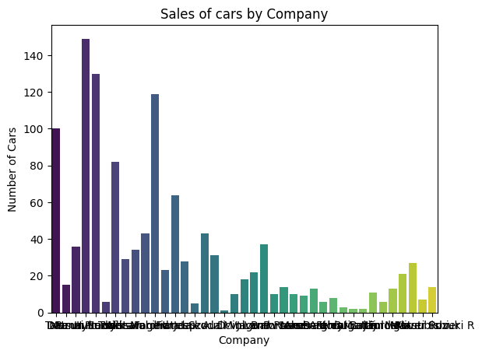
Inference: Which car company has the highest sales

2:
plt.figure(figsize=(8, 5))
sns.countplot(data=df, x='Fuel_Type', order=df['Fuel_Type'].value_counts().index)
plt.title('Count of Cars by Fuel Type')
plt.xticks(rotation=45)
plt.tight_layout()
plt.show()

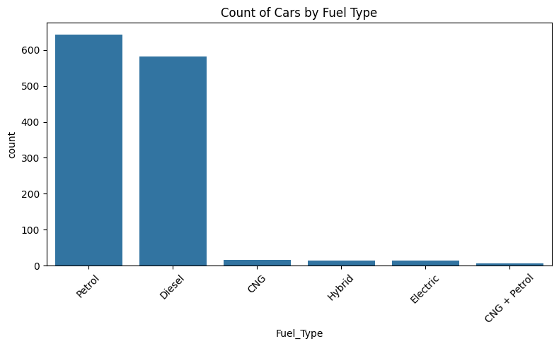
Inference: Which fuel type is the best selling

3:
df['Ex-Showroom_Price'] = df['Ex-Showroom_Price'].str.replace(r'[^\d.]', '', regex=True).astype(float)

plt.figure(figsize=(8, 5))
sns.histplot(df['Ex-Showroom_Price'].dropna(), bins=30, kde=True)
plt.title('Distribution of Ex-Showroom Prices')
plt.xlabel('Price (in ₹)')
plt.tight_layout()
plt.show()
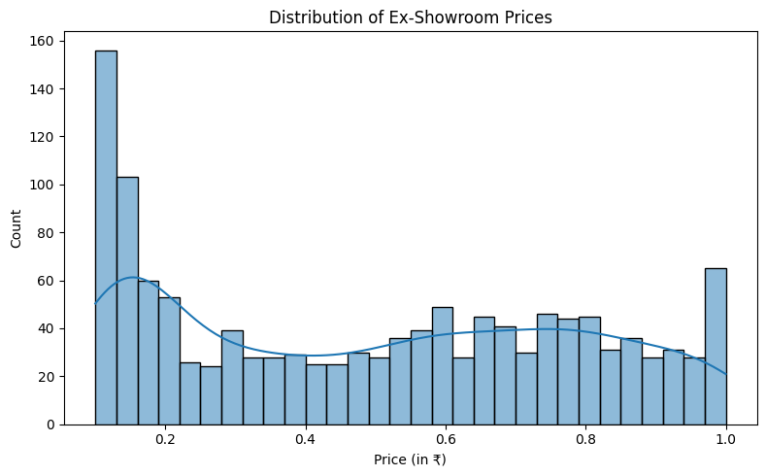
Inference: Shows the most selling price bracket

4:
top_makes = df['Make'].value_counts().nlargest(10)

plt.figure(figsize=(8, 5))
sns.barplot(x=top_makes.values, y=top_makes.index)
plt.title('Top 10 Most Frequent Car Brands')
plt.xlabel('Number of Models')
plt.tight_layout()
plt.show()

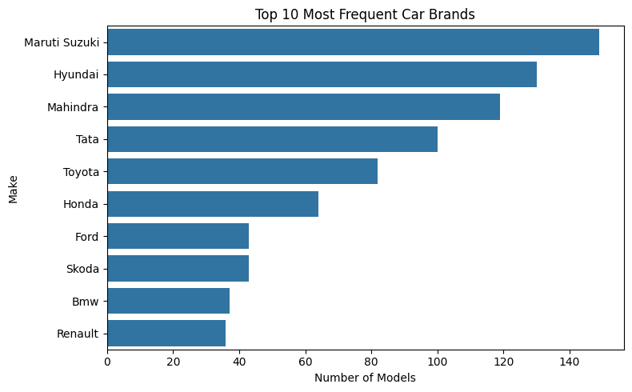
Inference: Best selling car brand

5:
plt.figure(figsize=(10, 6))
avg_price_by_body = df.groupby('Body_Type')['Ex-Showroom_Price'].mean().sort_values(ascending=False)

sns.barplot(x=avg_price_by_body.values, y=avg_price_by_body.index)
plt.title('Average Ex-Showroom Price by Body Type')
plt.xlabel('Average Price (₹)')
plt.tight_layout()
plt.show()
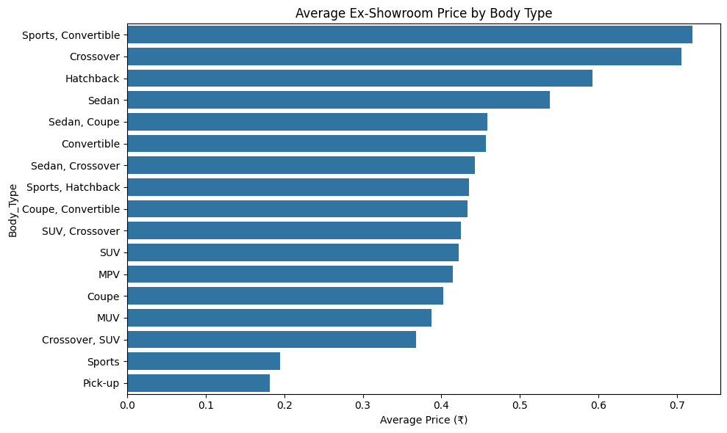
Inference: Average price of car per body type

6:
plt.figure(figsize=(8, 5))
sns.boxplot(data=df, x='Cylinders', y='Ex-Showroom_Price')
plt.title('Price Distribution by Number of Cylinders')
plt.tight_layout()
plt.show()

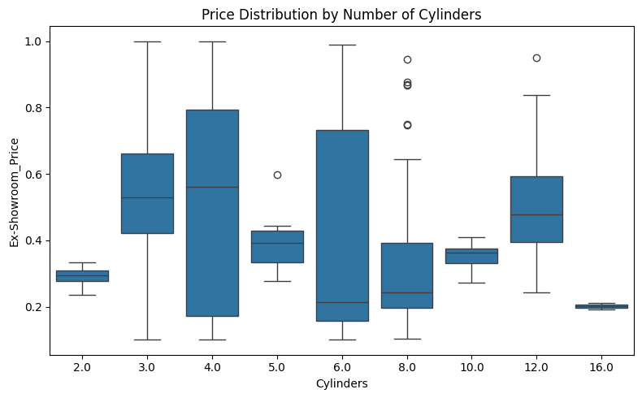
Inference: Car price compared with its cylinders in engine

7:
df['Drivetrain'].value_counts().plot.pie(autopct='%1.1f%%', figsize=(6, 6), title='Drivetrain Distribution')
plt.ylabel('')
plt.tight_layout()
plt.show()

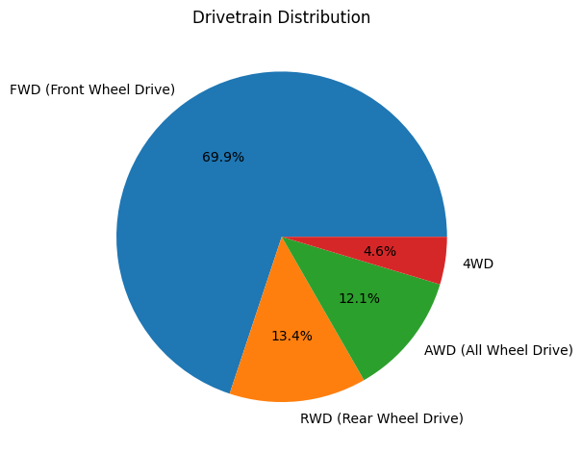
Inference: % share of each Drive type in the market

8:
plt.figure(figsize=(10, 6))
sns.boxplot(data=df, x='Body_Type', y='Ex-Showroom_Price')
plt.title('Price Distribution by Body Type')
plt.ylabel('Price (₹)')
plt.xticks(rotation=45)
plt.show()
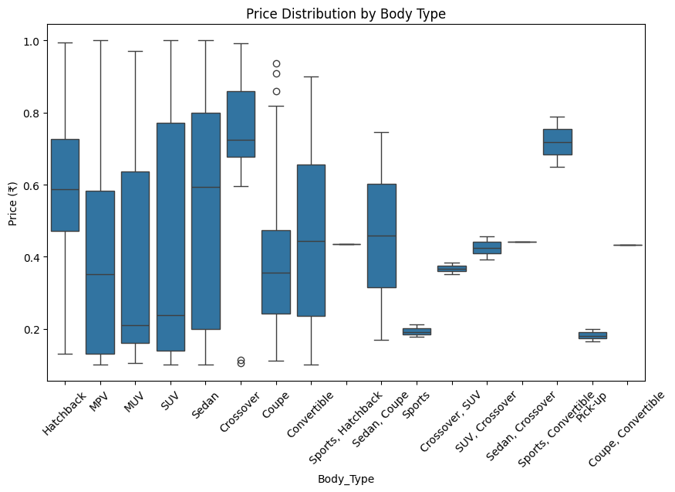
Inference: Price bracket of each body type

9:
plt.figure(figsize=(8, 6))
sns.countplot(data=df, x='Fuel_Type', hue='Drivetrain')
plt.title('Car Count by Fuel Type & Drivetrain')
plt.show()
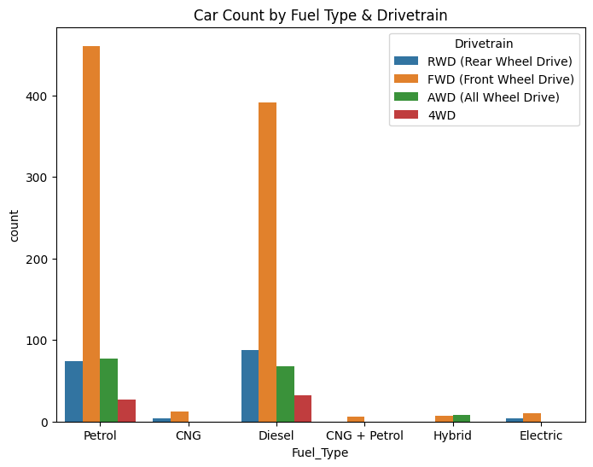
Inference: Sales of Drivetrain with each Fuel type

Post Lab Questions:
- Which visualization helped you understand your dataset best and why?
- bar chart
- How does visualization simplify identifying patterns compared to raw tables?
- Raw tables are very hard to refer and patterns can’t be easily detected with our eyes especially for huge datasets that is when Charts and Visualizations help
- Explain how correlation heatmap can help in decision-making.
- I haven’t found any suitable heatmap
- Which chart is best for categorical comparison and why?
- Count Plot because it is simple to understand like bar chart yet provides deep insights

Conclusion:
Through this experiment, I learned how to apply various visualisations like bar charts, pie charts, countplot and plots. I was able to identify patterns, trends and infer more easily than before (with raw tables). I have gained the ability to decide graphs based on the dataset.

Signature of faculty in-charge with Date:

