Course Name: | Data Visualization Laboratory (Honours_ Data Science for Emerging Analytics) | Semester: | III
Date of Performance: |  | Batch No: | A1
Faculty Name: | Dr. Rupali Patil | Roll No: | 16010324044
Faculty Sign & Date: |  | Grade/Marks: | XX/25

Experiment No: 4
Title: Data Importing, Preprocessing, and Visualization using Tableau

Aim and Objective of the Experiment:
- To import datasets into Tableau and prepare them for analysis.
- To perform basic preprocessing like renaming, removing null values, and changing data types in Tableau.
- To create meaningful visualizations using Tableau and derive insights.

COs to be achieved:
CO1: Learn how to locate and download datasets, extract insights from that data and present their findings in a variety of different formats
CO3: Apply data visualization best practices

Tools required:
Tableau

Code/Task:
Part A: Import and Basic Preprocessing
- Open Tableau and connect to the dataset (xyz.csv).
- Explore the data pane:
Data Cleaning:
Removing null or missing values
Replacing nulls with default values
Filtering out unwanted rows or columns
Splitting combined fields (e.g., splitting "Full Name" into First and Last Name)
Trimming whitespaces
Changing data types (e.g., string to date, integer to string)
Renaming fields for clarity
Data Aggregation and Grouping
Aggregating values (SUM, AVG, MIN, MAX)
Grouping similar categories (e.g., multiple brands under one parent brand)
Creating hierarchies (e.g., Country > State > City)
Sorting and Filtering
Sorting values (ascending/descending)
Applying filters to remove unwanted records
Using top N or conditional filters
Part B: Interactive Visualizations (Minimum 5)
Sample visualizations:
- Bar Chart: Compare product count by category.
- Pie Chart: Show the proportion of returned vs non-returned products.
- Histogram: Distribution of unit price.
- Box Plot: Quantity sold by category.
- Map or Tree Map: (if applicable based on dataset) showing distribution by store location.
Output:
Part A:
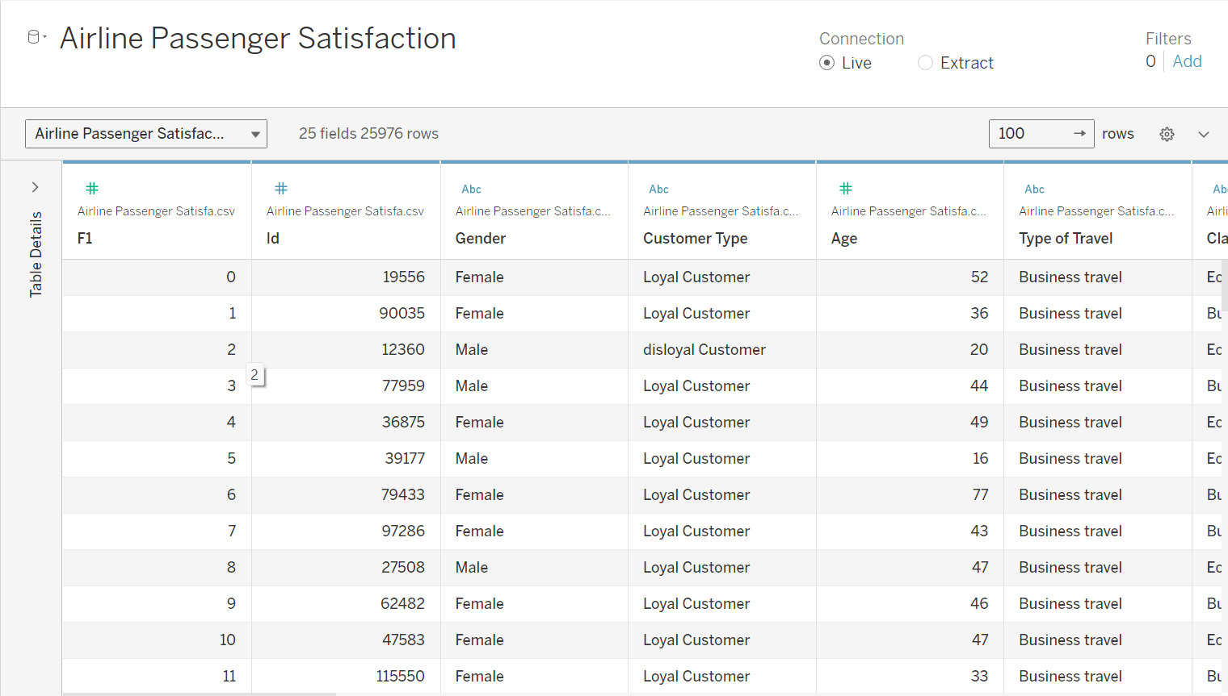
Data Cleaning:
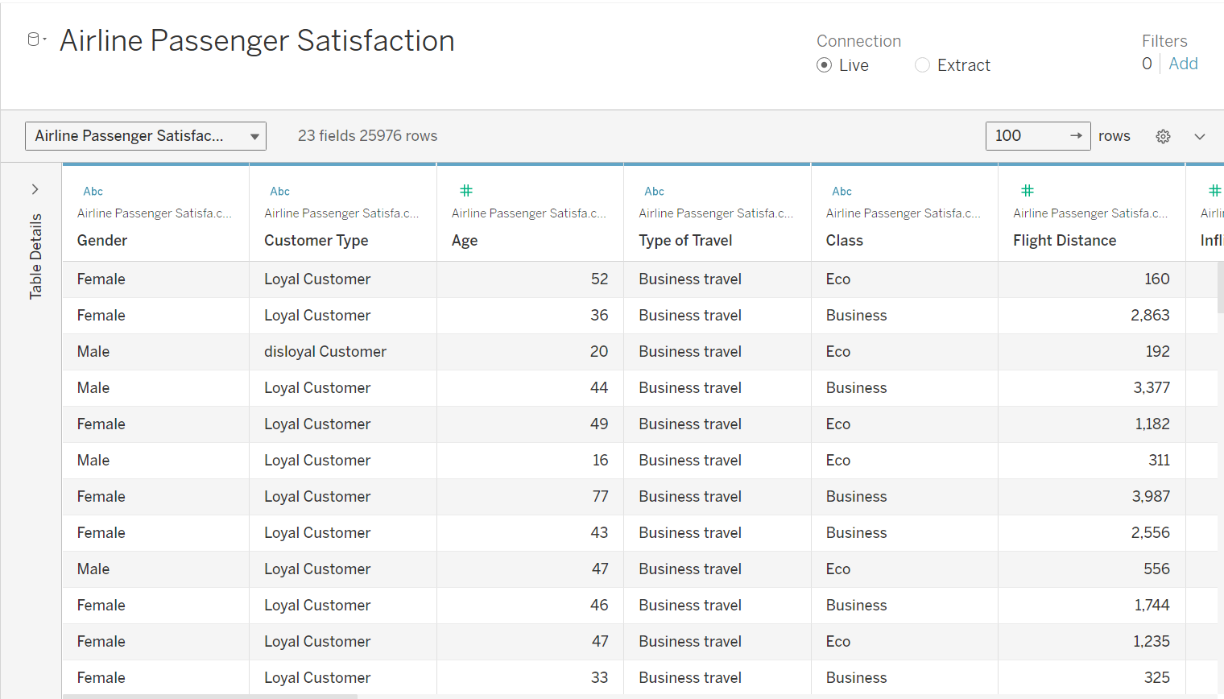

Data Sorting:
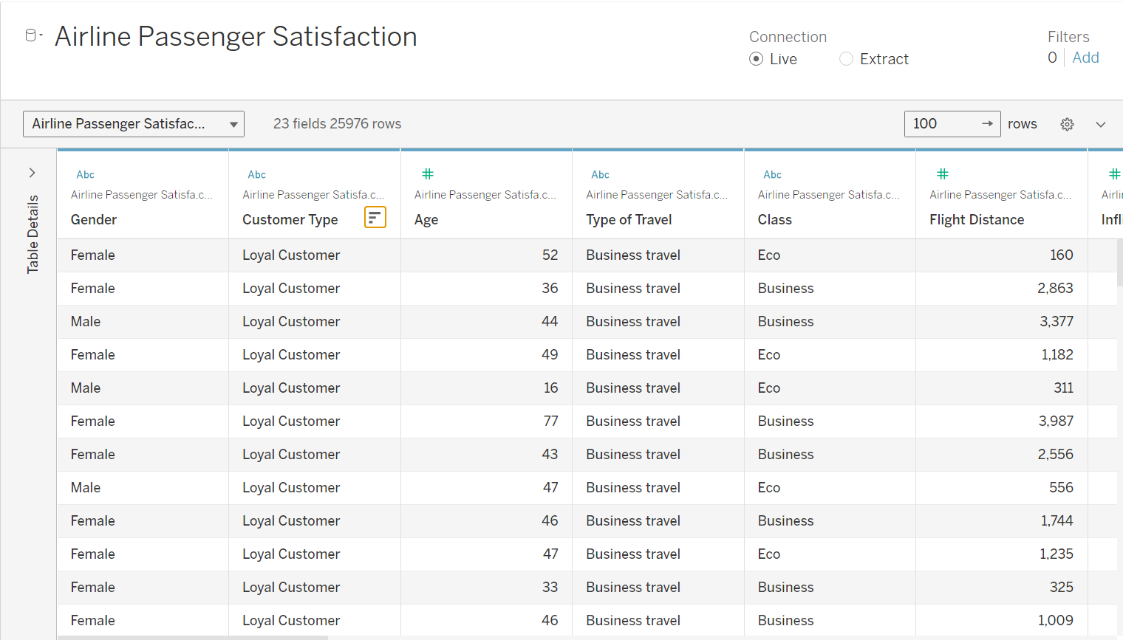

Part B:
Pie Charts:
1.
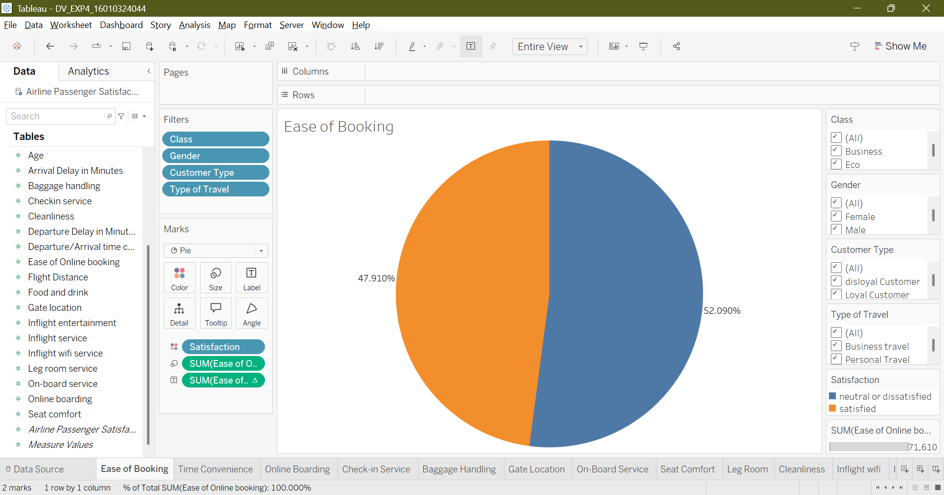
2.
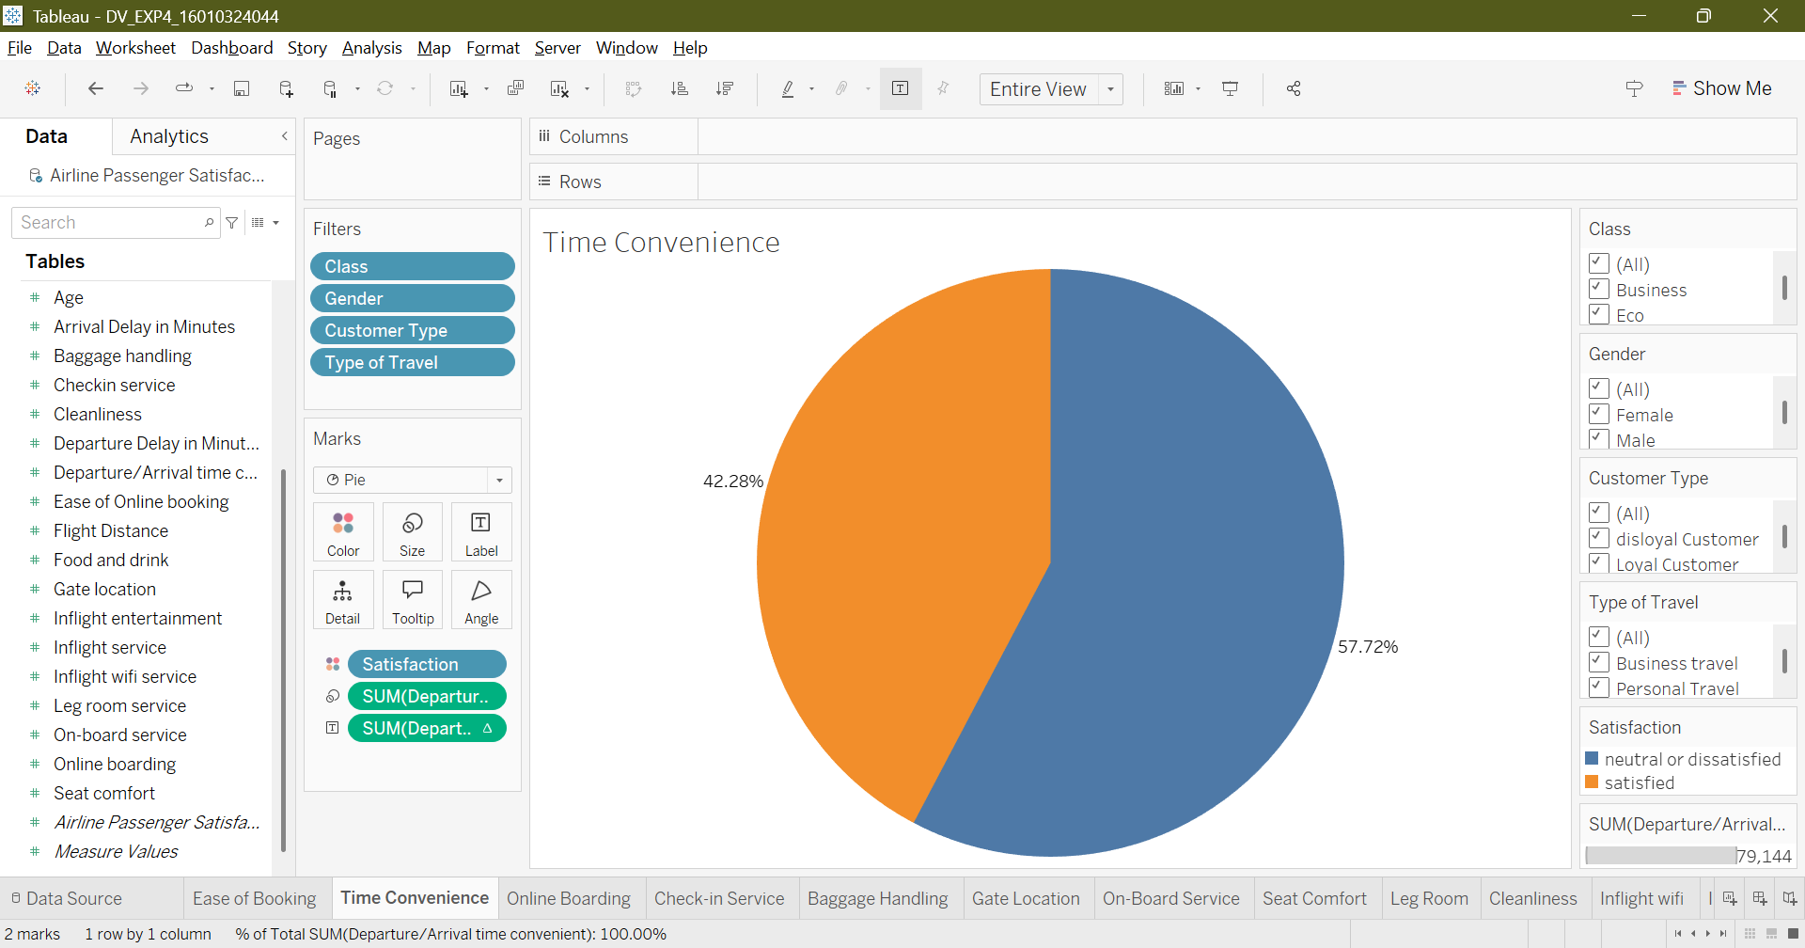
3.
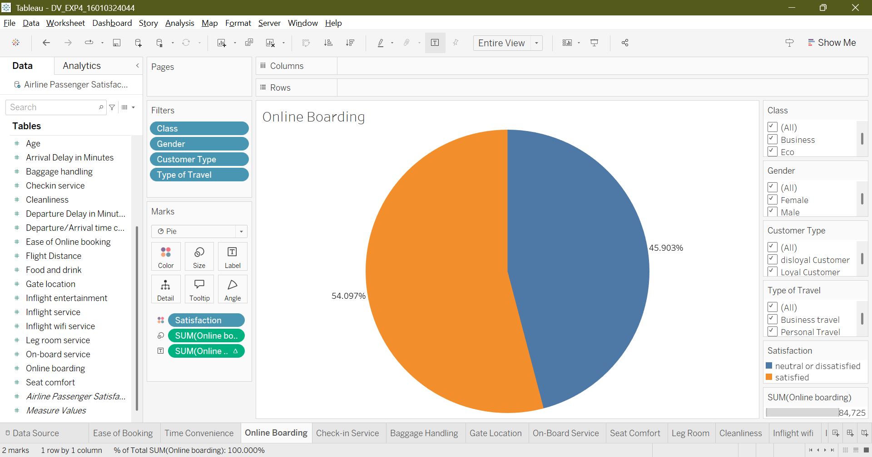
4.
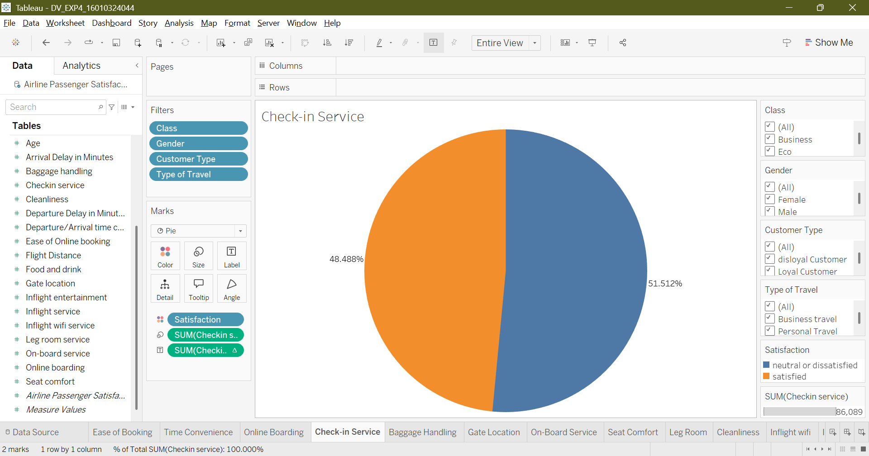
5.
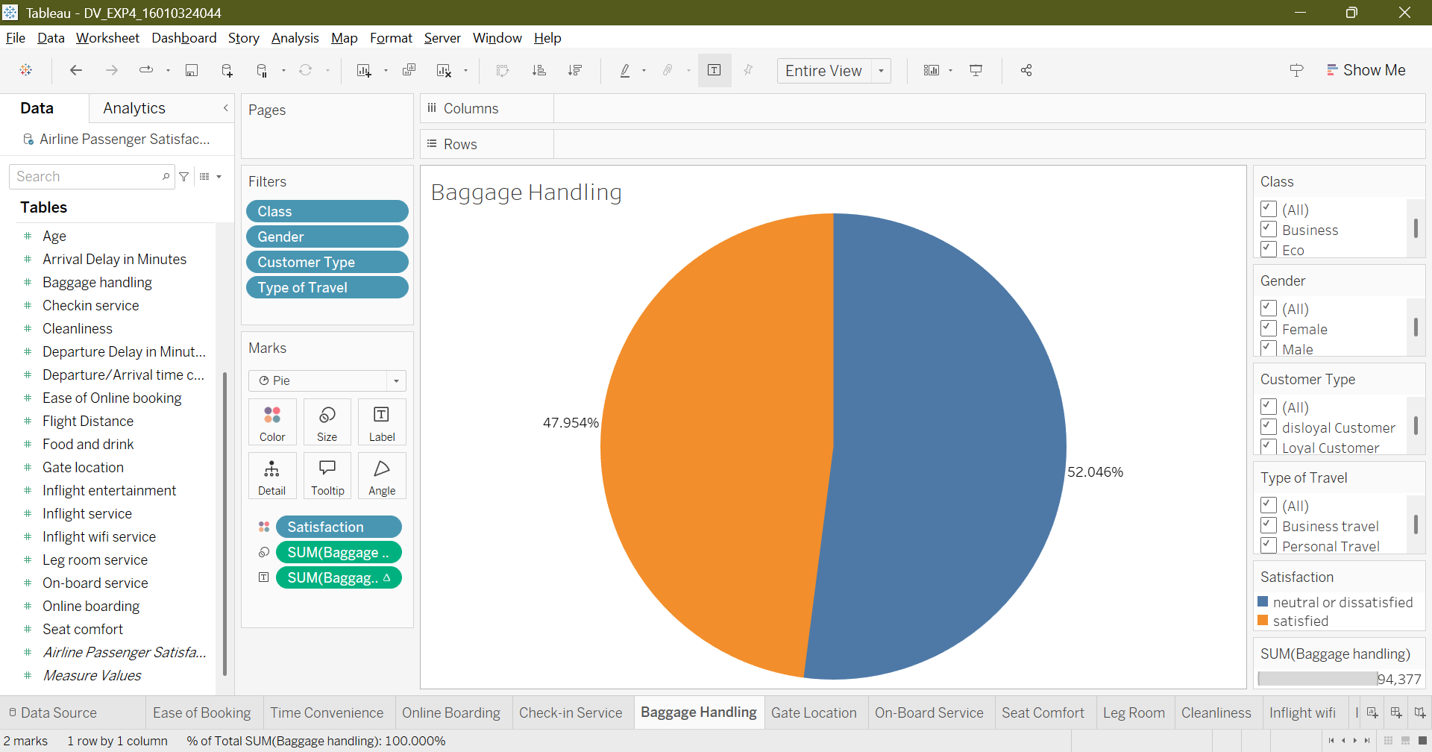
6.
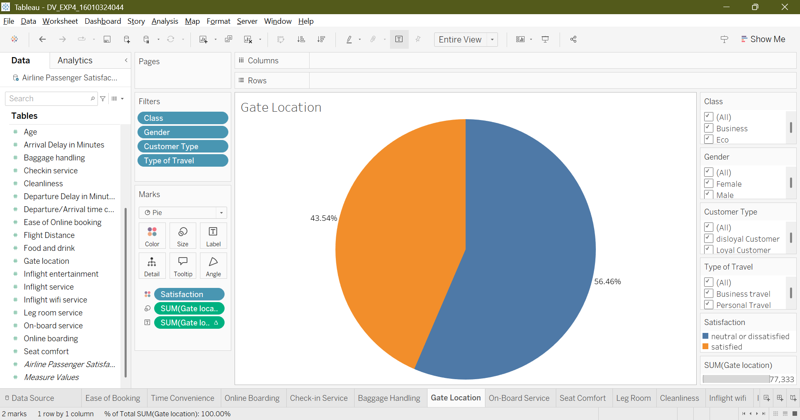
7.
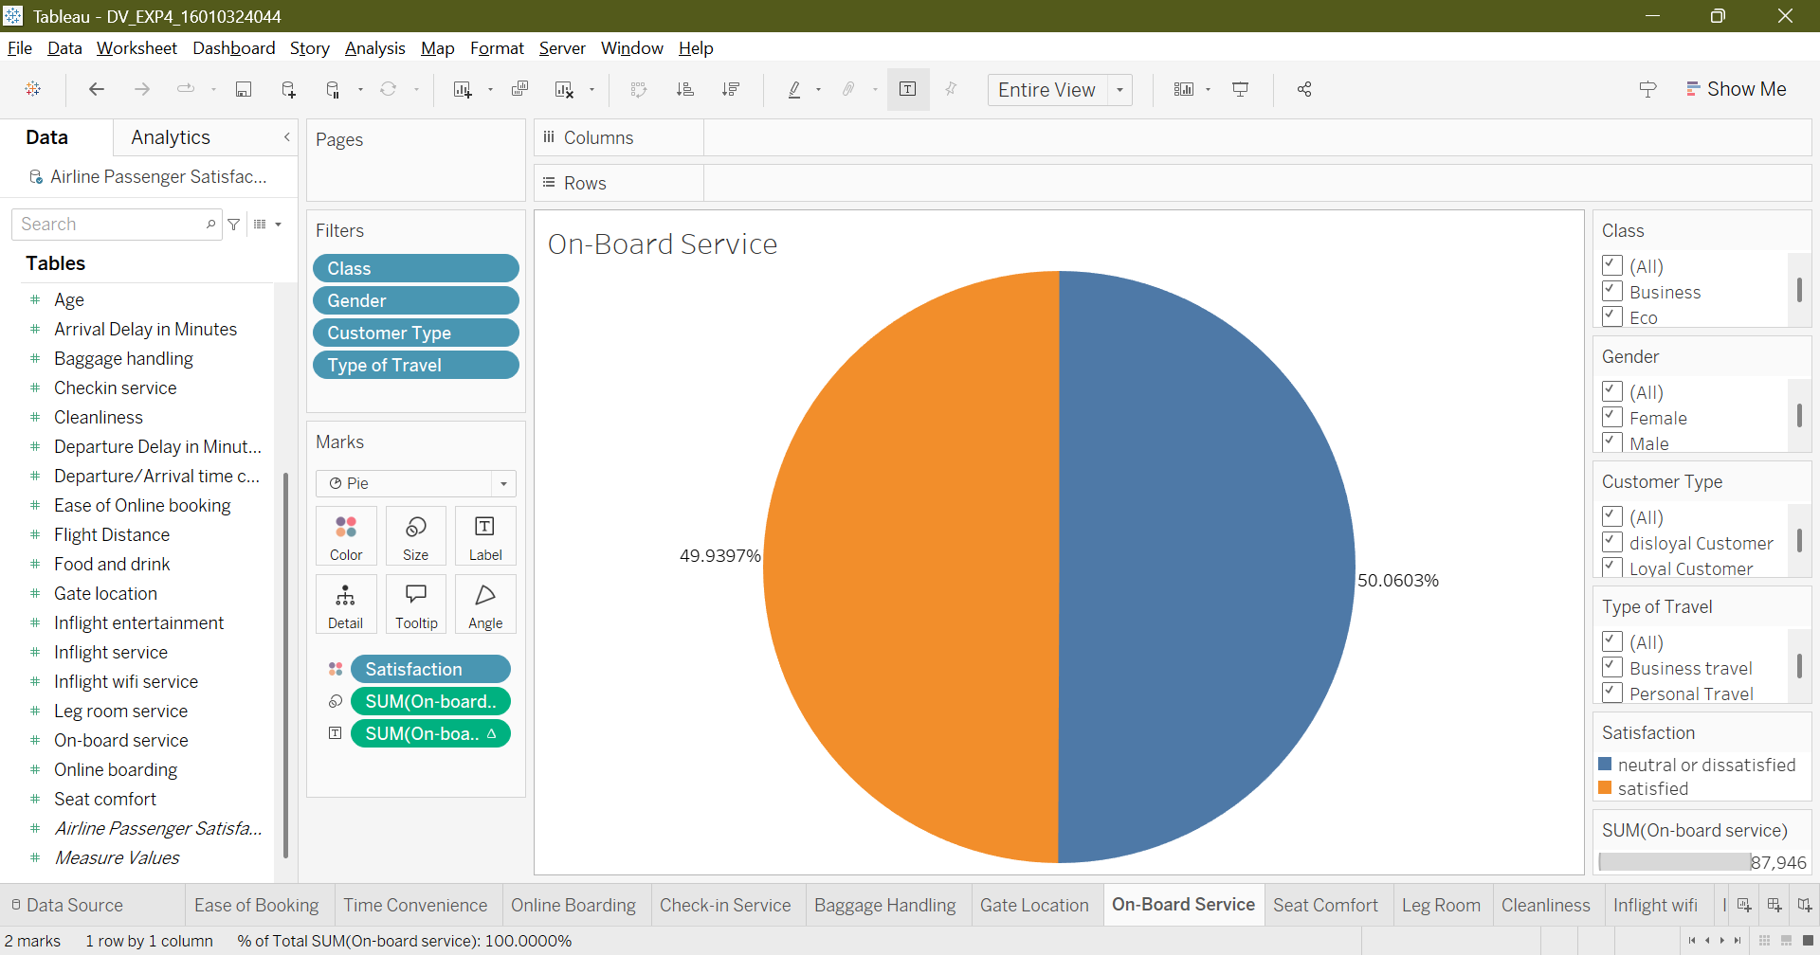
8.
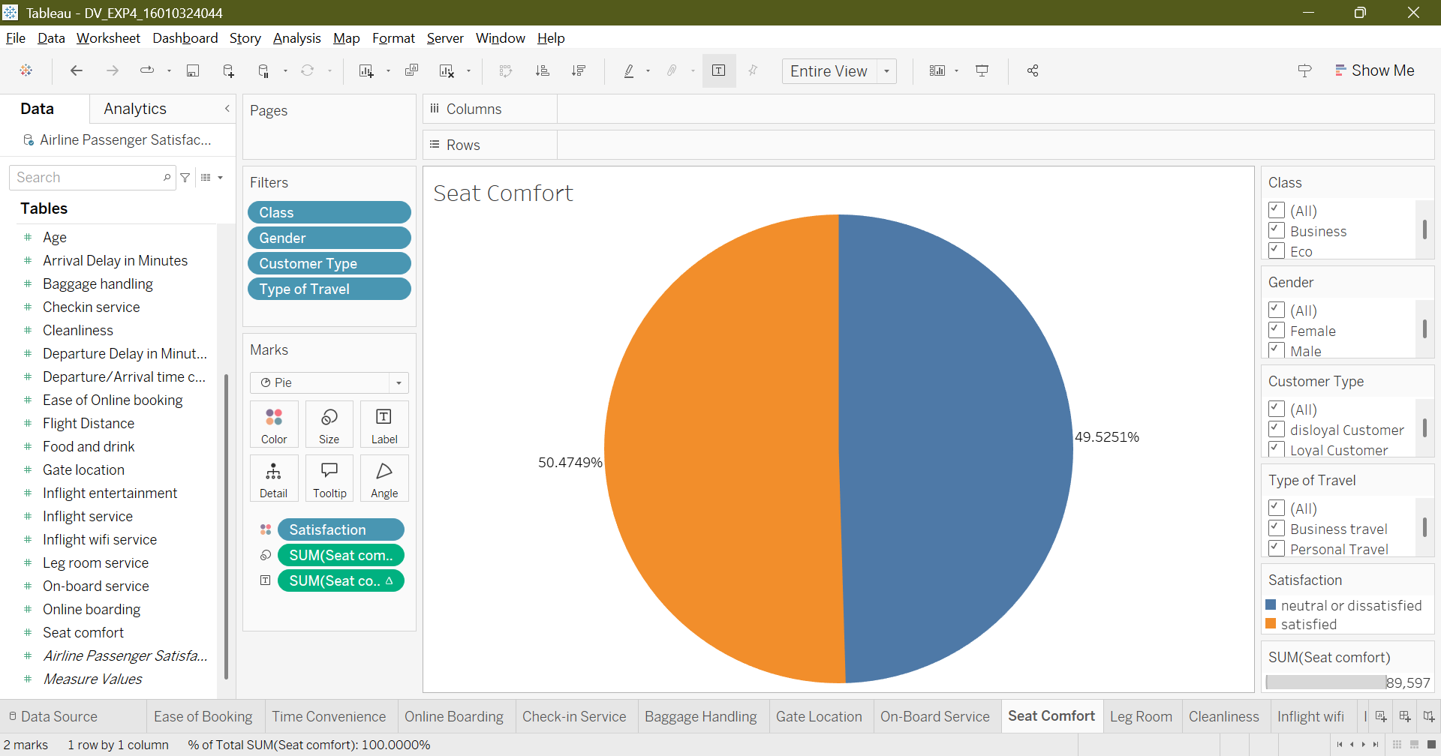
9.
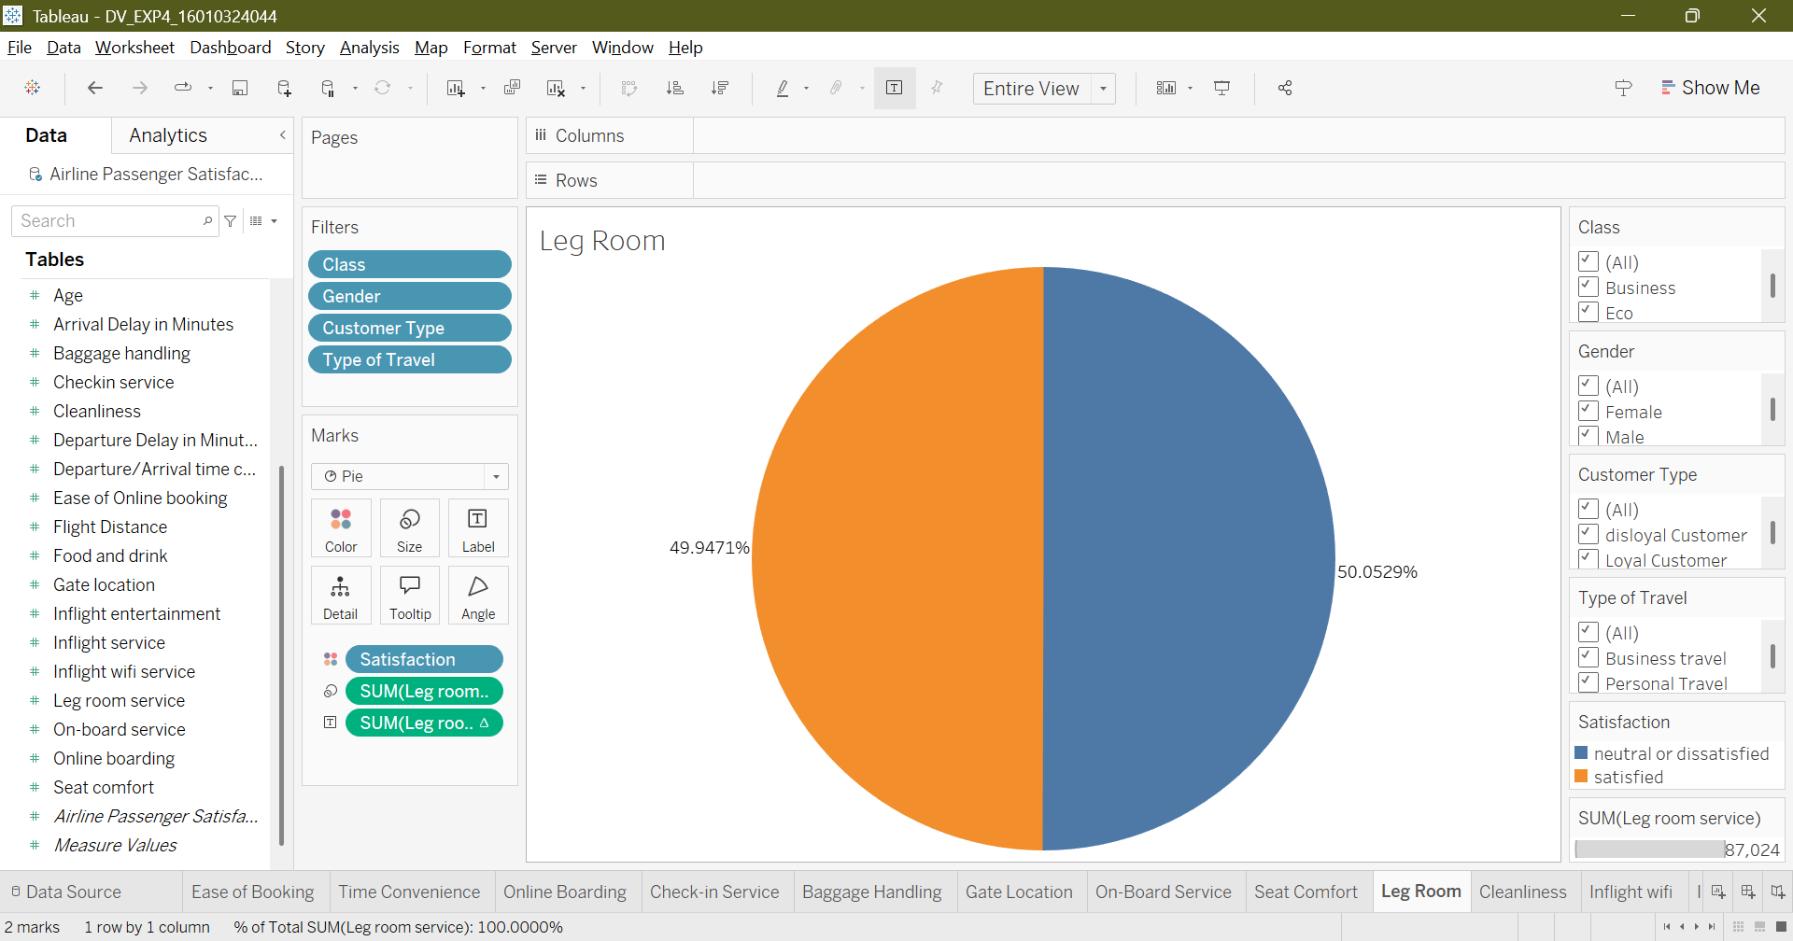
10.
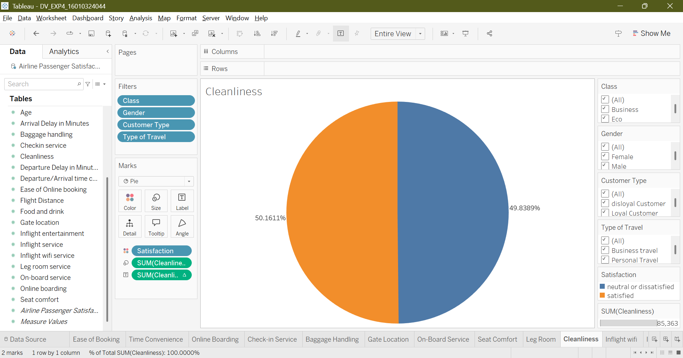
11.
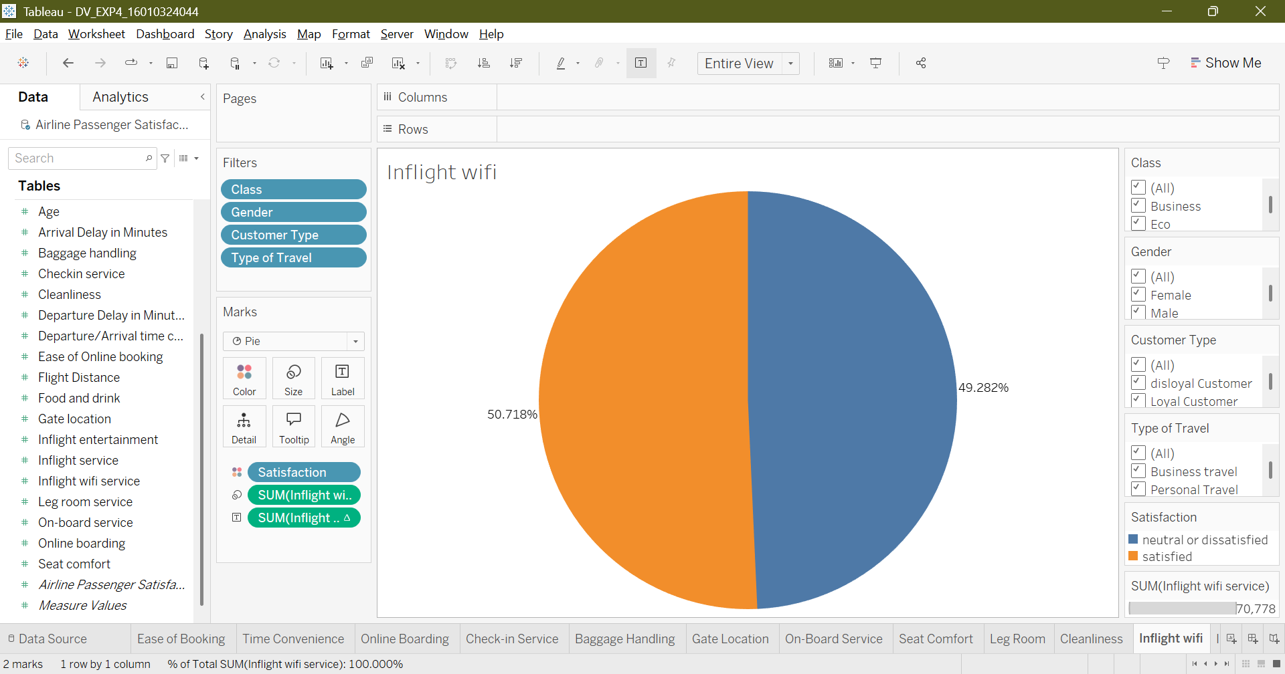
12.
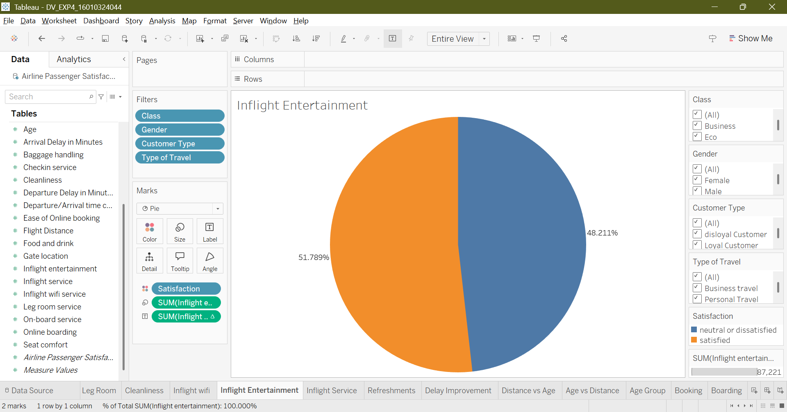
13.
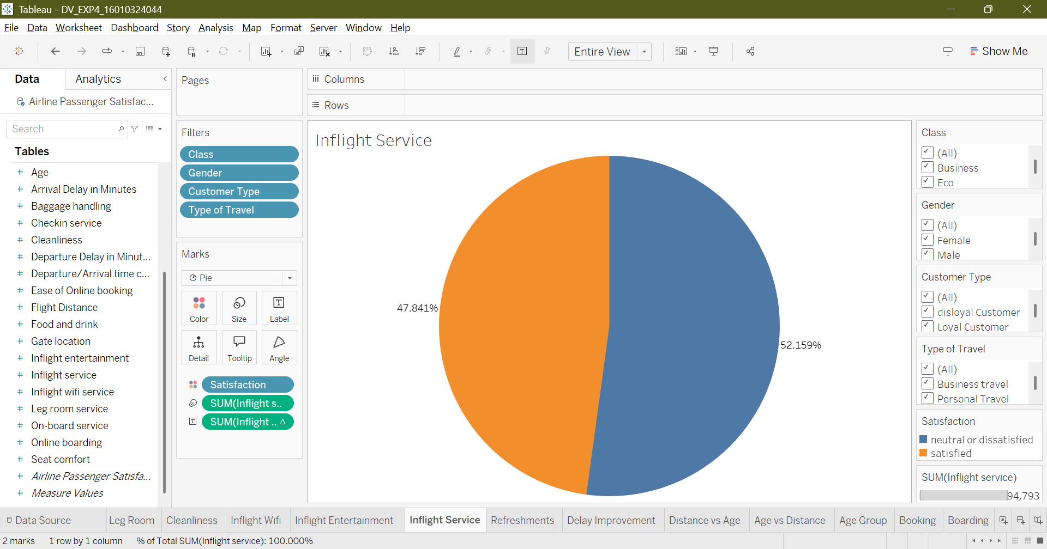
14.
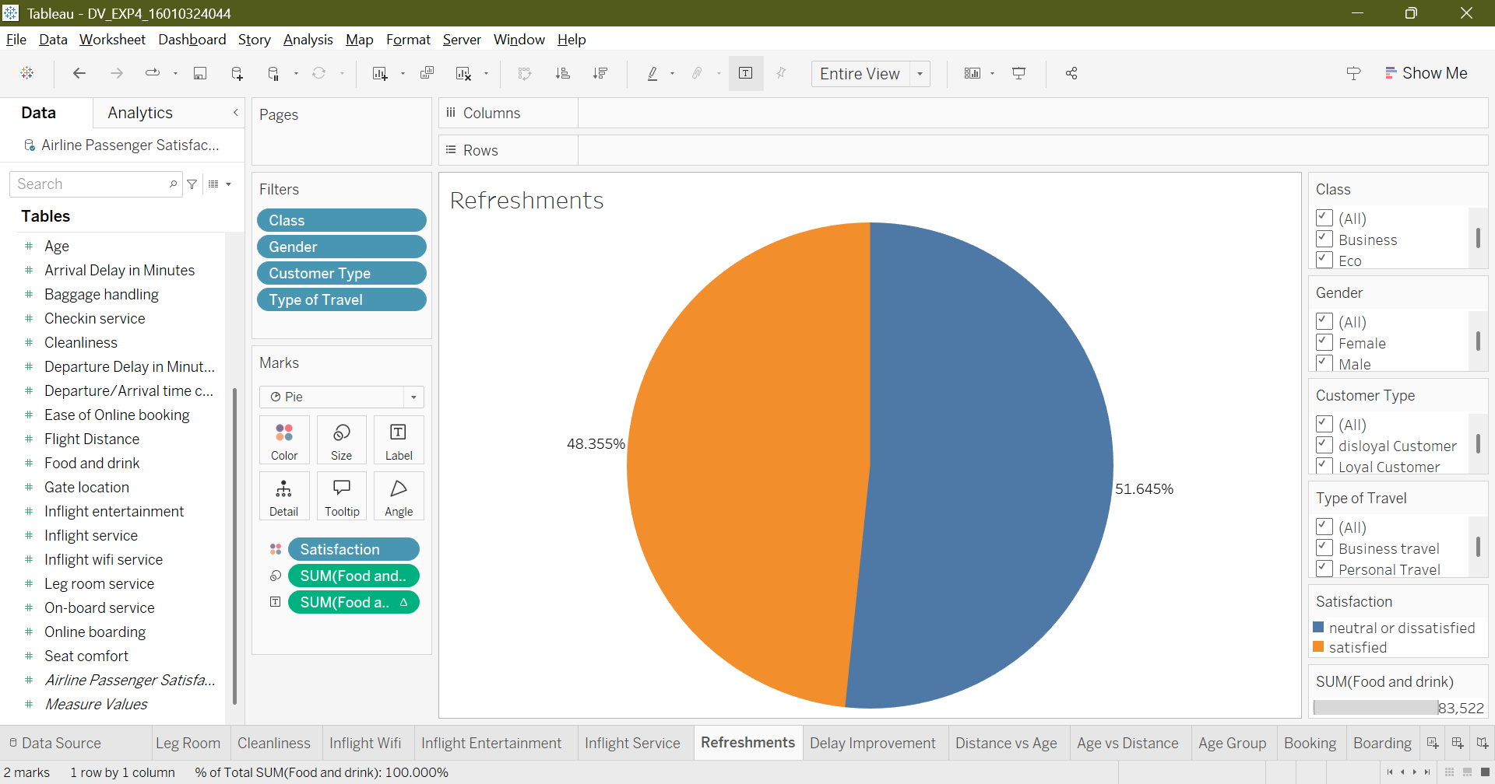

Bar Chart:
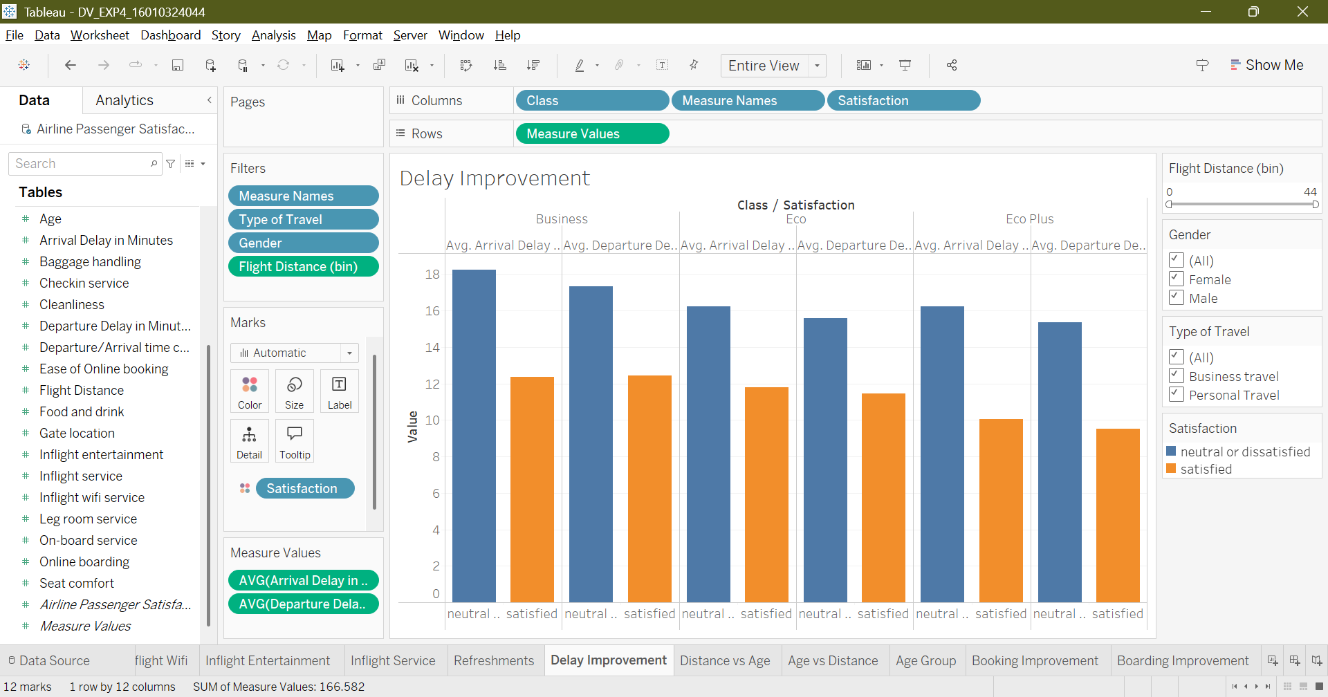

Histogram:
1.
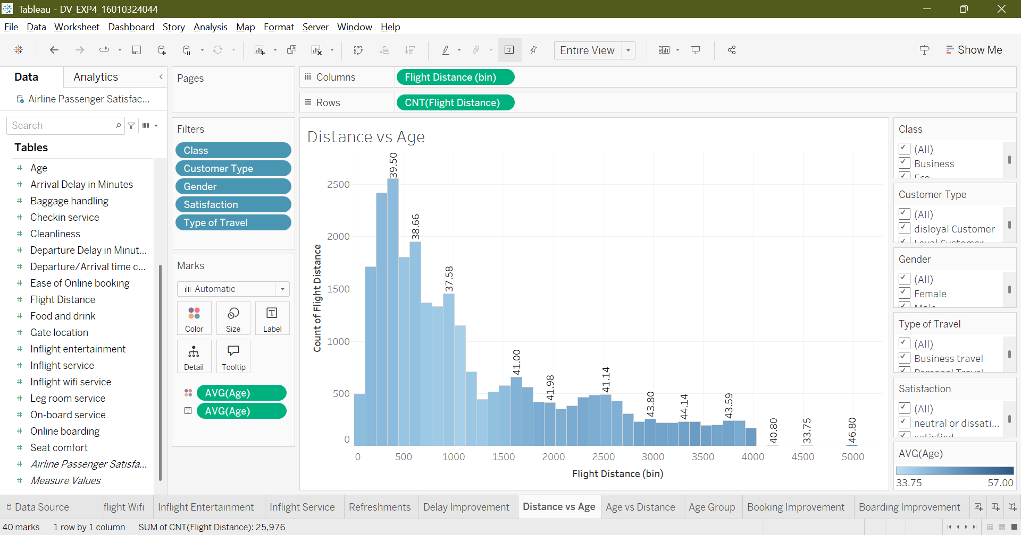
2.
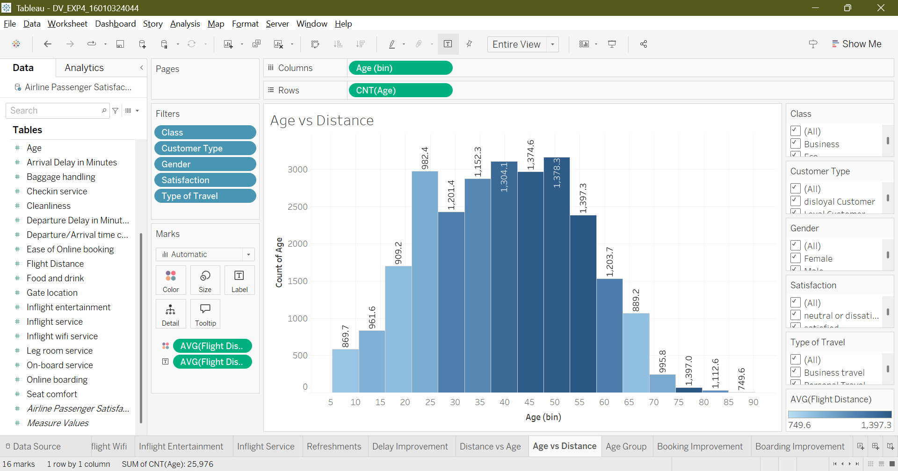

Treemap:
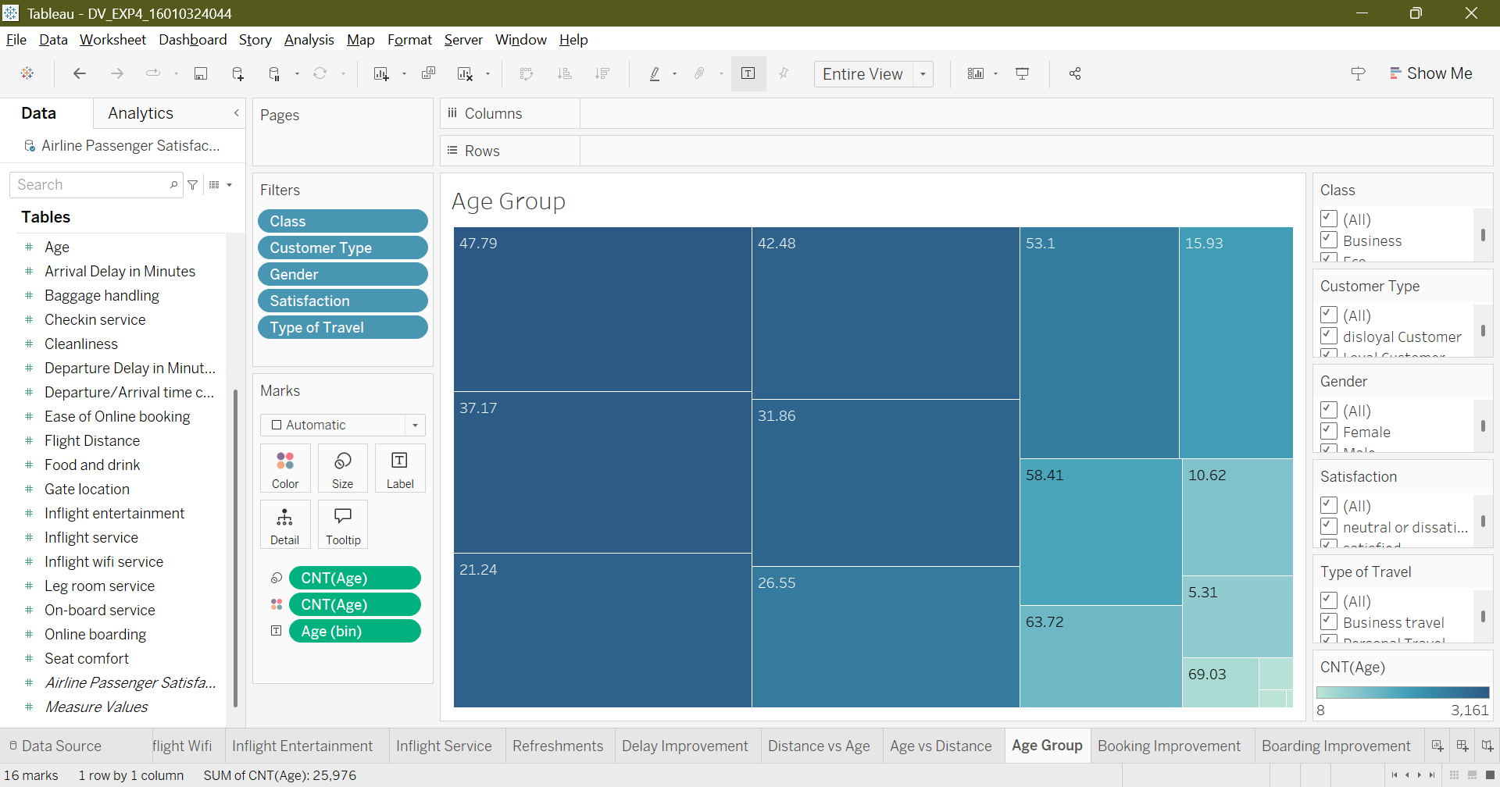

Box plot:
1.
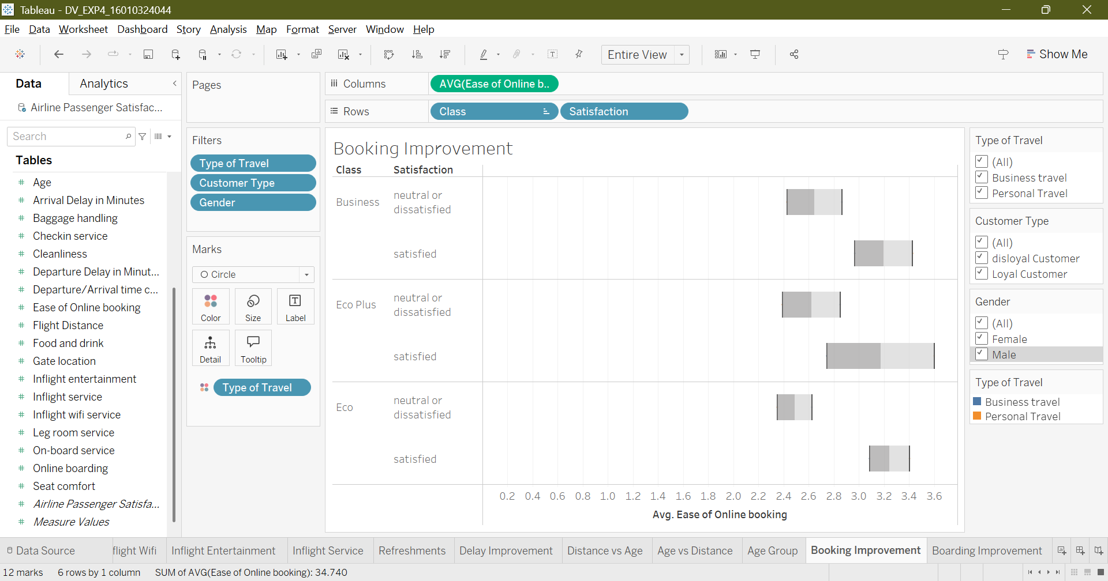
2.
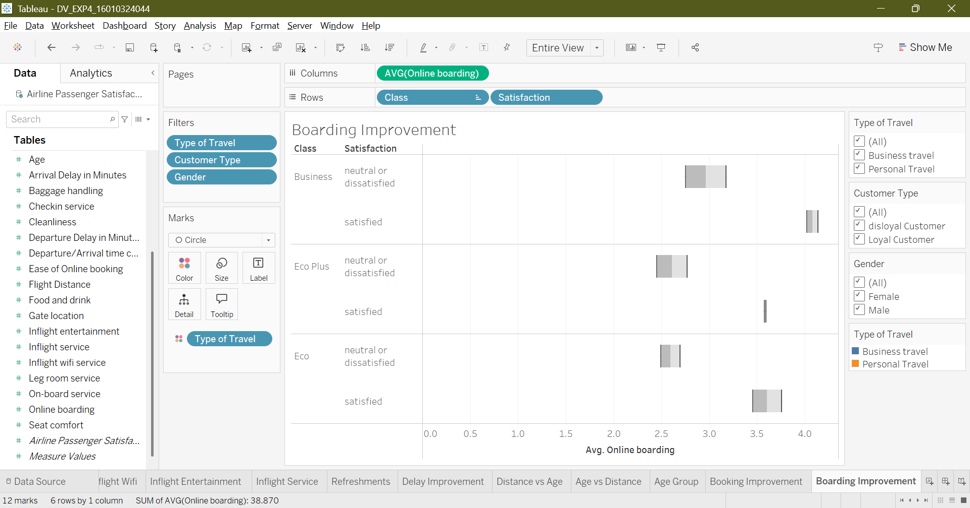

Post Lab Questions:
- Which visualization in Tableau gave you the most insight and why?
- In my case, Histogram because it was able to nicely relate distance and age data giving amazing insights

- How does Tableau handle missing values differently from Python?
- It is more user friendly because it is more GUI based and can smartly turn missing into zeros or fill it based on context

- What is the benefit of dashboards compared to individual charts?
- They provide an interactive experience when compared to the traditional charts

- Which chart is best for categorical comparison in Tableau and why?
- All bar charts because they are easy to understand still provides comprehensive information

Conclusion:
In this experiment, I learnt how to import datasets into Tableau, clean and preprocess it by handling null values, changing and sorting data types. I understood the power of Tableau in creating various visualizations such as bar charts, pie charts, histograms, box plots, etc.

Signature of faculty in-charge with Date:

