Course Name: | Data Visualization Laboratory (Honours_ Data Science for Emerging Analytics) | Semester: | III
Date of Performance: |  | Batch No: | A1
Faculty Name: | Dr. Rupali Patil | Roll No: | 16010324044
Faculty Sign & Date: |  | Grade/Marks: | XX/25

Experiment No: 5
Title: To create an effective Dashboard and Story

Aim and Objective of the Experiment:
- To design an interactive and insightful Dashboard in Tableau.
- To create a Story in Tableau that communicates insights effectively.
- To understand how dashboard interactivity (filters, actions) enhances decision-making.

COs to be achieved:
CO1: Learn how to locate and download datasets, extract insights from that data and present their findings in a variety of different formats
CO3: Apply data visualization best practices

Tools required:
Tableau

Code/Task:

Part A: Dashboard Creation
- Prepare Your Worksheets:
  - Create at least 3–5 visualizations from your dataset (e.g., bar chart, pie chart, map, trend line, tree map).
  - Ensure each visualization has relevant titles and cleaned data.
- Build Dashboard:
  - Go to the New Dashboard.
  - Drag prepared worksheets into the dashboard layout.
  - Adjust sizing to Fit Entire View.
  - Arrange charts logically (related visuals near each other).
- Add Interactivity:
  - Add filters (e.g., filter by category, date, or region).
  - Add highlight actions (clicking on a bar highlights related data in other charts).
  - Add URL actions (optional, open links to product pages or reports).
- Formatting:
  - Use consistent color palette.
  - Add a title and description.
  - Avoid clutter by balancing white space.

Part B: Story Creation
- New Story:
  - Click New Story from bottom tab bar.
  - Drag sheets or dashboards into story points.
- Narrative Flow:
  - Each story point should answer a question (e.g., “Which category sells most?” → “Why is this category growing?” → “What can be improved?”).
  - Add captions explaining insights.
- Final Touches:
  - Use filters within story points to focus on key areas.
  - Keep it concise and visually engaging.

Output:
Part A:
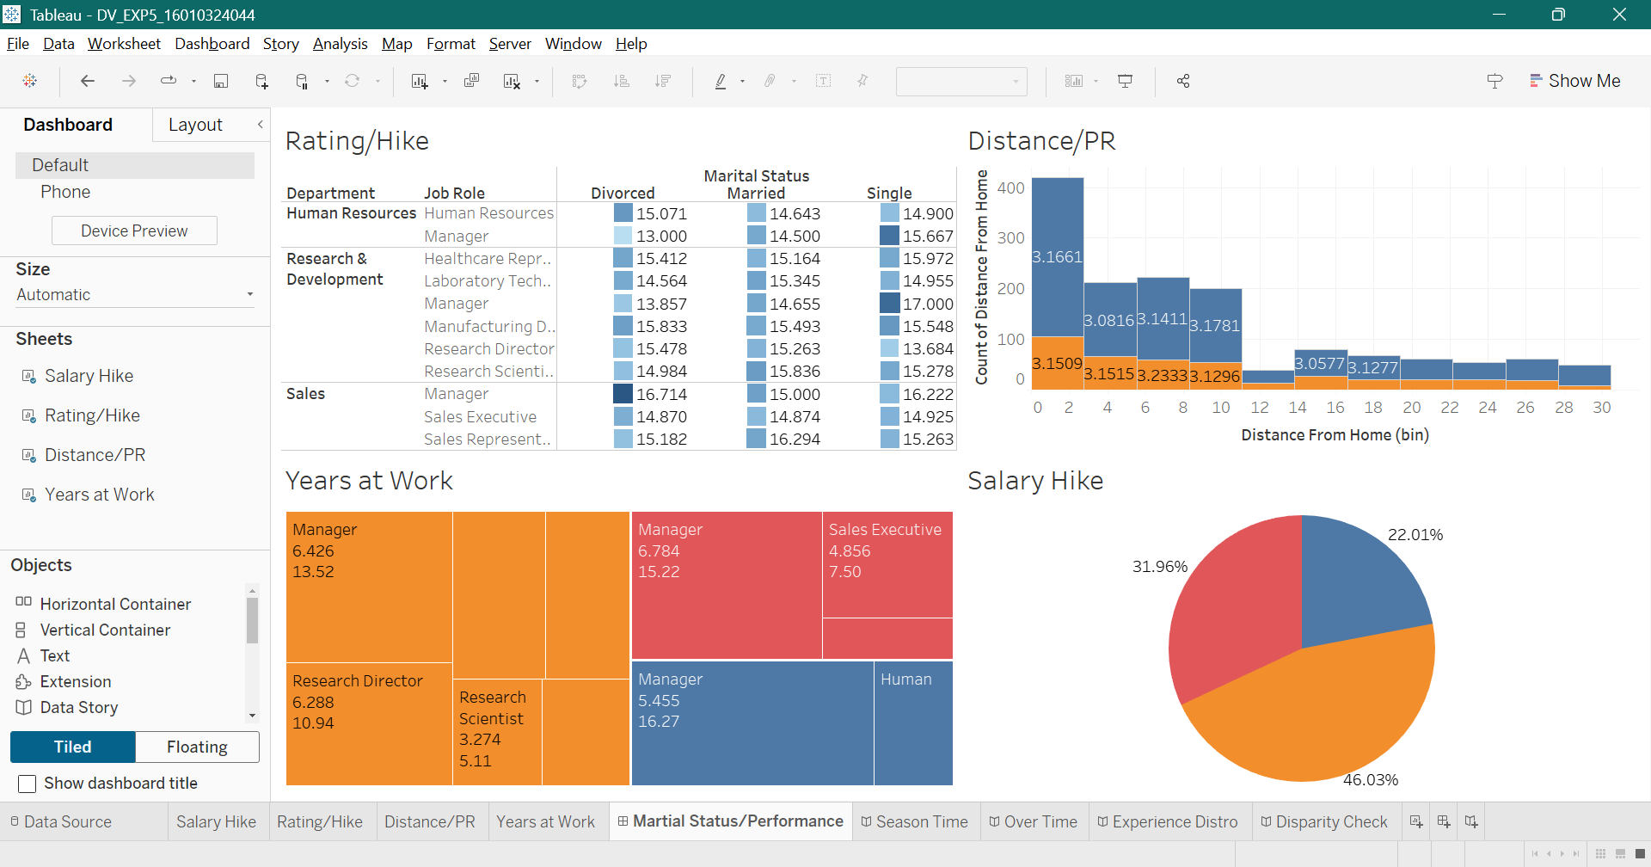

Part B:
Story 1:
- I chose the heat map because I scan through each department in the company using filters which helps me to quickly catch patterns
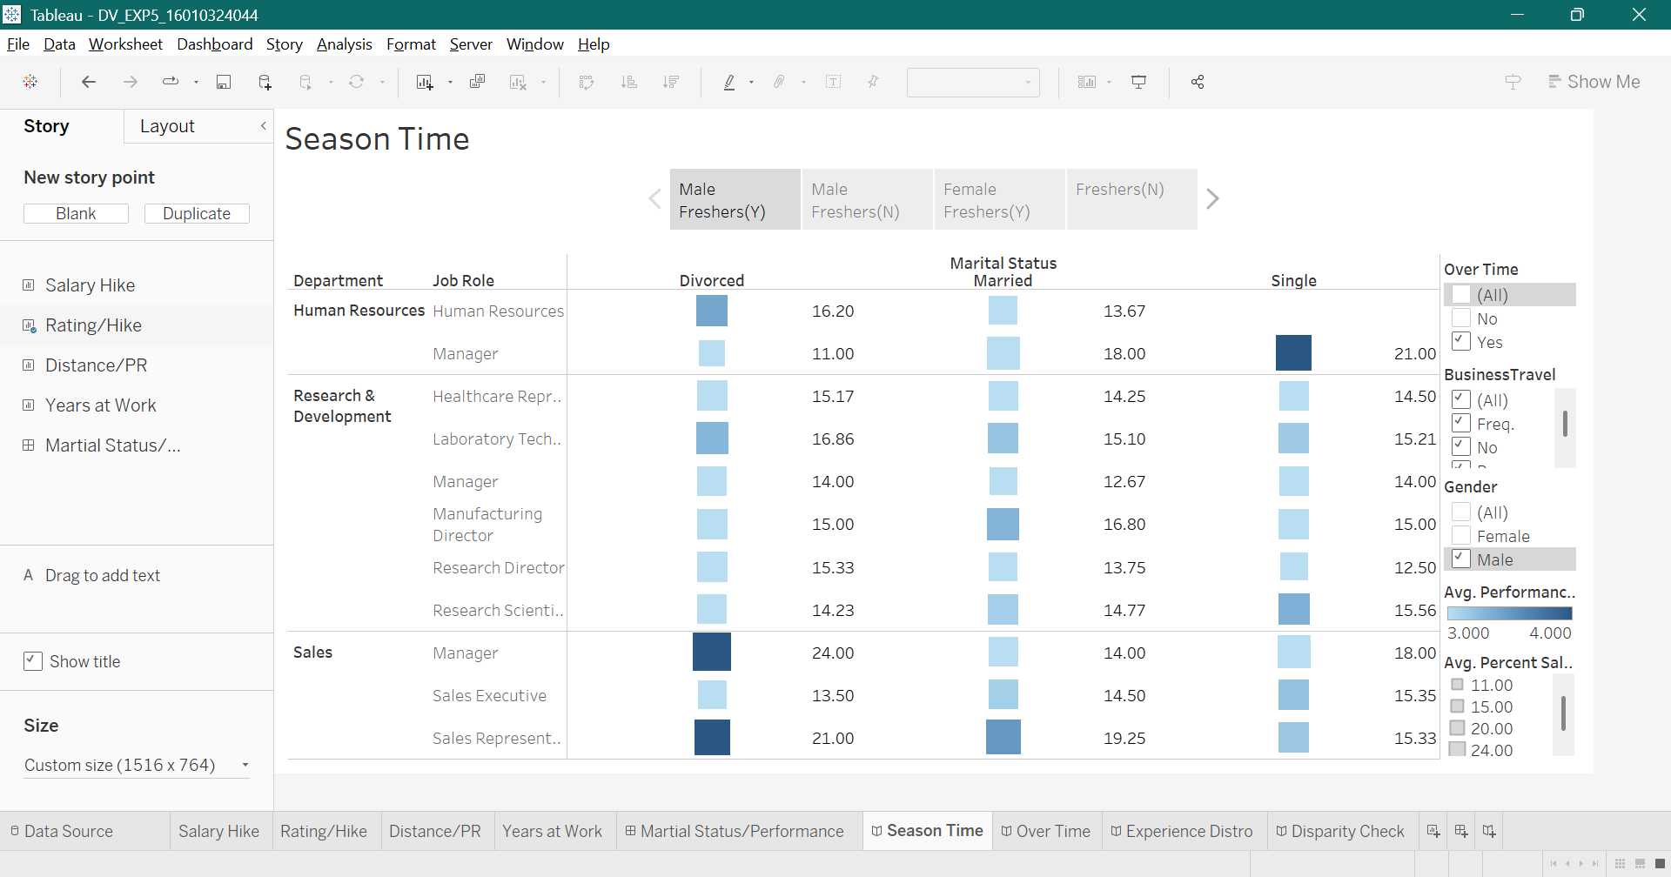
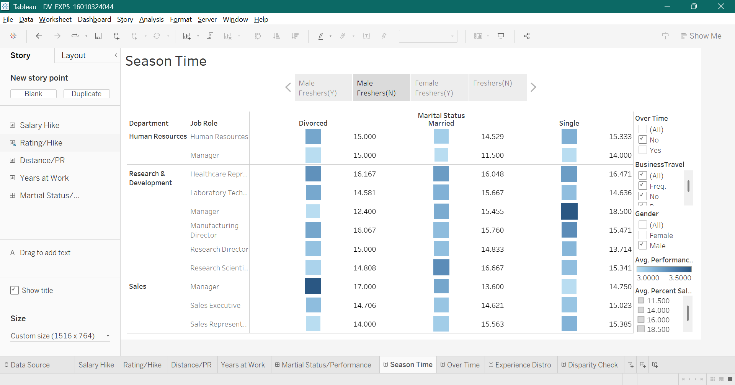
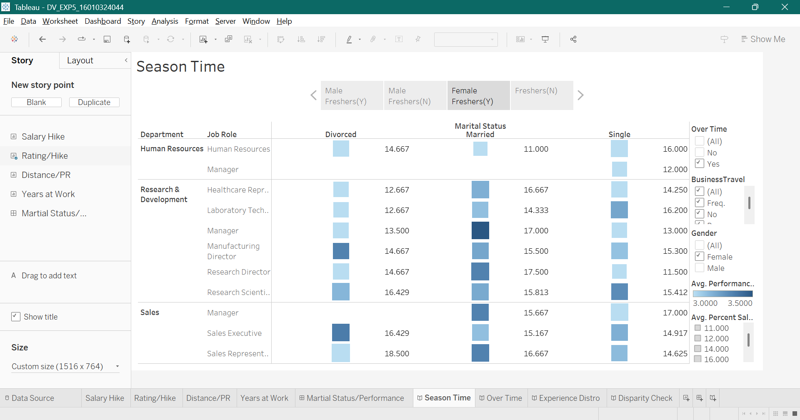
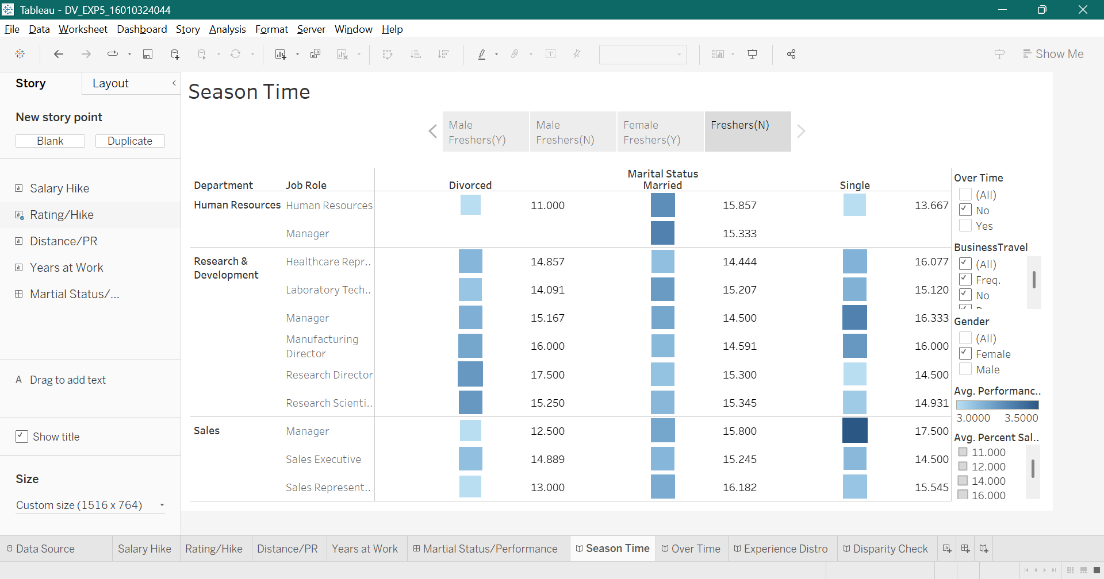

Story 2:
- I chose Histogram here as it helps me visualise number and department of employees living in the vicinity or not helping me to decide for rainy season overtime
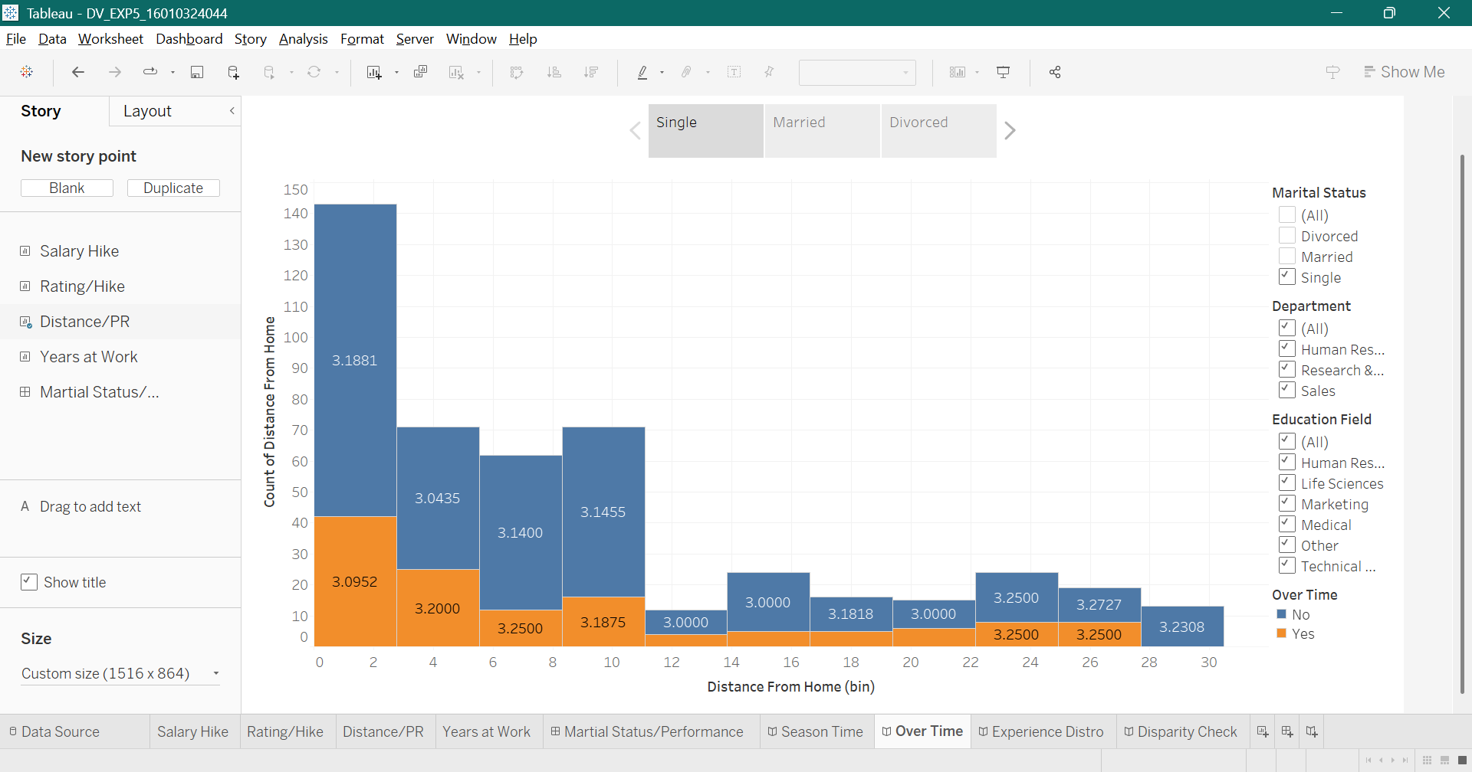
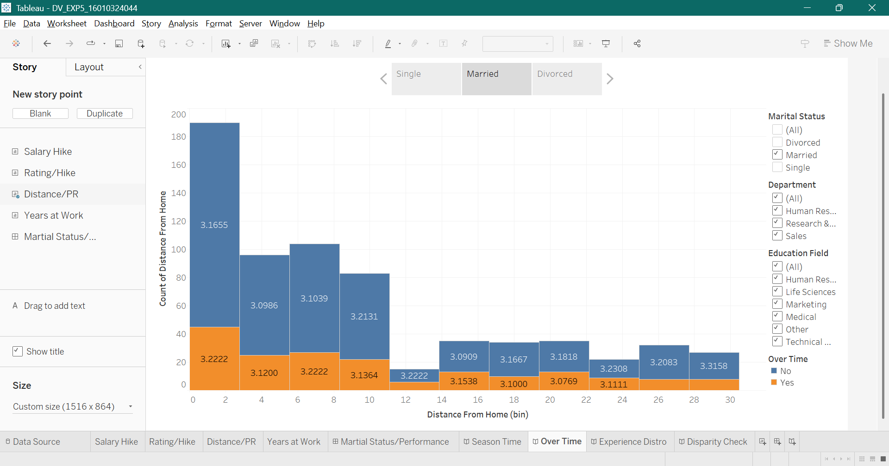
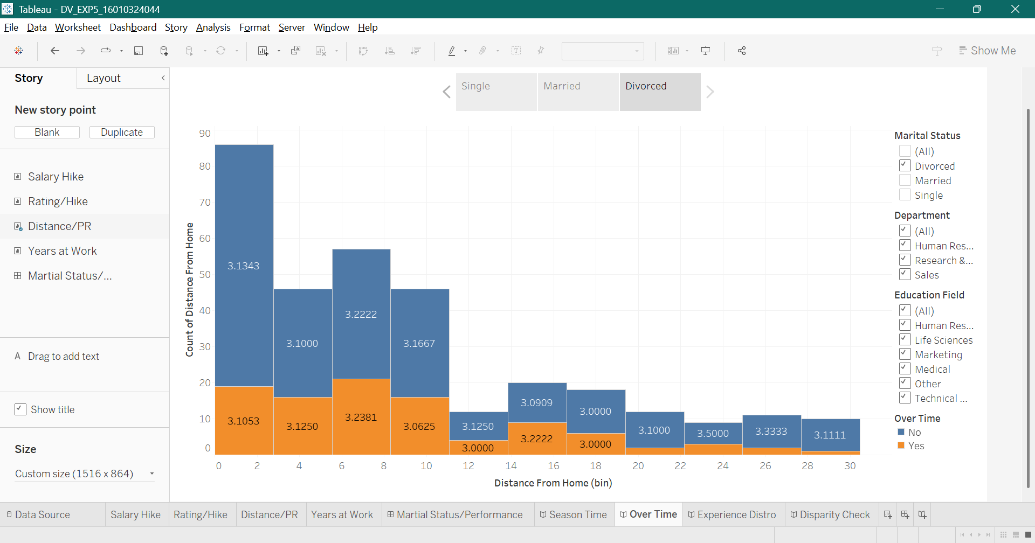

Story 3:
- Tree map here gives proportionality which makes years of experience easy to visualise
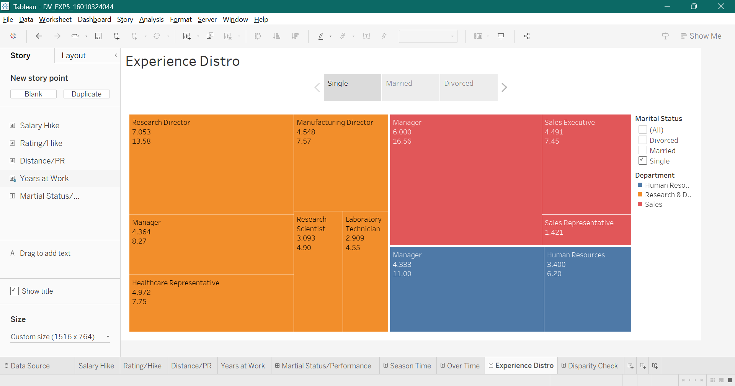
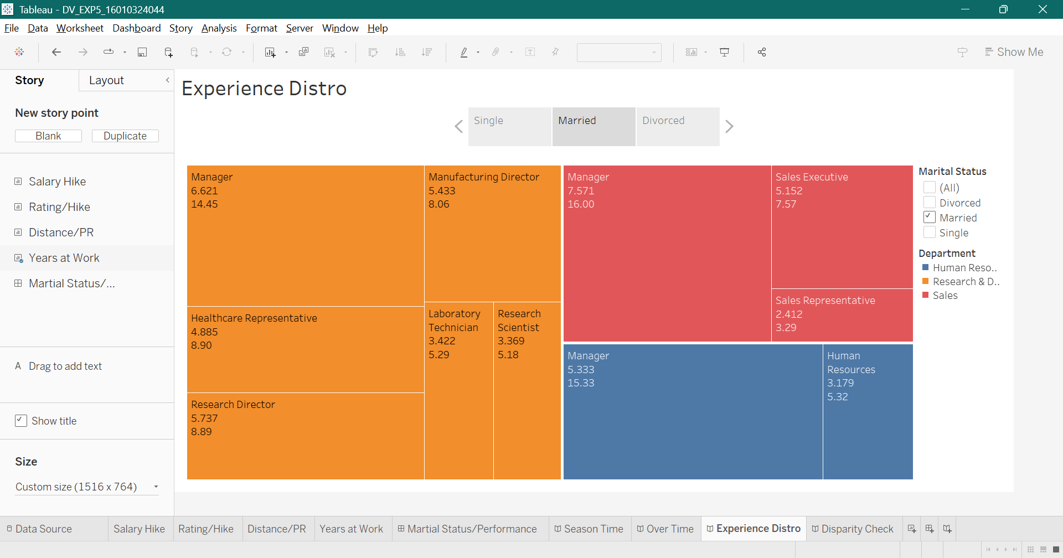
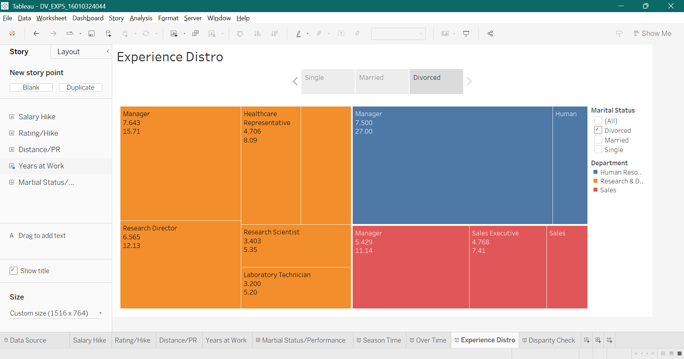

Story 4:
- Pie chart is used here because it are best suited for percentages
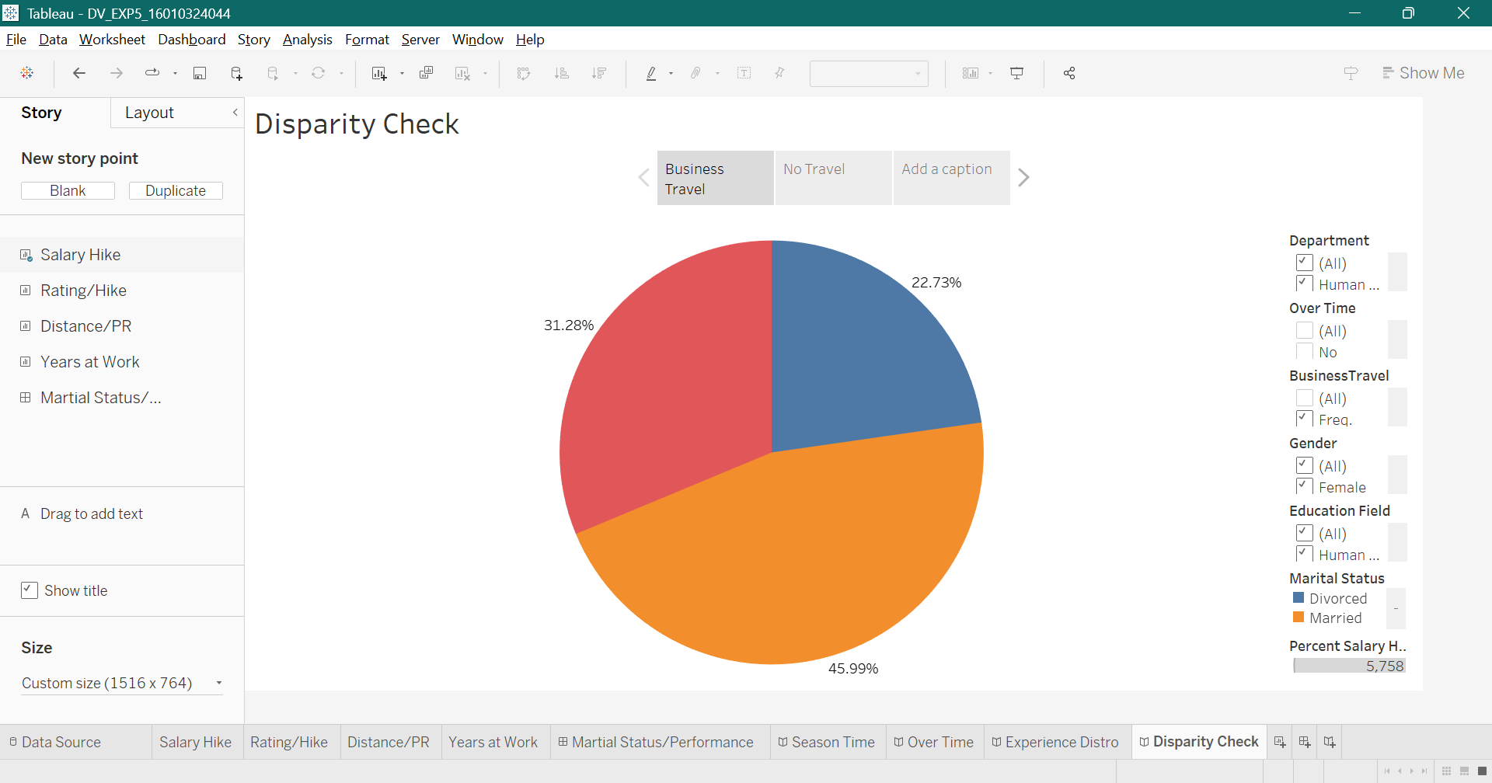
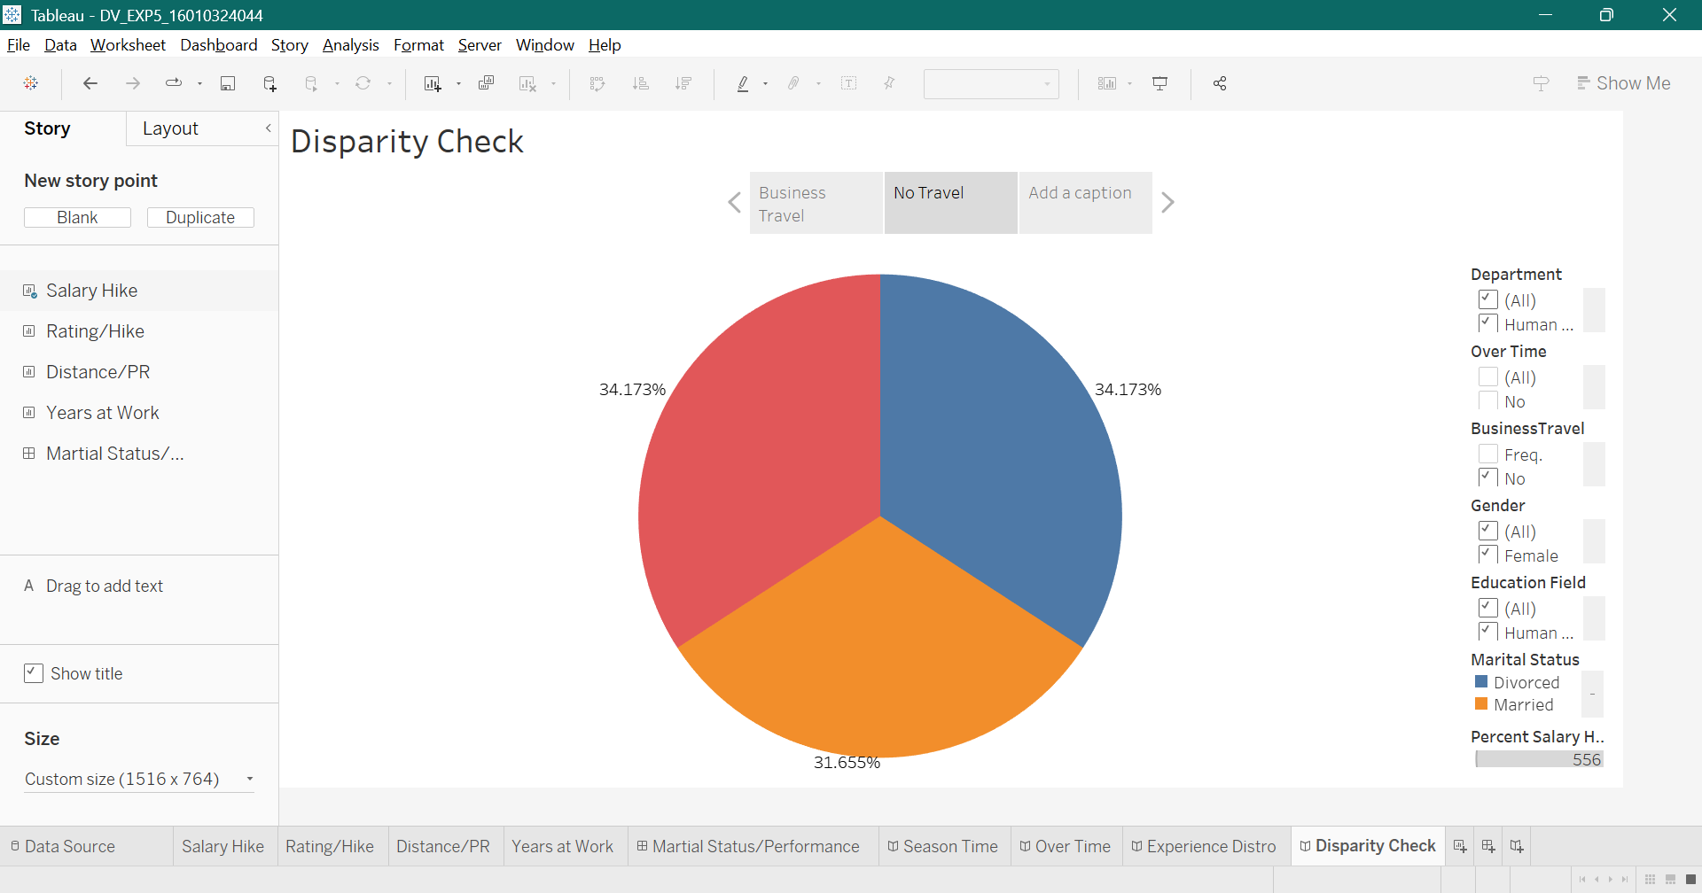

Key Insights:
- The analysis helped determine which department had the capacity to work during extra hours.
- Using filters allowed me to use the same visualization across different categories like department, age, and gender, improving flexibility.
- Dashboards provided a concise overview, while Stories offered a detailed narrative and sequential flow
- Combining multiple charts improved trend identification, correlation analysis, and pattern recognition compared to single visualizations.
- Best practice is to include dashboards interactive, clean and logically arranged for effective decision-making

Post Lab Questions:
- How is a Dashboard different from a Story in Tableau?
- Dashboard gives a brief overview while Story gives a detailed overview

- Which interactive feature in your Dashboard added the most value?
- Filters, it let me use the same visualisation type for different categories like department, age, gender, etc. without the need to make separate ones

- What are some best practices for designing dashboards?
- Always keep them as interactive as possible which helps in adding the most amount of info

- How does combining multiple charts change your analysis compared to a single chart?
- It allows for more efficient comparison of different data and helps in identifying trends, correlations, and patterns

Conclusion:
In this experiment, I learned the importance of interactive dashboards in quickly summarizing data and enabling better decision-making.
Creating a story in Tableau provided a structured and sequential narrative that helped me explain insights step by step, making the data more understandable and actionable.
Together, dashboards and stories enhanced the ability to extract, analyze, and present data insights effectively, aligning with data visualization best practices

Signature of faculty in-charge with Date:

