Course Name: | Data Visualization Laboratory (Honours_ Data Science for Emerging Analytics) | Semester: | III
Date of Performance: |  | Batch No: | A3
Faculty Name: | Dr. Rupali Patil | Roll No: | 44
Faculty Sign & Date: |  | Grade/Marks: | XX/25

Experiment No: 6
Title: Working with Geospatial data

Aim and Objective of the Experiment:
- To import datasets containing geographical information into Tableau.
- To learn how to create and customize maps.
- To apply geospatial visualizations for better insights.
- To use filters, layers, and geographic hierarchies to explore location-based patterns.

COs to be achieved:
CO1: Learn how to locate and download datasets, extract insights from that data and present their findings in a variety of different formats
CO4: Design static charts, interactive Dashboards

Tools required:
Tableau

Code/Task:
Part A: Import & Prepare Data
- Open Tableau → Connect to CSV/Excel dataset (e.g., Superstore Sales or any dataset with City, State, Country, Latitude, Longitude).
- Verify Tableau automatically assigns geographic roles (shown with a globe icon).
- If not, manually assign geographic role → Right-click column → Geographic Role → City/State/Latitude/Longitude.
Part B: Create Maps
- Basic Map:
  - Drag State or City into Rows.
  - Drag Sales/Profit into Size/Color.
  - Tableau generates a map visualization.
- Filled Map (Choropleth):
  - Drag State into view.
  - Use Profit as Color.
  - Each state is shaded based on profit values.
- Symbol Map:
  - Drag City to view.
  - Drag Sales to Size and Profit to Color.
  - Creates proportional circles showing sales and profit.
- Dual-Axis Map:
  - Add Sales as one map layer (size).
  - Add Profit as another layer (color).
  - Right-click → Dual-Axis.
- Following maps also should be demonstrated
  - Proportional symbol maps
  - Point distribution maps
  - Density maps (heatmaps)
  - Flow maps (path maps)
  - Spider maps (origin-destination maps)
- Demonstrate how to visualize geospatial data
  - Auto Geo-tagging
  - Custom Geo-tagging
Output:
Part A:
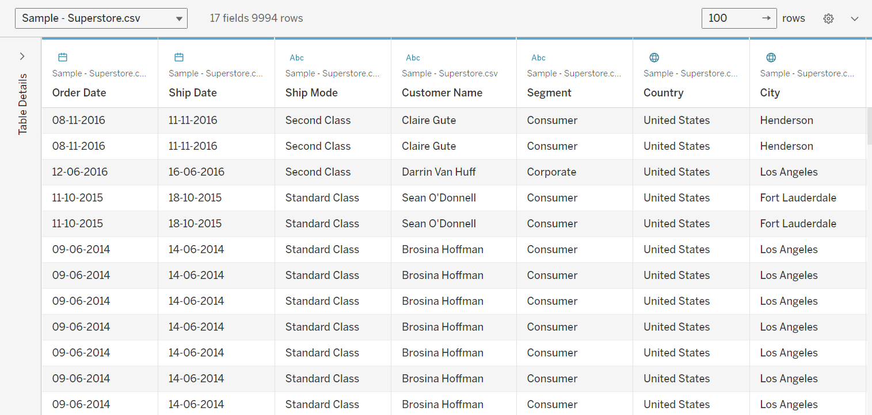

Part B:
Basic Map 1:
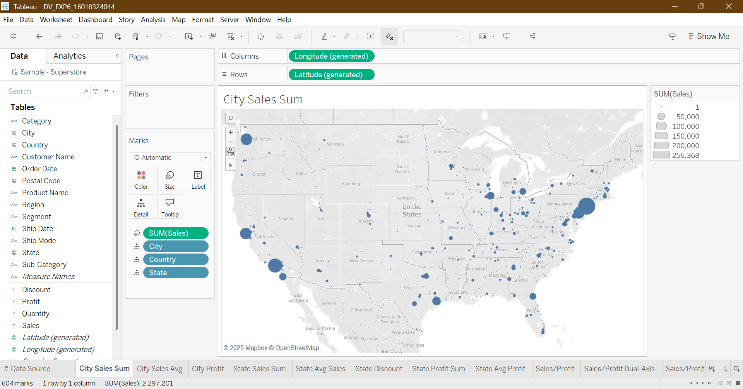

Basic Map 2:
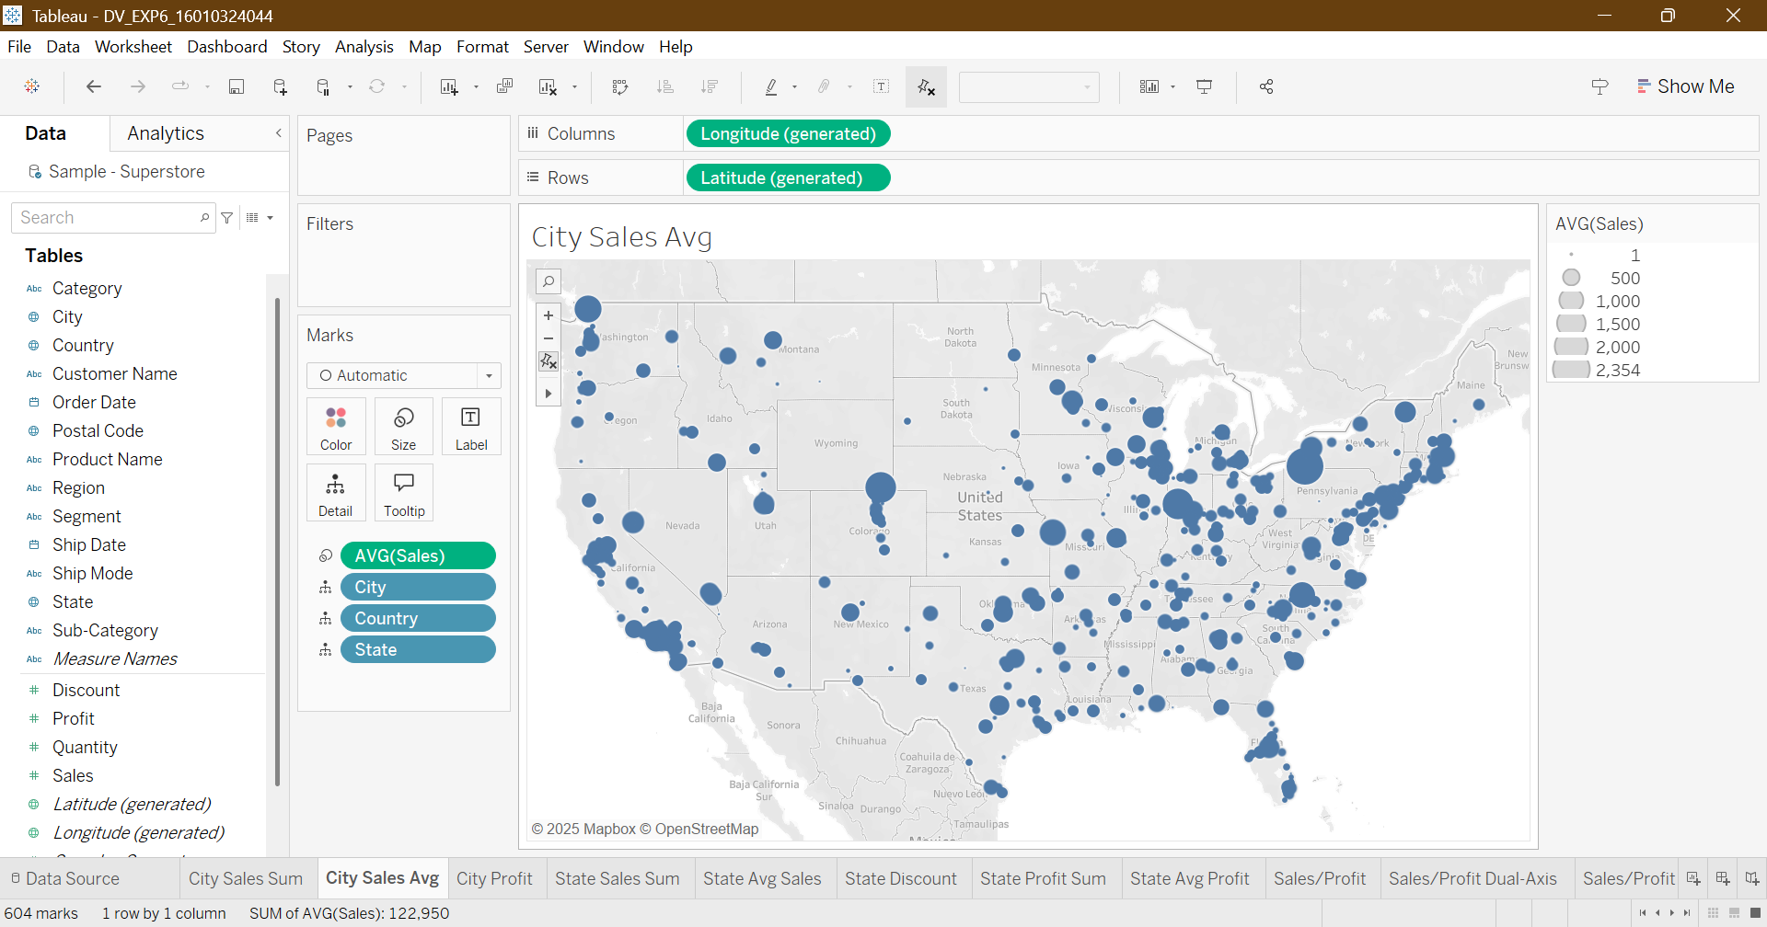

Proportional Symbol Map:
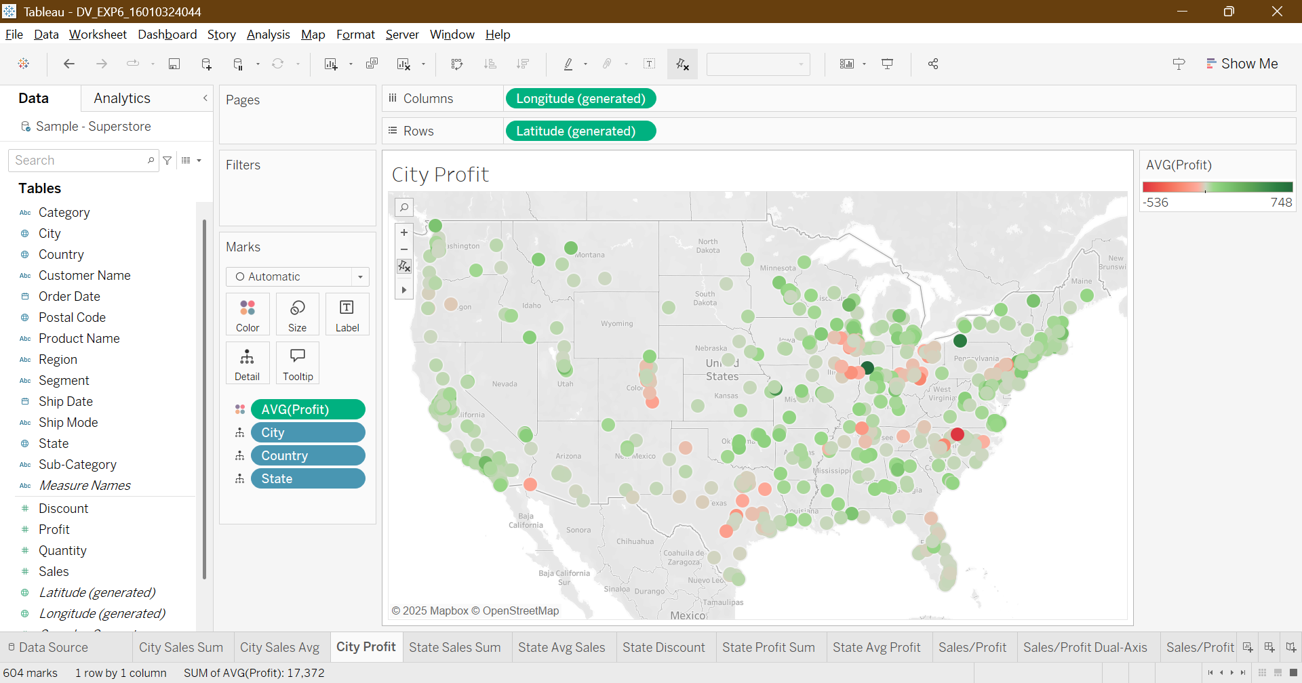

Filled Map 1:
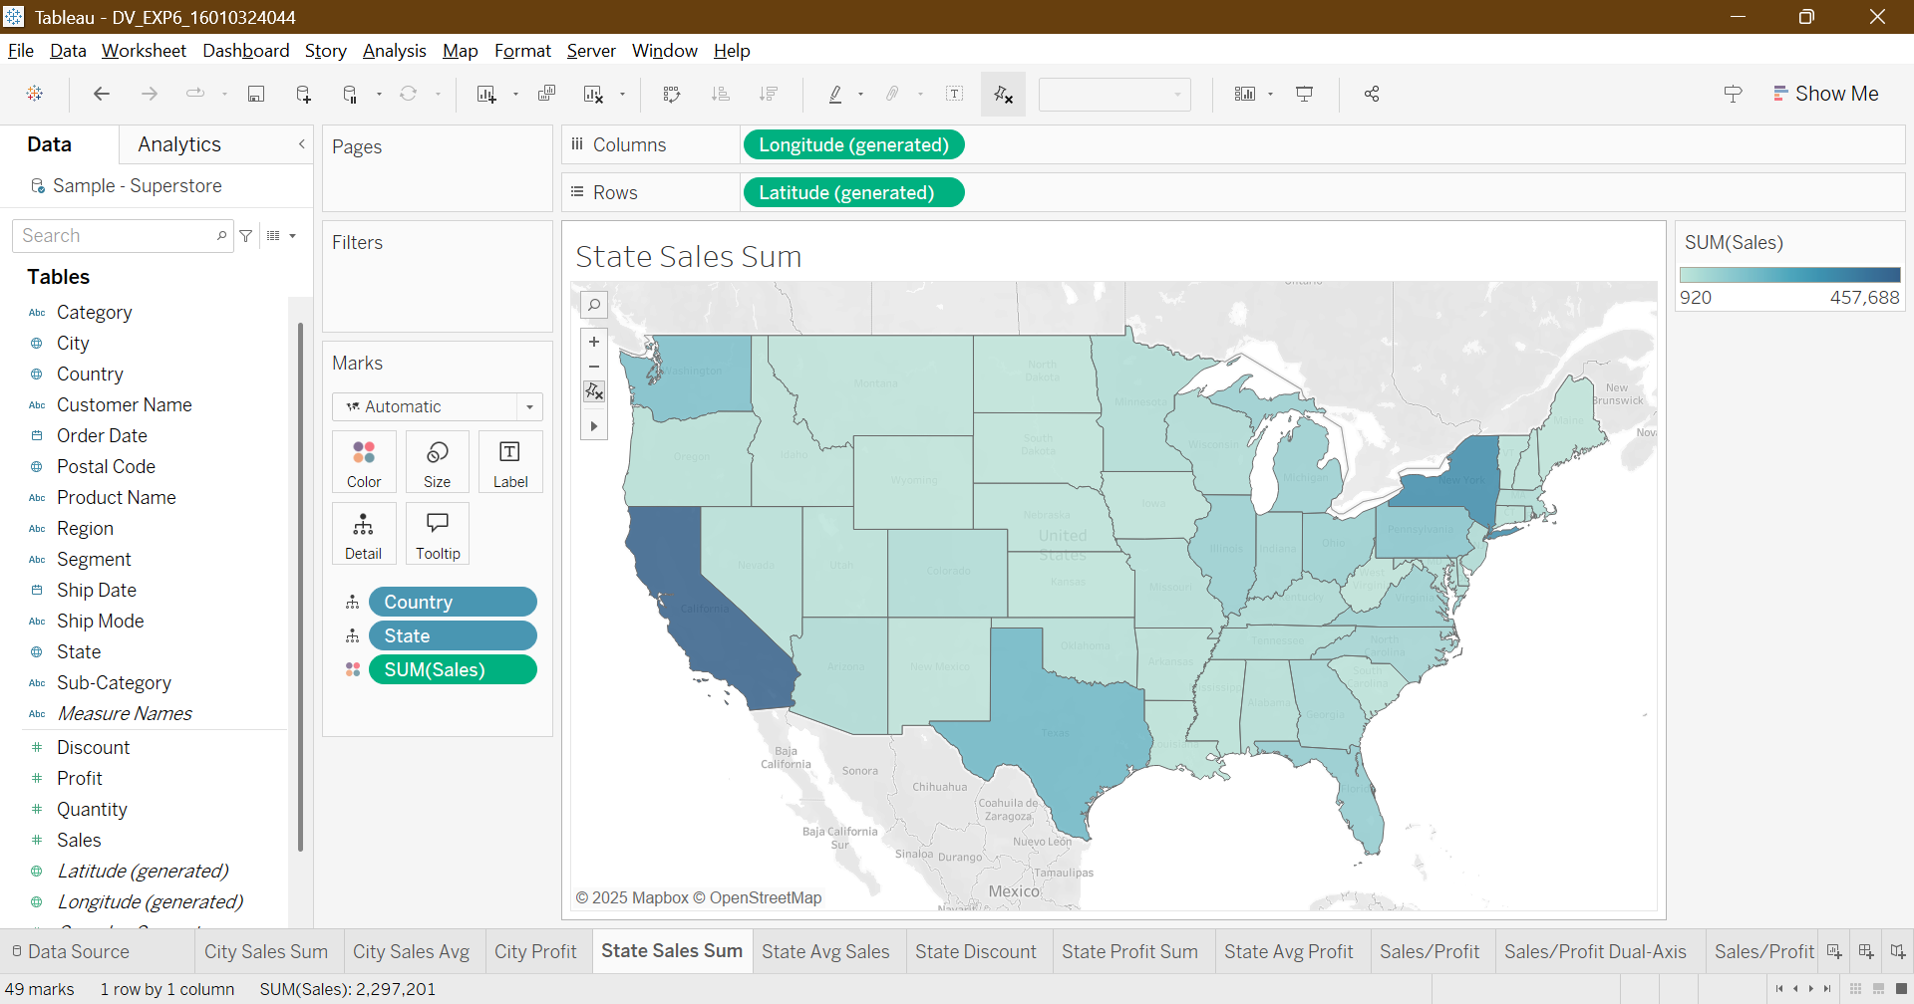

Filled Map 2:
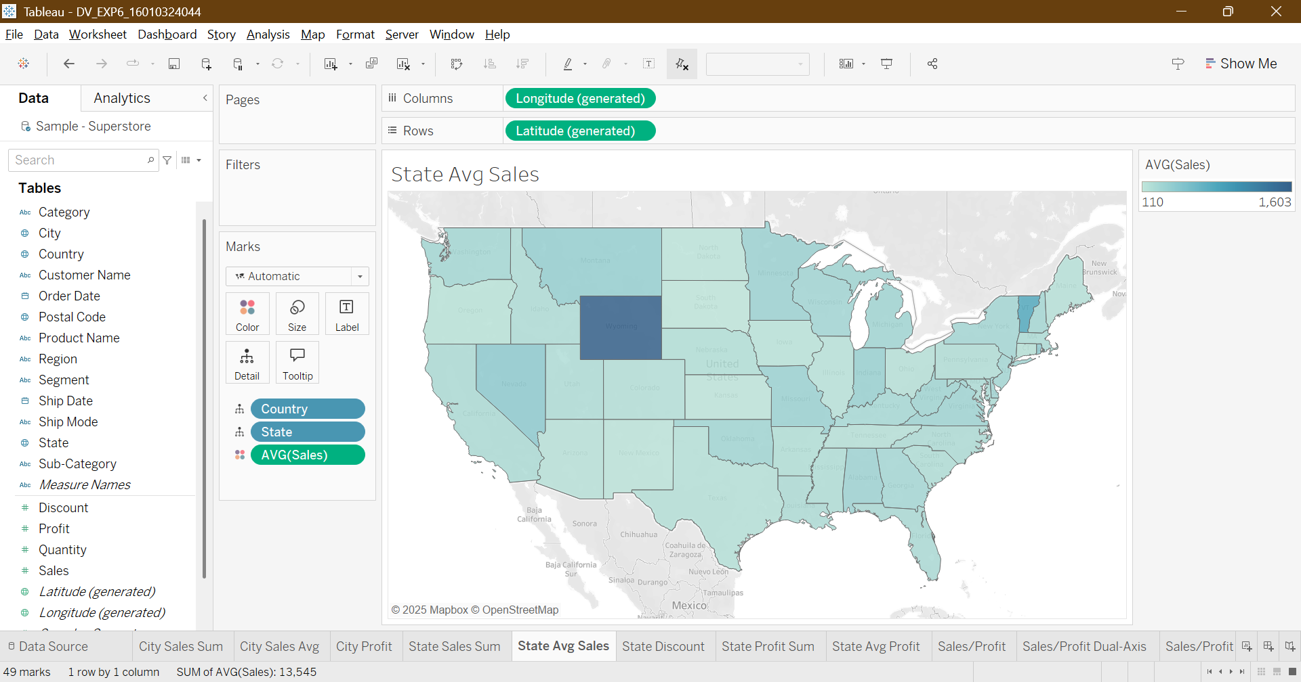

Filled Map 3:
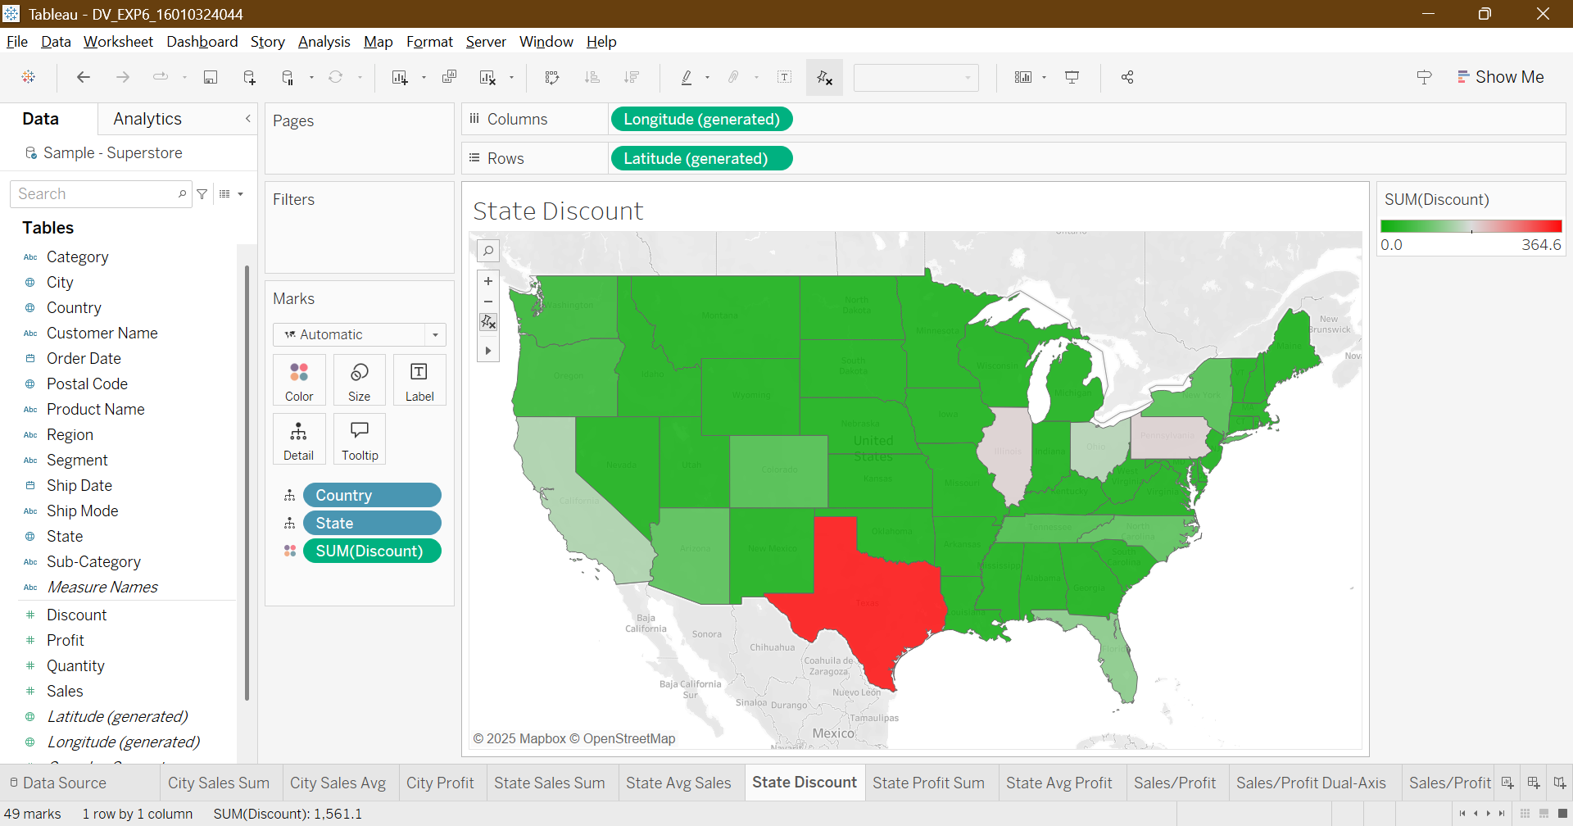

Filled Map 4:
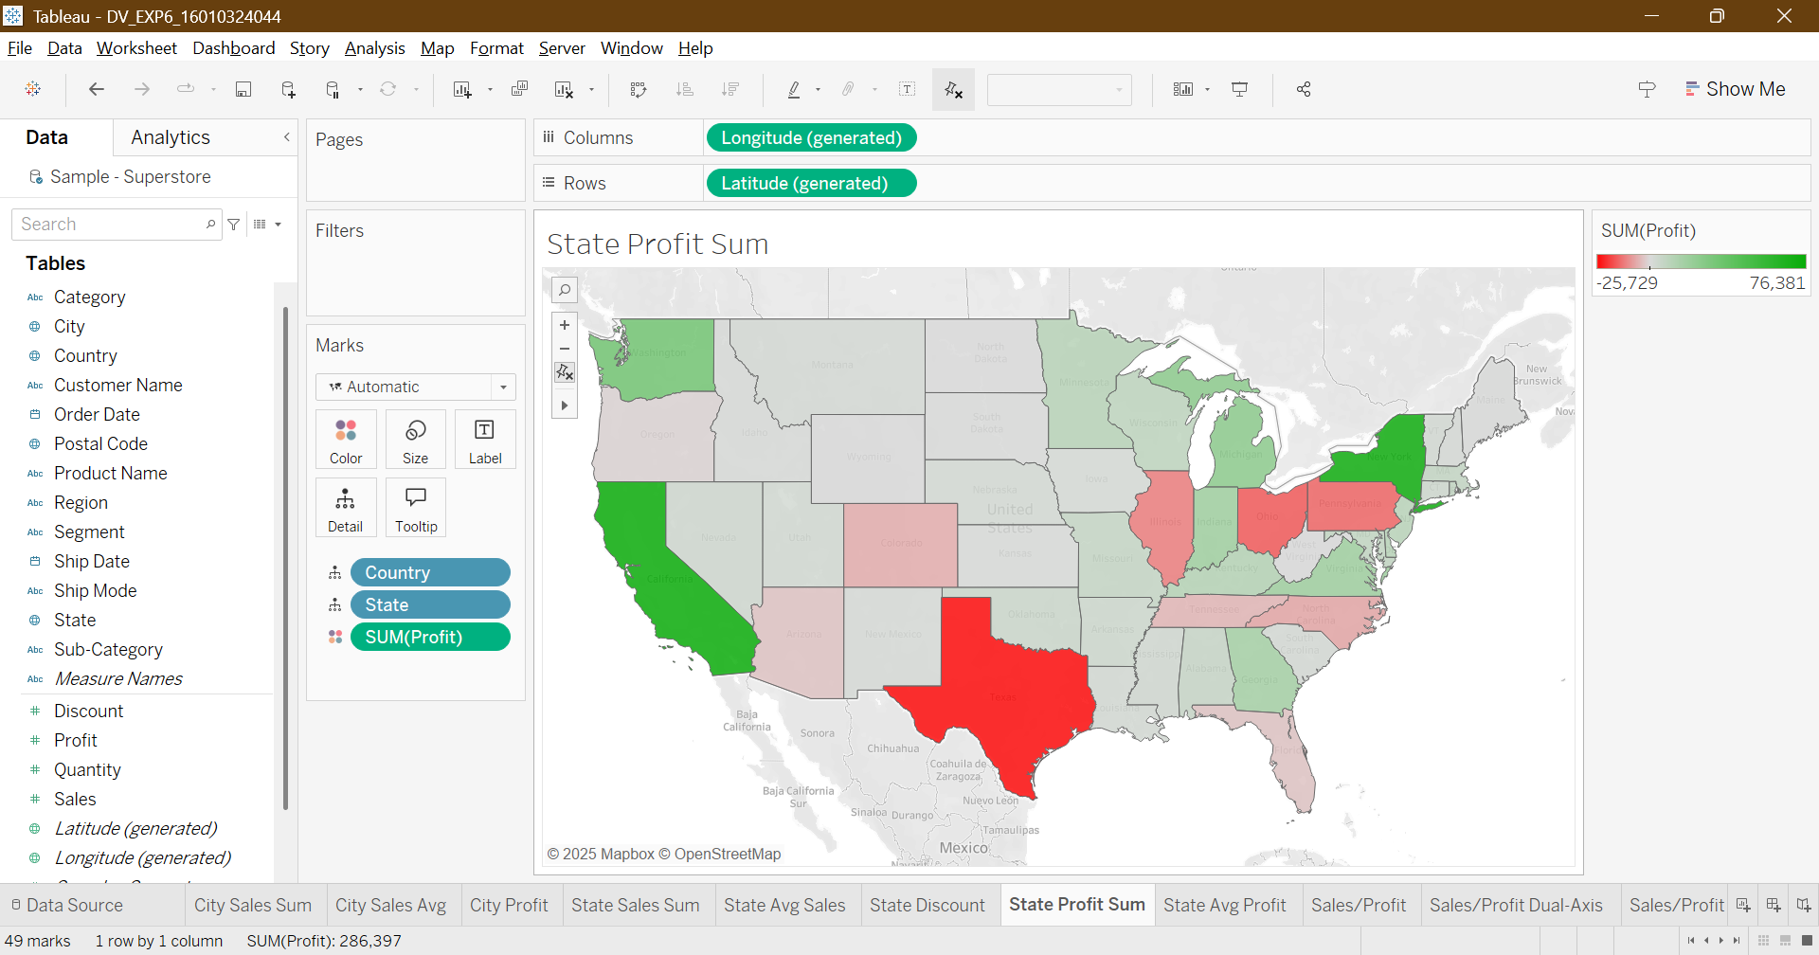

Filled Map 5:
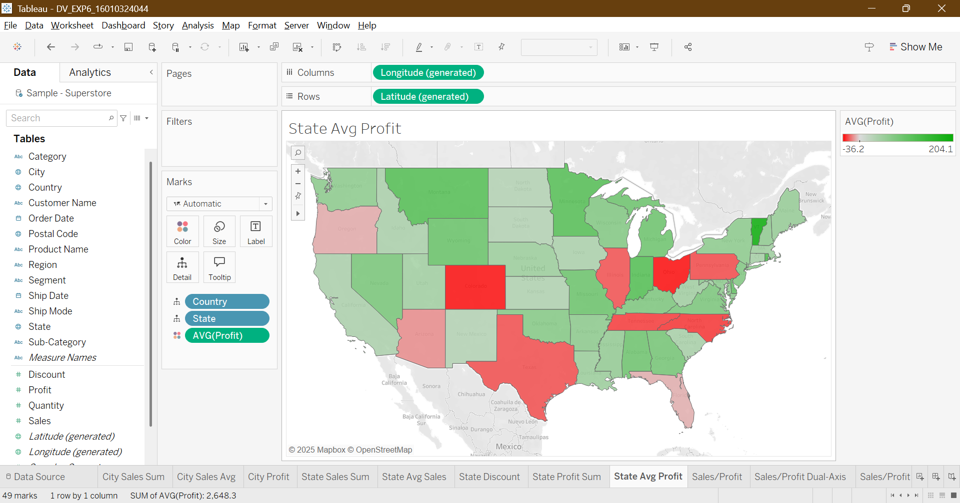

Symbol Map:
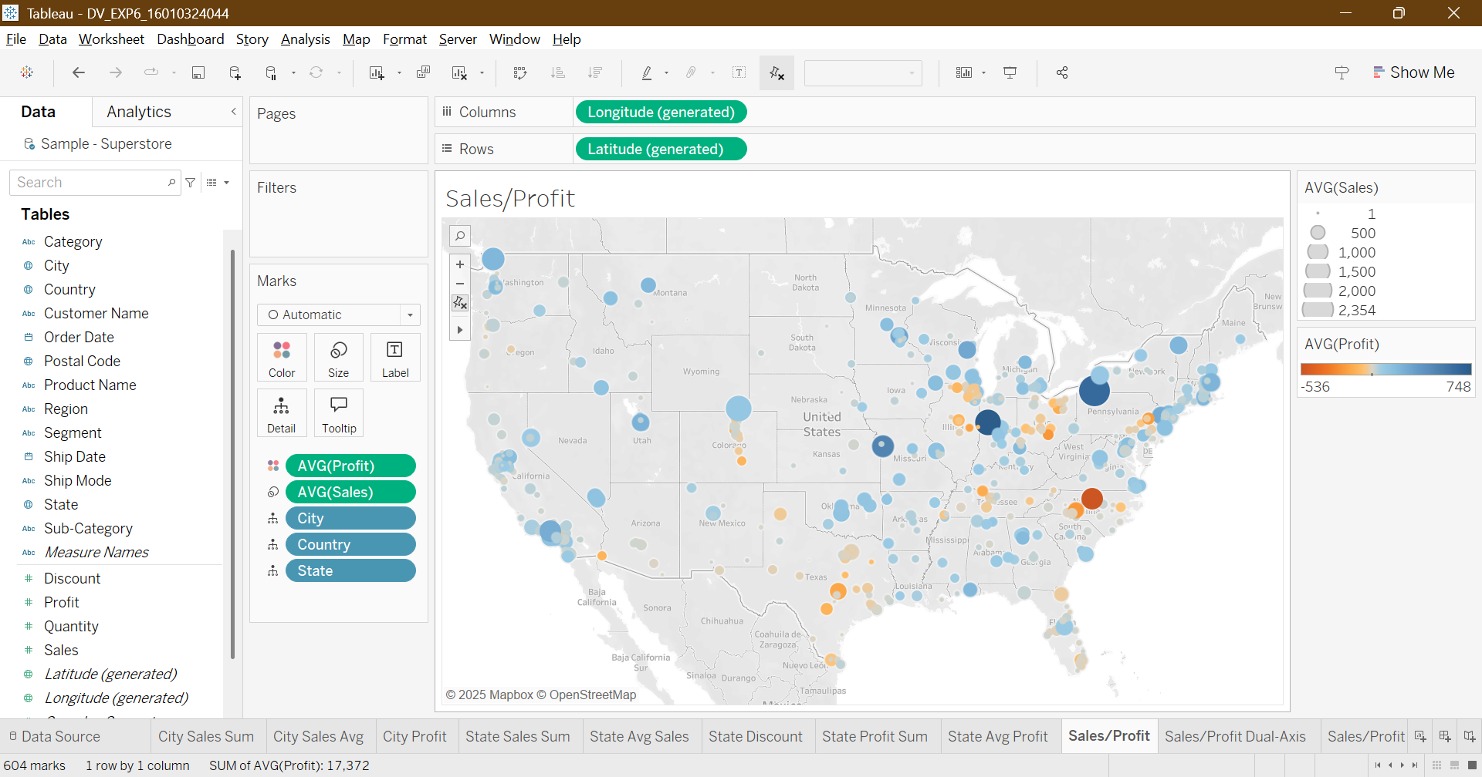

Dual Axis Map:
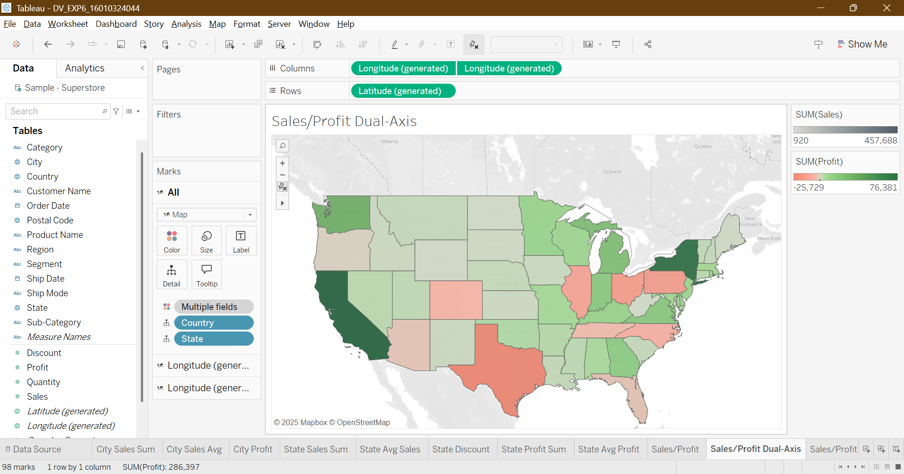

Line Chart 1:
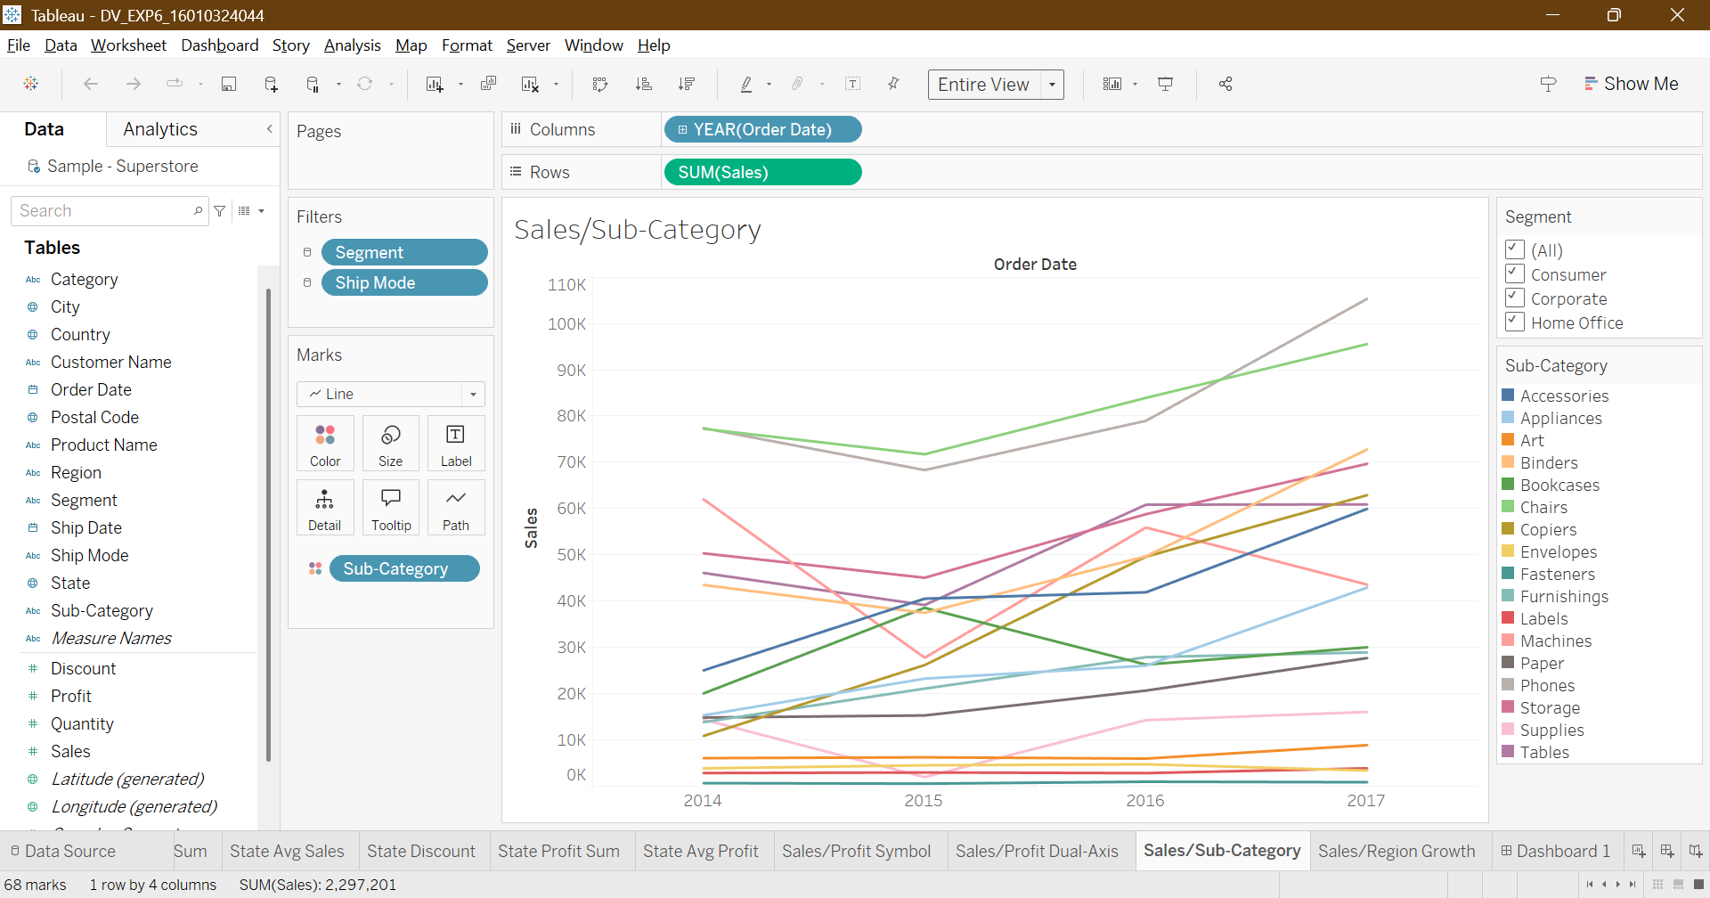

Line Chart 2:
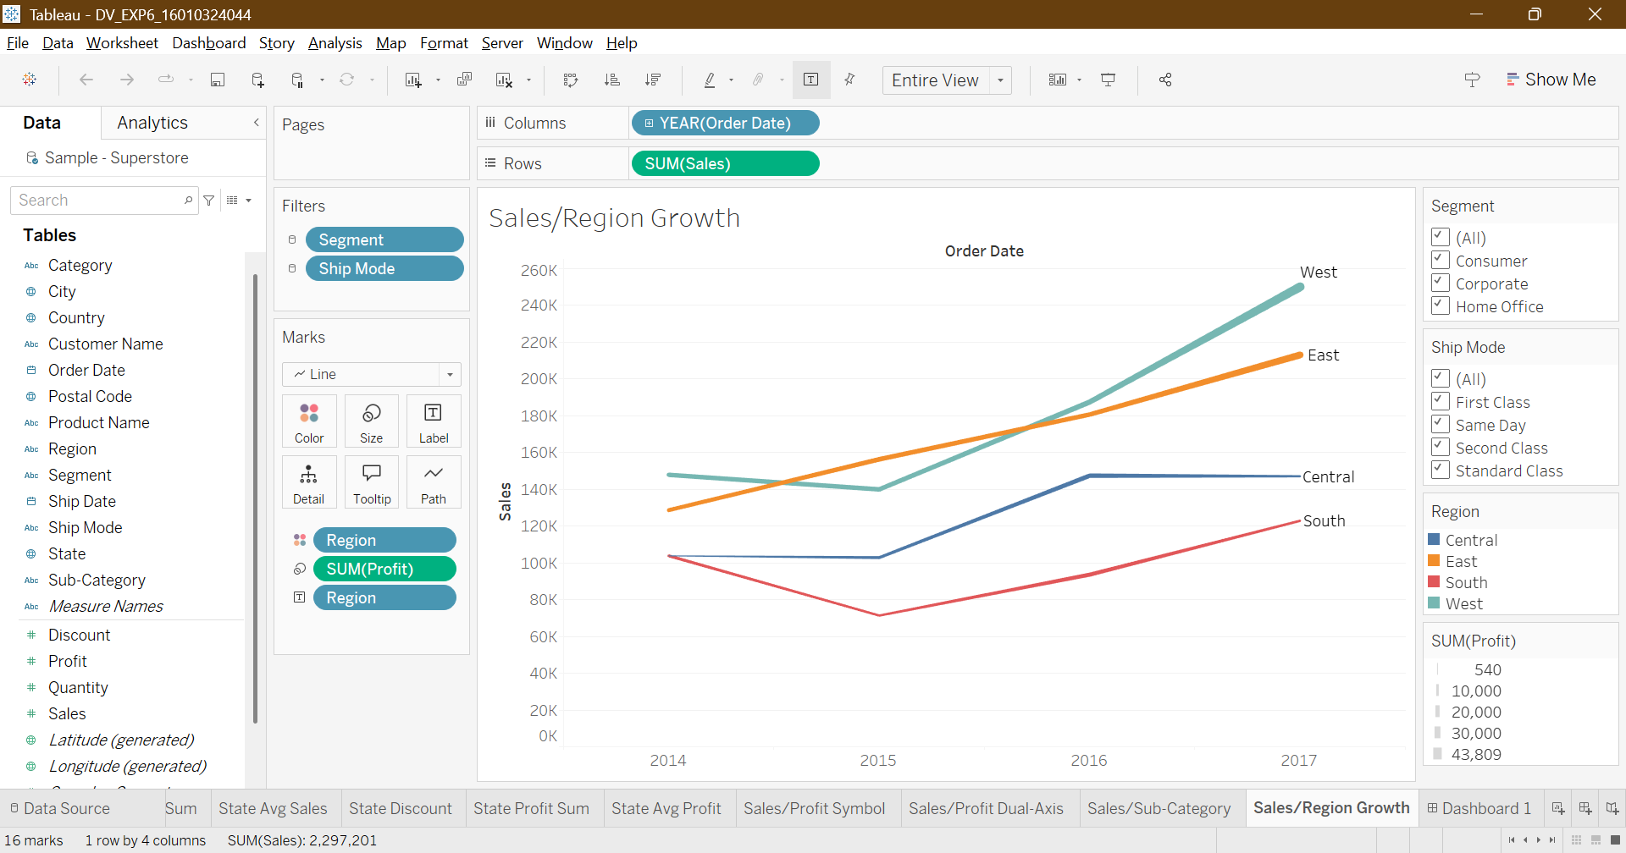

Dashboard:
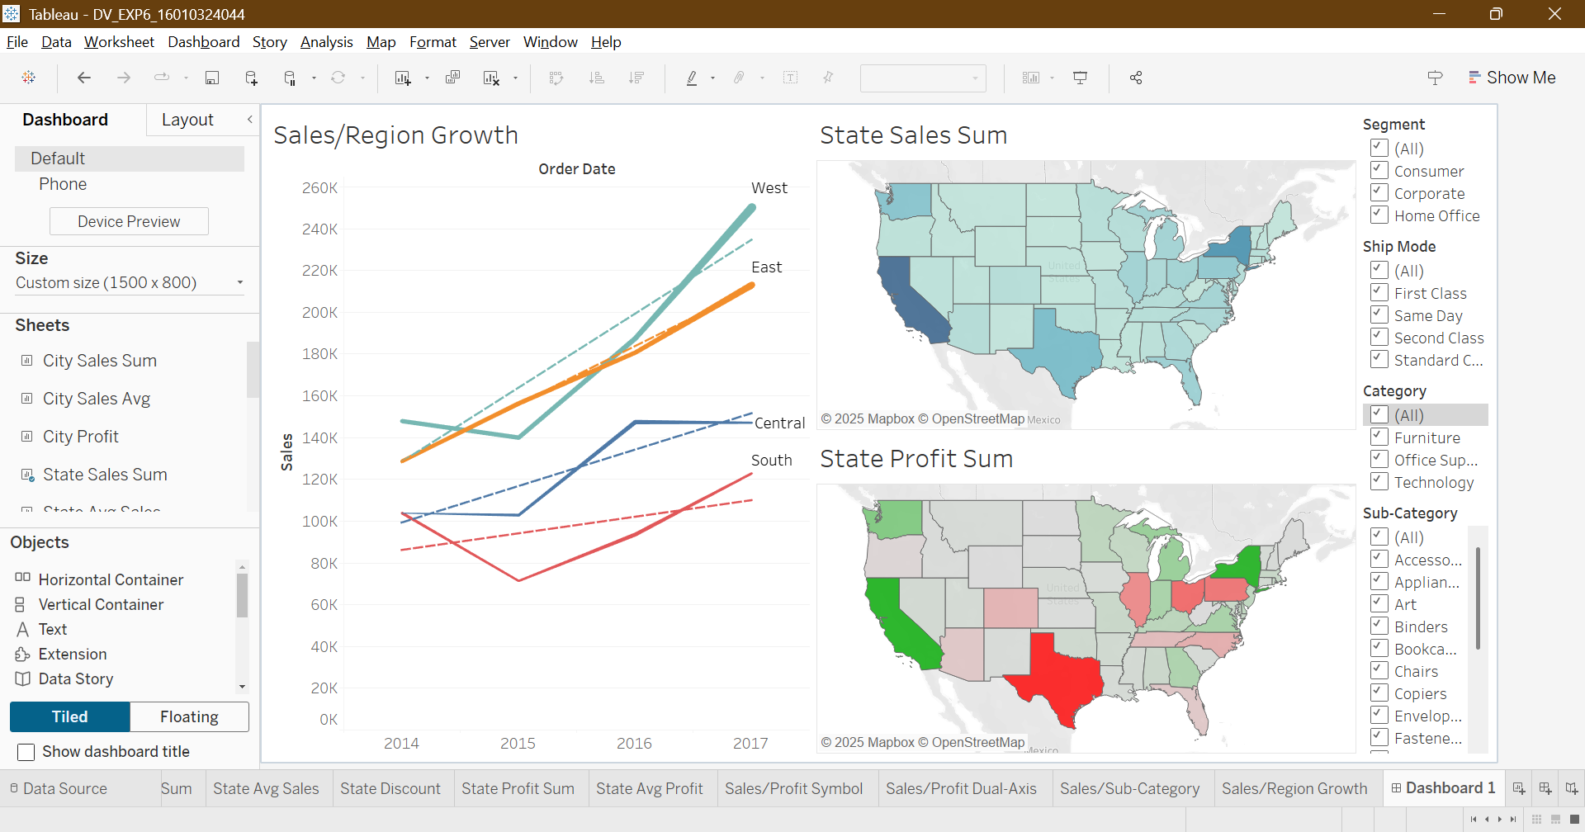

Insights:
– States in the West (e.g., California, Washington) and East (e.g., New York) recorded the highest sales, while central and southern states showed relatively lower sales volumes.

– Despite high sales, states like California and Texas exhibited mixed profitability, with some categories contributing to losses, whereas states like New York and Washington consistently showed high profits.

– Density maps indicated strong clustering of orders in major metropolitan areas such as Los Angeles, New York City, and Chicago.

– Flow/spider maps highlighted that key distribution hubs supplied goods to multiple regions, with heavy flows toward the East and West coasts.

– Proportional symbols and dual-axis maps demonstrated that high sales do not always mean high profits. Texas had significant sales but negative profits in certain product segments.

Overall, the geospatial visualizations showed that while sales are concentrated on the coasts, profitability varies by state and product.

Auto-geo tagging:
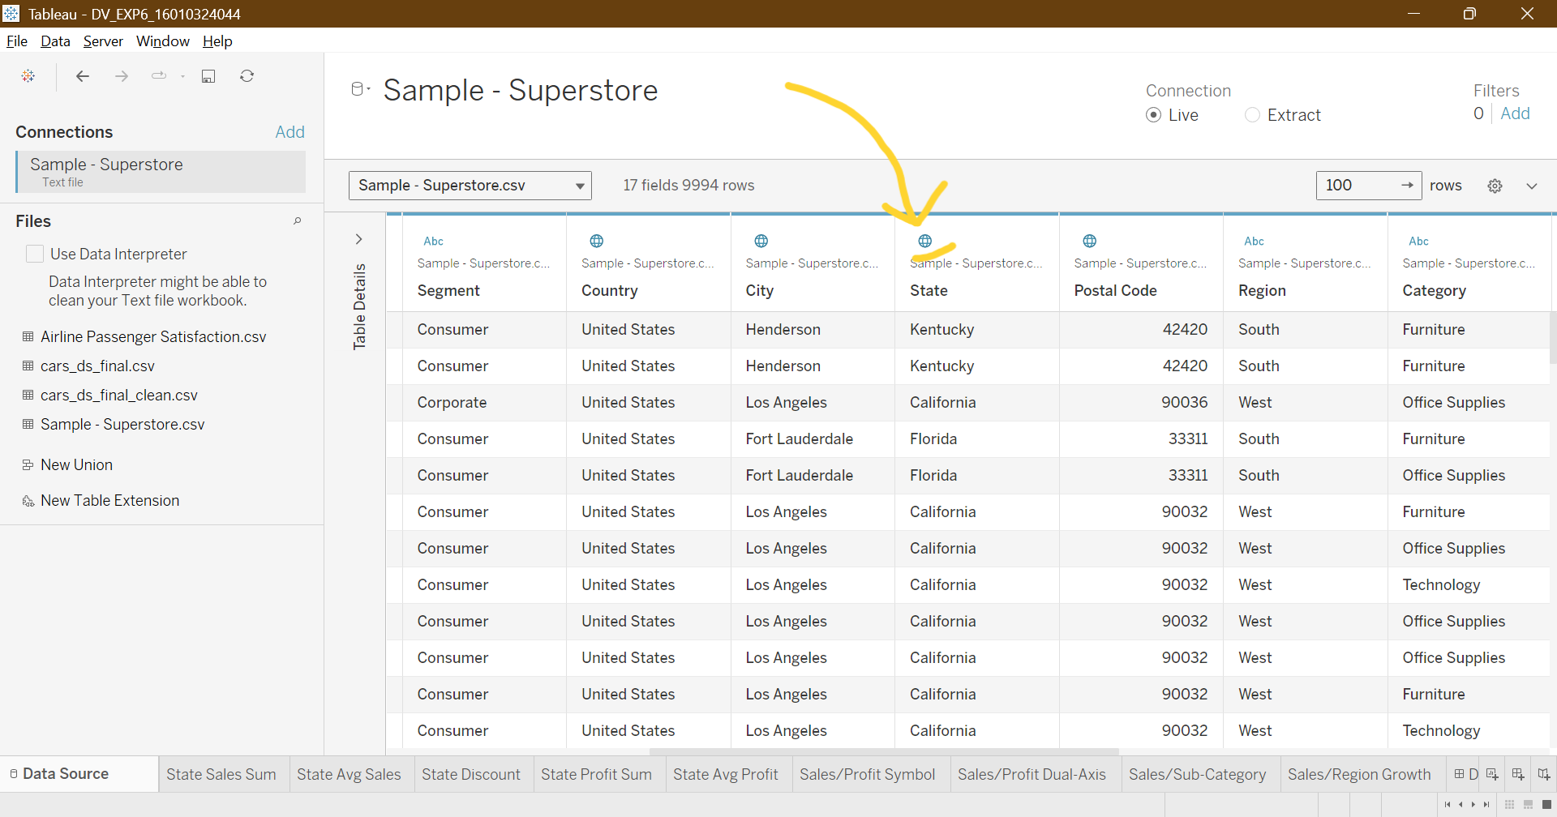

Custom-geo tagging:
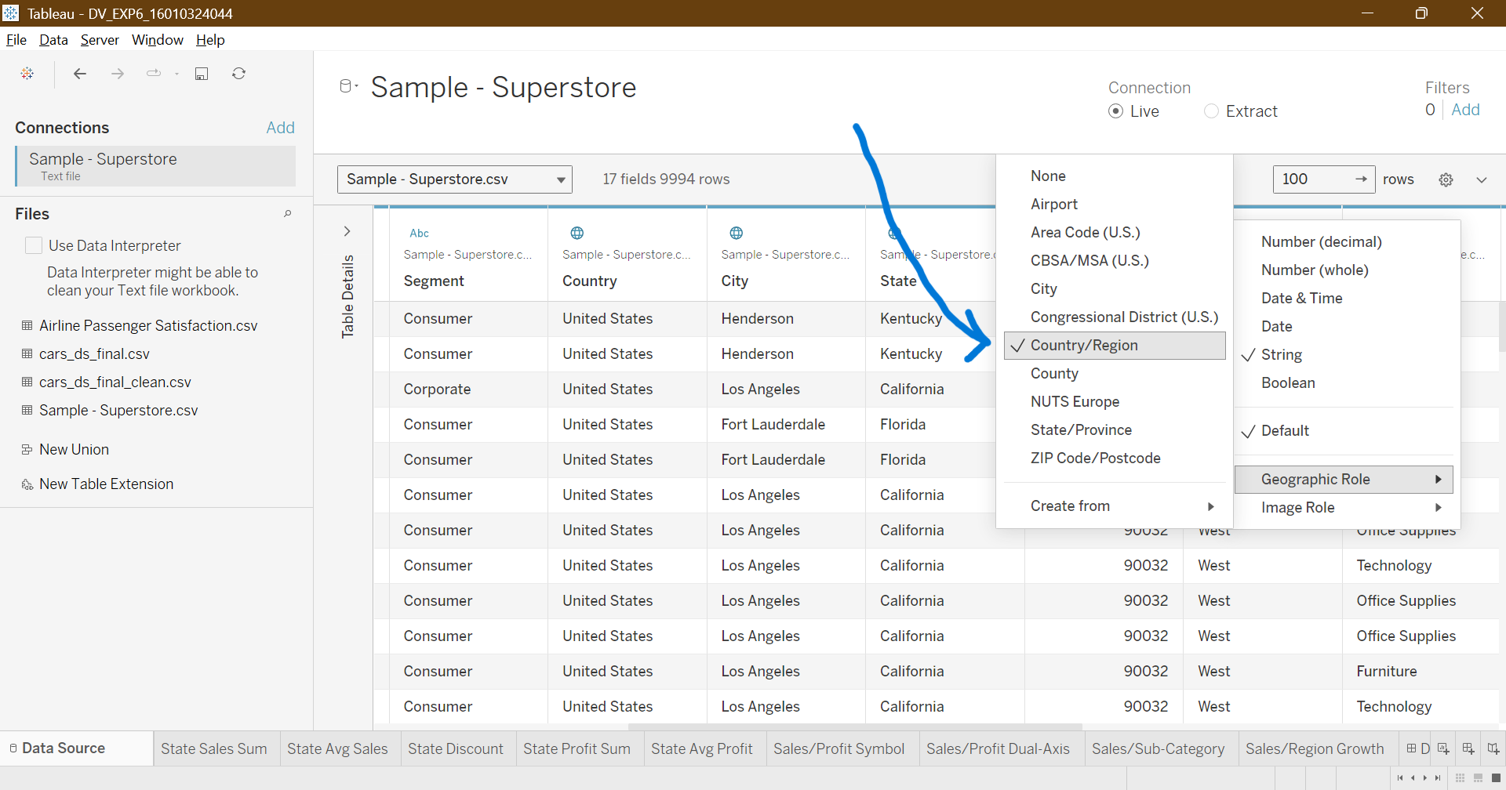

Post Lab Questions:
- What is the difference between a filled map and a symbol map in Tableau?
- Filled map colours the entire region (state/country) based on a measure.
- Symbol map shows points (like cities) with size/color representing measures.

- How can geographic roles be assigned manually in Tableau?
- Right-click on the field in the Data Pane → Geographic Role → select the appropriate role (City, State/Province, Country, Latitude, Longitude, etc.).

- Why is dual-axis mapping useful in business analytics?
- Lets you plot two measures on the same map (e.g., Sales = size, Profit = color).
- Helps compare performance more effectively.

- How does interactivity (filters, drill-down) improve map-based dashboards?
- Filters and drill-down make dashboards dynamic and user-friendly.
- Users can explore data at different levels for deeper insights.

Conclusion:
In this experiment, I learned how to work with geospatial data in Tableau. We created different types of maps like filled maps, symbol maps, density maps, and dual-axis maps to understand sales and profit patterns across regions. The visualizations helped me to see how sales and profits vary by state and how customer orders are concentrated in major cities (making it easier to analyse data).

Signature of faculty in-charge with Date:

