Course Name: | Data Visualization Laboratory (Honours_ Data Science for Emerging Analytics) | Semester: | III
Date of Performance: |  | Batch No: | A3
Faculty Name: | Dr. Rupali Patil | Roll No: | 44
Faculty Sign & Date: |  | Grade/Marks: | XX/25

Experiment No: 7
Title: Data Transformation and Visualization using Power BI

Aim and Objective of the Experiment:
To import unique datasets in Power BI and perform basic cleaning, modeling, and visualization tasks using Power BI-specific features.

COs to be achieved:
CO1: Learn how to locate and download datasets, extract insights from that data and present their findings in a variety of different formats
CO3: Apply data visualization best practices

Tools required:
Power BI

Code/Task:
Each student will:

Part A – Import & Explore
- Import the assigned dataset (Get Data → Text/CSV).
- Explore dataset columns and data types.

Part B – Power Query Cleaning
Perform at least 3 transformations such as:
- Replace null or missing values.
- Format text (uppercase/lowercase/trim spaces).
- Change data types (string, number, date).
- Remove duplicates.
- Add a calculated column in Power Query (e.g., Total = Quantity × Price).

Part C – DAX Measures
Create at least 3 simple measures:
- Total / Average of a numeric column.
- Percentage (e.g., % returns, % sales).
- A ratio metric (e.g., Profit per Order, Score per Attempt).

Part D – Visualizations
Create at least 4 visuals including 2 that are unique to Power BI:
- Bar/Column chart (basic comparison).
- Card Visuals (KPIs).
- Decomposition Tree (to analyze factors affecting one measure).
- Key Influencers (to identify drivers of an outcome).

Part E – Interactivity
- Add a slicer for one categorical column.
- Add a basic filter (e.g., Region, Category, Gender).
Output:
Part A:
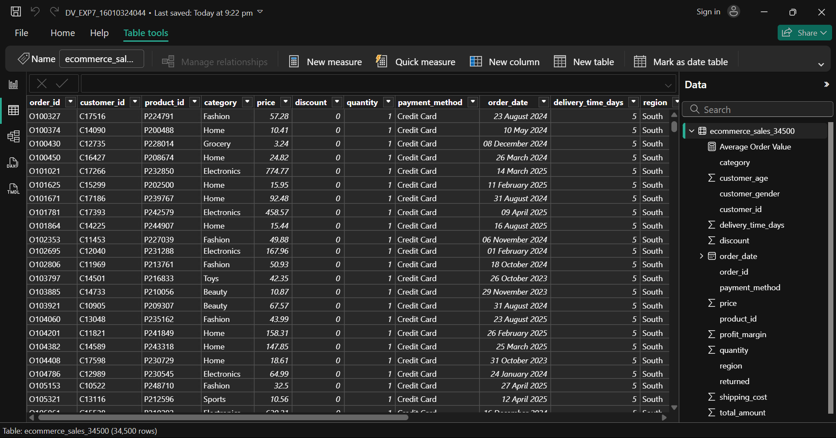

Part B:
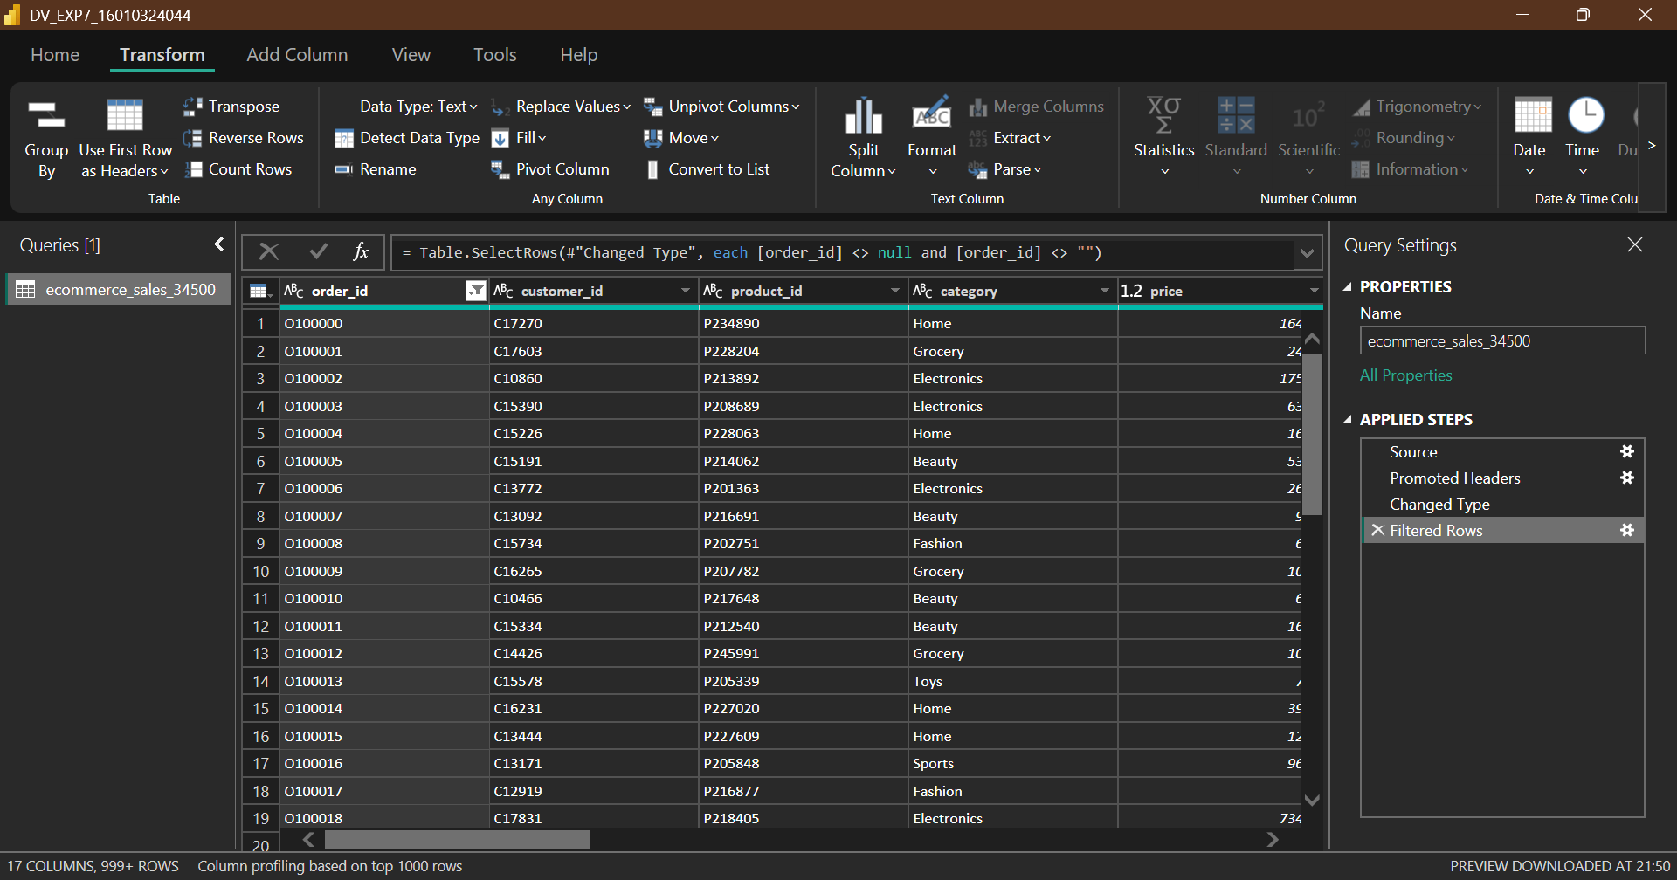

Part D:
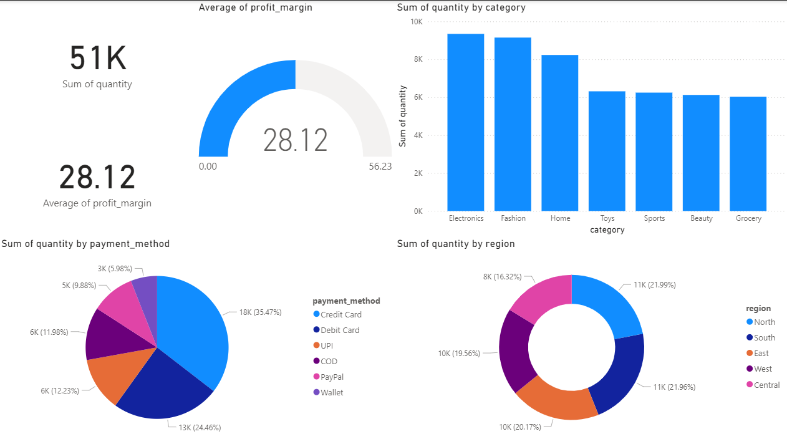
Inference:
People are buying electronic goods on credit card with majority of them being from North as well as South region

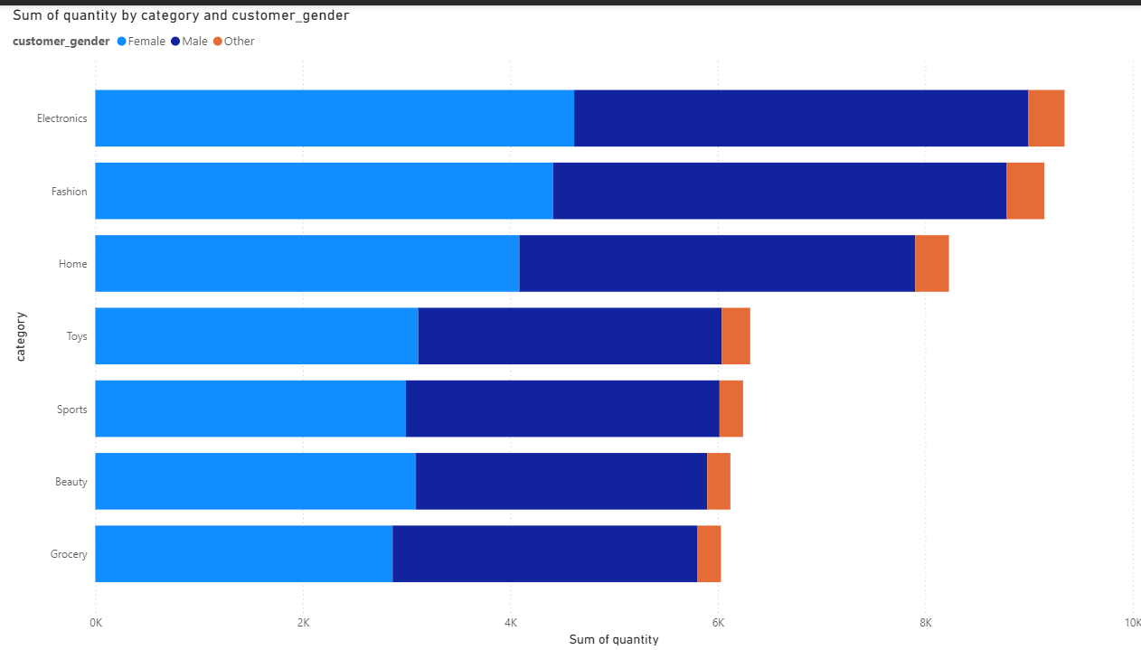
Inference:
Female buyers contributing more to company sales

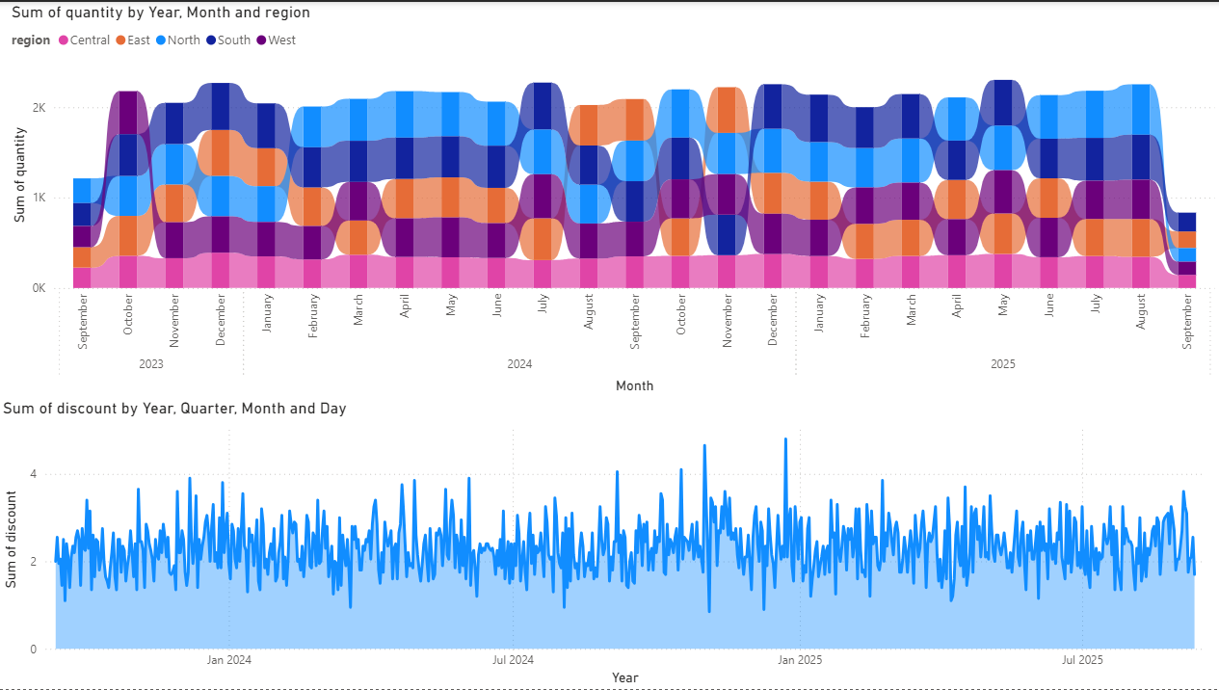
Inference:
East region purchases more during discounts

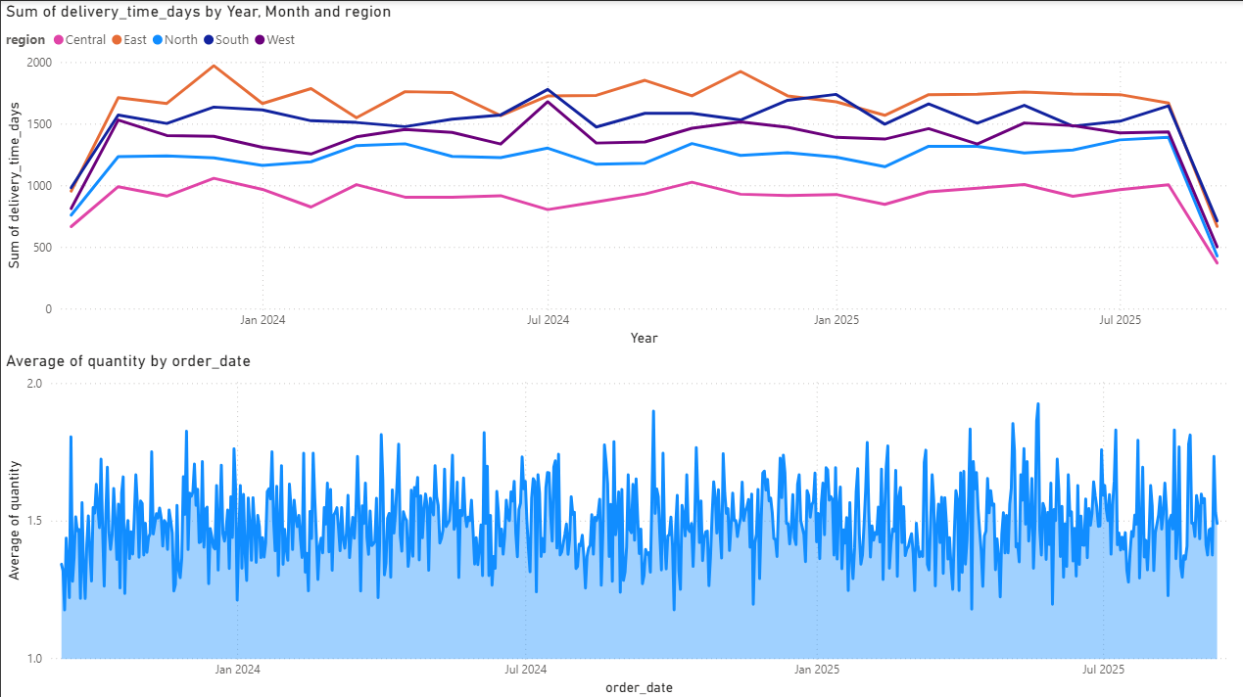
Inference:
Slight increase in delay time in the month of July

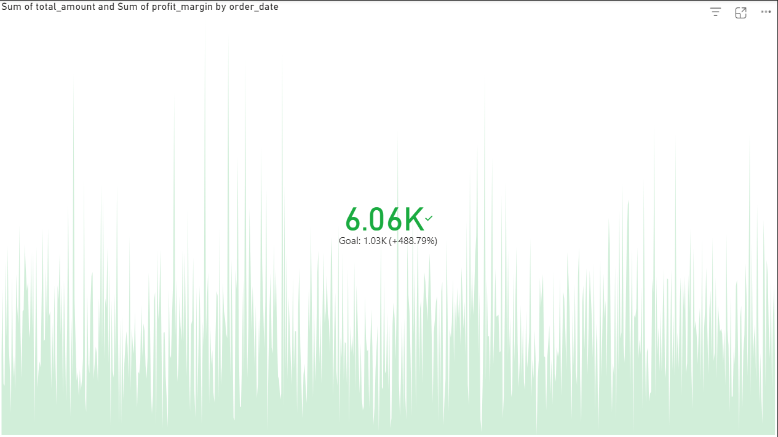

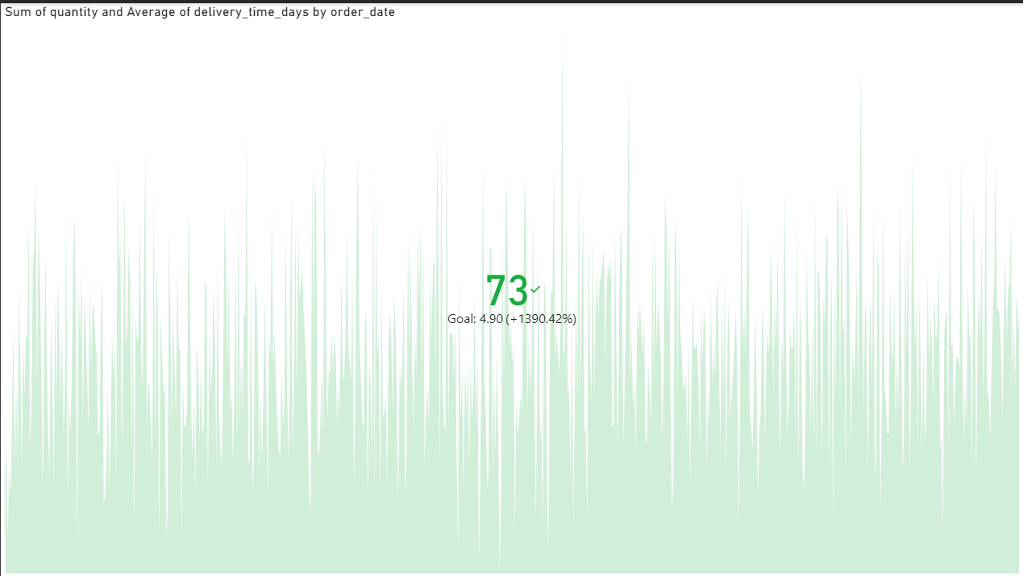

Part E:
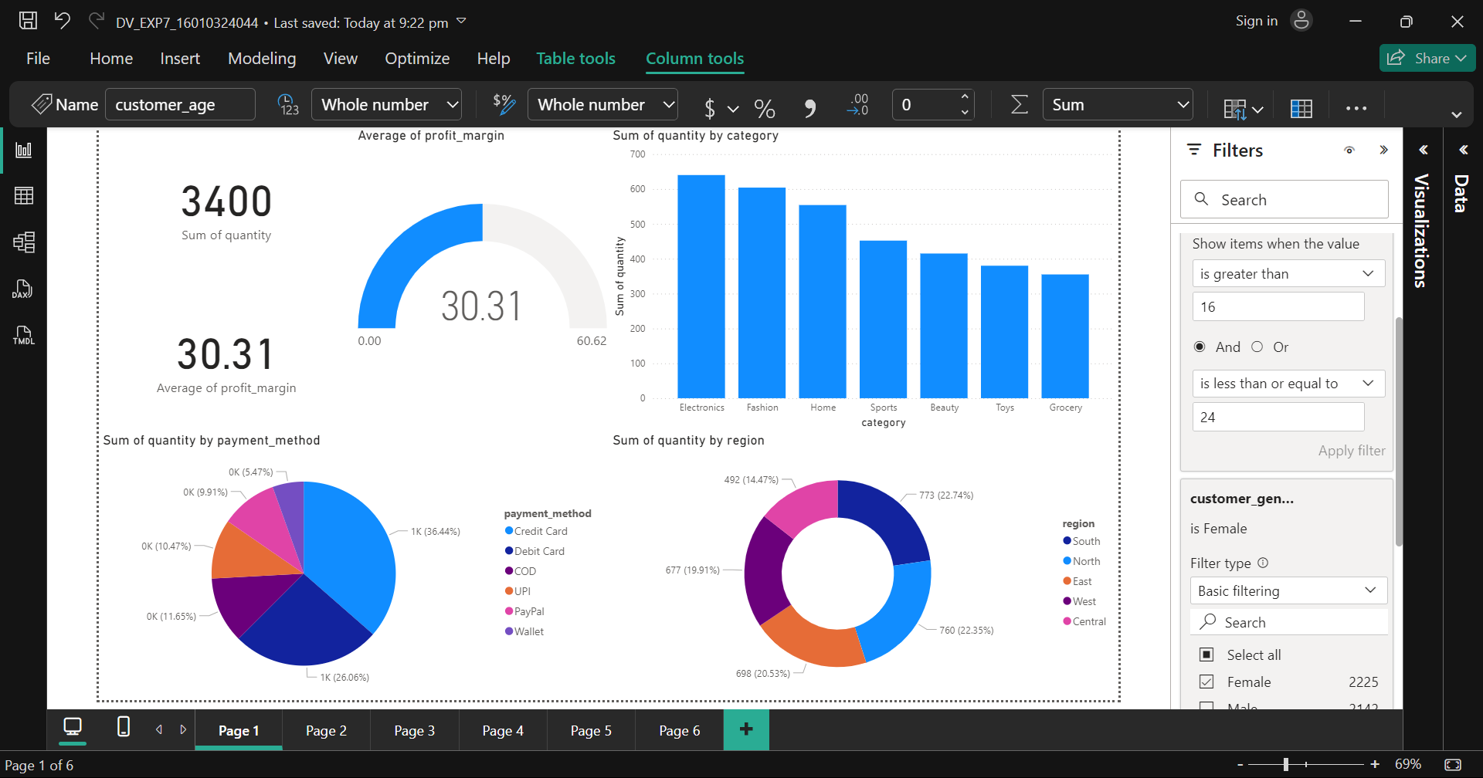

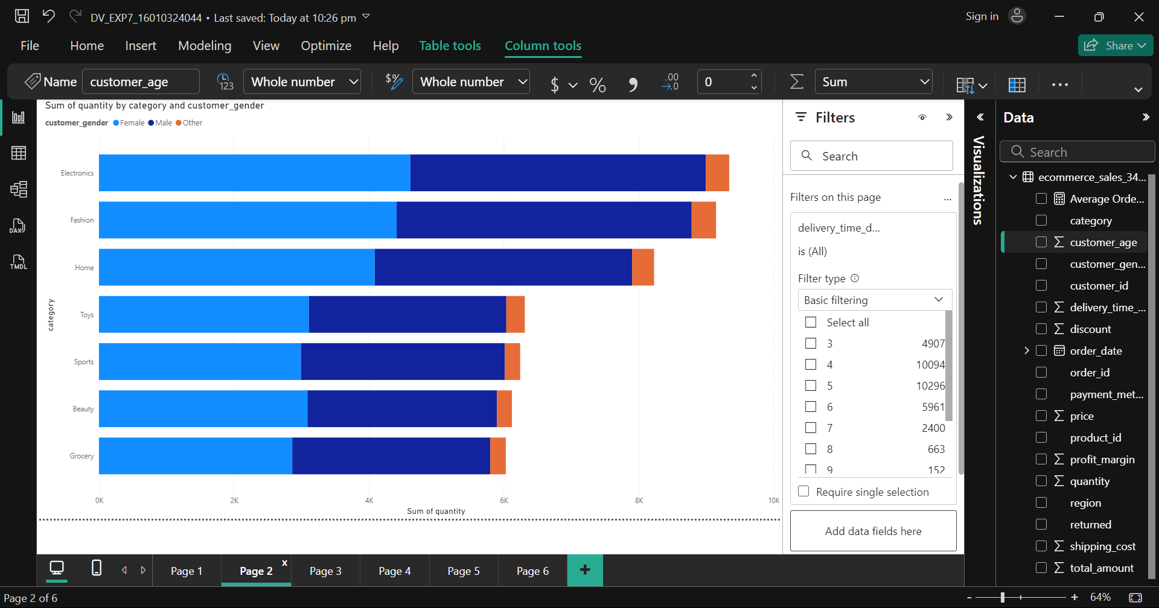

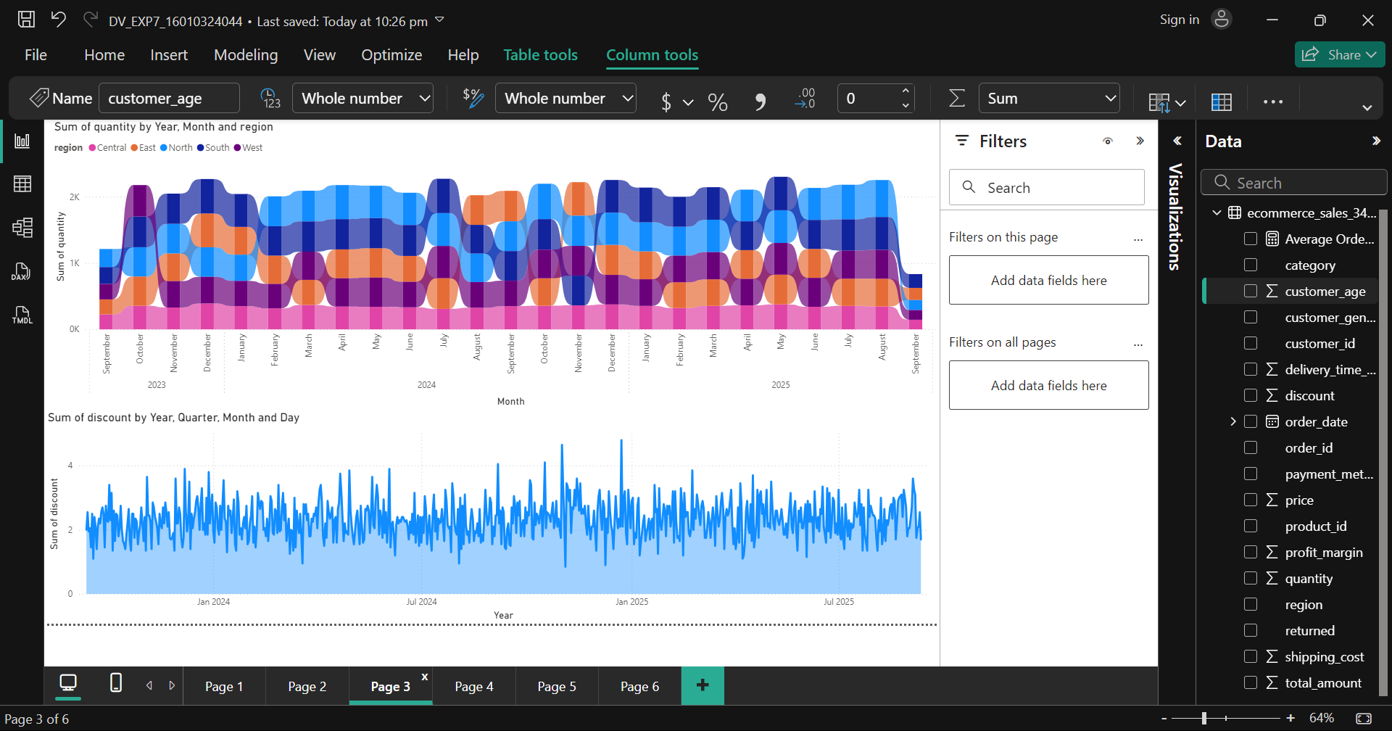

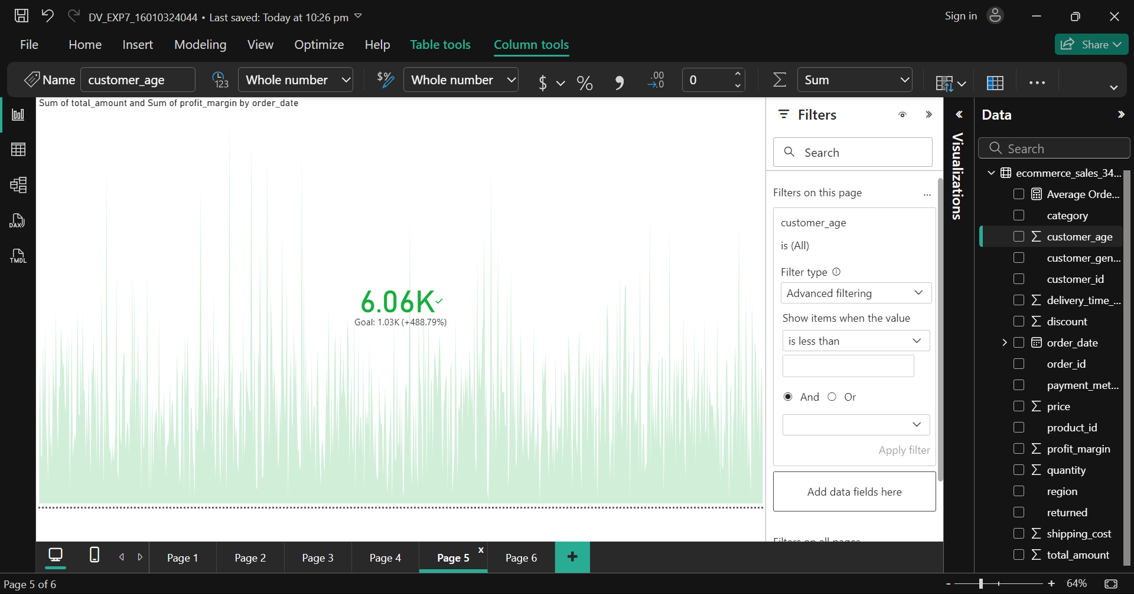

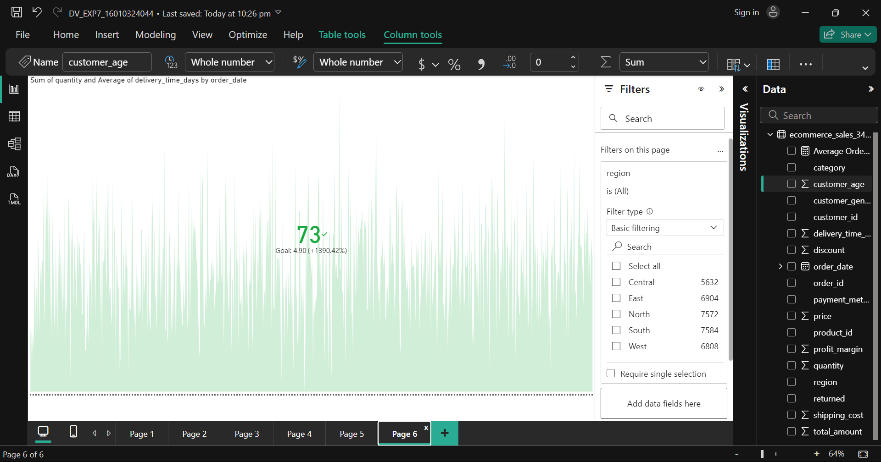
Post Lab Questions:
- How is Power BI different from Python and Tableau?
- Power BI is more user friendly than Tableau, since both are applications they are easier and than Python

- Which platform do you appreciate out of the three learnt? Why?
- Power BI - easy for creating visvualisations
- What is the difference between Power Query transformations and DAX measures?
- Power Query alters data in preprocessing and DAX is used during analysis of data

- Why is the Decomposition Tree useful in business analysis?
- It breaks down a complex metric into its contributing factors across multiple dimensions

- How does the Key Influencers visual help in decision making?
- It identifies and rank the top factors that drive a specific metric and the factor driving it, helping to make targeted decisions

Conclusion:
In this experiment, I learned how to clean, transform, and visualize data using Power BI. I gained practical knowledge of Power Query and understood how to use Key Influencers to make interactive visuals that can help derive meaningful decisions.

Signature of faculty in-charge with Date:

