Course Name: | Data Visualization Laboratory (Honours_ Data Science for Emerging Analytics) | Semester: | III
Date of Performance: |  | Batch No: | A1
Faculty Name: | Dr. Rupali Patil | Roll No: | 44
Faculty Sign & Date: |  | Grade/Marks: | XX/25

Experiment No: 8
Title: To create an effective Dashboard and Story using Power BI

Aim and Objective of the Experiment:
- To design an interactive and insightful Dashboard in Power BI.
- To create a Report that communicates insights effectively.
- To understand how dashboard interactivity (slicers, drill-through, bookmarks) enhances decision-making.

COs to be achieved:
CO2: Detect and understand the stories within datasets and its applications.
CO4: Design static charts, interactive Dashboards

Tools required:
Power BI

Code/Task:

Part A: Dashboard Creation in Power BI
Prepare Your Data:
- Import dataset using Get Data (Excel, CSV, SQL Server, etc.).
- Clean and transform data using Power Query Editor.
- Create relationships between tables in Model View.
Create Visualizations:
- Use visuals like Clustered Bar Chart, Pie Chart, Map, Line Chart, Tree Map, and Gauge.
- Add Slicers for filtering by category, date, or region.
- Use Drill-through pages to explore detailed views from summary visuals.
- Apply Conditional Formatting to highlight key metrics.
Add Interactivity:
- Use Bookmarks to toggle between views or highlight scenarios.
- Add Buttons with actions (e.g., navigation, reset filters).
- Use Tooltips to show additional data on hover.
- Implement Sync Slicers across multiple pages.
Advanced Features (Power BI Exclusive):
- Write DAX (Data Analysis Expressions) to create calculated columns, measures, and KPIs.
- Use Q&A Visual to ask natural language questions.
- Embed R or Python visuals for advanced analytics.
- Customize visuals using Themes and Custom Visual Marketplace.
Formatting:
- Use Page Size and Canvas Settings to optimize layout.
- Add Report Title, Logo, and Text Boxes for context.
- Maintain consistent color palette and font styles.

Part B: Report Creation (Power BI Equivalent of Story)
New Report Page:
- Add multiple pages to tell a data-driven story.
- Use Bookmarks + Selection Pane to simulate narrative flow.
Narrative Flow:
- Each page should answer a business question (e.g., “Which region performs best?” → “What drives this performance?” → “What actions can be taken?”).
- Use Captions and Annotations to explain insights.
Final Touches:
- Use Drill-through filters to focus on specific data points.
- Keep visuals clean and engaging.
- Export to PDF or PowerPoint for presentation.

Output:
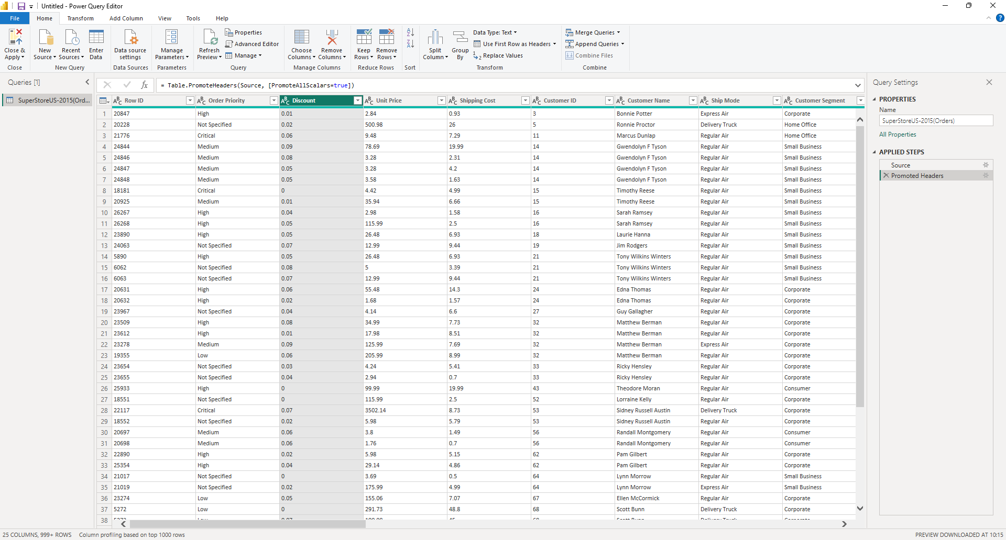
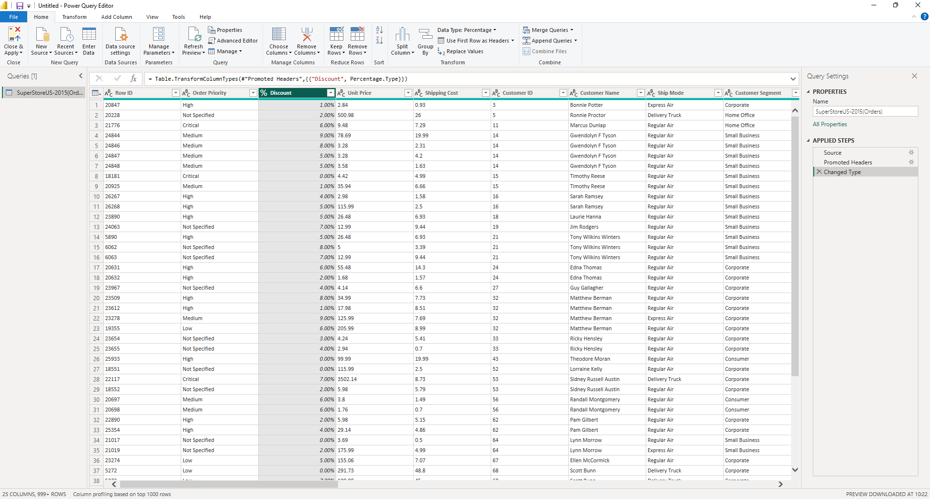
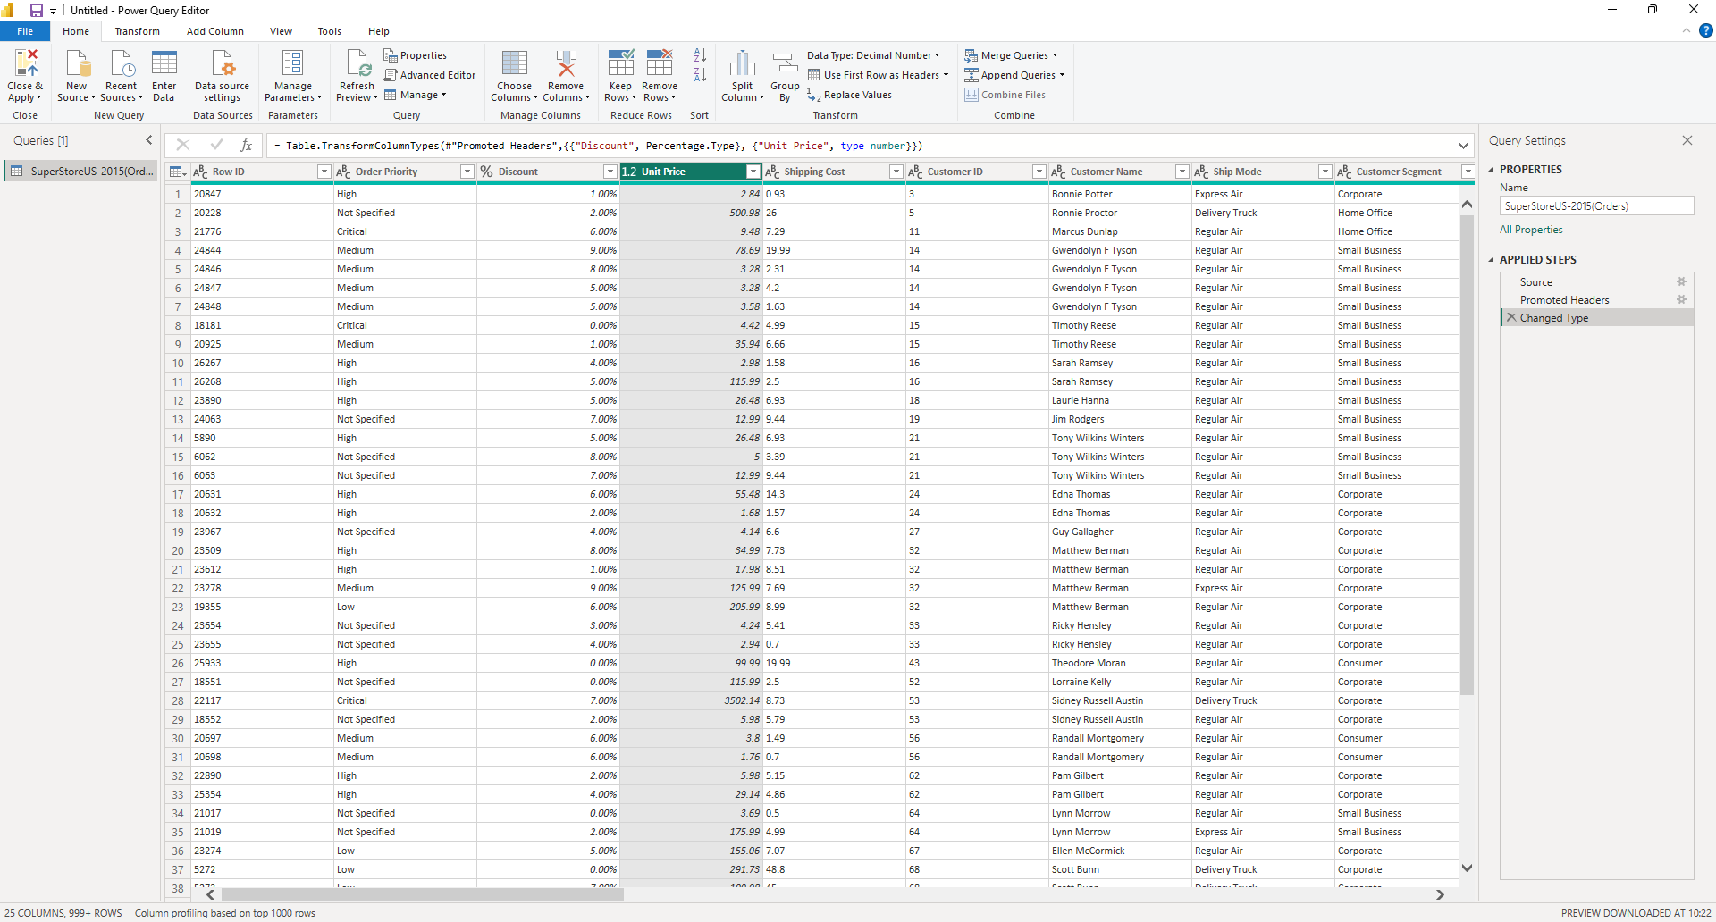
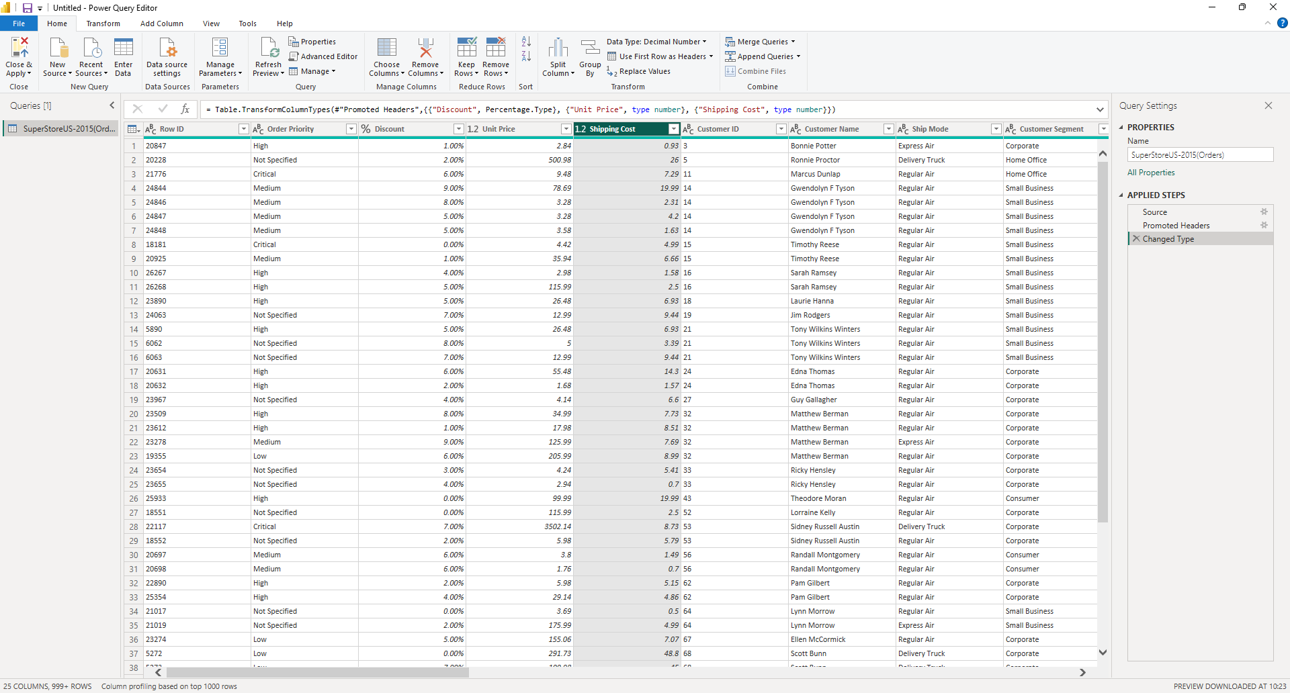
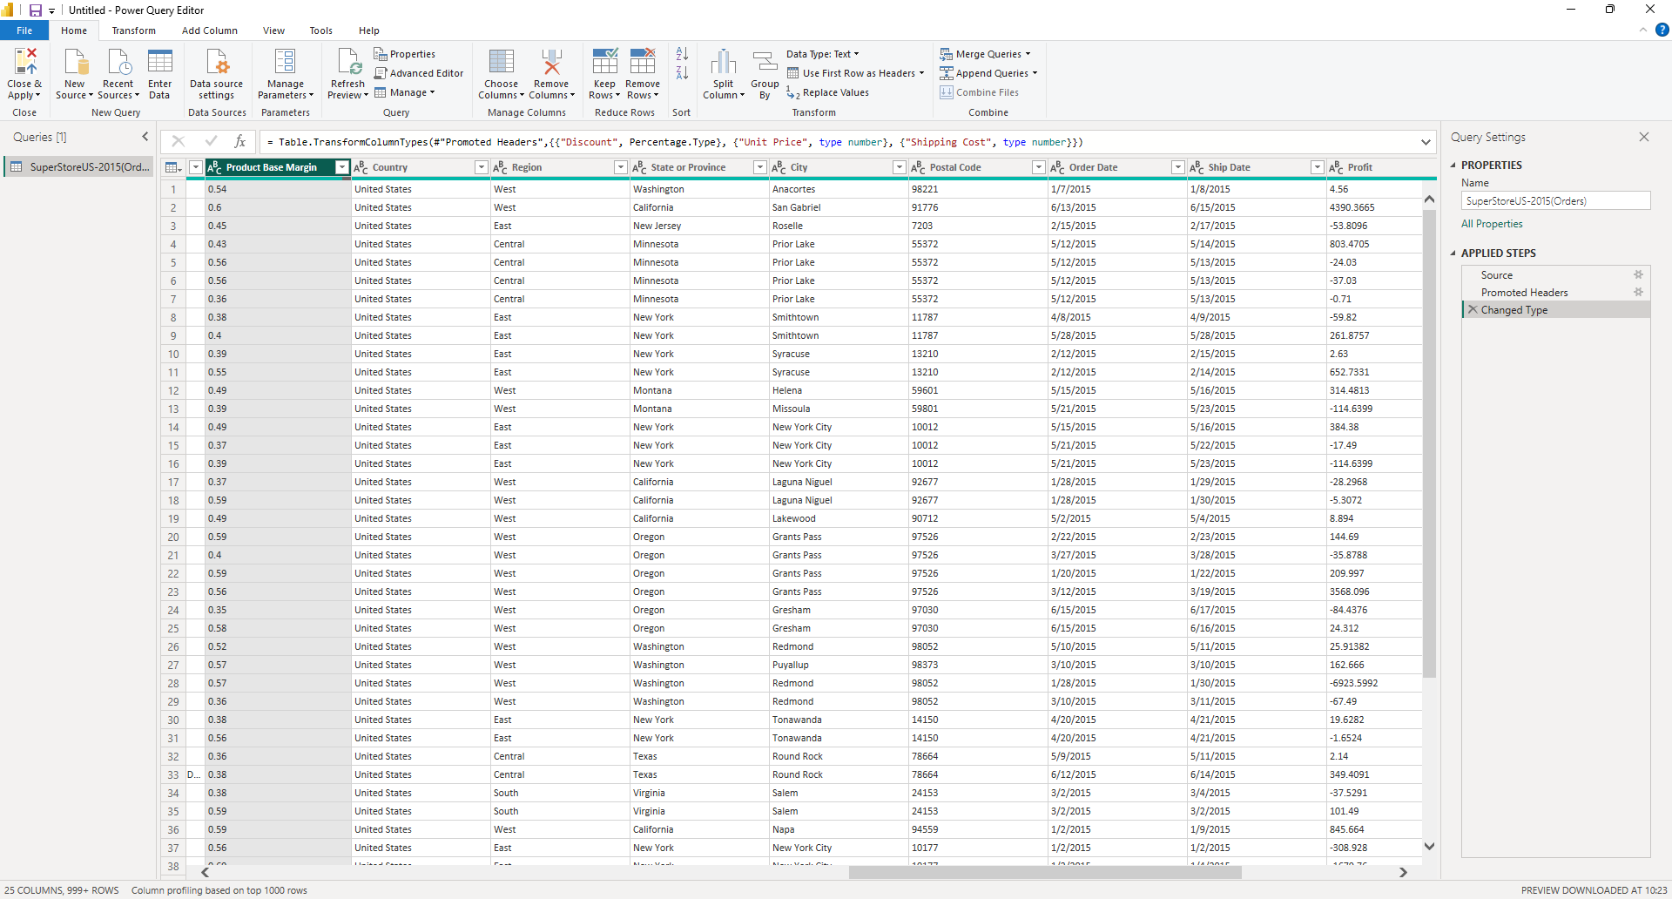
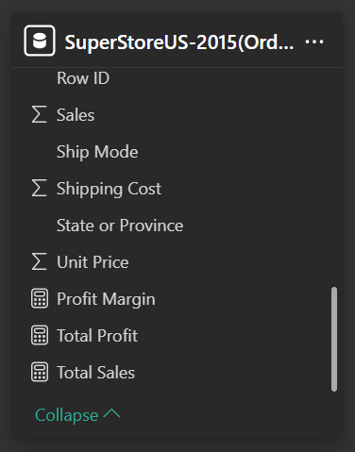

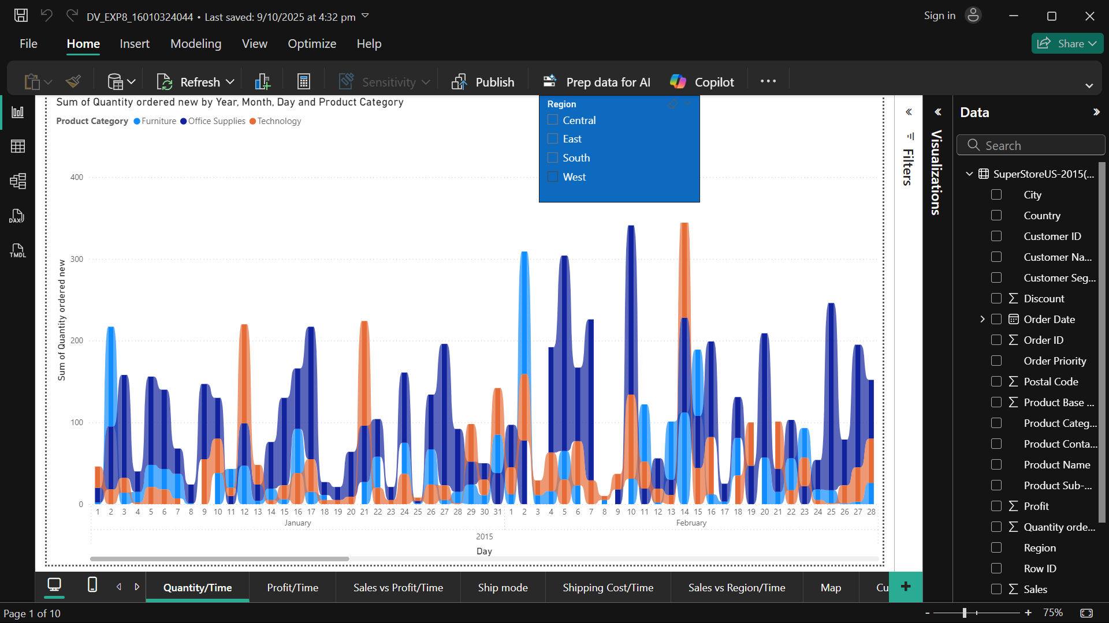
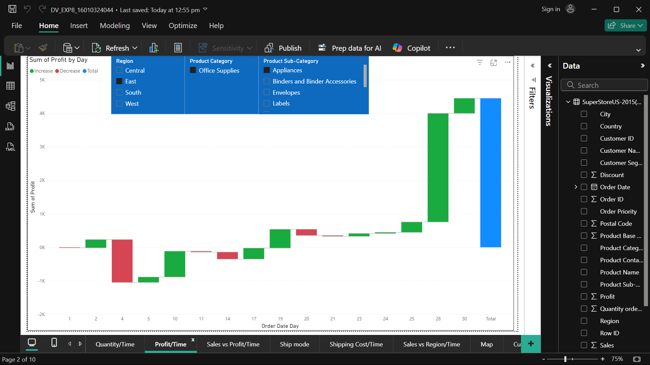
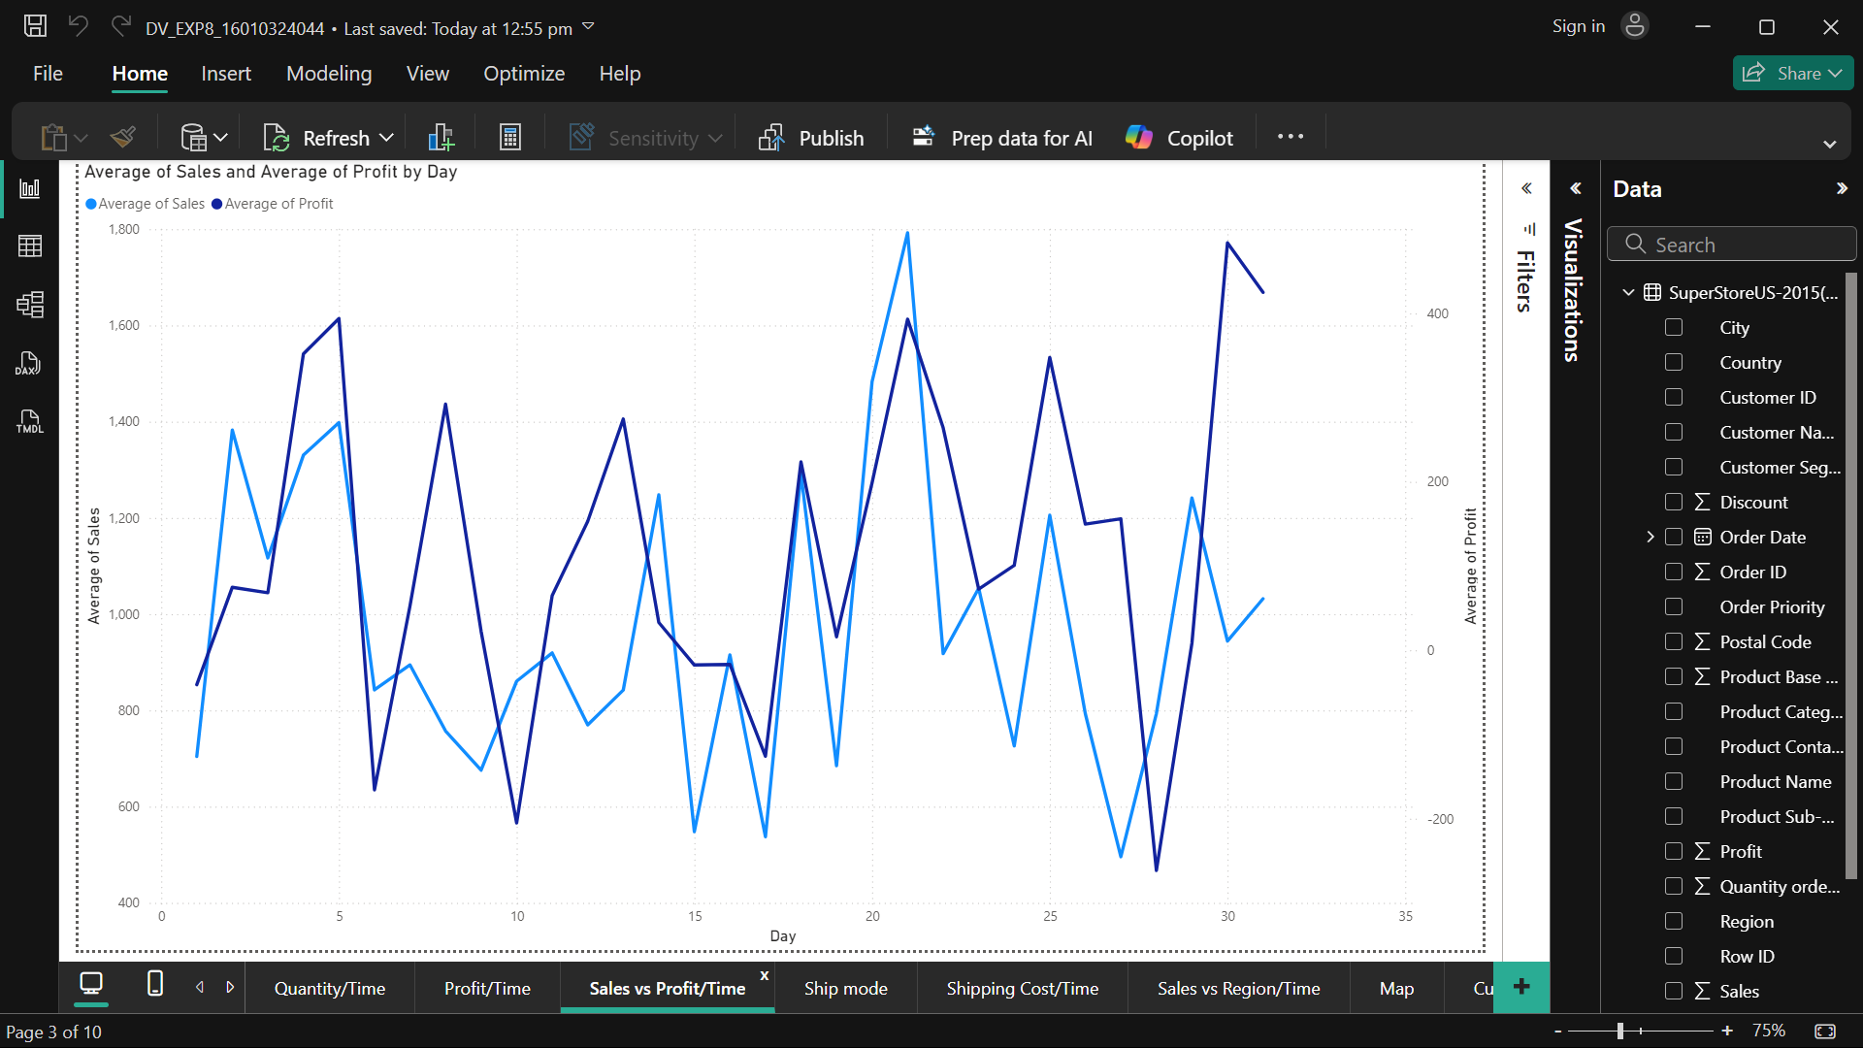
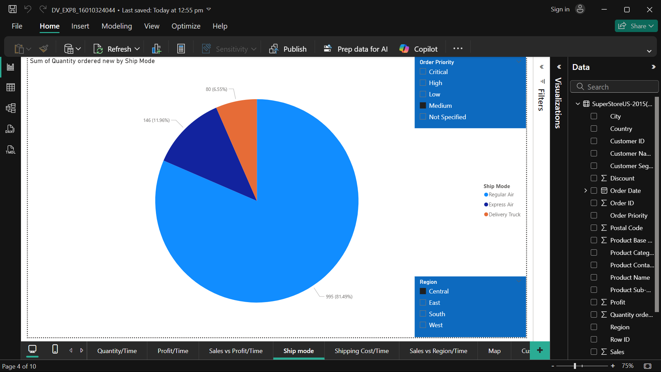
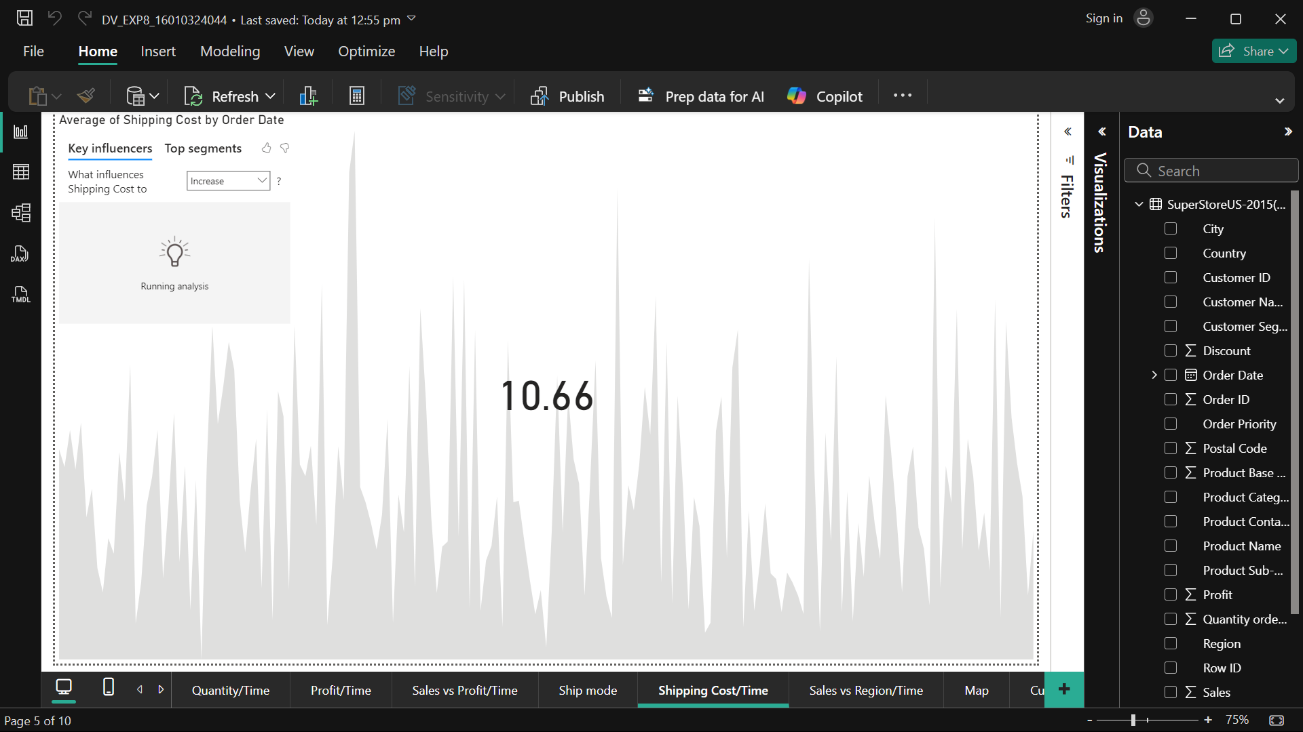
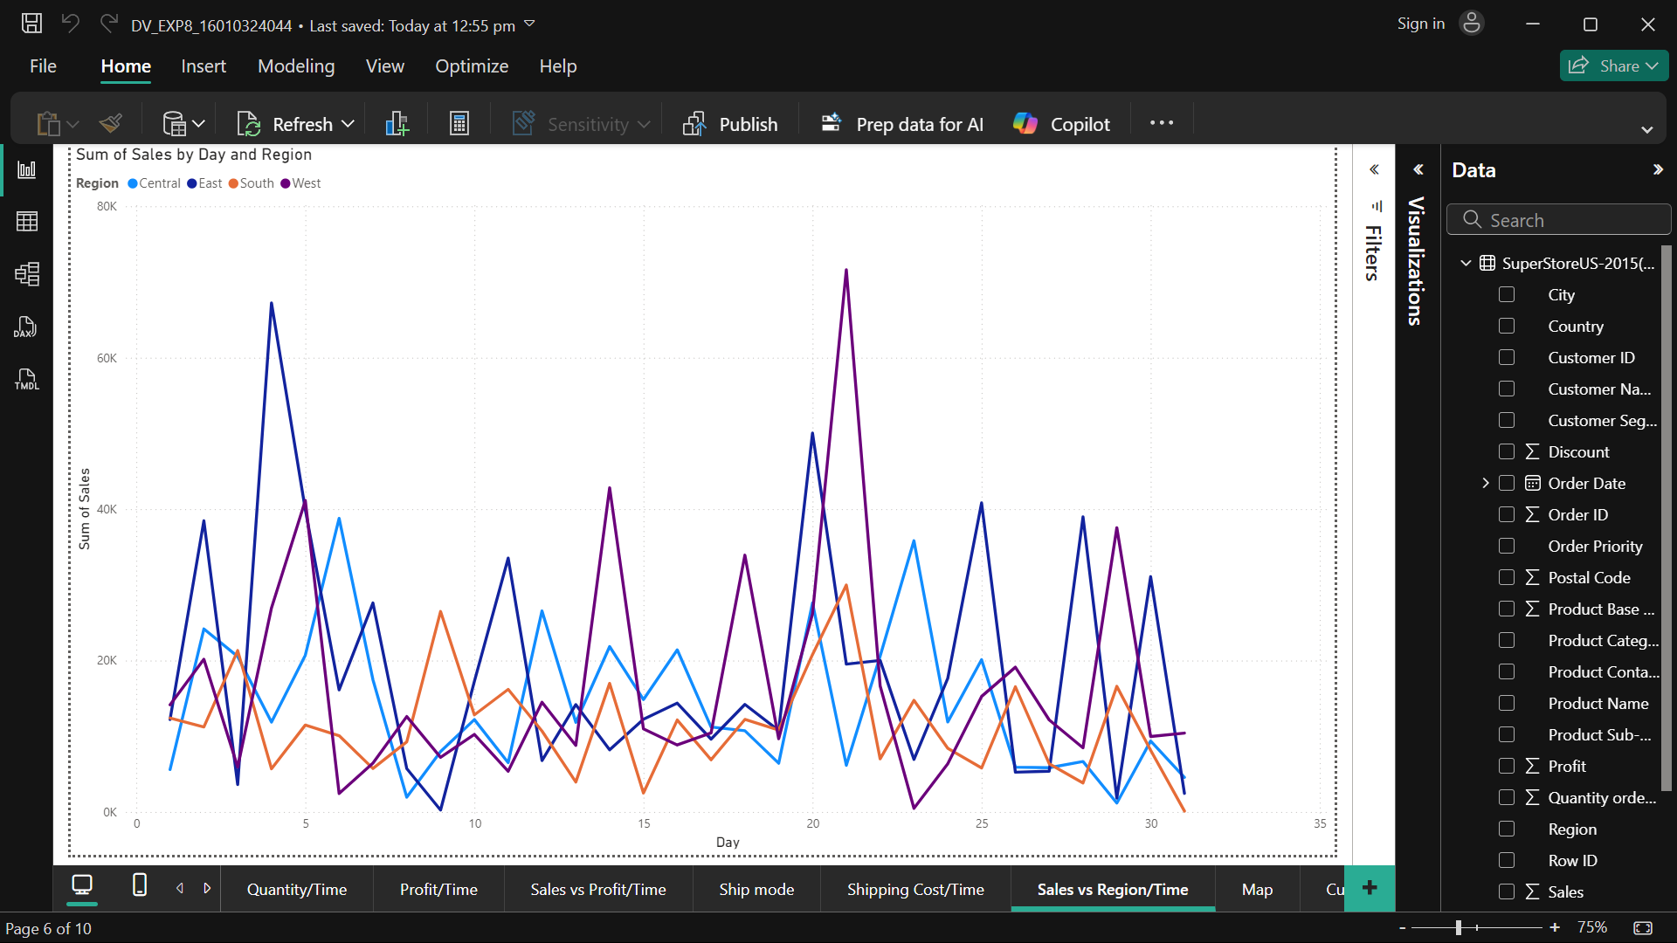
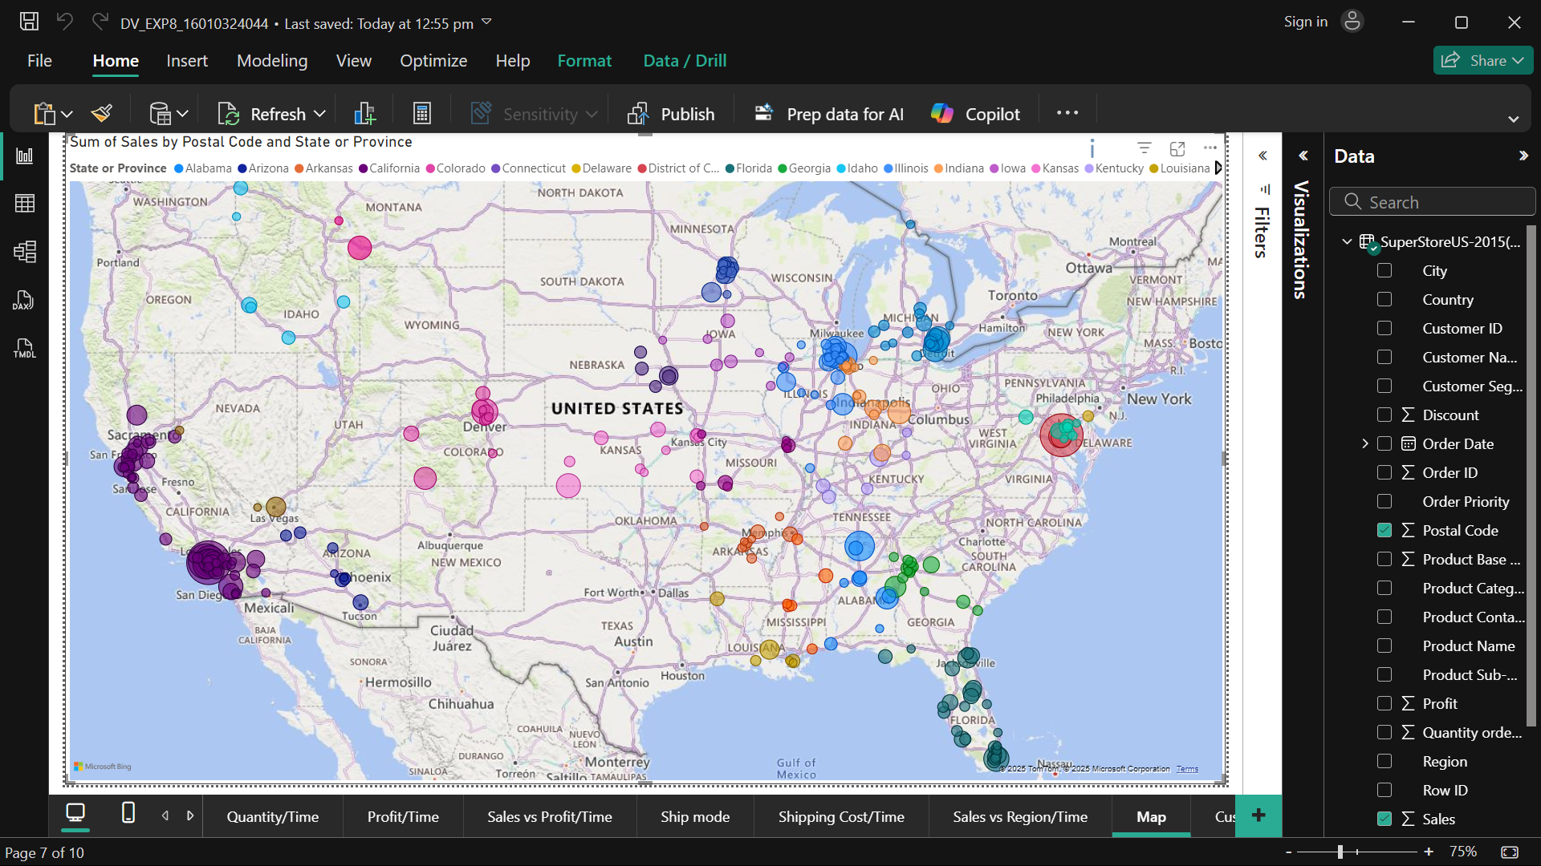
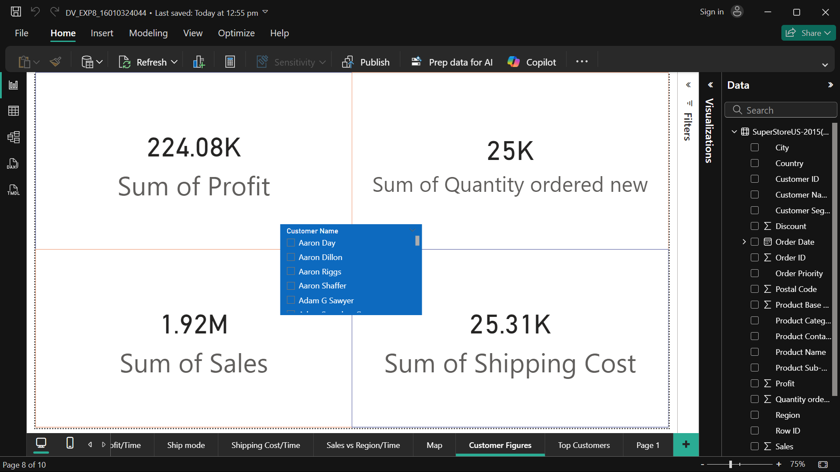
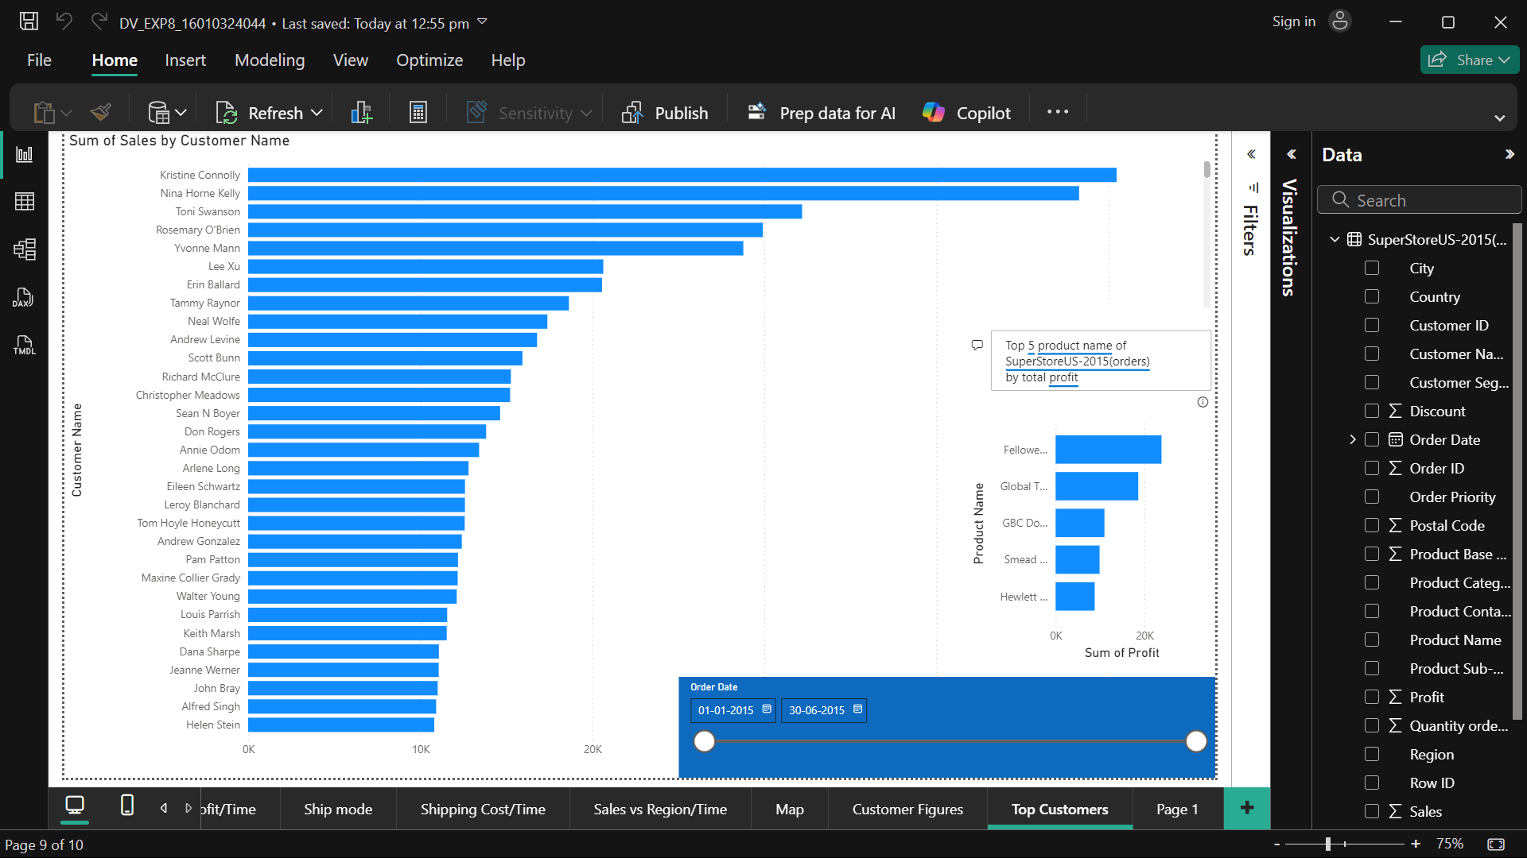

Post Lab Questions:
- How does Power BI’s DAX enhance data analysis compared to Tableau?
- It is very useful for custom, complex and dynamic calculations. (For eg: Stock Market)

- Which Power BI feature added the most value to your dashboard?
- Waterfall chart is ready to use, in Tableau it requires some configuration to be done

- What are some best practices for designing reports in Power BI?
- Use the right visuals, take full advantage of DAX and keep it simple.

- How does drill-through improve storytelling in Power BI?
- More data can be shown without saturating the visuals with information

Conclusion:
In this experiment, I learned how to create interactive dashboards in Power BI and use features like slicers and drill-through to make data more meaningful. It improved my skills in visualizing and presenting insights effectively.

Signature of faculty in-charge with Date:

