Course Name: | Advanced Data Analytics | Semester: | IV
Date of Performance: |  | Batch No: | ADA-2
Grade/Marks: | /25 | Roll No: | 16010324044

Experiment No: 1
Title: Box plot and Scatter plot

Aim and Objective of the Experiment:
Part 1: Choose a relevant variable from the available dataset and plot the Box plot to interpret the results
Part 2:
- Construct a scatterplot that shows two-variable data
- Investigate and describe patterns of association from scatterplot

COs to be achieved:
CO4: Collect, analyze, and interpret data, making informed decisions based on quantitative insights.

Tools required:
- Data set website
- Python programming : Pandas, Matplotlib

Theory:
- Box Plot in Python using Matplotlib:
- A Box Plot is also known as Whisker plot is created to display the summary of the set of data values having properties like minimum, first quartile, median, third quartile and maximum. In the box plot, a box is created from the first quartile to the third quartile, a vertical line is also there which goes through the box at the median. Here x-axis denotes the data to be plotted while the y-axis shows the frequency distribution.
- Creating Box Plot
The matplotlib.pyplot module of matplotlib library provides boxplot() function with the help of which we can create box plots.
Syntax: matplotlib.pyplot.boxplot(data)
- ScatterPlot in Python using Matplotlib:

- matplotlib.pyplot.scatter() is used to create scatter plots, which are essential for visualizing relationships between numerical variables. Scatter plots help illustrate how changes in one variable can influence another, making them invaluable for data analysis.
- A basic scatter plot can be created using matplotlib.pyplot.scatter() by plotting two sets of data points on the x and y axes
- Correlation Coefficient

A correlation coefficient is a numerical measure that quantifies the strength and direction of a linear relationship between two variables. It ranges from -1 to 1, where:
  - +1 indicates a perfect positive correlation,
  - -1 indicates a perfect negative correlation,
  - 0 indicates no correlation
  - Interpreting Correlation Coefficients
The value of the correlation coefficient indicates the strength of the relationship:
  - +0.8 to +1.0 or -0.8 to -1.0: Very strong correlation
  - +0.6 to +0.8 or -0.6 to -0.8: Strong correlation
  - +0.4 to +0.6 or -0.4 to -0.6: Moderate correlation
  - +0.2 to +0.4 or -0.2 to -0.4: Weak correlation
  - 0.0 to +0.2 or 0.0 to -0.2: Very weak or no correlation

Task:
Plot Boxplot and scatter plot for a data set.
Following are the steps to be followed for the construction of plot:
- Select a dataset from the internet
- Display all available parameters in the dataset with their explanations
- Select a parameter/parameters as per requirement for your plot
- Write the problem statement based on the parameter selected
- Construct the relevant plot for the data selected
- Interpret the plot

1.
Box plot Dataset:
Tesla Stock Price History (2010–2022)
Box plot Parameters in dataset:
X-Axis: Year (Categorical variable for grouping data by year)
Y-Axis: Close (Numerical variable showing the stock price distribution)
Palette: viridis (To differentiate years visually)
Box plot Problem statement:
We want to analyze the distribution, volatility, and growth trend of Tesla's stock price year over year. Specifically, we want to see how the trading range (volatility) has expanded and when the major valuation shifts occurred.
Box plot Code:
import pandas as pd
import matplotlib.pyplot as plt
import seaborn as sns

# Load data
df = pd.read_csv('data-tesla_stock.csv')
df['Date'] = pd.to_datetime(df['Date'])
df['Year'] = df['Date'].dt.year

# Create plot
plt.figure(figsize=(12, 6))
sns.boxplot(x='Year', y='Close', data=df, palette="viridis")
plt.title('Tesla Stock Price Distribution by Year')
plt.xlabel('Year')
plt.ylabel('Close Price (USD)')
plt.show()

Box plot Output:
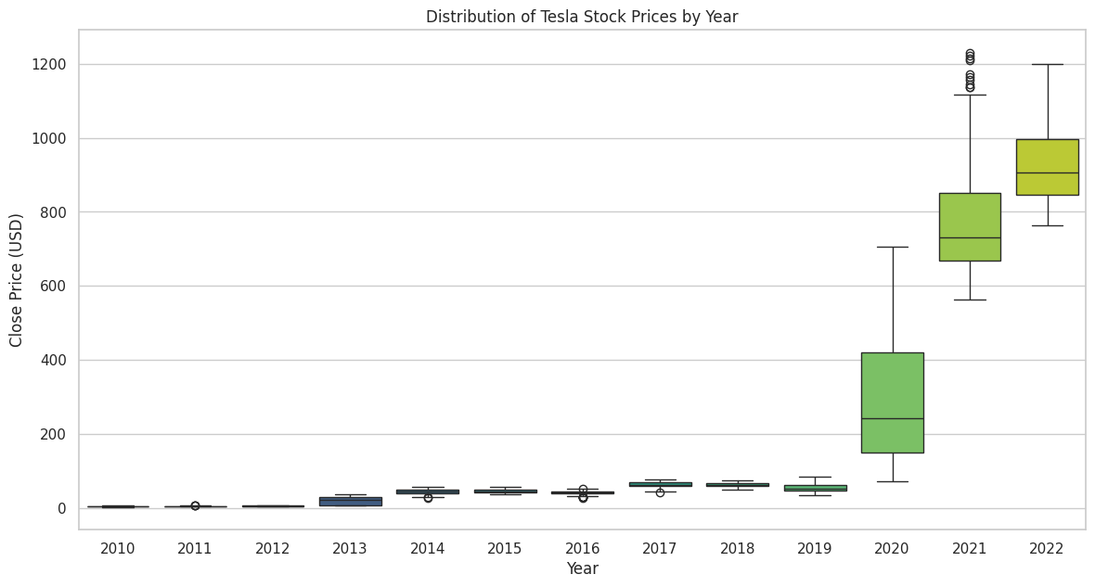
Box plot Interpretations:
The Breakout: clearly visualizes a decade of flat stagnation followed by a massive valuation explosion in 2020.
Volatility: The huge vertical spread in 2020–2021 indicates extreme daily price swings compared to the tight stability of the early years

Scatter plot Dataset:
Tesla Stock Price History (2010–2022)
Scatter plot Parameters in dataset:
X-Axis: Volume (Number of shares traded daily)
Y-Axis: Close (Closing price of the stock in USD)
Color/Hue: Year (To distinguish temporal trends)
Scatter plot Problem statement:
We want to investigate the relationship between trading activity (Volume) and the company's valuation (Close Price). Specifically, does higher trading volume correlate with higher stock prices, and how has this dynamic shifted over time as the company matured.
Scatter plot Code:
import pandas as pd
import matplotlib.pyplot as plt
import seaborn as sns

# Load data
df = pd.read_csv('data-tesla_stock.csv')
df['Date'] = pd.to_datetime(df['Date'])
df['Year'] = df['Date'].dt.year

# Create plot
plt.figure(figsize=(10, 6))
sns.scatterplot(x='Volume', y='Close', data=df, hue='Year', palette='viridis', alpha=0.6)
plt.title('Tesla: Trading Volume vs. Close Price (Colored by Year)')
plt.xlabel('Volume')
plt.ylabel('Close Price (USD)')
plt.show()

Scatter plot Output:
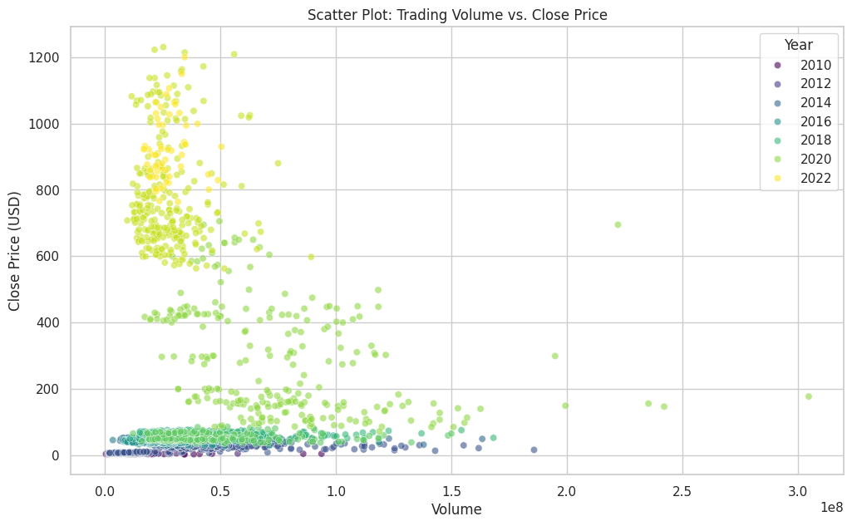
Scatter plot Interpretations:
Inverse Trend: High trading volumes historically coincided with low stock prices ("penny stock" era).
Maturation: Recent record-high prices (2020–2022) are accompanied by lower, stable volume, suggesting a shift from speculative day-trading to long-term holding.

2.
Box plot Dataset:
Student Test Scores (Math, Reading, Writing)
Box plot Parameters in dataset:
X-Axis: race/ethnicity (Categorical grouping variable)
Y-Axis: math percentage (Numerical test score variable)
Palette: Set2 (To distinguish between groups)
Box plot Problem statement:
We aim to visualize the distribution of math scores across different racial/ethnic groups to identify if there are any significant performance disparities, variations in score spread, or outliers within specific groups.

Box plot Code:
import pandas as pd
import matplotlib.pyplot as plt
import seaborn as sns

# Load data
df = pd.read_csv('data-student_performance.csv')
order = sorted(df['race/ethnicity'].unique())

# Create plot
plt.figure(figsize=(10, 6))
sns.boxplot(x='race/ethnicity', y='math percentage', data=df, order=order, palette="Set2")
plt.title('Math Score Distribution by Race/Ethnicity')
plt.xlabel('Race/Ethnicity Group')
plt.ylabel('Math Percentage')
plt.show()

Box plot Output:
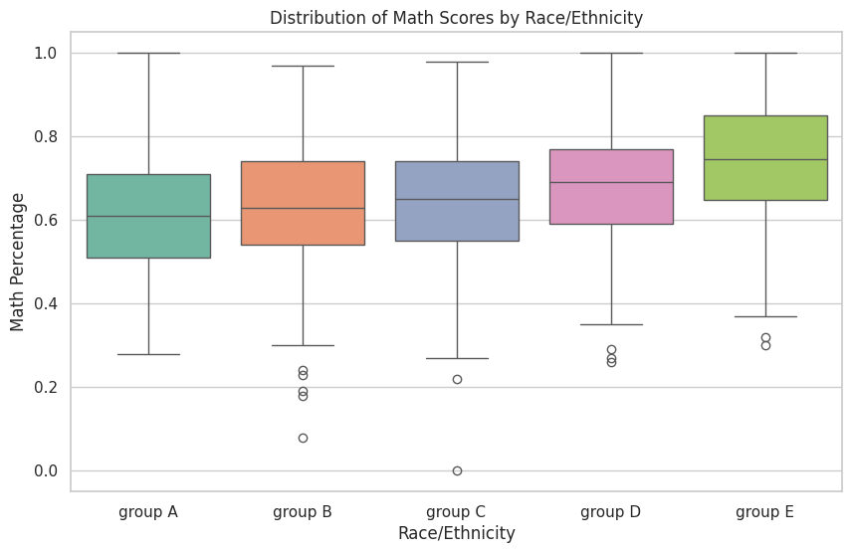
Box plot Interpretations:
Hierarchy: Reveals a step-wise increase in median math scores from Group A (lowest) to Group E (highest).
Consistency: The spread of scores is similar across groups, though Groups B and C show distinct lower-end outliers (struggling students).

Scatter plot Dataset:
Student Test Scores (Math, Reading, Writing)
Scatter plot Parameters in dataset:
X-Axis: reading score percentage
Y-Axis: writing score percentage
Color/Hue: sex (To observe gender-based clustering)
Scatter plot Problem statement:
We aim to determine if proficiency in one language skill (Reading) is a strong predictor of proficiency in another (Writing). Additionally, we want to see if there are distinct performance clusters based on gender.
Scatter plot Code:
import pandas as pd
import matplotlib.pyplot as plt
import seaborn as sns

# Load data
df = pd.read_csv('data-student_performance.csv')

# Create plot
plt.figure(figsize=(10, 6))
sns.scatterplot(x='reading score percentage', y='writing score percentage',
data=df, hue='sex', palette='deep', alpha=0.7)
plt.title('Student Performance: Reading vs. Writing Scores')
plt.xlabel('Reading Score Percentage')
plt.ylabel('Writing Score Percentage')
plt.show()

Scatter plot Output:
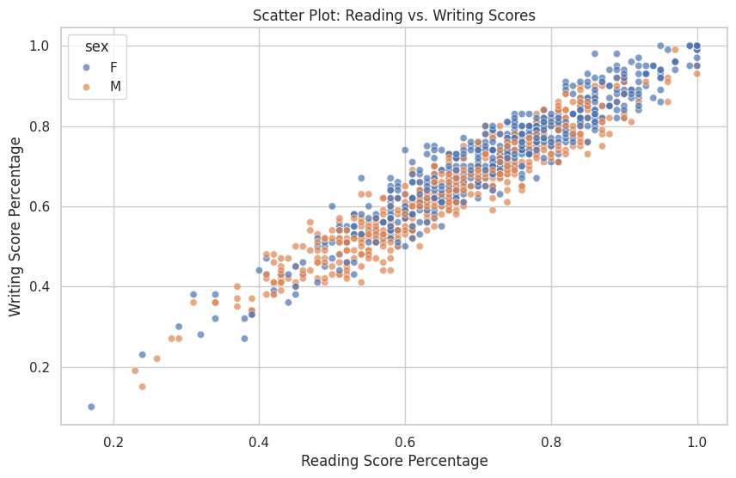
Scatter plot Interpretations:
Strong Correlation: Displays a near-perfect linear relationship (R ≅ 0.95); reading proficiency is an excellent predictor of writing ability.
Gender Bias: Females cluster slightly higher on the spectrum than males, indicating a marginal edge in language tasks.

3.

Box plot Dataset:
Medical Appointment No-Shows (Fitness Tracker Data)
Box plot Parameters in dataset:
X-Axis: NoShow (Categorical: 'Yes' vs 'No')
Y-Axis: Age (Numerical: Patient age)
Palette: pastel (Soft colors for clear distinction)
Box plot Problem statement:
We want to determine if age is a significant factor in whether a patient misses their medical appointment. By comparing the age distribution of those who showed up versus those who didn't, we can check for any age-related bias in attendance.
Box plot Code:
import pandas as pd
import matplotlib.pyplot as plt
import seaborn as sns

# Load data
df = pd.read_csv('data-fitness_tracker_data.csv')

# Create plot
plt.figure(figsize=(8, 6))
sns.boxplot(x='NoShow', y='Age', data=df, palette="pastel")
plt.title('Age Distribution by Appointment Status')
plt.xlabel('Did the Patient No-Show?')
plt.ylabel('Age')
plt.show()

Box plot Output:
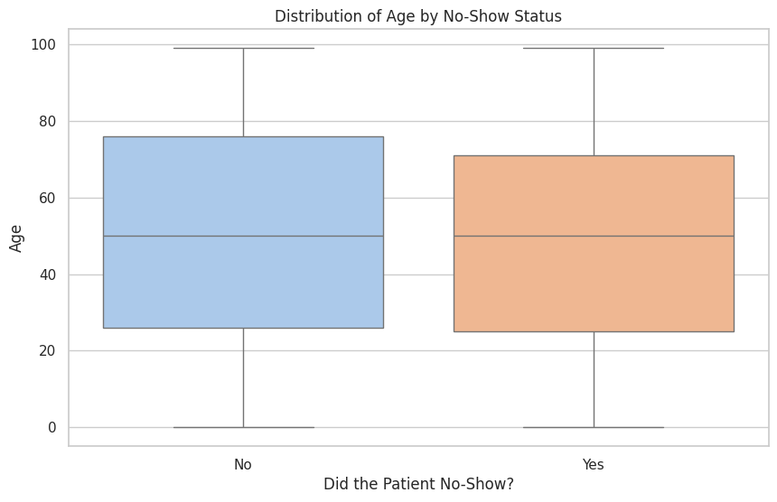
Box plot Interpretations:
Identical Distributions: The box plots for patients who showed up vs. those who didn't are virtually indistinguishable.
Conclusion: Age is not a factor in attendance; young and old patients miss appointments at the same rate.

Scatter plot Dataset:
Medical Appointment No-Shows (Fitness Tracker Data)
Scatter plot Parameters in dataset:
X-Axis: LeadTime (Days between scheduling and the actual appointment)
Y-Axis: Age (Patient age in years)
Color/Hue: NoShow (Red/Orange = Missed, Blue = Attended)
Scatter plot Problem statement:
We are investigating if the wait time for an appointment ("Lead Time") or the patient's age influences the likelihood of them missing the appointment ("No-Show"). Do older people show up more? Do long wait times cause people to forget?
Scatter plot Code:
import pandas as pd
import matplotlib.pyplot as plt
import seaborn as sns

# Load data and process dates
df = pd.read_csv('data-fitness_tracker_data.csv')
df['ScheduledDay'] = pd.to_datetime(df['ScheduledDay'])
df['AppointmentDay'] = pd.to_datetime(df['AppointmentDay'])
df['LeadTime'] = (df['AppointmentDay'] - df['ScheduledDay']).dt.days

# Create plot
plt.figure(figsize=(10, 6))
sns.scatterplot(x='LeadTime', y='Age', data=df, hue='NoShow', palette='bright', alpha=0.6)
plt.title('Medical Appointment: Lead Time vs. Age')
plt.xlabel('Lead Time (Days)')
plt.ylabel('Age')
plt.axvline(0, color='gray', linestyle='--') # Mark zero days
plt.show()

Scatter plot Output:
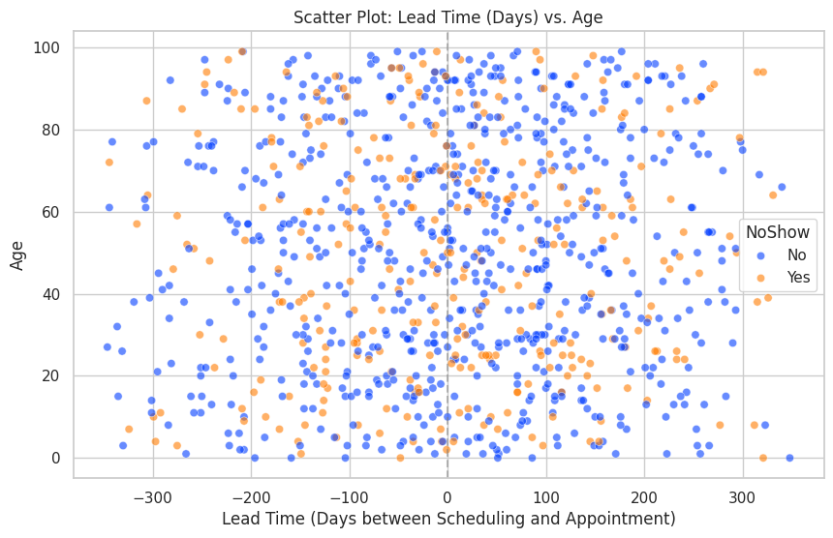
Scatter plot Interpretations:
No Correlation: The random scatter of "No-Show" points (orange) among "Show" points (blue) proves that neither long wait times nor patient age predicts missed appointments.
Data Quality: Presence of negative lead times highlights data entry errors (appointments logged before scheduling).

4.
Box plot Dataset:
Agriculture Products Exports (India)
Box plot Parameters in dataset:
X-Axis: Year (Financial Years)
Y-Axis: ExportValue (Numerical: Value in USD Millions)
Palette: Set3 (To distinguish years)
Box plot Problem statement:
We want to analyze the distribution of export values for agricultural commodities over consecutive years. This helps us understand if the sector is growing uniformly or if growth is driven by a few high-value outlier commodities.
Box plot Code:
import pandas as pd
import matplotlib.pyplot as plt
import seaborn as sns

# Load and clean data
df = pd.read_csv('data-agriculture_products_exports.csv', header=1)
year_cols = [col for col in df.columns if col.startswith('20')]

# Clean currency strings
def clean_currency(x):
if isinstance(x, str):
return float(x.replace(',', '').replace(' ', ''))
return x

for col in year_cols:
df[col] = df[col].apply(clean_currency)

# Melt data for plotting
df_melted = df.melt(id_vars='Commodity', value_vars=year_cols,
var_name='Year', value_name='ExportValue')

# Create plot
plt.figure(figsize=(12, 6))
sns.boxplot(x='Year', y='ExportValue', data=df_melted, palette="Set3")
plt.title('Distribution of Agriculture Exports by Year')
plt.xlabel('Financial Year')
plt.ylabel('Export Value (USD Millions)')
plt.xticks(rotation=45)
plt.show()

Box plot Output:
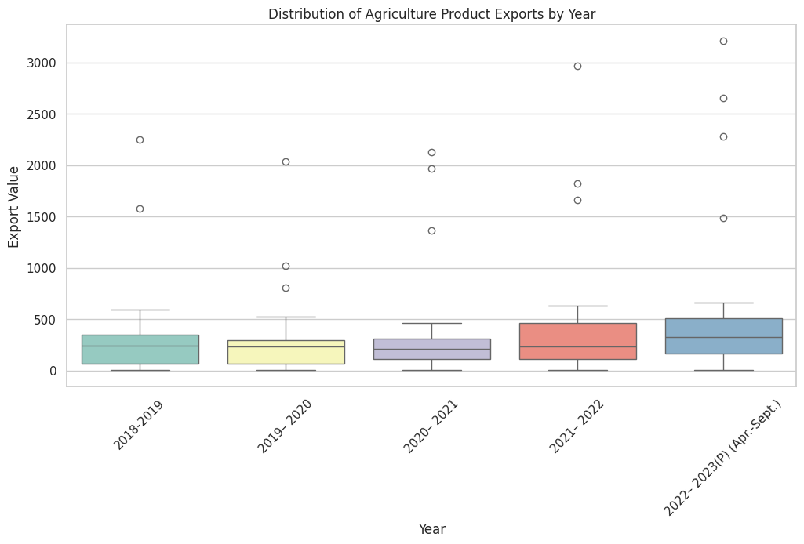
Box plot Interpretations:
Skewed Sector: The sector is defined by a low median value (most crops export little) and massive outliers (Rice exports billions).
Top-Heavy Growth: The overall distribution shape hasn't changed much, but the outliers have moved higher, indicating growth is driven by a few star commodities rather than the entire sector.

Scatter plot Dataset:
Agriculture Products Exports (India)
Scatter plot Parameters in dataset:
X-Axis: 2018-2019 Export Value
Y-Axis: 2021-2022 Export Value
Reference: Diagonal line (y=x) representing "No Growth"
Scatter plot Problem statement:
We want to compare the export performance of agricultural commodities between a baseline year (2018-19) and a recent post-pandemic year (2021-22) to identify which sectors have grown and which have stagnated.
Scatter plot Code:
import pandas as pd
import matplotlib.pyplot as plt
import seaborn as sns

# Load data (header is on row 1)
df = pd.read_csv('data-agriculture_products_exports.csv', header=1)

# Clean currency strings
def clean_currency(x):
if isinstance(x, str):
return float(x.replace(',', '').replace(' ', ''))
return x

df['2018-2019'] = df['2018-2019'].apply(clean_currency)
df['2021– 2022'] = df['2021– 2022'].apply(clean_currency)

# Create plot
plt.figure(figsize=(10, 6))
sns.scatterplot(x='2018-2019', y='2021– 2022', data=df, s=100, color='green', alpha=0.7)
plt.title('Agriculture: Exports 2018-19 vs 2021-22')
plt.xlabel('Exports 2018-2019')
plt.ylabel('Exports 2021-2022')
# Add reference line
limit = max(df['2018-2019'].max(), df['2021– 2022'].max())
plt.plot([0, limit], [0, limit], '--', color='grey')
plt.show()

Scatter plot Output:
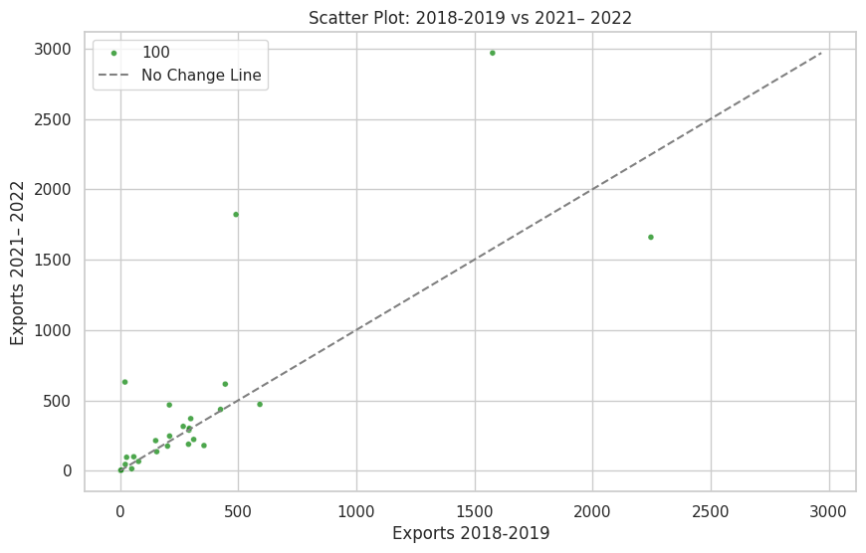
Scatter plot Interpretations:
Broad Growth: Most points lie above the "No Change" diagonal line, confirming that export values for most commodities increased between 2018 and 2021.
Top Performers: High-value commodities (Rice) show the largest absolute growth, appearing far to the top-right.

