Course Name: | Advanced Data Analytics | Semester: | IV
Date of Performance: | 22/01/26 | Batch No: | ADA-2
Grade/Marks: | /25 | Roll No: | 16010324044

Experiment No: 2
Title: Simple Linear Regression

Aim and Objective of the Experiment:
- Construct a scatterplot that shows two-variable data
- Calculate r to judge the correlation between the two random variables
- If there is good correlation, plot the regression line to predict the values

COs to be achieved:
CO4: Collect, analyze, and interpret data, making informed decisions based on quantitative insights.

Tools required:
- Data set website
- Python programming : Pandas, Numpy, Matplotlib

Theory:
- Linear regression is a statistical method for modeling the relationship between a dependent variable and one or more independent variables by fitting a linear equation.
- Implementing linear regression in Python involves using libraries like scikit-learn and statsmodels to fit models and make predictions.
- The formula for linear regression is $\hat{y}$= β ₀ + β ₁x , representing the linear relationship between variables.
- Simple linear regression involves one independent variable, whereas multiple linear regressions involve two or more.
- The scikit-learn library provides a convenient and efficient interface for performing linear regression in Python.
To implement linear regression in Python, you typically follow a five-step process: import necessary packages, provide and transform data, create and fit a regression model, evaluate the results, and make predictions.

Task:
Simple Linear Regression for a data set.
Following are the steps to be followed for the construction of plot:
- Select a dataset from the internet
- Display all available parameters in the dataset with their explanations
- Select two parameters as per requirement for your plot
- Write the problem statement based on the parameter selected
- Construct the relevant scatter plot for the data selected
- Calculate the best fit line coefficients for the available data
- Use the line equation to predict the future relevant to your problem statement

Scatter plot Dataset:
Netflix Revenue (2019 - 2020)
Scatter plot Parameters in dataset:
Independent Variable (x-axis): Netflix Streaming Memberships
Dependent Variable (y-axis): Global Revenue
Simple Linear Regression Problem statement:
Perform a simple linear regression analysis to model the relationship between the number of Netflix streaming memberships and the company's global revenue, in order to predict future revenue based on subscriber growth.

Simple Linear Regression Code:
import pandas as pd
import matplotlib.pyplot as plt
import seaborn as sns

# 1. Load the dataset
# Ensure 'netflix_revenue_updated.csv' is uploaded to your Colab files
df = pd.read_csv('netflix_revenue_updated.csv')

# Clean column names (remove potential trailing spaces)
df.columns = df.columns.str.strip()

# 2. Create the Basic Scatter Plot
plt.figure(figsize=(10, 6))
sns.scatterplot(data=df, x='Netflix Streaming Memberships', y='Global Revenue', s=100, color='blue')
plt.title('Scatter Plot: Global Revenue vs. Netflix Memberships', fontsize=16)
plt.xlabel('Netflix Streaming Memberships', fontsize=12)
plt.ylabel('Global Revenue', fontsize=12)
plt.grid(True, linestyle='--', alpha=0.6)
plt.show()

# 3. Create the Scatter Plot with a Regression Line
plt.figure(figsize=(10, 6))
sns.regplot(data=df, x='Netflix Streaming Memberships', y='Global Revenue',
scatter_kws={'s': 100, 'color': 'blue'},
line_kws={'color': 'red', 'linewidth': 2})
plt.title('Global Revenue vs. Memberships with Regression Line', fontsize=16)
plt.xlabel('Netflix Streaming Memberships', fontsize=12)
plt.ylabel('Global Revenue', fontsize=12)
plt.grid(True, linestyle='--', alpha=0.6)
plt.show()

# Optional: Print correlation coefficient
correlation = df['Netflix Streaming Memberships'].corr(df['Global Revenue'])
print(f"Correlation Coefficient: {correlation:.4f}")

Simple Linear Regression Output:
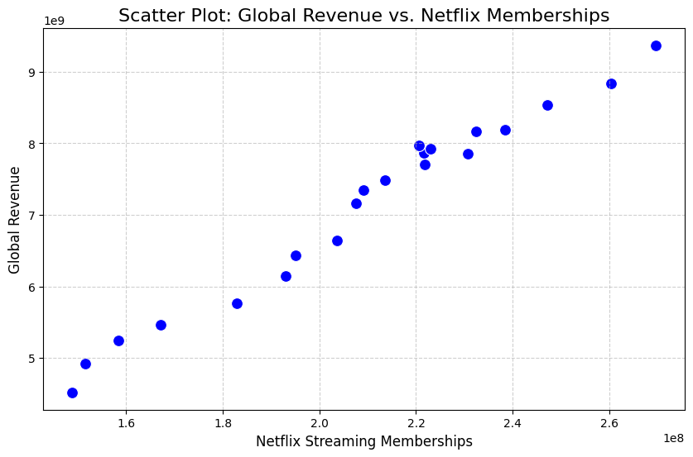
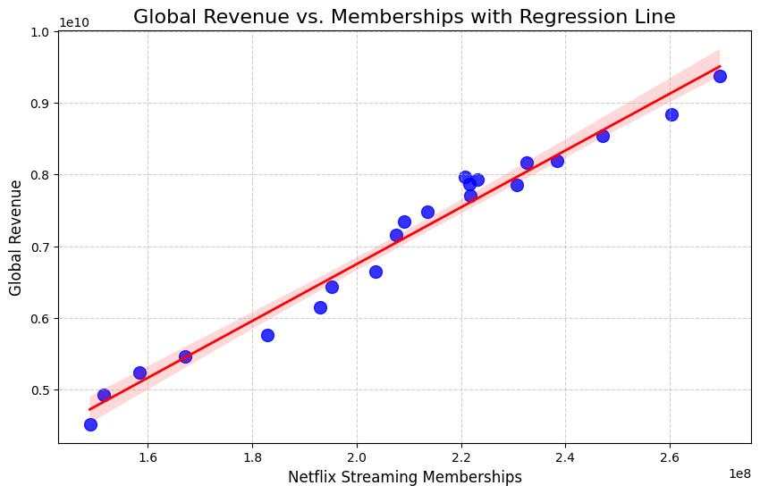
Simple Linear Regression Interpretations:
The scatter plot displays a very strong positive linear relationship between Netflix streaming memberships and global revenue, with a correlation coefficient of approximately 0.99. The data points cluster tightly around the regression line, indicating that as the number of subscribers increases, revenue grows proportionally and predictably. This suggests that membership growth is the primary driver of revenue for the observed period.

