Course Name: | Advanced Data Analytics | Semester: | IV
Date of Performance: |  | Batch No: | ADA-2
Grade/Marks: | /25 | Roll No: | 16010324044

Experiment No: 3
Title: Time series data

Aim and Objective of the Experiment:
- Reading Time series data from files
- Working with date and time in python

COs to be achieved:
CO 3. Design modelling, aggregating and knowledge representation of semantic web

Tools required: Reading Time series data from files
- Data set website
- Python programming
Technical requirements
In this chapter and forward, we will be using pandas 1.4.2 (released April 2,
2022) extensively.

You can download the Jupyter notebooks from the GitHub repository https://github.com/PacktPublishing/Time-Series-Analysis-with-Python-Cookbook./blob/main/code/Ch2/Chapter%202. ipynb) to follow along.
You can download the datasets used in this chapter from the GitHub repository using this link: https://github.com/PacktPublishing/Time-Series-Analysis -with-Python-Cookbook./tree/main/datasets/Ch2

Theory: Reading Time series data from files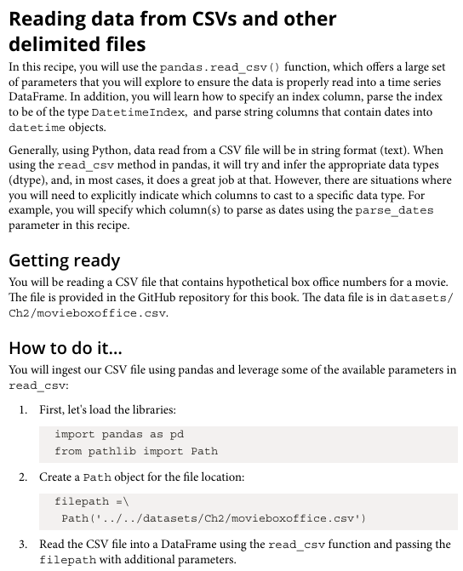
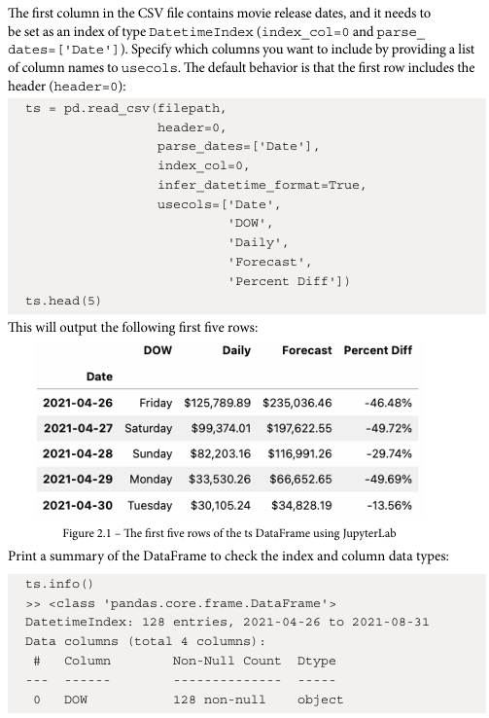

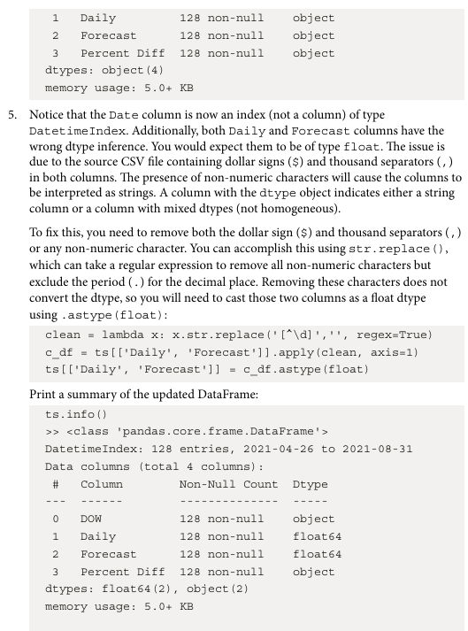
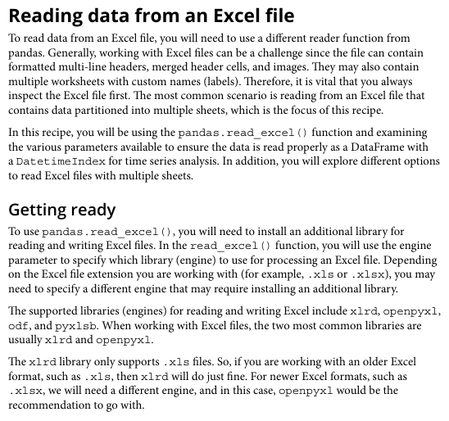
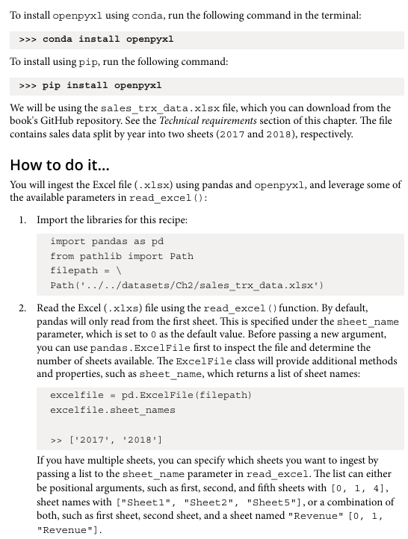

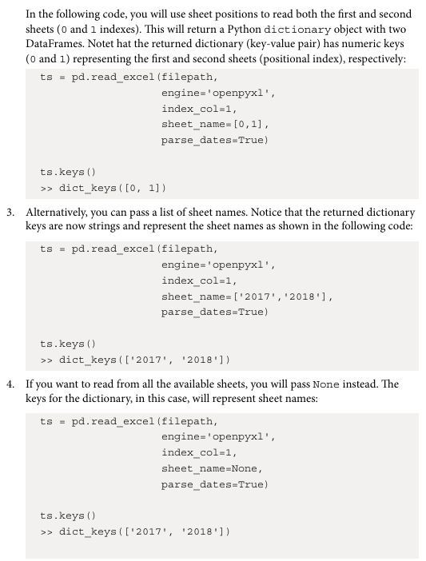

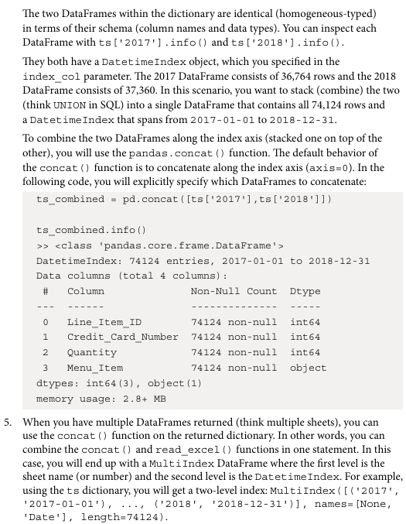

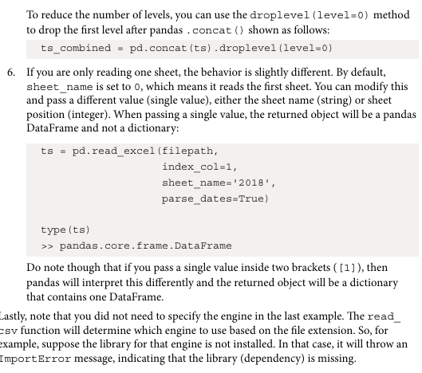

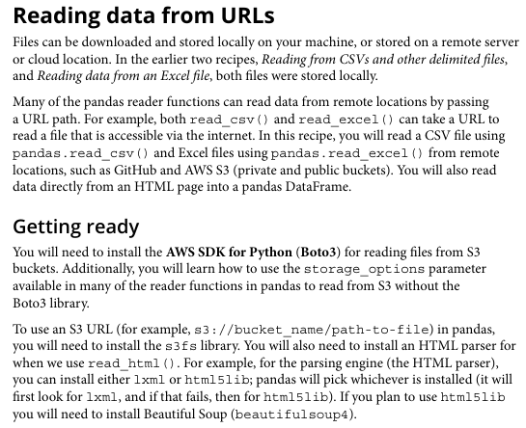

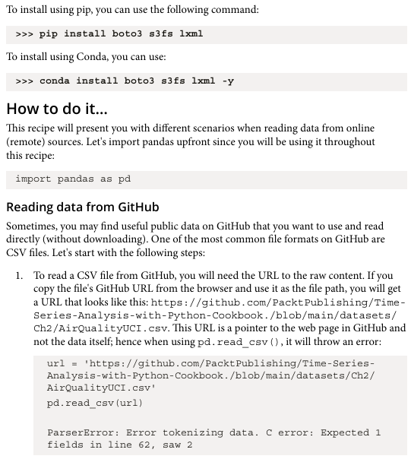

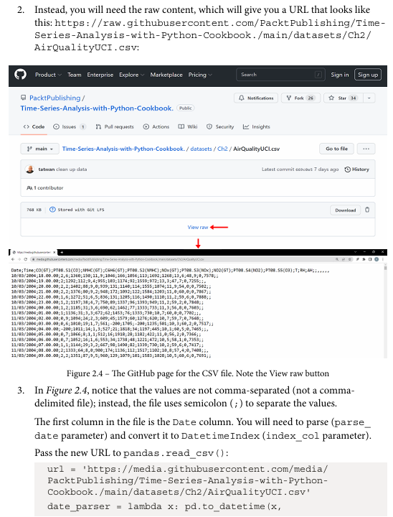

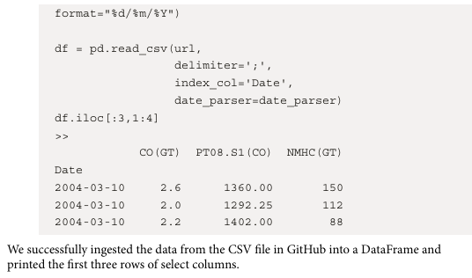

Reading Time series data from files
Dataset: Daily Temperature Time Series Dataset
Parameters in dataset:
- Date — Represents the calendar date of observation
- Temperature — Daily recorded temperature value (in °C)
- Frequency — Daily interval data
- Total Records — 100 rows (daily samples)
- Data Type — Time series (date-indexed numerical data)
- Index Type — Datetime index after conversion using pandas
Libraries in Python used:
- pandas — data handling
- numpy — numerical operations
- matplotlib — visualization
- datetime — date and time operations
Important functions used with their syntax and purpose:
Code:
import pandas as pd
import numpy as np
import matplotlib.pyplot as plt
import datetime as dt
dates = pd.date_range(start="2024-01-01", periods=100, freq="D")
temperature = np.random.randint(20, 35, size=100)

df = pd.DataFrame({
"Date": dates,
"Temperature": temperature
})

df.head()
df.to_csv("temperature.csv", index=False)

ts = pd.read_csv("temperature.csv")
ts.head()
ts["Date"] = pd.to_datetime(ts["Date"])
ts.set_index("Date", inplace=True)

ts.head()
ts.plot()
plt.title("Daily Temperature Time Series")
plt.show()

Output:
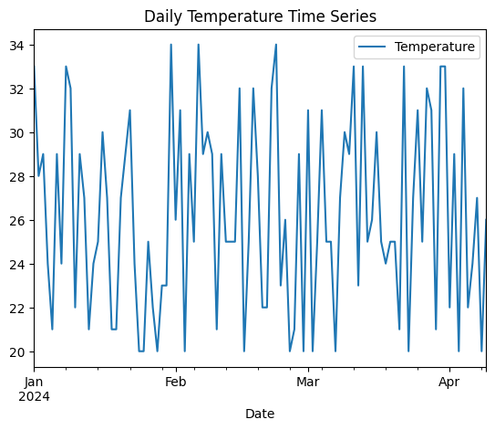
Interpretations:
The time series graph shows fluctuations in daily temperature values across the given period. Using datetime indexing allows easy filtering, aggregation, and analysis of temporal patterns.

Tools required: Working with date and time in python
- Data set website
- Python programming
- We will extensively use pandas 1.4.2 (released on April 2, 2022. This applies to all the recipes in this chapter.
Load these libraries in advance, since you will be using them throughout the chapter:
import pandas as pd
import numpy as np
import datetime as dt
You will use dt, np, and pd aliases going forward.
You can download the Jupyter notebooks from the GitHub repository at https://github.com/PacktPublishing/Time-Series-Analysis-with-Python-Cookbook./tree/main/code/Ch6
to follow along

Theory: Working with date and time in python
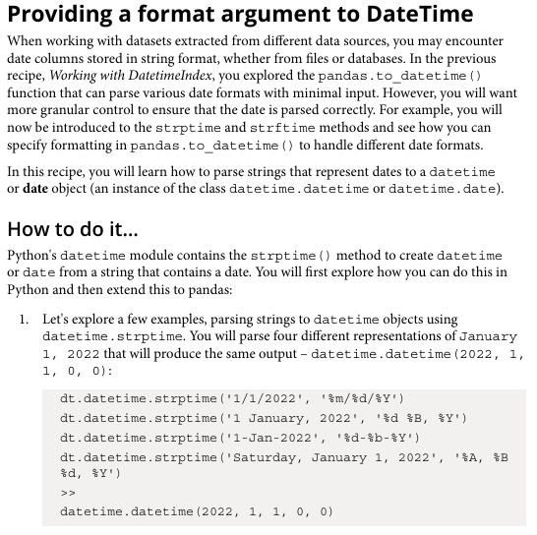

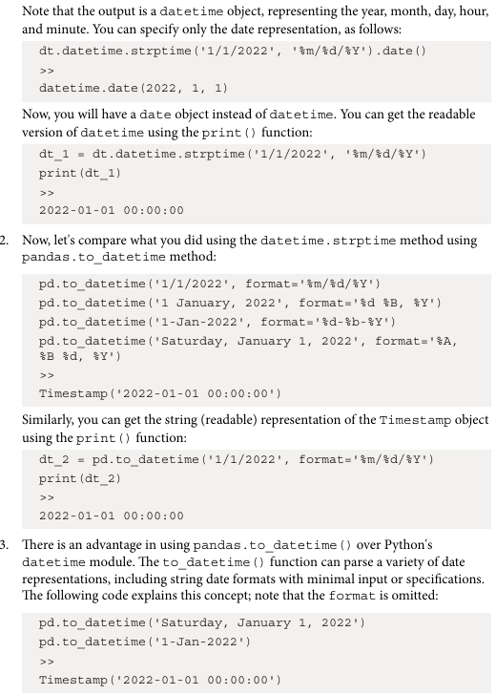
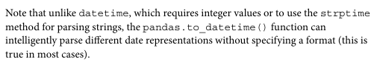

Working with date and time in python
Dataset: Generated Date-Time Series Dataset
Parameters in dataset:
- Datetime Index — Automatically generated date range
- Year — Extracted year from date
- Month — Extracted month value
- Day — Extracted day value
- Derived Fields — Year, Month, Day columns created from datetime
- Aggregation Level — Monthly average calculated using resampling
- Date Range Type — Continuous daily sequence
Libraries in Python used:
- pandas — data handling
- numpy — numerical operations
- datetime — date and time operations
Important functions used with their syntax and purpose:

Code:
now = dt.datetime.now()
print("Current Date Time:", now)
today = dt.date.today()
future = today + dt.timedelta(days=10)

print("Today:", today)
print("After 10 days:", future)
ts["Year"] = ts.index.year
ts["Month"] = ts.index.month
ts["Day"] = ts.index.day

ts.head()
monthly_avg = ts.resample("M").mean()
monthly_avg

Output:
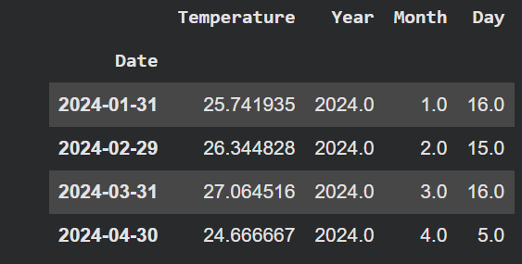
Interpretations:
Date-time functions allow easy extraction of calendar information and enable grouping or aggregation based on time intervals such as months or weeks. This is useful for trend and seasonal analysis.

