Course Name: | Advanced Data Analytics | Semester: | IV
Date of Performance: |  | Batch No: | ADA-2
Grade/Marks: | /25 | Roll No: | 16010324044

Experiment No: 4
Title: Handling missing data

Aim and Objective of the Experiment:
- Performing data quality checks
- Handling missing data with univariate imputation using pandas
- Handling missing data with univariate imputation using scikit-learn

COs to be achieved:
CO 3. Design modelling, aggregating and knowledge representation of semantic web
CO 4. Collect, analyse, and interpret data, making informed decisions based on quantitative insights.

Tools required:
- Data set website
- Python programming
You can download the Jupyter notebooks and the requisite datasets from the GitHub
repository to follow along:
- Jupyter notebooks: https://github.com/PacktPublishing/Time-Series-Analysis-with-Python-Cookbook./blob/main/code/Ch7/ Chapter%207.ipynb
- Datasets: https://github.com/PacktPublishing/Time-Series-Analysis-with-Python-Cookbook./tree/main/datasets/Ch7
In this chapter and beyond, you will extensively use pandas 1.4.2 (released April 2, 2022).
There will be four additional libraries that you will be using:
NumPy (≥ 1.20.3)
Matplotlib (≥ 3.5.0)
statsmodels (≥ 0.11.0)
scikit-learn (≥ 1.0.1)
SciPy (≥ 1.7.1)

If you are using pip, then you can install these packages from your terminal with the
following command:
pip install matplotlib numpy statsmodels scikit-learn scipy
If you are using conda, then you can install these packages with the following command:
conda install matplotlib numpy statsmodels scikit-learn scipy
In this chapter, two datasets will be used extensively for the imputation and interpolation
recipes: the CO2 Emissions dataset, and the e-Shop Clickstream dataset. The source for
the Clickstream dataset comes from clickstream data for online shopping from the UCI
machine learning repository, which you can find here:
https://archive.ics.uci.edu/ml/datasets/clickstream+data+for+online+shopping
The source for the CO2 emissions dataset comes from the Annual CO2 emissions report
from Our World in Data, which you can find here: https://ourworldindata.org/co2-emissions

Theory:
Data can be missing for a variety of reasons, such as unexpected power outages, a device that got accidentally unplugged, a sensor that just became defective, a survey respondent declined to answer a question, or the data was intentionally removed for privacy and compliance reasons. In other words, missing data is inevitable. Generally, missing data is very common, yet sometimes it is not given the proper level of attention in terms of formulating a strategy on how to handle the situation. One approach for handling rows with missing data is to drop those observations (delete the rows). However, this may not be a good strategy if you have limited data in the first place, for example, if collecting the data is a complex and expensive process. Additionally, the drawback of deleting records, if done prematurely, is that you will not know if the missing data was due to censoring (an observation is only partially collected) or due to bias (for example, high-income participants declining to share their total household income in a survey). A second approach may involve tagging the rows with missing data by adding a column describing or labeling the missing data. For example, suppose you know that there was a power outage on a particular day. In that case, you can add Power Outage to label the missing data and differentiate it from other missing data labeled with Missing Data if the cause is unknown

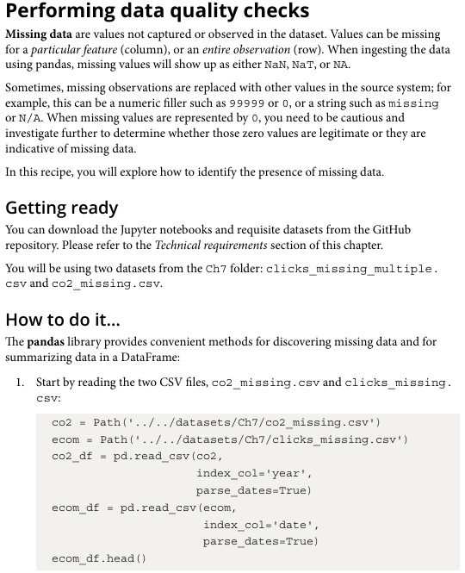

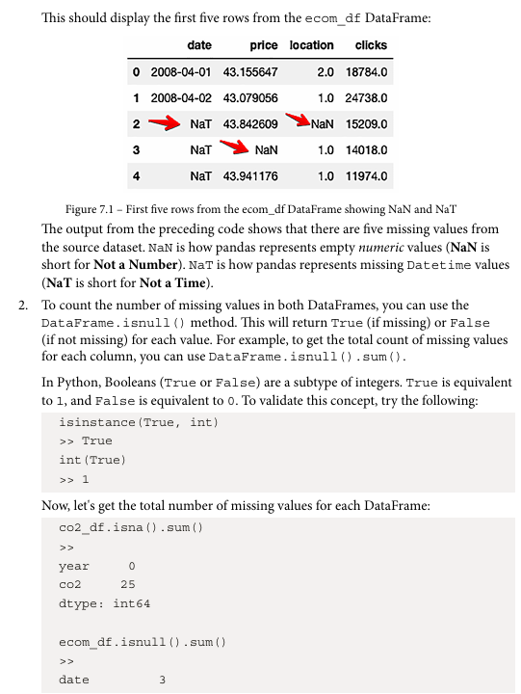

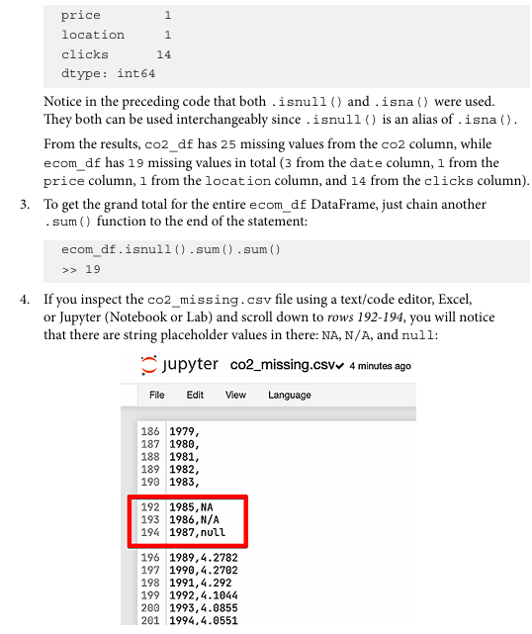

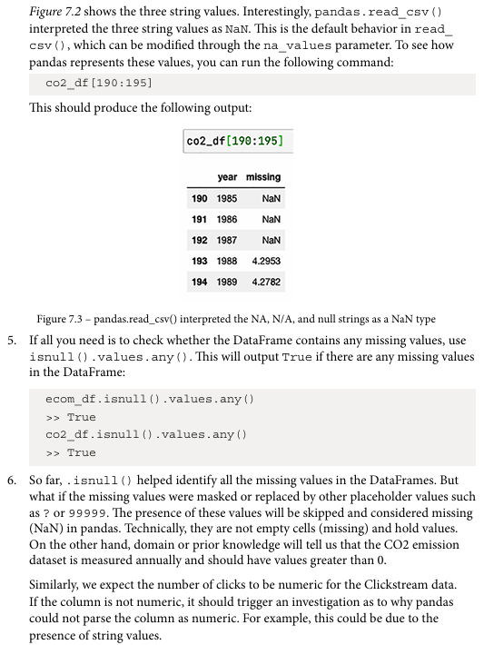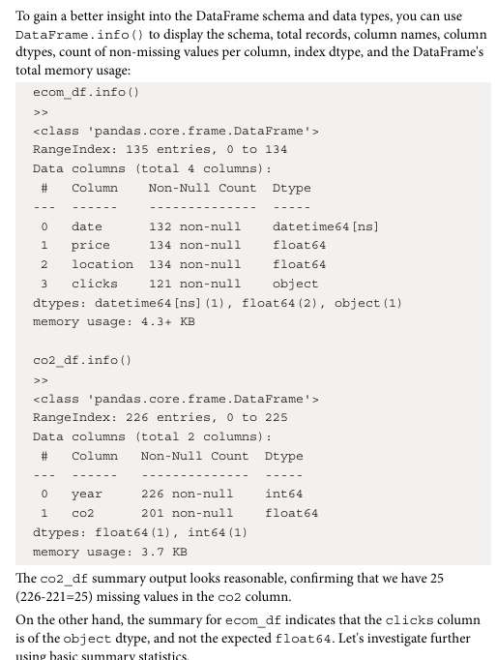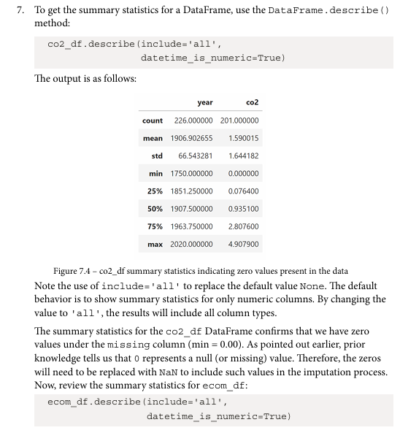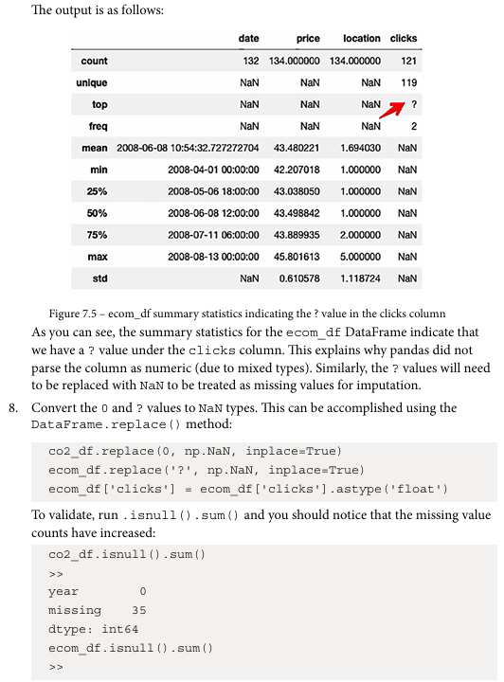
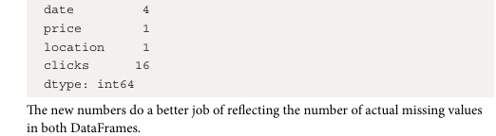
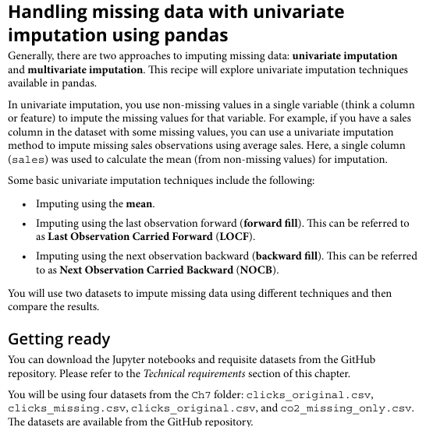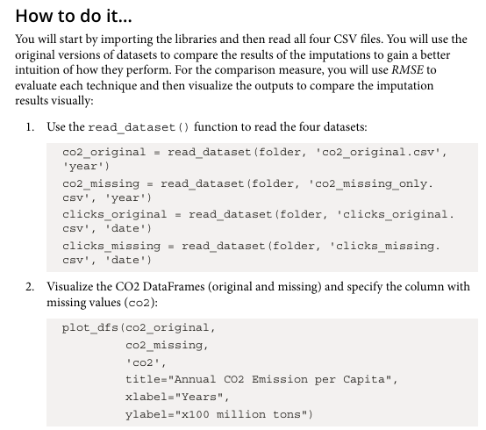
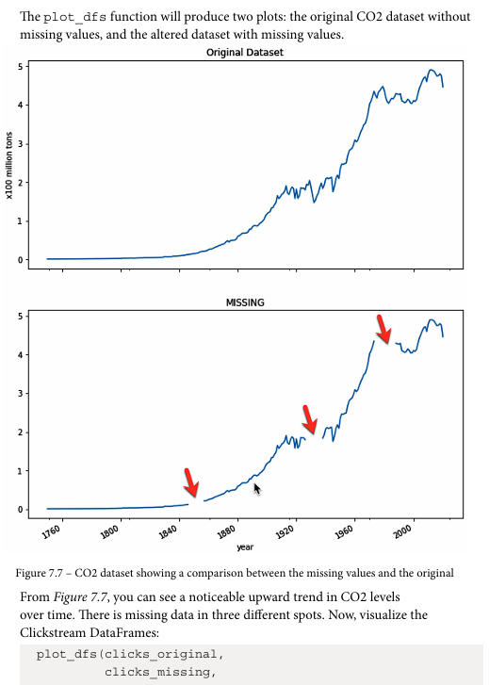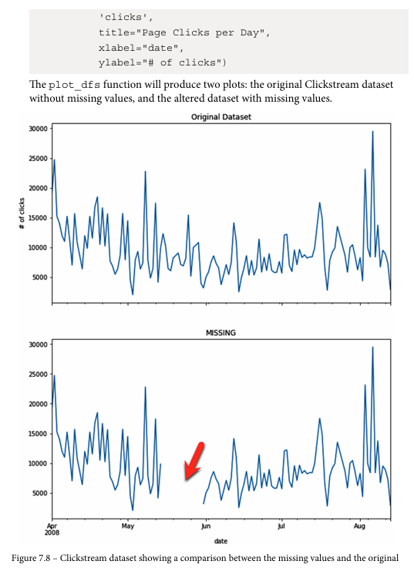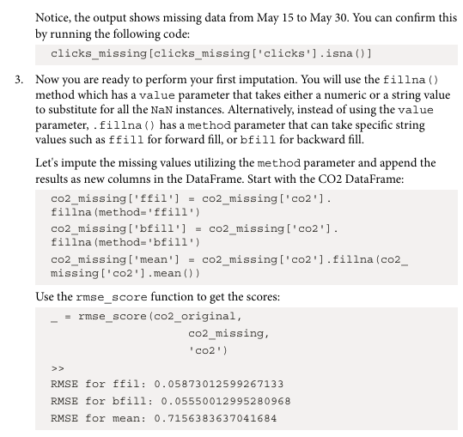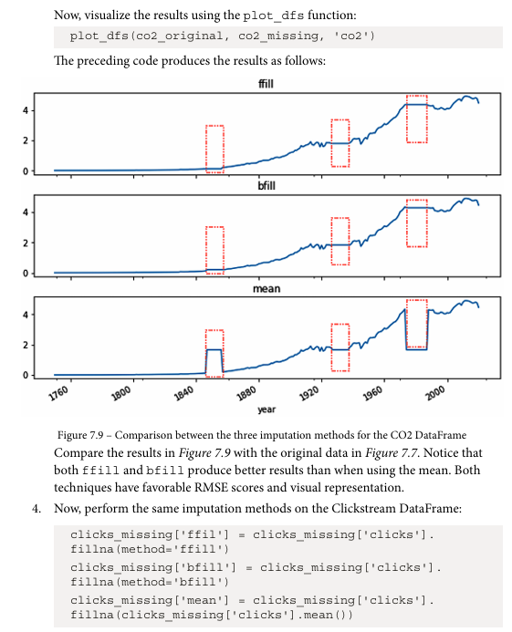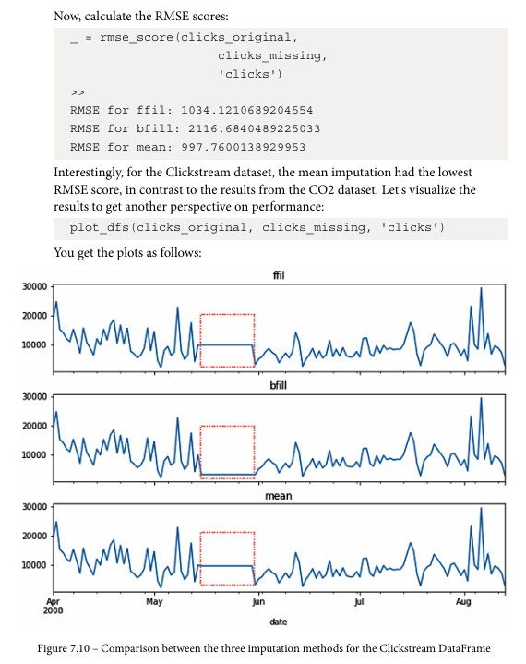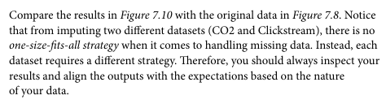

Handling missing data with univariate imputation using pandas
Dataset:
A sample employee dataset containing Age, Salary and Experience with missing values.
Parameters in dataset:
- Age — employee age
- Salary — monthly salary
- Experience — years of experience
Libraries in Python used:
- pandas
- numpy
Important functions used with their syntax and purpose:
- df.isnull() → checks missing values
- df.fillna() → fills missing values
- df.mean() → calculates mean
- df.median() → calculates median
Code:
import numpy as np
import pandas as pd
from sklearn.impute import SimpleImputer
data = {
"Age": [22, 25, np.nan, 28, 35, np.nan, 40],
"Salary": [25000, np.nan, 32000, 28000, np.nan, 50000, 52000],
"Experience": [1, 3, 5, np.nan, 10, 12, np.nan]
}

df = pd.DataFrame(data)
df

df.info()

df.isnull().sum()

df.describe()

df_mean = df.fillna(df.mean())
df_mean

df_median = df.fillna(df.median())
df_median

df_ffill = df.fillna(method="ffill")
df_ffill

Output:
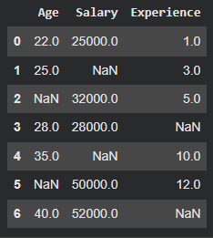
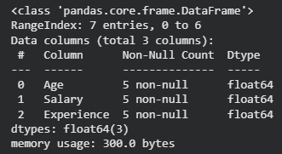
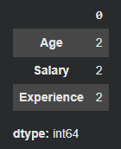
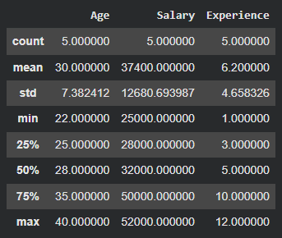
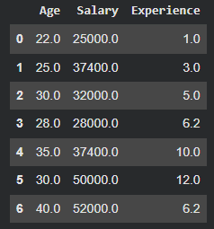
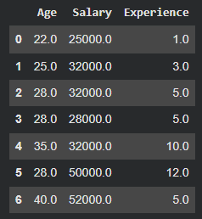
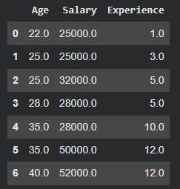
Interpretations:
Missing values were handled using different pandas techniques. Mean and median imputation replaced null values with statistical averages, while forward fill used previous row values. This helps maintain dataset size without dropping rows.

Theory:
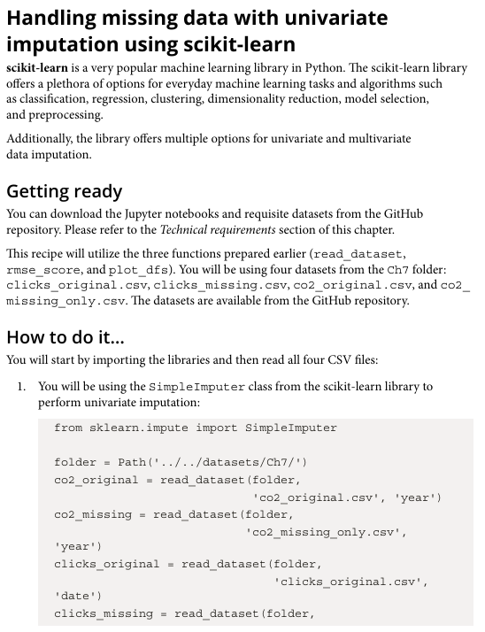
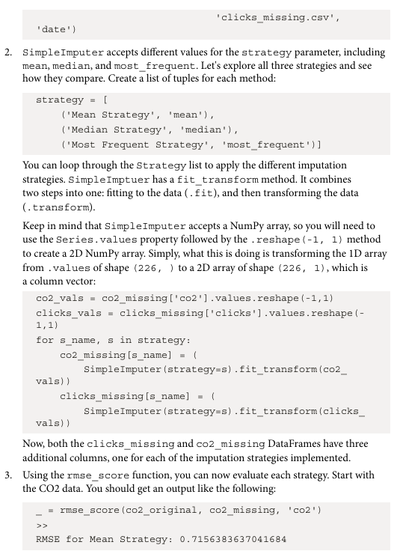
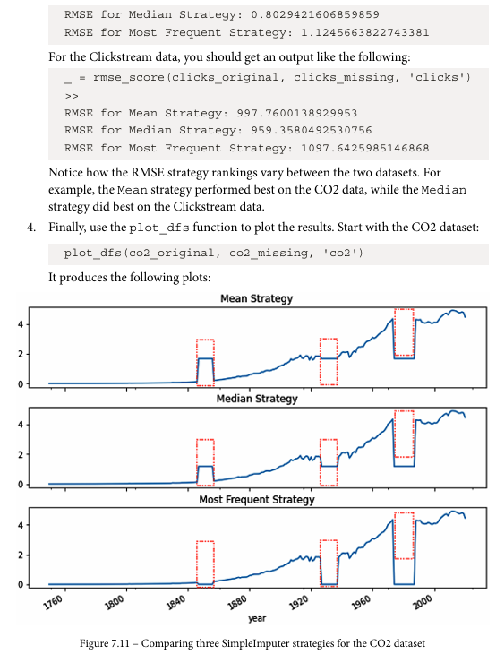
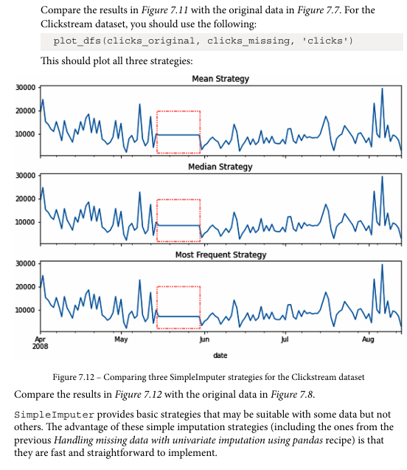

Handling missing data with univariate imputation using scikit-learn
Dataset:
Same dataset as above
Parameters in dataset:
- Age — employee age
- Salary — monthly salary
- Experience — years of experience
Libraries in Python used:
- pandas
- numpy
- sklearn.impute.SimpleImputer
Important functions used with their syntax and purpose:
- SimpleImputer(strategy="mean") → replaces with mean
- SimpleImputer(strategy="median") → replaces with median
- fit_transform() → computes and applies imputation
Code: Same lines as above and -
imputer_mean = SimpleImputer(strategy="mean")
df_sklearn_mean = pd.DataFrame(
imputer_mean.fit_transform(df),
columns=df.columns
)

df_sklearn_mean

imputer_median = SimpleImputer(strategy="median")

df_sklearn_median = pd.DataFrame(
imputer_median.fit_transform(df),
columns=df.columns
)

df_sklearn_median

Output:
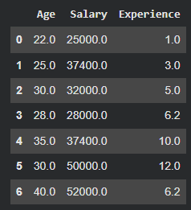
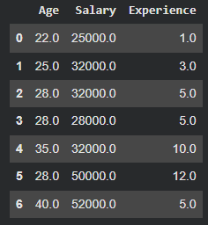
Interpretations:
Scikit-learn SimpleImputer provides a structured and model-friendly way of handling missing data. It is useful in ML pipelines and ensures consistent preprocessing.

