Course Name: | Advanced Data Analytics | Semester: | IV
Date of Performance: |  | Batch No: | ADA-2
Grade/Marks: | /25 | Roll No: | 16010324044

Experiment No: 5
Title: Decomposing time series data

Aim and Objective of the Experiment:
- Plotting time series data using pandas
- Decomposing time series data

COs to be achieved:
CO 3. Design modelling, aggregating and knowledge representation of semantic web
CO 4. Collect, analyse, and interpret data, making informed decisions based on quantitative insights.

Tools required:
- Data set website
- Python programming
You can download the Jupyter notebooks and datasets needed from the GitHub repository
to follow along:
• Jupyter notebooks: https://github.com/PacktPublishing/Time-Series-Analysis-with-Python-Cookbook./blob/main/code/Ch9/Chapter%209.ipynb
• Datasets: https://github.com/PacktPublishing/Time-Series-Analysis-with-Python-Cookbook./tree/main/datasets/Ch9
In this chapter and onward, we will extensively use pandas 1.4.2 (released April 2, 2022).
There are four additional libraries that we will be using:
• hvplot and PyViz
• seaborn
• matplotlib

If you are using pip, then you can install these packages from your terminal with
the following:
pip install hvplot seaborn matplotlib jupyter plotly==5.5.0
If you are using conda, then you can install these packages with the following:
conda install -c conda-forge seaborn
conda install -c plotly plotly=5.5.0
conda install -c pyviz hvplot
The visualizations should work in Jupyter notebooks, but if you plan to use JupyterLab,
then you will need to install an additional extension, jupyterlab_pyviz:
conda install jupyterlab
jupyter labextension install @pyviz/jupyterlab_pyviz
Throughout this chapter, you will be using three datasets (Closing Price Stock Data,
CO2, and Air Passengers). The CO2 and Air Passengers datasets are provided with the
statsmodels library. The Air Passengers dataset contains monthly airline passenger
numbers from 1949 to 1960. The CO2 dataset contains weekly atmospheric carbon
dioxide levels on Mauna Loa. The Closing Price Stock Data dataset includes Microsoft,
Apple, and IBM stock prices from November 2019 to November 2021.
To get started, you will need to load the datasets and store them as pandas DataFrames
and load any libraries or methods that are needed throughout:
import pandas as pd
from pathlib import Path
import matplotlib.pyplot as plt
from statsmodels.datasets import co2, get_rdataset
file = Path('../../datasets/Ch9/closing_price.csv')
closing_price = pd.read_csv(file,
index_col='Date',
parse_dates=True)
co2_df = co2.load_pandas().data
co2_df = co2_df.ffill()
air_passengers = get_rdataset("AirPassengers")
airp_df = air_passengers.data
airp_df.index = pd.date_range('1949', '1961', freq='M')
airp_df.drop(columns=['time'], inplace=True)
Now, you should have three DataFrames: airp_df, closing_price, and co2_df

Theory:

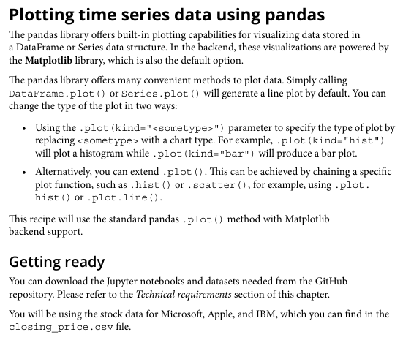

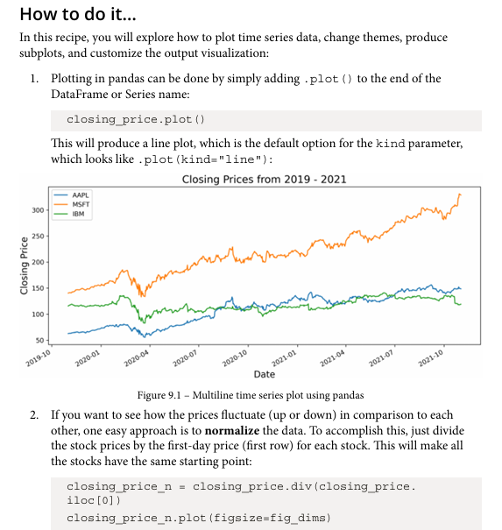

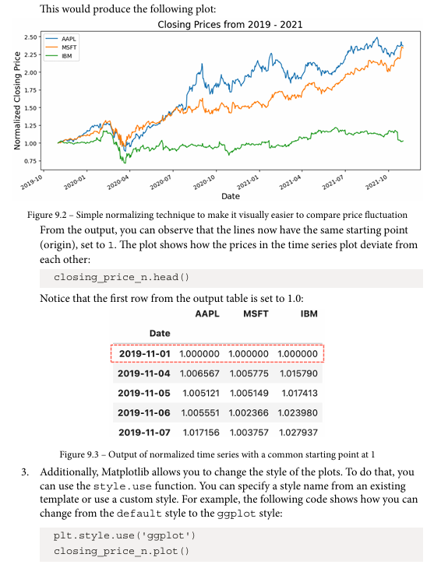

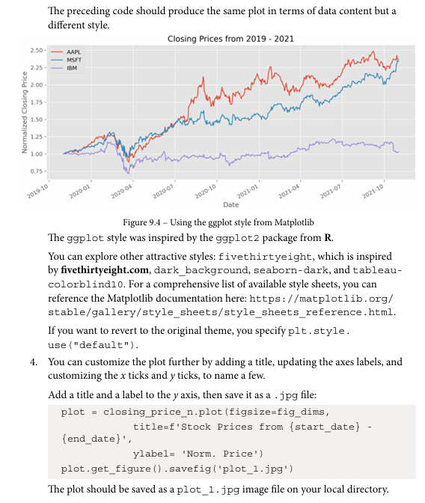

Plotting time series data using pandas
Dataset:
AirPassengers and CO2 dataset
Parameters in dataset:
AirPassengers Dataset Parameters:
- Monthly airline passenger count
- Time index in monthly frequency (1949–1960)
- Single numeric variable representing number of passengers
- Contains trend and seasonal components suitable for decomposition
CO2 Dataset Parameters:
- Weekly atmospheric CO₂ concentration levels
- Time index in weekly frequency
- Continuous numeric measurement (ppm — parts per million)
- Shows long-term upward trend with repeating seasonal variation
Libraries in Python used:
- Pandas
- Matplotlib
- Seaborn
- Statsmodels
Important functions used with their syntax and purpose:
- pd.read_csv() — load dataset
- plot() — plot time series
- ffill() — fill missing values

Code:
!pip install pandas matplotlib seaborn statsmodels hvplot plotly==5.5.0

import pandas as pd
import matplotlib.pyplot as plt
import seaborn as sns

from statsmodels.datasets import co2, get_rdataset
from statsmodels.tsa.seasonal import seasonal_decompose

# CO2 dataset
co2_df = co2.load_pandas().data
co2_df = co2_df.ffill()

# AirPassengers dataset
air_passengers = get_rdataset("AirPassengers")
airp_df = air_passengers.data
airp_df.index = pd.date_range('1949', '1961', freq='M')
airp_df.drop(columns=['time'], inplace=True)

print(co2_df.head())
print(airp_df.head())

co2_df.plot(figsize=(12,5), title="CO2 Time Series Data")
plt.show()

airp_df.plot(figsize=(12,5), title="Air Passengers Time Series")
plt.show()

Output:
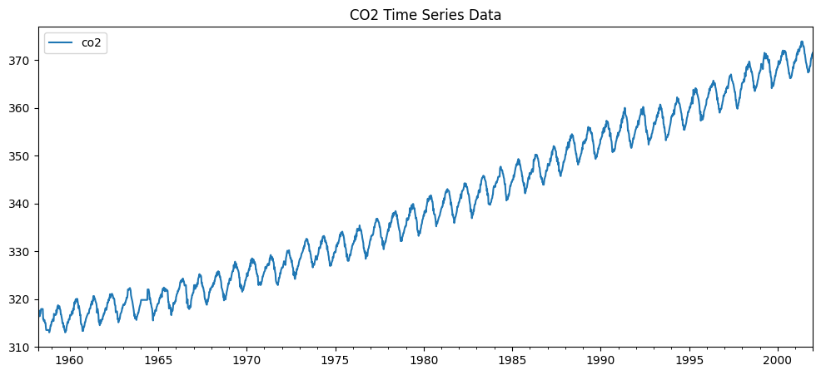
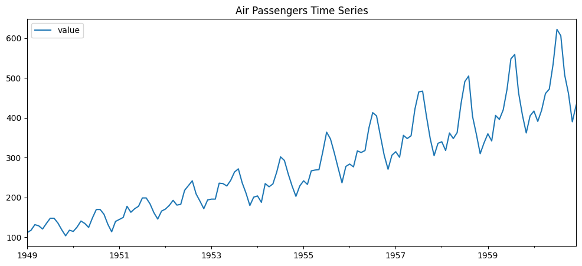
Interpretations:
The plotted time series graphs clearly show how the data changes over time. The CO2 dataset shows a steady increasing trend with seasonal variation. The AirPassengers dataset shows both upward growth and repeating seasonal patterns.

Theroy:
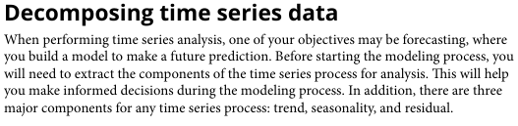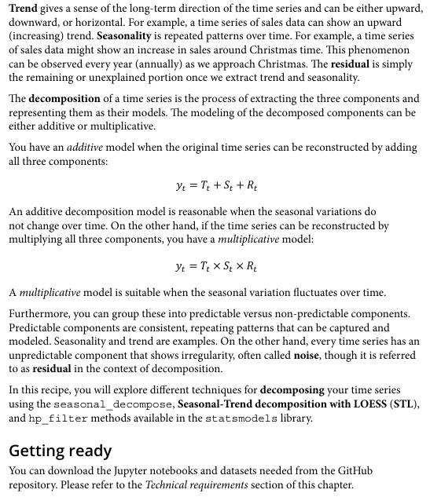
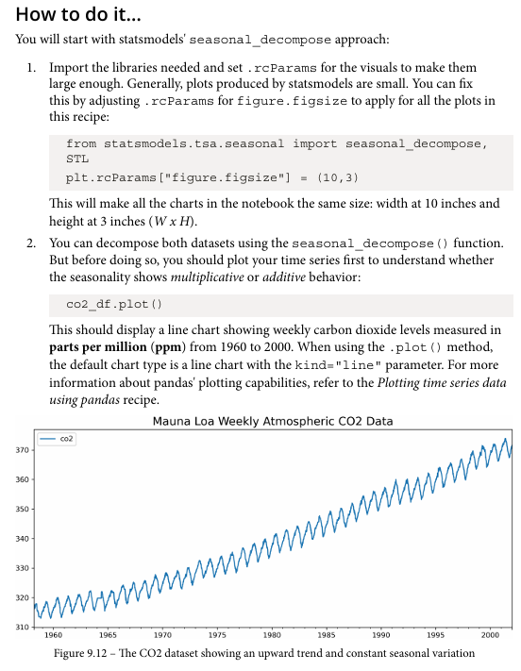
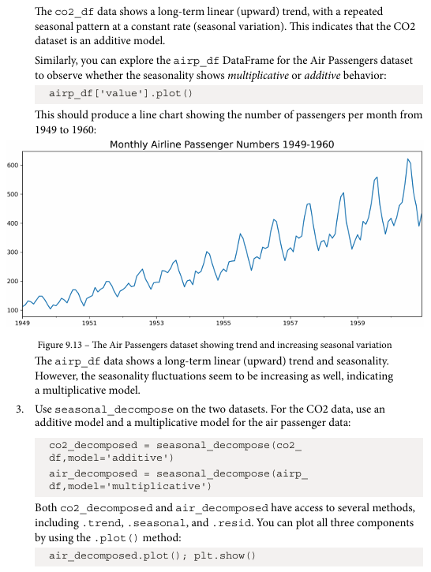
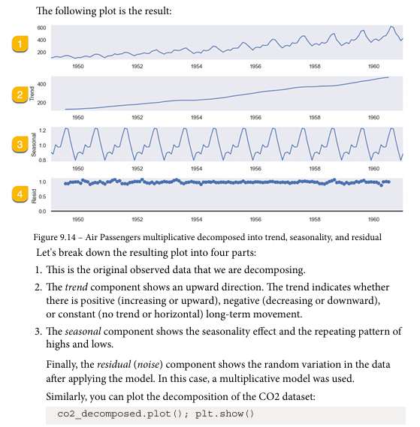
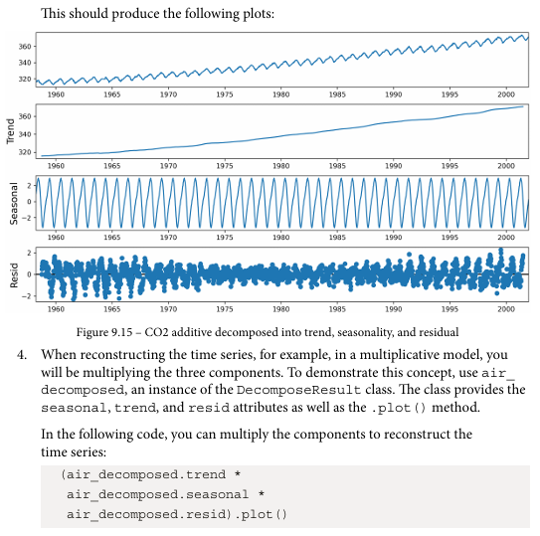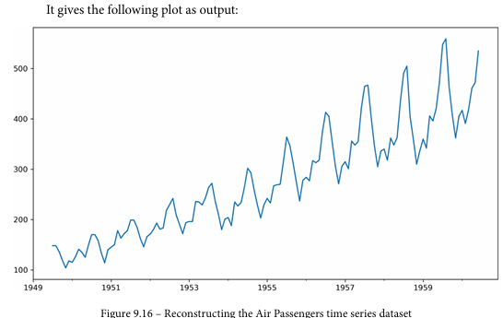
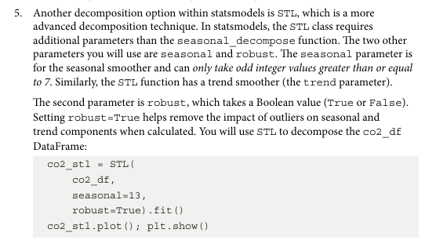
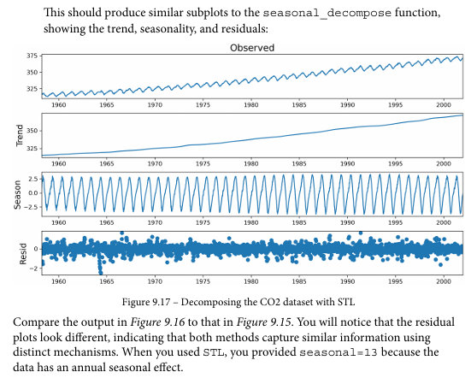

Decomposing time series data
Dataset:
AirPassengers and CO2 dataset
Parameters in dataset:
AirPassengers Dataset Parameters:
- Monthly airline passenger count
- Time index in monthly frequency (1949–1960)
- Single numeric variable representing number of passengers
- Contains trend and seasonal components suitable for decomposition
CO2 Dataset Parameters:
- Weekly atmospheric CO₂ concentration levels
- Time index in weekly frequency
- Continuous numeric measurement (ppm — parts per million)
- Shows long-term upward trend with repeating seasonal variation
Libraries in Python used:
statsmodels.tsa.seasonal
Important functions used with their syntax and purpose:
seasonal_decompose() — splits series into trend + seasonality + residual

Code:
result = seasonal_decompose(airp_df['value'], model='multiplicative')

result.plot()
plt.show()

result2 = seasonal_decompose(co2_df['co2'], model='additive', period=52)

result2.plot()
plt.show()

Output:
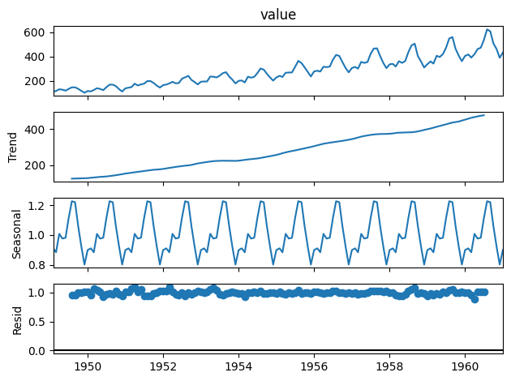
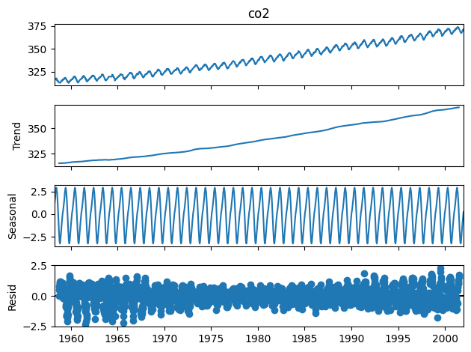
Interpretations:
After decomposition, the time series is divided into trend, seasonal, and residual components. The trend shows long-term movement, seasonal shows repeating patterns, and residual shows random noise. This helps in better understanding and forecasting the data.

