Course Name: | Advanced Data Analytics | Semester: | IV
Date of Performance: |  | Batch No: | ADA-2
Grade/Marks: | /25 | Roll No: | 16010324044

Experiment No: 6
Title: Forecasting univariate time series data with exponential smoothing

Aim and Objective of the Experiment:
- Plotting ACF and PACF
- Forecasting univariate time series data with exponential smoothing

COs to be achieved:
CO 3. Design modelling, aggregating and knowledge representation of semantic web
CO 4. Collect, analyse, and interpret data, making informed decisions based on quantitative insights.

Tools required:
- Data set website
- Python programming
You can download the Jupyter Notebooks and necessary datasets from this book's
GitHub repository:
• Jupyter Notebook: Time-Series-Analysis-with-Python-Cookbook/code/Ch10/Chapter 10.ipynb at main · PacktPublishing/Time-Series-Analysis-with-Python-Cookbook · GitHub

• Datasets: https://github.com/PacktPublishing/Time-Series-Analysis-with-Python-Cookbook./tree/main/datasets/Ch10

Before you start working through the recipes in this chapter, please run the following code
to load the datasets and functions that will be referenced throughout:
1. Start by importing the basic libraries that will be shared across all the recipes in
this chapter:
import pandas as pd
import numpy as np
import matplotlib.pyplot as plt
import warnings
from statsmodels.tsa.api import (kpss, adfuller,
seasonal_decompose, STL)
from statsmodels.tools.eval_measures import rmspe, rmse
from sklearn.metrics import mean_absolute_percentage_
error as mape
from statsmodels.graphics.tsaplots import plot_acf, plot_
pacf
from itertools import product
from pathlib import Path
warnings.filterwarnings('ignore')
plt.rcParams["figure.figsize"] = [12, 5]
2. You will be working with two datasets throughout this chapter: Life Expectancy from
Birth and Monthly Milk Production. Import these datasets, which are stored in CSV
format (life_expectancy_birth.csv, and milk_production.csv), into
pandas DataFrames. Each dataset comes from a different time series process, so
they will contain a different trend or seasonality. Once you've imported the datasets,
you will have two DataFrames called life and milk:
life_file = Path('../../datasets/Ch10/life_expectancy_
birth.csv')
milk_file = Path('../../datasets/Ch10/milk_production.
csv')
life = pd.read_csv(life_file,
index_col='year',
parse_dates=True,
skipfooter=1)
milk = pd.read_csv(milk_file,
index_col='month',
parse_dates=True)
Inspect the data visually and observe if the time series contains any trend
or seasonality. You can always come back to the plots shown in this section
for reference:
fig, ax = plt.subplots(2, 1, figsize=(16, 12))
life.plot(title='Annual Life Expectancy',
legend=False, ax=ax[0])
milk.plot(title='Monthly Milk Production',
legend=False, ax=ax[1])
This should display two time series plots:
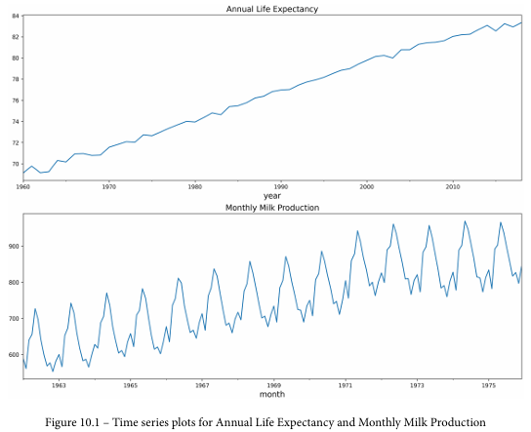
The preceding figure shows a time series plot for the life DataFrame showing
a positive (upward) trend and no seasonality. The life expectancy data contains
annual life expectancy records at birth from 1960 to 2018 (59 years). The original
dataset contained records for each country, but you will be working with world
records in this chapter. The time series plot for the milk DataFrame shows
a positive (upward) trend and a repeating seasonality (every summer). The milk
production data is recorded monthly from January 1962 to December 1975 (168
months). The seasonal magnitudes and variations over time seem to be steady,
indicating an additive nature. Having a seasonal decomposition that specifies the
level, trend, and season of an additive model will reflect this as well.
3. You will need to split the data into test and train datasets. Then, you must train
the models (fitting) on the training dataset and use the test dataset to evaluate the
model and compare your predictions. A forecast that's created for the data that will
be used in training is called an in-sample forecast, while forecasting for unseen data
such as a test set is called an out-of-sample forecast. When you're evaluating the
different models, you will be using the out-of-sample or test sets.
Create a generalized function, split_data, which splits the data based on a test
split factor. This way, you can experiment on different splits as well. We will be
referencing this function throughout this chapter:
def split_data(data, test_split):
l = len(data)
t_idx = round(l*(1-test_split))
train, test = data[ : t_idx], data[t_idx : ]
print(f'train: {len(train)} , test: {len(test)}')
return train, test
4. Call the split_data function to split the two DataFrames into test and train
datasets (start with 15% test and 85% train). You can always experiment with
different split factors:
test_split = 0.15
milk_train, milk_test = split_data(milk, test_split)
life_train, life_test = split_data(life, test_split)
>>
train: 143 , test: 25
train: 50 , test: 9
5. You will be checking for stationarity often since it is an essential assumption for
many of the models you will build. For example, in Chapter 9, Exploratory Data
Analysis and Diagnosis, in the Detecting time series stationarity recipe, we discussed
the importance of testing for stationarity and using the Augmented Dickey-Fuller
test. Create a function that you can refer to throughout this chapter to perform the
test and interpret the results:
def check_stationarity(df):
results = adfuller(df)[1:3]
s = 'Non-Stationary'
if results[0] < 0.05:
s = 'Stationary'
print(f"'{s}\t p-value:{results[0]} \t
lags:{results[1]}")
return (s, results[0])
6. There will be recipes in which you will run multiple variations of a model as you
search for the optimal configuration, a practice commonly called hyperparameter
tuning. For example, you may train an ARIMA model with different parameter
values and thus produce multiple variations of the ARIMA model (multiple
models). The get_best_model function will compare the different models –
for example, ARIMA models – to select the best model and the set of parameters
associated with that model. The get_best_model function will take a dictionary
that contains the produced model, parameters used, and the scores for each model.
The function will return the winning model based on a scoring (metric) criterion
of your choice. This is the c parameter of the function, which defaults to AIC. For
instance, you may choose the evaluation (the c parameter) to be based on the Root
Mean Squared Percentage Error (RMSPE), Root Mean Square Error (RMSE),
Mean Square Error (MSE), Akaike's Information Criteria (AIC), Corrected
Akaike's Information Criteria (AICc), and Bayesian Information Criteria (BIC),
which will be used as evaluation metrics for each model:
def get_best_model(score, c='AIC'):
initial_score = score[0][c]
best_model = 0
for k,v in score.items():
if v[c] < initial_score:
initial_score = v[c]
best_model = k
print(f'Best model: {best_model} with lowest {c}
score: {initial_score}')
return score[best_model]['model']
7. Create the plot_forecast function, which takes a model object that you have
trained, a starting position, and both the train and test datasets to create a plot that
compares the forecast (predicted values) against actuals. This will become clearer as
you dive into this chapter's recipes:
def plot_forecast(model, start, train, test):
forecast = pd.DataFrame(model.forecast(test.
shape[0]),
index=test.index)
ax = train.loc[start:].plot(style='--')
test.plot(ax=ax)
forecast.plot(ax=ax, style = '-.')
ax.legend(['orig_train', 'orig_test', 'forecast'])
plt.show()
8. Lastly, create a combinator utility function that takes a list of parameter values
and returns a Cartesian product of these choices. You will use this when performing
a grid search for hyperparameter tuning. In grid search, you specify a combination
of parameter values to train multiple models on each set and then evaluate the
winning model using the get_best_model function. For example, suppose
your list contains three possible values for three different parameters. In such
a case, the combinator function will return a list containing 3x3 or nine possible
combinations. This will become clearer as you dive into this chapter's recipes:
def combinator(items):
combo = [i for i in product(*items)]
return combo

Theory:
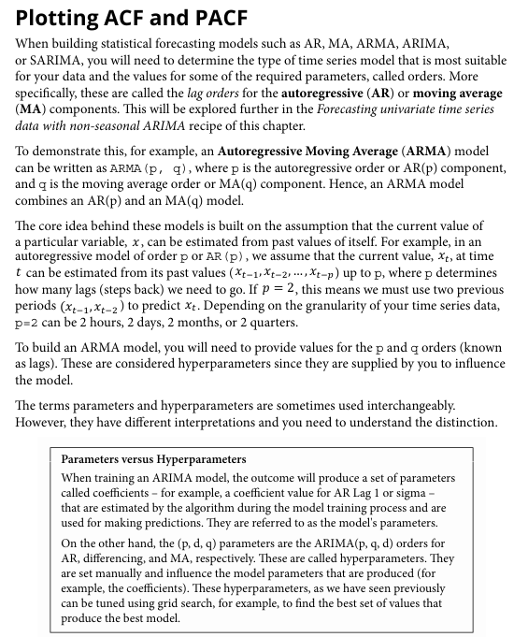

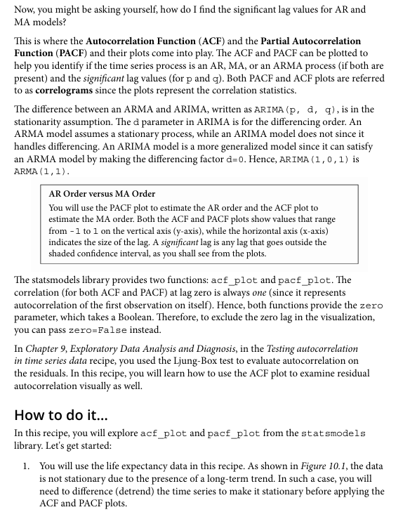

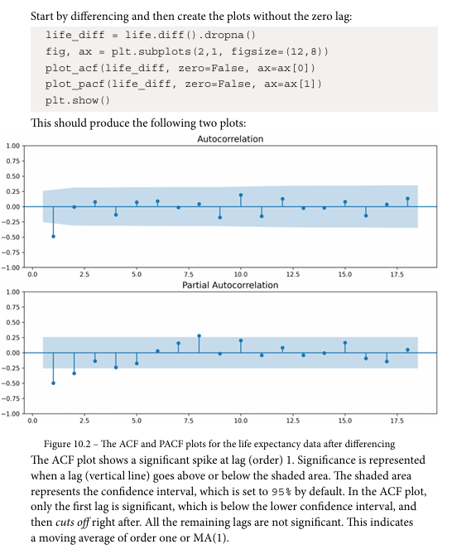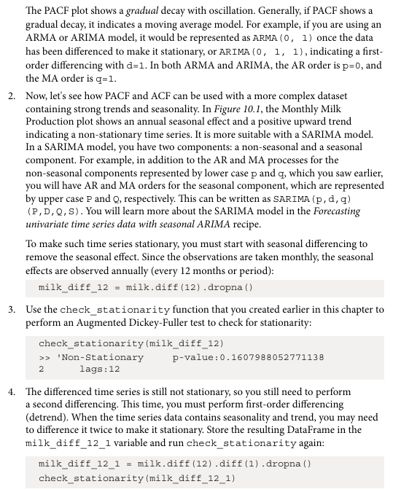

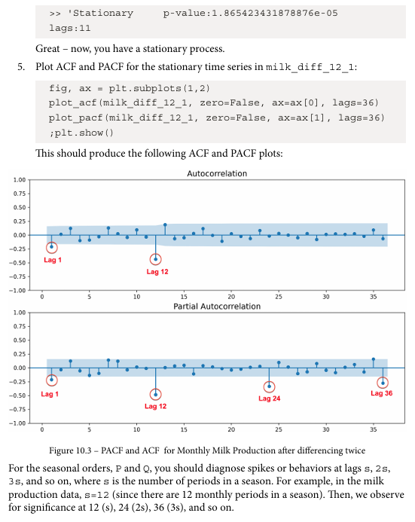
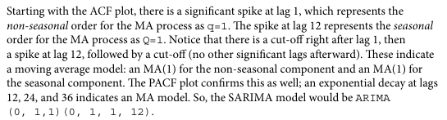

Plotting ACF and PACF
Dataset: Monthly Milk Production dataset
Parameters in dataset: Month (Date index) and Milk production value
Libraries in Python used:
- pandas — data handling
- numpy — numerical operations
- matplotlib — plotting
- statsmodels — time series modeling
- sklearn — evaluation metrics
Important functions used with their syntax and purpose:
plot_acf(data)
Used to plot autocorrelation of time series.
plot_pacf(data)
Used to plot partial autocorrelation.
ExponentialSmoothing()
Builds exponential smoothing forecasting model.
forecast(n)
Predicts next n future values.
adfuller()
Tests stationarity of time series.
Code:
!pip install statsmodels pandas matplotlib scikit-learn

import pandas as pd
import numpy as np
import matplotlib.pyplot as plt
import warnings

from statsmodels.tsa.api import ExponentialSmoothing
from statsmodels.tsa.stattools import adfuller
from statsmodels.graphics.tsaplots import plot_acf, plot_pacf

warnings.filterwarnings('ignore')
plt.rcParams["figure.figsize"] = [12,5]

milk = pd.read_csv(
"https://raw.githubusercontent.com/PacktPublishing/Time-Series-Analysis-with-Python-Cookbook/main/datasets/Ch10/milk_production.csv",
index_col='month',
parse_dates=True
)

milk.head()

milk.plot(title="Monthly Milk Production")
plt.show()

def split_data(data, test_split):
l = len(data)
t_idx = round(l*(1-test_split))
train, test = data[:t_idx], data[t_idx:]
print(f"train: {len(train)}, test: {len(test)}")
return train, test

milk_train, milk_test = split_data(milk, 0.15)

Output:
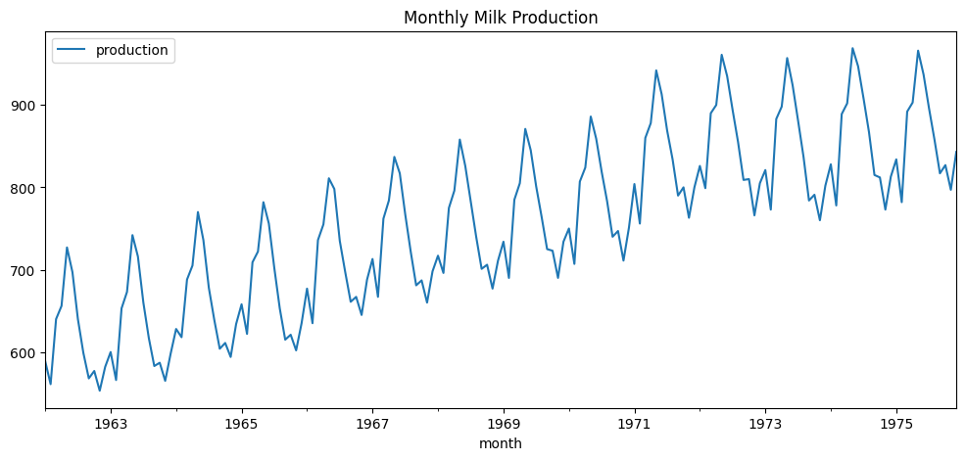
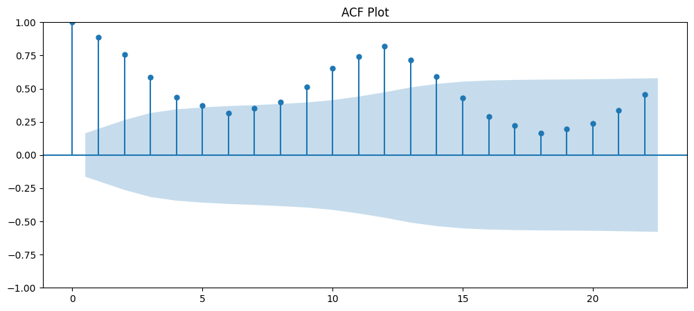
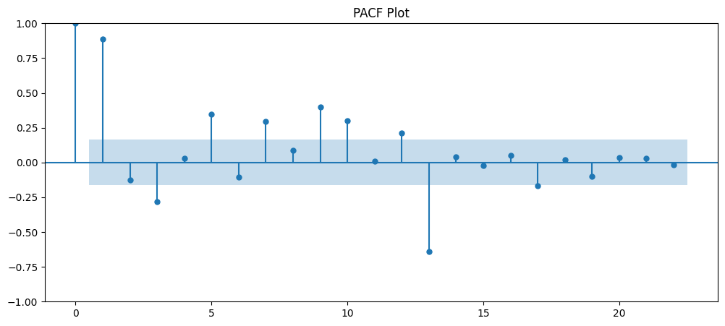
Interpretations:
- ACF shows strong seasonal correlation.
- PACF indicates limited direct lag dependency.
- Data has additive seasonality.

Theory:
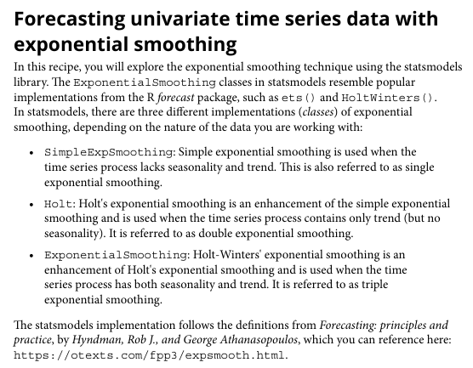

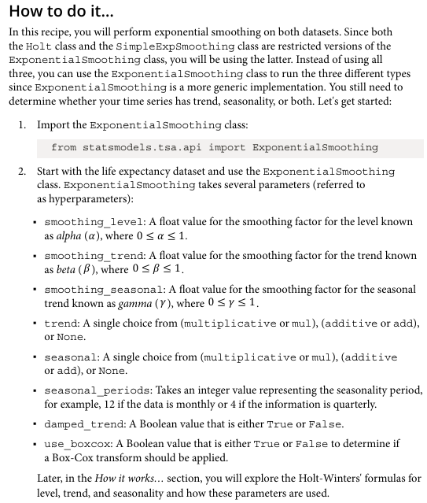
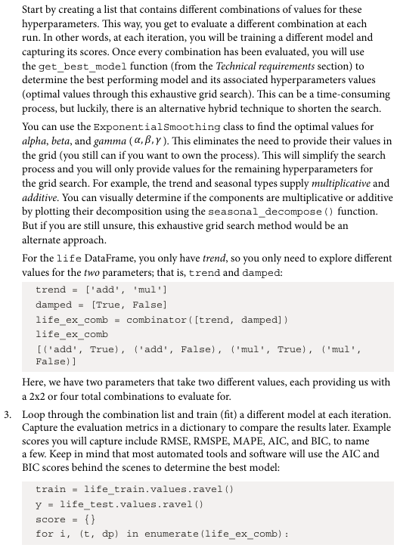

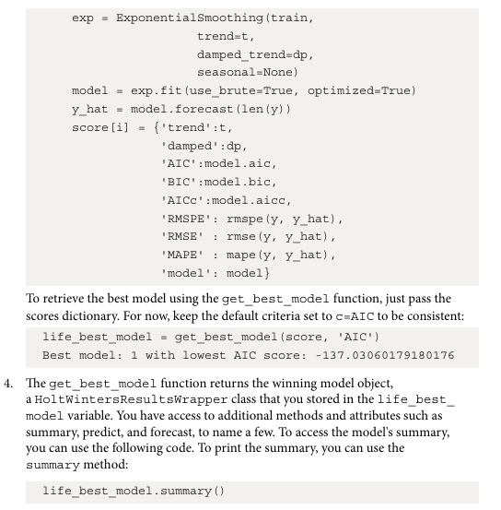
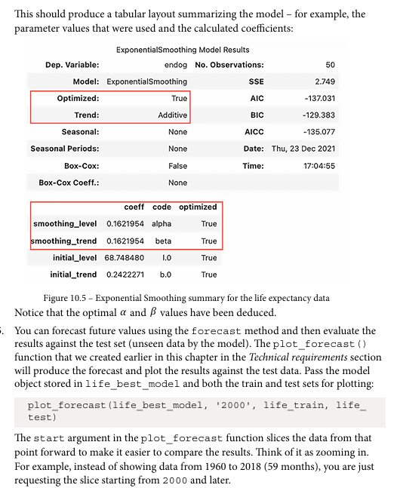
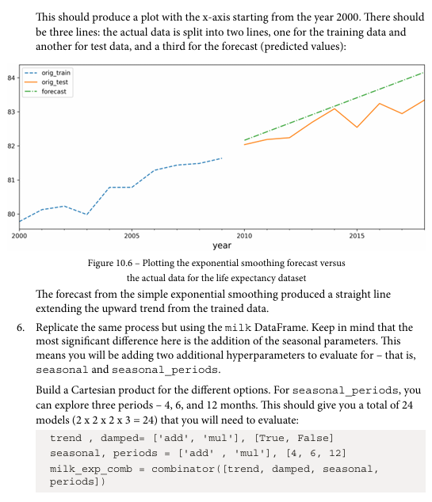
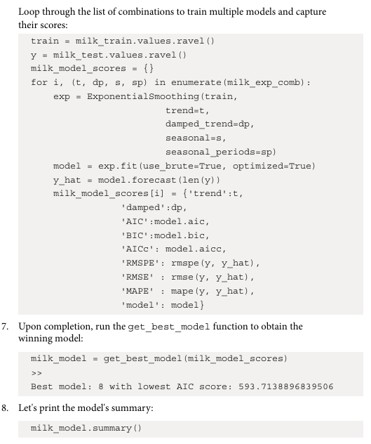
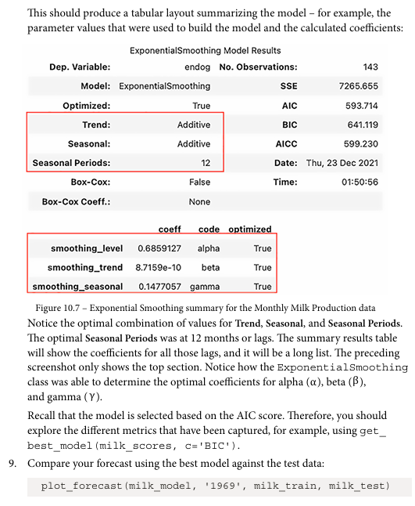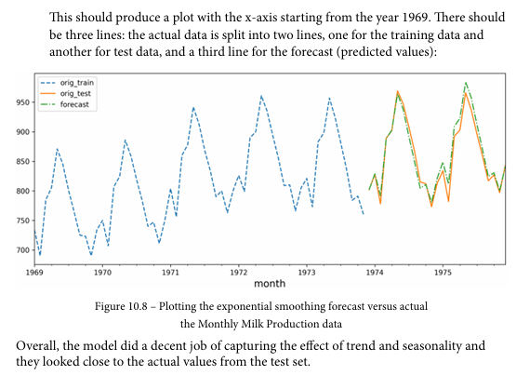

Forecasting univariate time series data with exponential smoothing
Dataset: Monthly Milk Production dataset
Parameters in dataset: Month (Date index) and Milk production value
Libraries in Python used:
- pandas — data handling
- numpy — numerical operations
- matplotlib — plotting
- statsmodels — time series modeling
- sklearn — evaluation metrics
Important functions used with their syntax and purpose:
plot_acf(data)
Used to plot autocorrelation of time series.
plot_pacf(data)
Used to plot partial autocorrelation.
ExponentialSmoothing()
Builds exponential smoothing forecasting model.
forecast(n)
Predicts next n future values.
adfuller()
Tests stationarity of time series.
Code:
model = ExponentialSmoothing(
milk_train,
trend="add",
seasonal="add",
seasonal_periods=12
).fit()

forecast = model.forecast(len(milk_test))

milk_train.plot(label="Train")
milk_test.plot(label="Test")
forecast.plot(label="Forecast")
plt.legend()
plt.show()

Output:
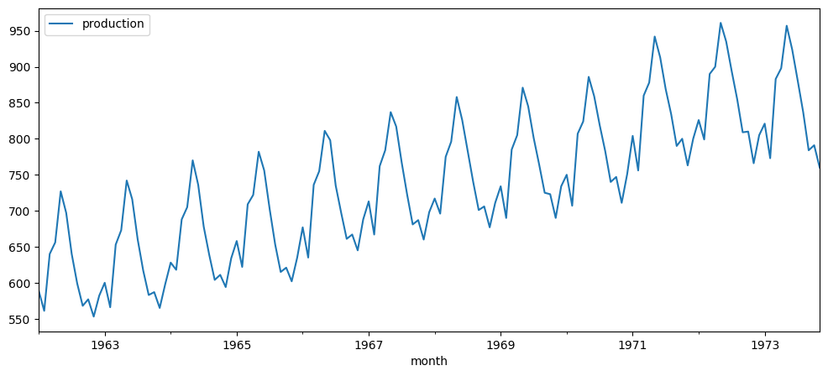
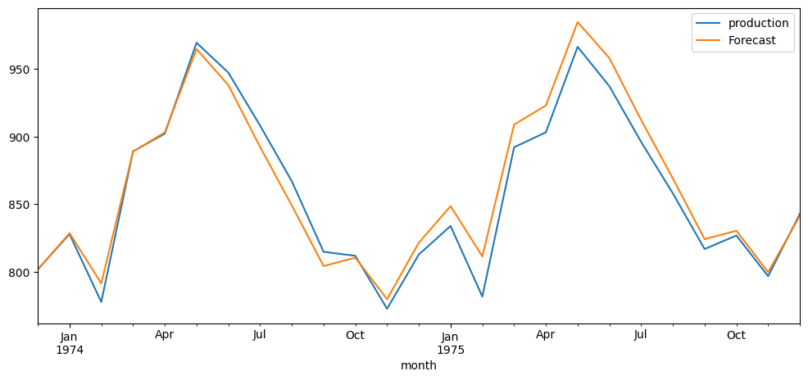
Interpretations:
- Exponential smoothing works well for this dataset.
- Forecast trends matches actual values reasonably.

