Course Name: | Advanced Data Analytics | Semester: | IV
Date of Performance: |  | Batch No: | ADA-2
Grade/Marks: | /25 | Roll No: | 16010324044

Experiment No: 7

Title: AutoRegressive Integrated Moving Average(ARIMA)

Aim and Objective of the Experiment:
- Detecting time series stationarity
- Forecasting univariate time series data with non-seasonal ARIMA

COs to be achieved:
CO 3. Design modelling, aggregating and knowledge representation of semantic web
CO 4. Collect, analyse, and interpret data, making informed decisions based on quantitative insights.

Tools required:
- Data set website
- Python programming
Use the same technical requirements used for Experiment 6

Theory:
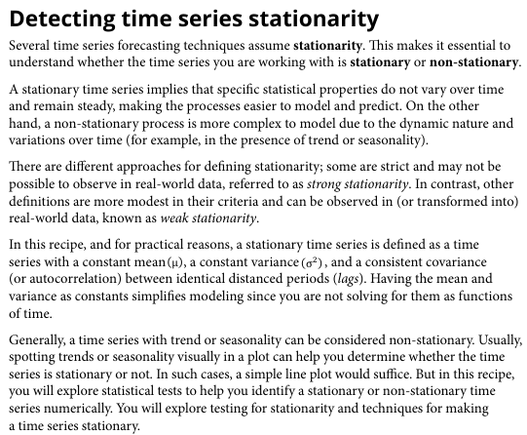
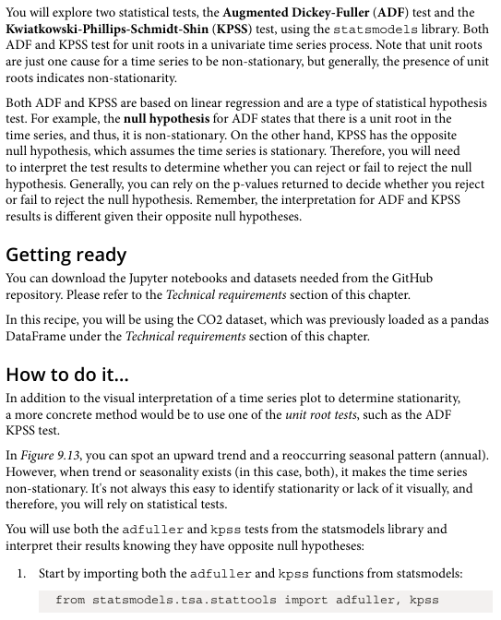
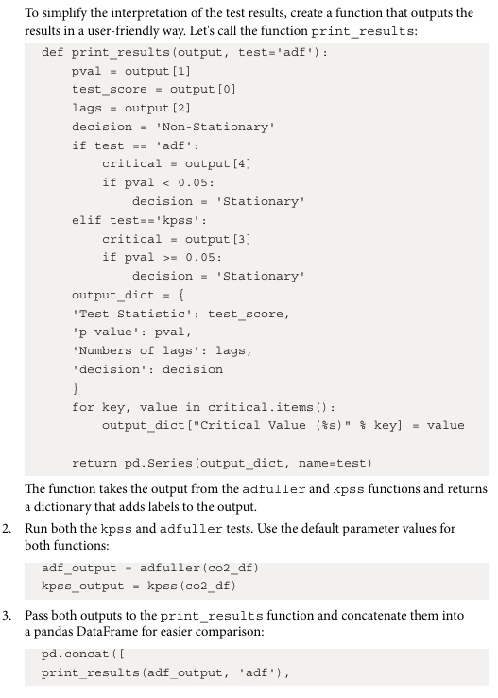
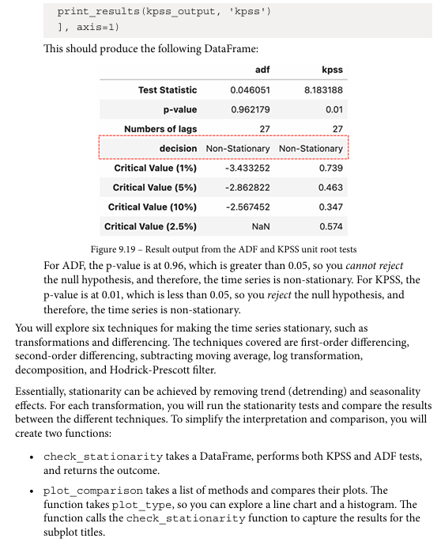
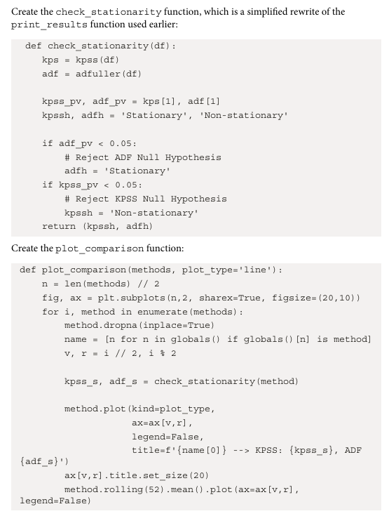
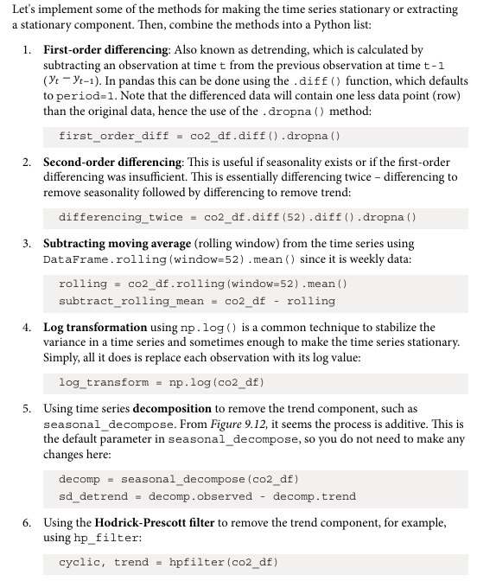
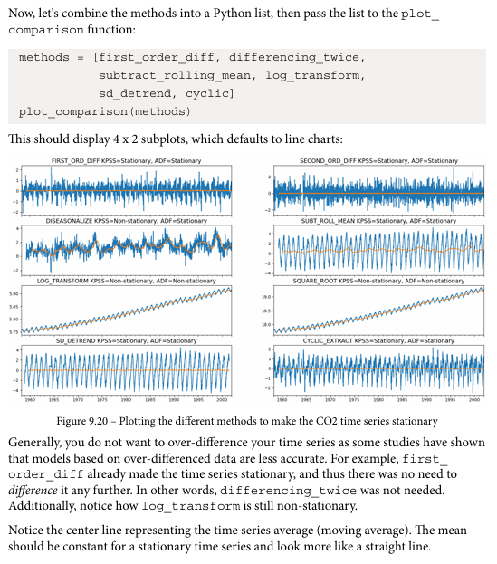

Detecting time series stationarity
Dataset: AirPassengers Dataset
Parameters in dataset:
- Month - Date of observation
- Passengers - Number of airline passengers
Libraries in Python used:
- pandas
- numpy
- matplotlib
- statsmodels
Important functions used with their syntax and purpose:
- pd.read_csv() - Load dataset
- plt.plot() - Visualize time series
- adfuller(series) - Perform ADF stationarity test
- series.diff() - Make series stationary
Code:
import pandas as pd
import numpy as np
import matplotlib.pyplot as plt

from statsmodels.tsa.stattools import adfuller

# Load dataset
url = "https://raw.githubusercontent.com/jbrownlee/Datasets/master/airline-passengers.csv"
data = pd.read_csv(url)

data['Month'] = pd.to_datetime(data['Month'])
data.set_index('Month', inplace=True)

print(data.head())

# Plot time series
plt.figure(figsize=(10,5))
plt.plot(data['Passengers'])
plt.title("Air Passenger Time Series")
plt.xlabel("Year")
plt.ylabel("Passengers")
plt.show()

# ADF Test
result = adfuller(data['Passengers'])

print("ADF Statistic:", result[0])
print("p-value:", result[1])

# Differencing to make stationary
data_diff = data['Passengers'].diff().dropna()

plt.figure(figsize=(10,5))
plt.plot(data_diff)
plt.title("Differenced Time Series")
plt.show()

Output:
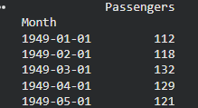
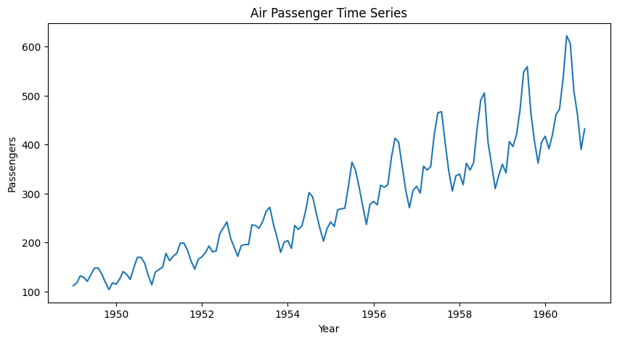
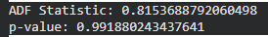
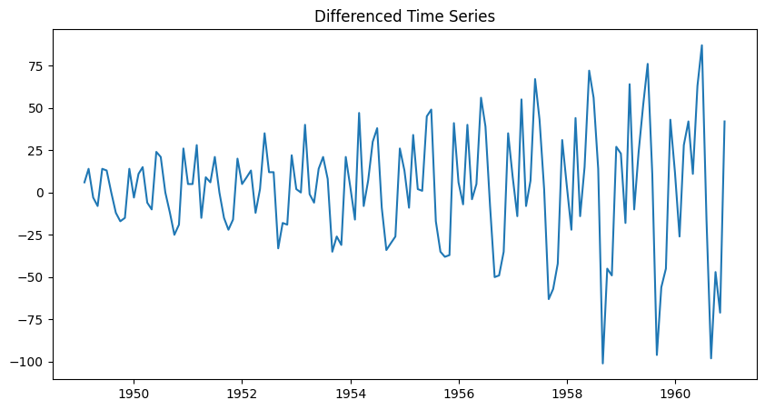
Interpretations:
- Original data shows trend → non-stationary.
- ADF test p-value > 0.05, confirming non-stationarity.
- After applying first-order differencing, the series becomes stationary.

Theory:
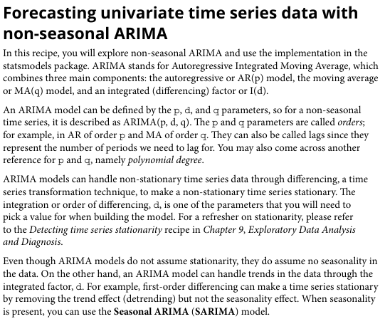

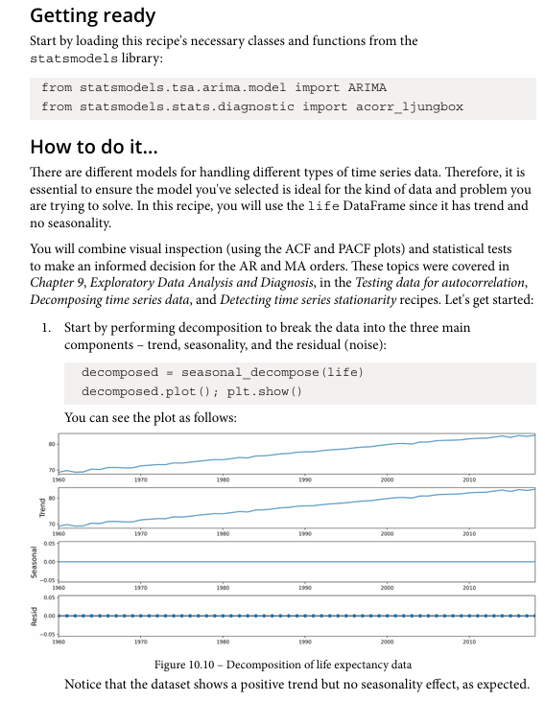

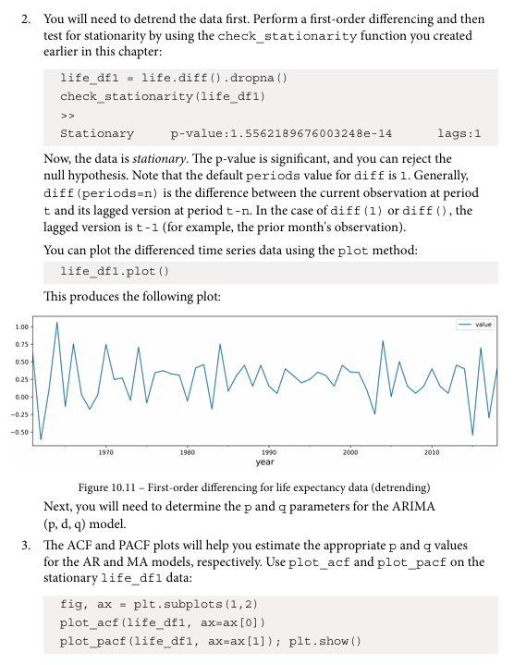
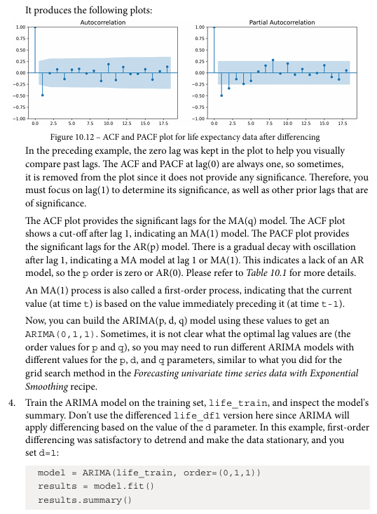
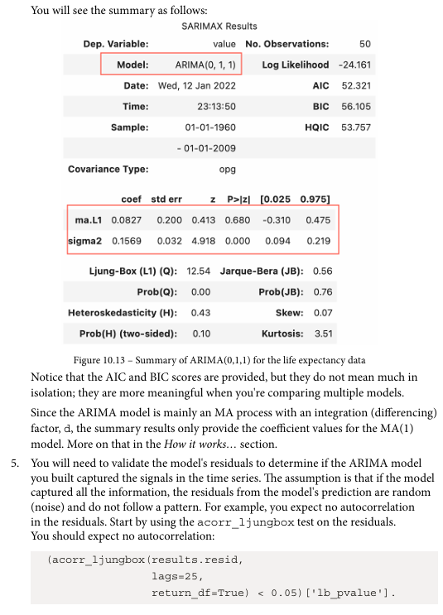
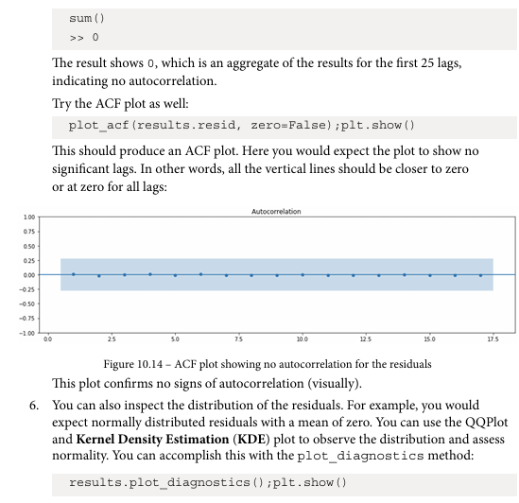
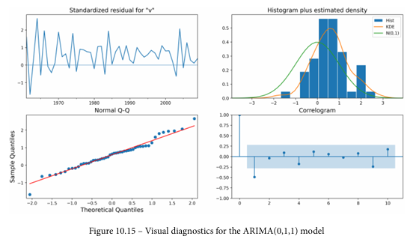

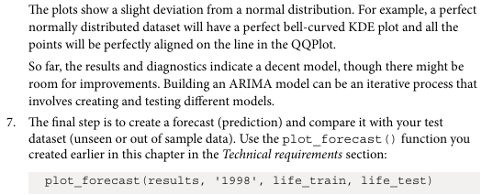
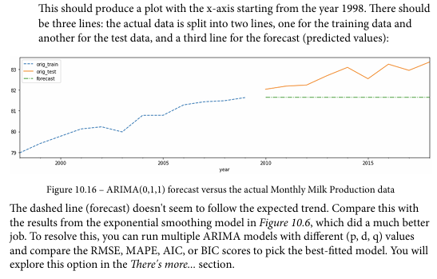
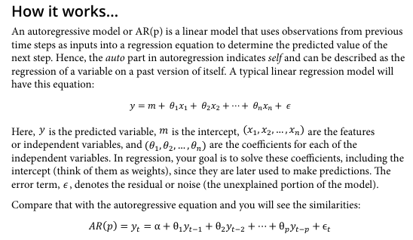
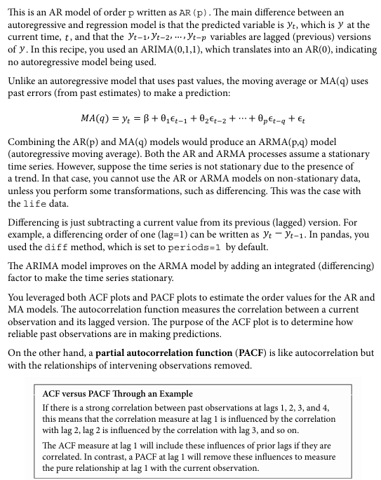
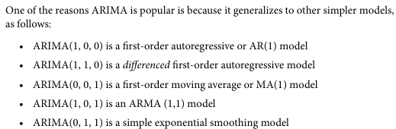

Forecasting univariate time series data with non-seasonal ARIMA
Dataset: AirPassengers
Parameters in dataset:
Month - Time index
Passengers - Observed values
Libraries in Python used:
- pandas
- matplotlib
- statsmodels
Important functions used with their syntax and purpose:
- ARIMA(data, order=(p,d,q)) - Build ARIMA model
- model.fit() - Train model
- model.forecast() - Predict future values
Code:
from statsmodels.tsa.arima.model import ARIMA

# Fit ARIMA model
model = ARIMA(data['Passengers'], order=(1,1,1))
model_fit = model.fit()

print(model_fit.summary())

# Forecast next 10 months
forecast = model_fit.forecast(steps=10)

print("Forecasted Values:")
print(forecast)

# Plot forecast
plt.figure(figsize=(10,5))
plt.plot(data['Passengers'], label="Original")
plt.plot(forecast, label="Forecast", color='red')
plt.legend()
plt.title("ARIMA Forecast")
plt.show()

Output:
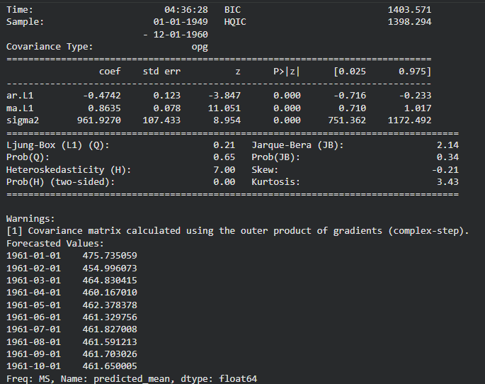
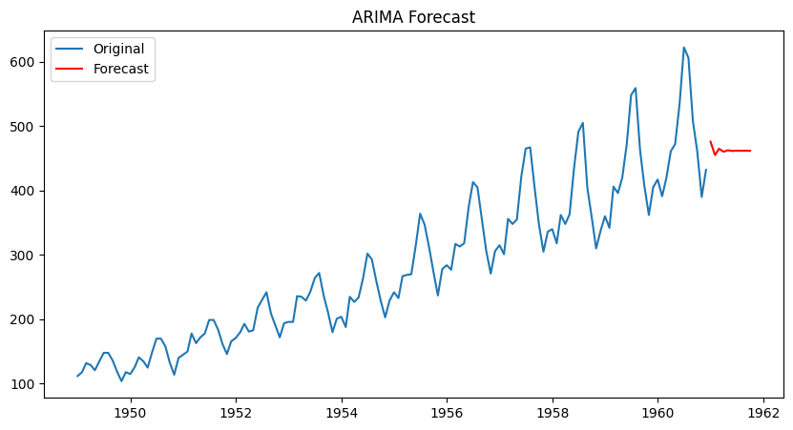
Interpretations:
- ARIMA model successfully predicts future passenger numbers.
- The forecast shows a continuing upward trend.
- The model captures trend patterns in historical data.

