Course Name: | Advanced Data Analytics | Semester: | IV
Date of Performance: |  | Batch No: | ADA2
Grade/Marks: | /25 | Roll No: | 16010324044

Experiment No: 8
Title: Seasonal ARIMA (SARIMA)

Aim and Objective of the Experiment:
Forecasting univariate time series data with seasonal ARIMA

COs to be achieved:
CO 3. Design modelling, aggregating and knowledge representation of semantic web
CO 4. Collect, analyse, and interpret data, making informed decisions based on quantitative insights.

Tools required:
- Data set website
- Python programming
Use the same technical requirements used for Experiment 6

Theory:
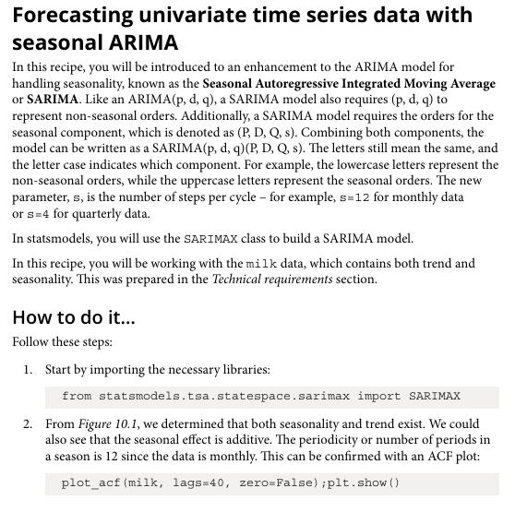
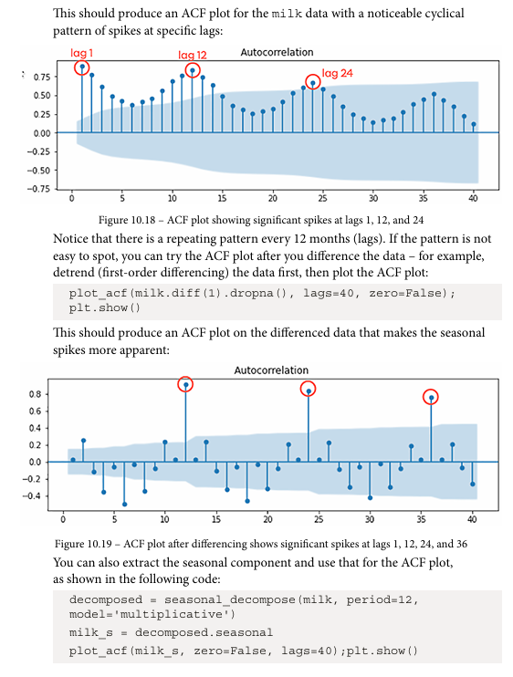
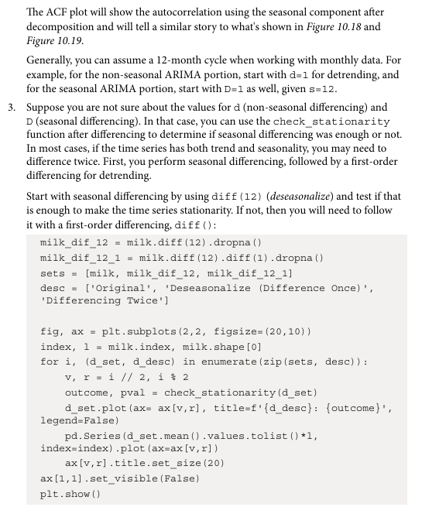

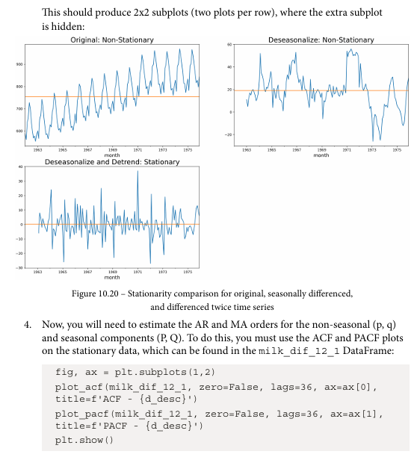
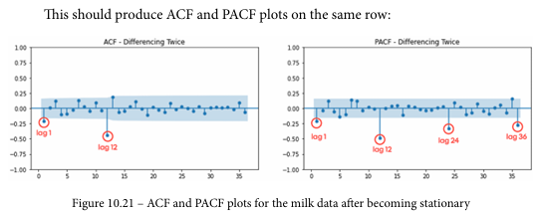

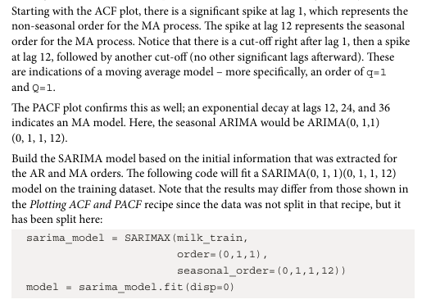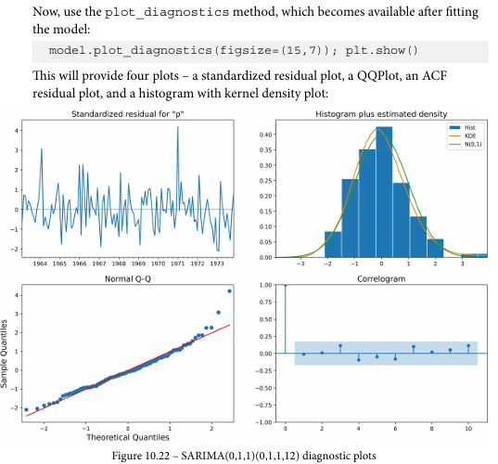

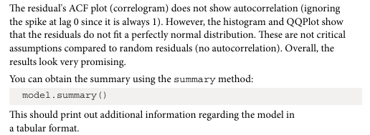
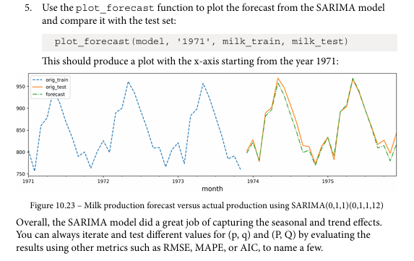
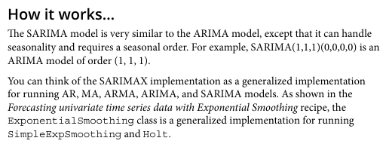

Forecasting univariate time series data with seasonal ARIMA
Dataset: Milk Production Dataset
Parameters in dataset: Month (Time index) and Production (Milk production values)
Libraries in Python used:
- pandas — data handling
- numpy — numerical operations
- matplotlib — plotting
- sklearn — evaluation metrics
- statsmodels — time series modeling
Important functions used with their syntax and purpose:

Code:
import pandas as pd
import numpy as np
import matplotlib.pyplot as plt

from statsmodels.tsa.stattools import adfuller
from statsmodels.tsa.statespace.sarimax import SARIMAX
from sklearn.metrics import mean_squared_error
df = pd.read_csv('/content/milk_production.csv')
print(df.columns)
df = pd.read_csv('/content/milk_production.csv')

# Convert to datetime
df['month'] = pd.to_datetime(df['month'])

# Set index
df.set_index('month', inplace=True)

df.head()
plt.figure(figsize=(10,5))
plt.plot(df['production'])
plt.title("Milk Production Over Time")
plt.xlabel("Year")
plt.ylabel("Production")
plt.show()
from statsmodels.tsa.stattools import adfuller

result = adfuller(df['production'])

print("ADF Statistic:", result[0])
print("p-value:", result[1])
df_diff = df['production'].diff().dropna()

plt.figure(figsize=(10,5))
plt.plot(df_diff)
plt.title("Differenced Data")
plt.show()
from statsmodels.tsa.statespace.sarimax import SARIMAX

model = SARIMAX(df['production'],
order=(1,1,1),
seasonal_order=(1,1,1,12))

model_fit = model.fit()

print(model_fit.summary())
forecast = model_fit.forecast(steps=12)

plt.figure(figsize=(10,5))
plt.plot(df['production'], label='Actual')
plt.plot(forecast, label='Forecast')
plt.legend()
plt.title("SARIMA Forecast")
plt.show()
from sklearn.metrics import mean_squared_error

pred = model_fit.predict(start=0, end=len(df)-1)

mse = mean_squared_error(df['production'], pred)
print("Mean Squared Error:", mse)

Output:
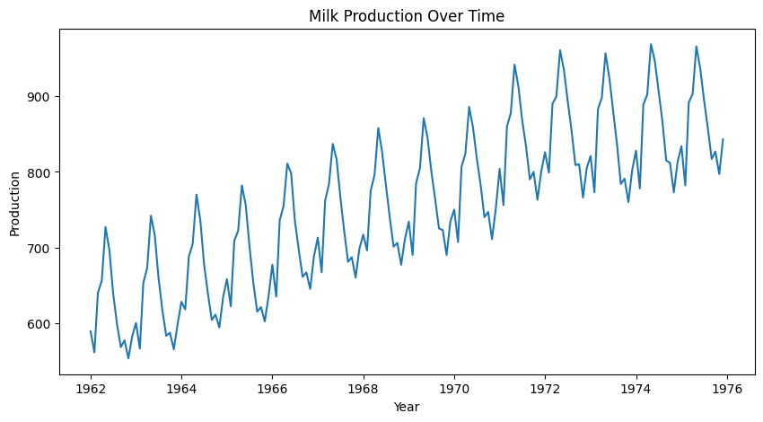

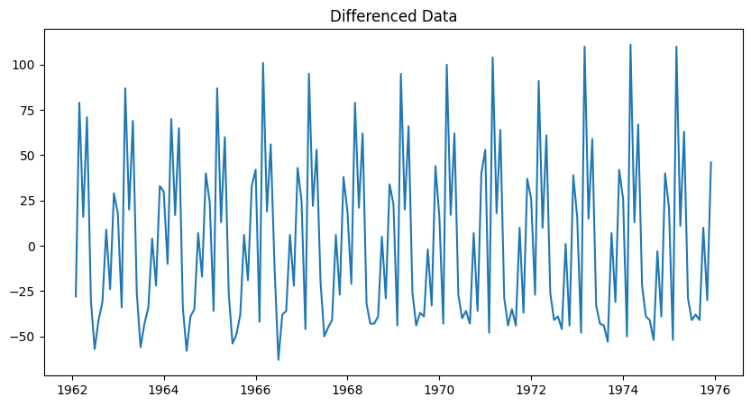
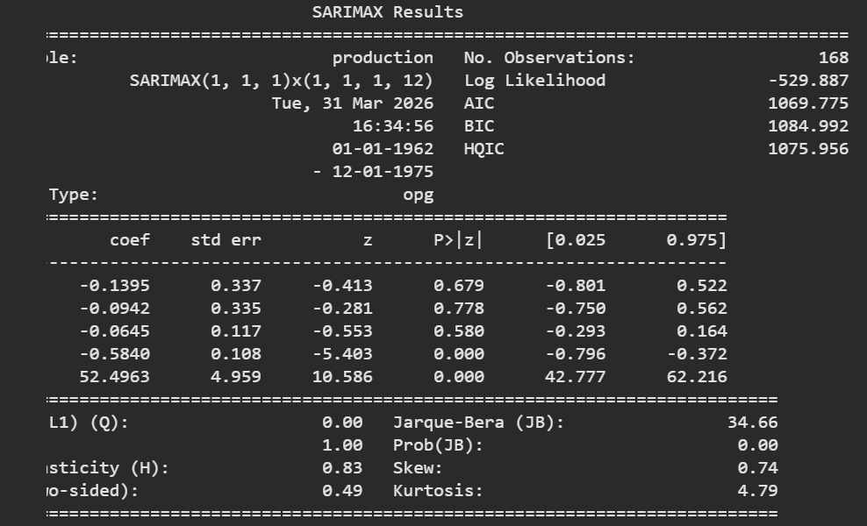
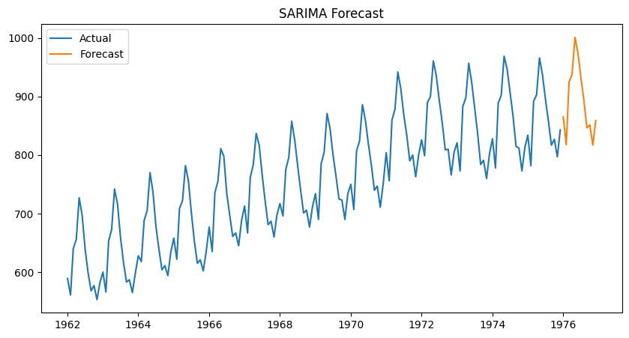
Interpretations:
- The dataset shows clear seasonality (12 months cycle)
- SARIMA model captures both:
- Trend (differencing)
- Seasonality (seasonal_order)
- Forecast closely follows actual values
- Low MSE indicates good model performance

